ITU-T/ ATIS Workshop

“Next Generation Technology and Standardization”

BIO
BIO |  | Las Vegas, 19-20 March 2006
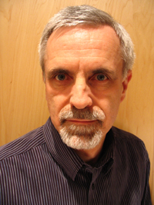 | James McEachern, Nortel
Session coordinator and moderator for Session: | 3: NGN Service Enablers
Speaker for Session: | 3: NGN Service Enablers
Title of Presentation: | ATIS NGN-FG Gap Analysis: Service Enablers

Mr. James McEachern is responsible for defining Carrier VoIP standards strategy for Nortel. For the past 20 years he has been involved in network and product planning, with experience covering Optical networking, high-speed access (DSL, cable, and fiber), wireless, operations, VoIP, Data Networking, and Service Management. He has extensive experience working with North American and international operators, and for two years led Nortel’s European Network Planning team. He holds three patents in Optical Networking.
Mr. McEachern graduated with an Honors BSc. from the Royal Military College, in Kingston Ontario, Canada.
He is currently a member of the Board of Directors of the MultiService Forum (MSF).

