ITU-T/ ATIS Workshop

“Next Generation Technology and Standardization”

BIO
BIO |  | Las Vegas, 19-20 March 2006
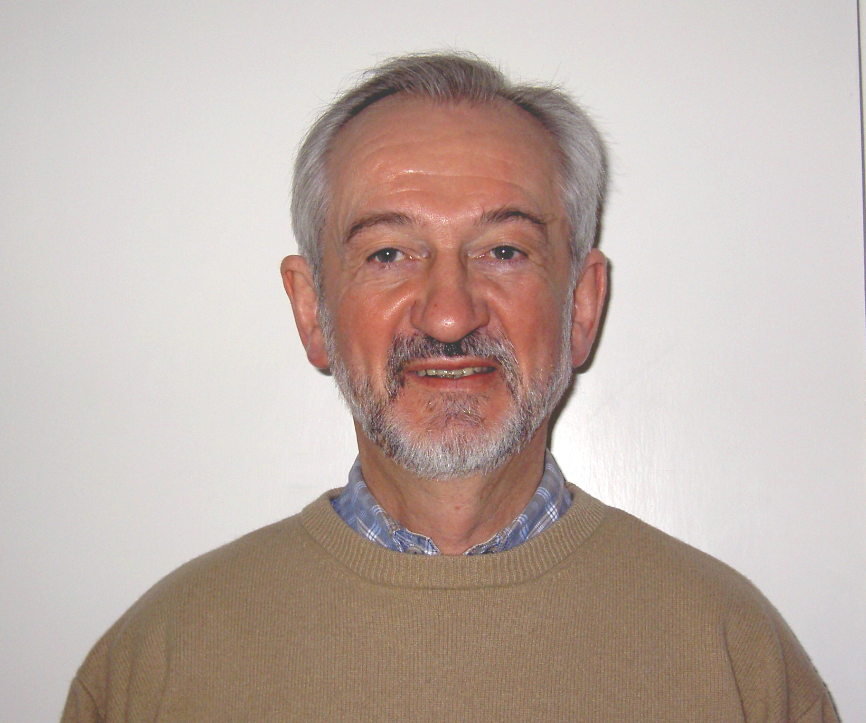 | Brian Moore  Lucent Technologies
Session: | Session 1: ITU-T/ATIS, update on NGN activities
Title of Presentation: | ITU-T NGN Activities

Biography: B W Moore MSc BSc CEng FIEE

Brian Moore has been working in the telecomms standardisation field for over thirty years and has held many chairmanships in CEPT, ETSI and the ITU in the area of network standards. He has been involved in standards development for data networks, signalling systems, the ISDN and IP-based networks. He is currently chairman of ITU-T Study Group 13 which is the focal point for the standardisation activities on Next Generation Networks.

