This ITU-T IPTV Global Technical Workshop reviewed and examined IPTV standardization, political and regulatory aspects, business models and various case studies as well as technical developments and service provider’s operational aspects.  IPTV represents a convergence between the traditional telecommunication and broadcast industries. And, as with any convergence a lot of work is needed to ensure interoperability. Standards are clearly a key enabler for this.  With many of the conditions necessary for IPTV rollout in place - global IP connectivity over managed broadband infrastructure with such guarantees as QoS and security, and broadband connectivity with enhanced network capabilities - there is a strong demand for globally accepted standards to ensure smooth service rollout and interoperability. The workshop provided a review of the current status of IPTV work as well as an examination of where to go next. 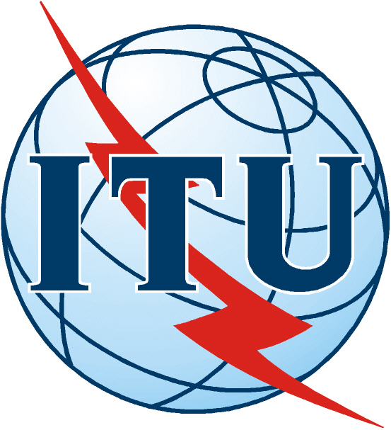 |  | INTERNATIONAL TELECOMMUNICATION UNION
 |  | ITU-T | Final Report

ITU-T IPTV Global Technical Workshop

(Seoul, Korea, 12-13 October 2006)

Executive Summary

In recent years, IPTV has become an increasingly important service to the ICT market. More and more ITU-T Members are facing challenges from technical as well as regulatory issues. With many of the conditions necessary for IPTV rollout in place - global IP connectivity over managed broadband infrastructure with such guarantees as QoS and security, and broadband connectivity with enhanced network capabilities - there is a strong demand for globally accepted standards to ensure smooth service rollout and interoperability.

At the kind invitation from Korea Telecom, Samsung Electronics, IPTV Forum Korea and Telecommunications Technology Association, ITU-T organized this IPTV Global Technical Workshop in Korea to share with Korean experts the progress of ITU-T FG IPTV and identify current and future technology trends, and provide a framework for moving forward standardization work.

The workshop was opened by Mr. Chul-Hee Kang, the Chairman of IPTV Forum Korea. Mr. Houlin Zhao, the Director of ITU-TSB sent his opening message to this workshop, followed by welcome addresses from Mr. Joong-Soo Nam, president&CEO of KT, and Mr. Ghassem Koleyni, Chairman of ITU-T FG IPTV. Mr. Koleyni introduced the progress of ITU-T FG IPTV in his keynote presentation.

In the nine following technical sessions, this workshop reviewed, examined and investigated important issues related to promote global IPTV as a key driving force for the future, such as political and regulatory aspects, business models and various case studies as well as technical developments and provider’s operational experiences. This workshop was very successful that it was attended by 442 participants, half from Korea and half from over 15 more countries worldwide.

All presentations were posted on the workshop website and can be accessed at http://www.itu.int/ITU-T/worksem/iptv/programme.html.

Highlights of Technical Sessions

Session 1: Challenges facing IPTV deployment
In this session, Mr. James Thomson and Mr. Reza Tadayoni introduced present marketing trends, policy and regulatory environments in Europe and the Asia-Pacific region which the deployment of IPTV is facing. The presentation about the European environment focused in the commercial IPTV offer in five largest EU members (France, Germany, Italy, Spain and the UK). The analysis of Asia-Pacific region mainly bases on the discussions in Korea, China and the US.

Session 2: Market Developments
In this session, IPTV market deployments and experiences in OECD countries, Hong Kong and Korea were presented. The OECD presentation provides an analysis based on 87 firms in 30 OECD countries in multiple play services and some of the policy issues which may appear as more operators offer converged services. Package and pricing details for 2-3 providers in each country were also included.

Session 3: Regulatory issues
This session reviewed the current status of IPTV related regulatory and political frameworks in Netherland, Hong Kong and the UK. Speakers in this session argued that the emergence of All IP networks is of fundamental importance for regulation; while regulators worldwide are facing challenges of the new and complex competitive dynamics caused by the emergence of All IP networks.

Session 4: Direction for Global Environments
This session continued the discussion on regulatory and policy challenges in the previous session. Analysis of worldwide proceedings related to the IPTV taking into consideration specific regional situations pointed out existing similarities and demonstrate a direction in which the ICT sector policies and regulation are moving.

Session 5: Services and applications over IPTV
In this session, speakers from Samsung Korea, Motorola, Pyroworks USA and TNO Netherland introduced various IPTV service and application features.

Session 6: IPTV Service Enablers
In this session, speakers from Huawei, Telecom Italia, ETRI and HGI shared their views on various enabling capabilities of network and service to support IPTV services, including IMS, DRM and home gateway functions.

Session 7: IPTV Service Delivery Mechanism
This session discussed delivery mechanisms for various contents over IPTV. In addition to transport aspects of video delivery over IPTV network, service and transport control view points such as DRM, Security, QoS and middleware were also discussed.

Session 8: IPTV Standardization
In this session, speakers introduced the IPTV standards activities in Korea, China, MPEG, DVB, ATIS and ITU-T to provide a snapshot of the worldwide IPTV standardization status and investigated target goals of IPTV standardization activities as a key enabler of business aspects related to IPTV.

Annex: Workshop Evaluation Result

Of 442 participants, 52 returned the filled evaluation form. From the respondents, 21% indicated an overall ranking for the Workshop as —very satisfied“, 63% as —satisfied and 13% as —neutral“.

The average overall ranking of the Workshop was: 4.0

To the question ‘Would you like to see another event on the same subject?’, 50% of respondents answered ‘yes’ and wanted it in the next 1-2 years, while 13% of the respondents said ‘no’.

