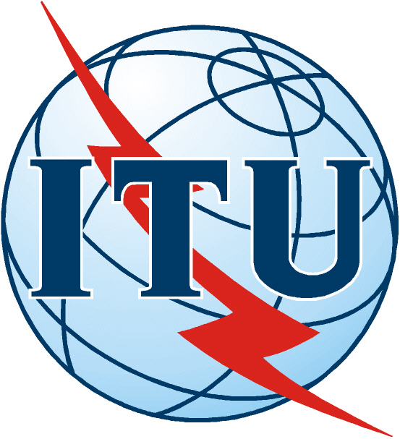 |  | INTERNATIONAL TELECOMMUNICATION UNION
 |  | ITU-T | Final Report
Cybersecurity Symposium II

(Moscow, Russian Federation, 29 March 2005)

1
On 29 March, Moscow, ITU-T held its Cybersecurity Symposium II event on the first day of the Russian Association for Networks and Services (RANS) Conference - Security and Trust for Info-communication Networks Deployment - at the kind invitation of Russian Federation.

As an essential part of information and communication technologies (ICT), cybersecurity is increasingly becoming the decisive issue in coordinating the efforts of state institutions and business for the harmonized development of normative, legal, technological and organizational aspects of an effective infrastructure. The first ITU-T Cybersecurity Symposium, held in Florianopolis in 2004 alongside the WTSA (World Telecommunication Standardization Assembly) began the dialogue between interested parties. This second Symposium has built on the results of that event and on many events which have occurred since, many stimulated by the first event.

This one-day symposium consisted of an opening session, three presentation sessions and a panel discussion session. It attracted around 200 participants with high-quality presentations from key speakers from Russia and all over the world, from the telecom, insurance, finance and education industries, as well as from research institutes. Policy, legislation and regulation topics especially attracted participation from governmental organizations of US, UK, Canada, China and other countries as well as non-governmental organizations. During these sessions, topics such as technology and standardization, legislation, policy and public/private partnership issues and case-studies from different industry sectors were discussed.

The following issues were identified for further action and discussion:

- Need for a common understanding of the terms relating to security issues amongst all interested parties - these include technology, standards, legal, service provider, governments, consumers and e-commerce issues
- Need for accelerated development of necessary standards to build secure networks and services, and in particular to progress towards a next-generation network (NGN) with built-in security
- Need to make the Internet/NGN more robust – a secure and trusted global telecommunications platform, without constraining its evolution and growth
- Need to recognize that the Internet is based on a culture of individuals more than of States and formal institutions, so the challenge is to allow its unfettered evolution, free of overt regulation and yet evolving to become the trusted platform needed for secure commercial and civil society use
- Need for partnerships and collaboration both between the public and private sectors (the latter in many countries is the owner and operator of the telecommunications infrastructure), and amongst governments.

This symposium appreciated the unique strength and contribution of ITU from its public/private partnership as the UN specialized agency for international telecommunication and emphasized that ITU should continue to play a more important role in coordination and collaboration with other stakeholders toward a secure information society. Based on the excellent discussions and very animated exchange among participants of this symposium, a number of outreach efforts must be undertaken to identify which organizations, inter alia IETF, ETSI, ITU, RANS, ENISA, the governmental organizations and the private sector, are interested in keeping the conversation going and how.

Cybersecurity Symposium II together with the first Cybersecurity Symposium formed the basis for a continuing and proactive engagement of ITU on cybersecurity, with the potential to lead to an enriched exchange of information, ideas and activities amongst the global community on key issues crucial to development of a secure next-generation network - a global packet-based telecommunication platform with built-in security that can be used with trust and confidence by all members of society.

Thirty-three of all the participants returned the filled-out evaluation form. The average overall ranking of the Workshop was between satisfied and very satisfied. Eighty-two percent of respondents would welcome another Workshop on the same subject in the next one to two years.

Symposium Conclusions and Recommendations

This symposium suggested that ITU-T should work toward a Cybersecurity Symposium III in a year or so from now, perhaps held in a different region of the world from the last two. A potential theme for such an event could be built around development of a trust and confidence model identifying the key elements and interactions involving among others, standardization challenges, external cooperation, awareness, stakeholder roles and so on.

Secondly, interested organizations can be encouraged to communicate on possibilities for cooperative work and collaboration amongst themselves.

Thirdly, it may be possible to find a volunteer organization such as RANS to act as a focal point for bringing together some principal parties involved in the Moscow event, such as the Chair of ITU-T SG 17 and other interested members of the Symposium Steering committee to meet by teleconference or other means to take a leadership role in ensuring that the conversation does not stop once the Symposium is ended.

This symposium agreed on the high value of the outcomes of the ITU-T Cybersecurity Symposiums and recommended the report of the Moscow event should be prepared and posted on the ITU-T website and circulated to as many potential interested parties as possible to share the outcome and stimulate interest in engagement.

