CV: Speaker: John M. Cioffi, Hitachi America Chaired Prof of EE, Stanford.

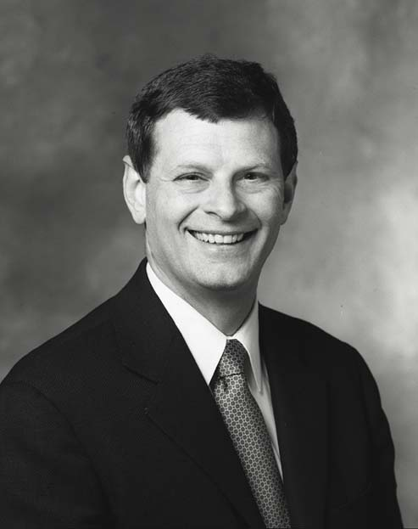

BS - Illinois 1978, PhD Stanford 1984. Member US Nat. Acad of Eng, Fellow IEEE. Also worked at Bell Labs 78-84, IBM 84-86, Amati/TI 1991-1999. Current Boards of Dir. ASSIA (COB), ClariPhy, Marvell, Teknovus, Teranetics.

