Trends of Wireless Access Technologies toward Ubiquitous Services

Shuji Kubota, Ph.D
Senior Research Engineer, Supervisor
NTT Access Network Service System Laboratories

Biography

Shuji Kubota received the B. E. degree from the University of Electro-Communications, Tokyo, in 1980 and the Ph. D. degree in Engineering from Osaka University in 1995, respectively. Since joining NTT in 1980, he has been engaged in research and development of forward error correction and modulation schemes for satellite and personal communication systems. He is currently a senior research engineer, supervisor in NTT Access Network Service System Laboratories, working on development of wireless LAN systems.

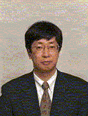
Shuji Kubota

