Biography
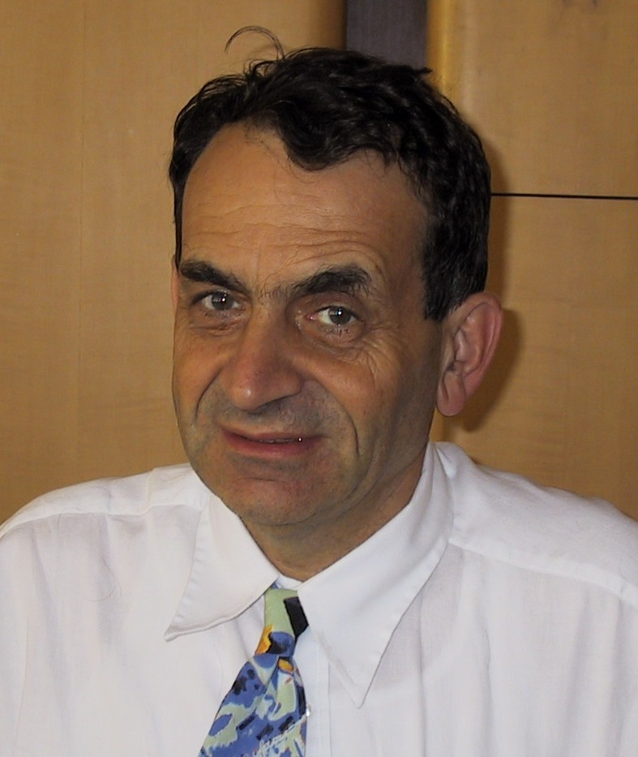
DDr. Istvan Sebestyen
Siemens Communications
Hofmannstr. 51
1379 München
Germany
Email: istvan.sebestyen@siemens.com
Tel: 49 89 722 47230
Fax : 49 89 722 47713
Mobile: 49 171 55 16 216

Why ITU-T:
Multimedia standardization is distributed over several SDOs (such as ITU-T, ISO/IEC, W3C,…) and Industry Fora (such as IMTC, Oasis, OMA,…). De-facto standards (e.g. MS) play an important role too. Being involved in the worldwide multimedia standardization work and in product planning, development process within Siemens I hope to bring into the ITU-T standardization work the blend of practical industry and user needs, as well as the input from cooperating Standards Developing Organizations and Fora. With my background and long experience with the United Nations I think I have a good understanding of the standardization needs of both developed and developing countries.
Current Position:
Director Multimedia and Applications Standards.
Nearly 20 years of telecommunication standardization experience in CCITT, ITU-T, ISO/IEC, ETSI and DIN. ITU-T Rapporteur on still picture coding (JPEG, JBIG) between 1987-2000. Director of the International Multimedia Telecommunication Consortium (IMTC) since 1999, President since 2001.
Job career:
- Hardware- and Software engineer at the Institute for Coordination of Computer Techniques in Budapest (1970-1977)
- Research Scholar (computer networking, telematics) at the International Institute for Applied System Analysis (IIASA) in Laxenburg, Austria (1978-1985)
- Visiting Professor at the Technical University of Graz in Austria (1983-1985)
- Research Projects on Transnational Data Flows (Austrian Academy of Sciences) (1984-1985)
- University lecturing in the area of telecommunication and multimedia communication at the University of Klagenfurt, Austria since 1985
- Various Consultancy projects for the UN (UNIDO, UNESCO, UNCTAD, UN ECE) (1977-1986)
- Telecommunication Standardization (incl. CCITT, ITU-T) at Siemens since 1985
- About 100 science papers, 2 books, and about 12 patents.
Educational background:
- Studies and Diploma in Electrical Engineering at Technical University of Budapest (1970)
- PhD in Electrical Engineering at the Technical University of Budapest (1974)

