INTERNATIONAL TELECOMMUNICATION UNION |  | Focus Group On Next Generation Networks
TELECOMMUNICATION  STANDARDIZATION SECTOR  STUDY PERIOD 2001-2004 |  | FGNGN-ID-00070
 |  | Original: English
 |  | Geneva, 19 - 23 July 2004
INPUT DOCUMENT
Source: | Huawei Technologies Co. Ltd.
Title: | Reference model and QoS issues of Ethernet-based IP access network
Abstract
This contribution provides a generic reference model and QoS issues of Ethernet-based IP access network. And then three proposals are tabled.
- Discussion
According to the type of access aggregation technologies, IP access networks can be classified into two main categories: Ethernet-based IP access network and ATM-based IP access network. (Note that in some cases people use IP-based in comparison with ATM-based, which actually implies Ethernet-based.)
An Ethernet-based IP access network may include several different types of first/last mile user access technologies. For example, there is a style of Ethernet-based IP DSLAM products which can contemporarily support LAN/xDSL/WLAN user access. And it is also possible that the different types of Access Nodes be deployed and aggregated to the same BRAS in an Ethernet-based IP access network. Such an Ethernet-based IP access network cannot be simply named as a DSL access network.
An Ethernet-based IP access network is an IP access network which comprises Access nodes with Ethernet uplink interface, Ethernet-based aggregation nodes, Ethernet-based BRAS.

Reference model of Ethernet-based IP access network
Most of Ethernet-based IP access networks can be shown as the following reference model.
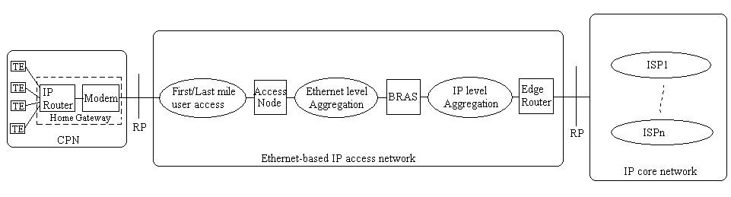
Figure 1 – Generic reference model of Ethernet-based IP access network
Considering the size of an access network and the position of BRAS, Ethernet level aggregation and IP level aggregation nodes may be deployed optionally. In some cases, BRAS may serves as an Edge router directly connected to IP core network.
Generally, L2 or L3 switches are used for Ethernet level traffic aggregation per subscriber, and L3 switches or IP routers for IP level aggregation per QoS class or service type.
In an Ethernet-based IP access network, BRAS, IP level aggregation nodes and Edge routers are IP-aware, while most of other elements are generally IP-unaware.

TE: Terminal Equipment
CPN: Customer Premises Network
Home Gateway: consists of Modem and IP router. Both elements may be needless or optional for some types of the first/last mile user access technologies.
Access Node: terminates the first/last mile link signals at the network side, and physically can be a single device or a chain of subtended devices. It may be located at a Central Office or a remote site or both if subtended. It must have one more Ethernet uplink interface when residing in an Ethernet-based IP access network.
BRAS: Broadband Remote Access Server terminates the user access session (e.g. PPP, EAP(rfc2284), VLAN) and aggregates the user traffic into VLAN or VPN or tunnels as with native IP traffic. The BRAS also provides the policy management interface, AAA interface and DHCP interface. Based on that, it makes user access control and assigns user IP addresses.
ER: Edge Router is an egress IP router which connects an IP access network to one or multiple IP service providers in IP core network. An ER aggregates IP traffic from one or more BRAS. It may also contain NAT and/or firewall elements.
The First/last mile user access technologies are diverse which may be LAN, xDSL, WLAN, EPON, PLC and so on. Different types of the first/last mile user access systems have different types of Modems and Access Nodes. Examples are given below. This list is not an exhaustive list.

The First/last mile user access technology type | Access Node | Modem/Adapter
LAN | L2 Switch | LAN adapter
xDSL | DSLAM | xDSL modem
WLAN | WLAN AP | WLAN adapter
Cable | CMTS | Cable Modem
PLC | EPLC-SHE | EPLC-SCPE
EPON | OLT | ONU
UMTS | RNC+Node B | USIM card

QoS issues of Ethernet-based IP access networks
QoS issues and mechanisms of Ethernet-based IP access network are very different from that of ATM-based IP access network due to the native difference between ATM and Ethernet.
Thanks to ATM native QoS design including fixed length cell switch and PVC connection mechanisms, it’s much easier to meet the QoS requirements for user traffic delivery in an ATM-based IP access network. Note that DLS forum now is working on a QoS architecture (TR-059) based on ATM aggregation.
However, Metro Ethernet networks are being constructed and Ethernet aggregation is increasing rapidly. At the same time, multi-services support requirement on broadband IP access is also increasing so that QoS issues of Ethernet-based IP access network become very urgent. Fortunately we have laboured on this topic for one year. The current draft recommendation Y.123.qos is focusing on the QoS issues in an Ethernet-based IP access network.
In nature, the bearer QoS (i.e. bearer network performance) control issues are the network resource control issues. Through optimizing resource allocation among traffic, the network performance objects including the upper bound on packet delay, jitter, loss and error can be met well. According to the difference of the resource attributes, QoS issues in an Ethernet-based IP access network should be partitioned into three segments and respectively addressed. They include the first/last mile user access segment, the Ethernet level aggregation segment, and the IP level aggregation segment.
At the joint nodes such as the access node, BRAS and Edge router, the mapping between the different QoS mechanisms should be done for end-to-end QoS delivery.
In addition, these joint nodes are usually as the injection nodes for support of dynamic and per-seesion QoS control and management based on policy and/or resource information database.
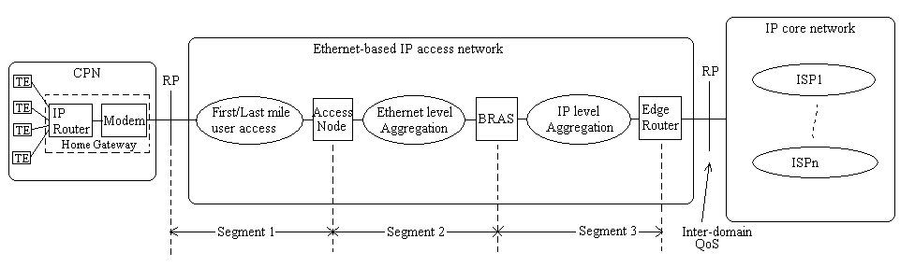

QoS mechanisms in the first/last mile user access segment
Generally this segment is IP-unaware and the technologies are very diverse. Each kind of the first/last mile user access technology has its own resource control mechanisms concomitant with the physical and link layer mechanisms.
Commonly the technology-invented organization is responsible to work out the QoS forwarding, control and management mechanisms for this portion, which are MAC technology specific.
The bandwidth resource contention among users shall be solved, especially if users must share the upstream/downstream link bandwidth.
For support of dynamic bandwidth allocation and per-session differentiated QoS, the access node shall have the interface with the QoS-related controller.

QoS mechanisms in the Ethernet level aggregation segment
IEEE 802.1 group defines the traffic class expediting mechanisms in std802.1p (published in 802.1D-1998) and the VLAN mechanisms in std802.1q.
The inner VLAN shall be configured per user from the Access Node to BRAS for solving resource contention and security, commonly called the ‘user VLAN’. Q-in-Q (i.e. VLAN nesting) mechanism could be used for Ethernet level traffic aggregation. The Access node and BRAS shall do the mapping between IP QoS classes and 802.1p classes.
For support of dynamic bandwidth allocation and per-session differentiated QoS, the Access Node and BRAS shall have the interface with the QoS-related controller.

QoS mechanisms in the IP level aggregation segment
IETF defines two sorts of IP QoS mechanisms (IntServ and Diffserv) and many tunnels and VPN mechanisms.
The tunnels and VPNs are configured per service type or QoS classes. MPLS, VLAN, L2TP, GRE, VPN and native IP could be used for IP level traffic aggregation. The BRAS and Edge router shall do the mapping between 802.1p classes, IP QoS classes, and MPLS exp.
For support of dynamic bandwidth allocation and per-session differentiated QoS, BRAS and the Edge Router shall have the interface with the QoS-related controller.

Focus of Y.123.qos
Based on the existing QoS mechanisms in the data plane, the focus of Y.123.qos is to define
- a QoS control architecture for support of dynamic QoS and per-session QoS differentiation in Ethernet-based IP access network (note that it’s not for only the the first/last mile portion);
- the QoS control interfaces and their requirements;
- the mapping of QoS parameters between the service layer and transport layer;
- the mapping of the different QoS mechanisms between two adjacent segments.
The QoS mechanisms for the first/last mile user access technologies are very MAC technology specific and should inherit from the technology-invented organizations. That is not the focus of Y.123.qos.

Proposals
Proposal 1：
We propose to include the above texts of section 1.1 and 1.2 into Y.123.qos and create two new sections separately titled as ‘Refer model of Ethernet-based IP access network’ and ‘QoS issues of Ethernet-based IP access network’.
Accordingly, the scope of Y.123.qos could be changed as follows.
“This recommendation provides a QoS control architecture for Ethernet-based IP access network. It specifies a reference model, a QoS control architecture model, the control interfaces requirements and key mapping mechanisms for support of dynamic QoS and per-session differentiated QoS in Ethernet-based IP access network.”
Short of time, the corresponding modifications for the figure 1, 2 and 3 could be left to the next meeting.
Proposal 2:
Since the scope and QoS requirements sections of Y.123.qos are reinforced and clarified within this contribution, ‘centralized’ resource control impression may be changed based on contributions and discussion in the subsequent meetings. And It isn’t the purpose but one of the means of Y.123.qos. So the title of Y.123.qos should be kept as “ A QoS control architecture for Ethernet-based IP access network”.
Proposal 3
Although Ethernet-based IP access network is rapidly increasing, there are many ATM-based IP access network existing. To protect the carrier’s investment, we also propose to start a new draft recommendation on ‘a QoS control architecture for ATM-based IP access network’. DSL forum TR-059 may be a good start point for this purpose.
__________

