INTERNATIONAL TELECOMMUNICATION UNION |  | Focus Group On Next Generation Networks
TELECOMMUNICATION  STANDARDIZATION SECTOR  STUDY PERIOD 2001-2004 |  | FGNGN-ID-00069
 |  | Original: English
 |  | Geneva, 19 - 23 July 2004
INPUT DOCUMENT
Source: | Huawei Technologies Co. Ltd.
Title: | Clarification for the scope of Y.123.qos
Abstract
At the June FG meeting the discussion arose about the meaning of Ethernet-based IP access network, since it lacks of the relevant definition for this term in Y.123.qos and the figure 1 which only reflects the controller and controlled points is too abstract to express the scope.
This contribution expresses the understanding and definition of Ethernet-based IP access network for clarification.

- Discussion

Definitions in Y.1231
Y.123.qos refers to Y.1231 for which provides the definitions regarding IP access network, IP core network, and the high-level architectural model of IP networks and IP access network.
Although the following two figures are very high level, they clearly show the scope of IP access network which encompasses the first/last mile user access nodes, aggregation nodes and access control devices between CPN and IP core network.
IP access network: An implementation comprising network entities to provide the required access capabilities between an "IP user" and an "IP service provider" for the provision of IP services. "IP user" and "IP service provider" are logical entities which terminate the IP layer and/or IP related functions, and may also include lower layer functions, and may also include lower layer functions.
IP core network: IP service provider's network, including one or more IP service providers.

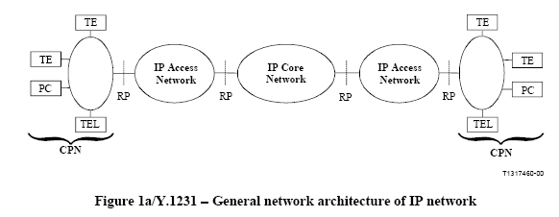

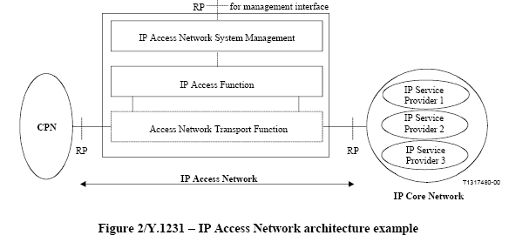

IP access network types
In the real network, access technologies are diverse. Especially, with the sprint of the broadband access services (usually access rate is above 2Mbps), the first/last mile user access technologies are enriched rapidly and seem emerging in endlessly, such as LAN, xDSL, Cable, WLAN, UMTS, APON, EPON, PLC and etc.
According to the type of first/last mile access technologies, IP access networks are named as LAN access network, xDSL access network, Cable access network, wireless LAN access network, UMTS access network, xPON access network (some 802.3ah group members call EPON access as EAN-Ethernet Access Network) and etc.
However, no matter what kind of first/last mile access technology is used, Ethernet and ATM predominate in the access aggregation part between access nodes (which terminate the first/last mile link signals) and IP core network. The type of the access aggregation technology will impact the selection of not only the interface type and inner implementation of Access Nodes and BRAS, but also the IP mapping mechanisms in the first/last mile user access line.
So, according to the type of access aggregation technologies, IP access networks can be classified into two main categories: Ethernet-based IP access network and ATM-based IP access network. (Note that in some cases people use IP-based in comparison with ATM-based, which actually implies Ethernet-based.)
With the predominating of IP in core networks and CPN, Ethernet gradually occupies more and more share for access aggregation due to its cheapness and simplicity. Metro Ethernet networks are being constructed by carriers for access aggregation and other service goals, whilst QoS issues of MEN are being addressed for providing QoS-assured data delivery performance close to what ATM can provided. At the same time, ATM is gradually used to aggregate the business user traffic with fixed access rate and strict QoS requirements for leased line or VPN service, not any more for IP access service.
An Ethernet-based IP access network may include several different types of first/last mile user access technologies. For example, there is a style of Ethernet-based IP DSLAM products which can contemporarily support LAN/xDSL/WLAN user access. And it is also possible that the different types of Access Nodes be deployed and aggregated to the same BRAS in an Ethernet-based IP access network. Such an Ethernet-based IP access network cannot be simply named as a DSL access network.

Definition of Ethernet-based IP access network
An IP access network comprises Access nodes with Ethernet uplink interface, Ethernet-based aggregation nodes, Ethernet-based BRAS.

Proposals
We propose to include the above texts into Y.123.qos and create a new section about the definition of Ethernet-based IP access network. It is useful to explain the purpose and requirement of Y.123.qos to the readers.

__________

