INTERNATIONAL TELECOMMUNICATION UNION |  | Focus Group On Next Generation Networks
TELECOMMUNICATION  STANDARDIZATION SECTOR  STUDY PERIOD 2001-2004 |  | FGNGN-ID-00063
 |  | Original: English
 |  | Geneva, 19 - 23 July 2004
INPUT DOCUMENT
Source: | Telekomunikacja Polska
Title: | Proposals for Clause 7.1 Evolutions scenarios to draft FG NGN 34 document: “PSTN evolution to NGN”

Abstract:
This contribution provides some proposals for Clause 7.1 Evolutions scenarios of draft FG NGN 34 document: “PSTN evolution to NGN”.

- Discussion
According to first FG NGN WG6 meeting commitment this document contains some modifications and description that better describe considered scenarios. In the proposal there is a new version of clause 7.1 with tracking modifications.
It is proposed to merge two scenarios (previous scenario 1 and 2) into one scenario and indicate that this new scenario consists of two phases where the first phase (previous scenario 1) is an optional step to the second phase (previous scenario 2). In figure 7-2 there are changes concerning numbering of PSTN elements. The figure is also modified - access elements from LE3 are connected directly to LE4 (not through RUAM).
Figure 7-3 is also modified. The left side of the picture shows evolution with phase 1 and the right side without phase 1.
In the previous scenario 3 there are modification to figure 7-4. The idea was to show an overlay network where some PSTN exchanges are upgraded and the remaining PSTN exchanges are left unchanged.
There is also a proposal to add a new scenario where PSTN is the transport layer for voice connection.

2. Proposal for the supplementary of Y.PSTN-MIG
It’s proposed to put the following changes into Y.PSTN-MIG as clause 7.
7.1 Evolution scenarios
Possible scenarios for evolution of PSTN access and core may be as follows:
7.1.1 Scenario 1
This scenario consists of two phases. Realisation of both phases depends on the technological possibility to upgrade PSTN elements.
Phase 1 (optional)
In this scenario PSTN Access reach is extended for certain subscriber units by replacing a local exchange with a RUAM or an Access Network (AN) as shown in Figure 7-2.

Figure 7-2: Extension of Access by replacing LE with RUAMs and ANs

Phase 2
This phase follows the previous phase but can be also executed without phase 1 After the Access is extended by replacing certain LEs with RUAMs or ANs, then they (i.e., RUAM and AN) themselves are replaced by a VAG (Voice Access Gateway) (left side of the picture).
There is also a direct way without phase 1 (right side of the picture) - UAM and AN are replaced by VAG.
There is also a possibility to connect directly AN to VAG, in this case AN doesn't have to be upgraded to VAG.
The VAG plays the role of a concentrator for ANs (V5 interface), RUAMs and possibly PBXs and also a switch as shown in Figure 7-3. The VAG also diverts traffic from PSTN to packet based networks. A Call Server also is used between VAGs. After introducing CS and VAG there is a possibility to deliver new NGN services.

Figure 7-3: Concentration of traffic to VAG and extension to packet based networks
7.1.2 Scenario 2

In this scenario some of the local exchanges (LEs) are upgraded to VAGs, additional VAGs may also be implemented and a Call Server (CS) is utilized between VAGs. The VAGs are connected via packet based networks. Realisation of scenario depends on the technological possibility to upgrade PSTN elements.
After introducing CS and VAG there is a possibility to deliver new NGN services. See Figure 7-4.

Figure 7-4: Conversion of some of LEs to VAGs and use of packet based network

Scenario 3
In this scenario Class 4 exchanges (also called as trunking exchange, TE) are converted to trunking gateway (TG) and new call servers (CSs) are introduced. The TGs are connected either using existing PSTN facilities or of the Packed Based Network.
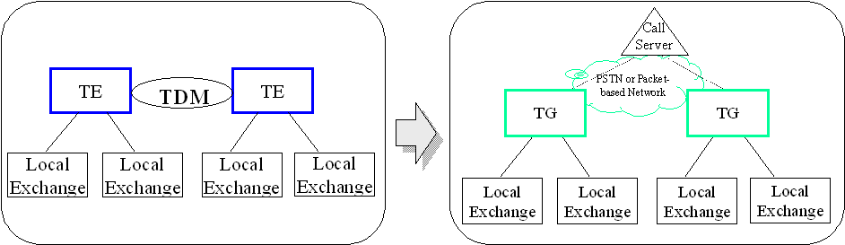
Figure 7-5: Replacement of TEs with TGs
Examples of such variants are shown in Appendix I.

Scenario 4 (New scenario)
In this scenario PSTN is the transport layer for voice connection. After introducing CS and VAG there is a possibility to deliver new NGN services.

__________________

