United Arab Emirates

FOCAL POINT REGARDING CORRESPONDENCE ON THIS QUESTIONNAIRE
(PARTS I, II AND III)

Please identify a focal point in your administration/organization who could provide a response to further correspondence regarding this questionnaire (see hereafter).

1. Mr./ Mohamed Abd Allah Mohamed
Family Name First Name

2. Country UAE

3. Name of the Administration/Organization Ministry Of Communications

4. Title : A/D Telecomm. Dept.

5. Address ;: UAE –ABU DHABI P.O.Box.900

6. Tel.: 0097126911122 Fax: 0097126668180 E-Mail: engrhassan@moc.uae.gov.ae

To be returned to:
ITU-D Study Groups Secretariat
Telecommunication Development Bureau
Fax: +41 22 730 54 84
E-Mail: devsg2@itu.int

Attachment 1
QUESTIONNAIRE - PART I
(To be completed by both Administrations and, where relevant, by Sector members)
Information on national radio frequency spectrum allocations: 960 – 3 000 MHz
1. Introduction
A national table of frequency allocations is a basic tool for an effective spectrum management process. It provides a general plan for spectrum use and the basic structure to ensure efficient use of the spectrum and the prevention of radio frequency interference between services. Through use of the table, manufacturers will have a guide to where in the spectrum to design and build equipment, and users will know where to operate. As described in the National Spectrum Management Handbook, the International Table of Frequency Allocations, Article 5 of the Radio Regulations forms the basis for national tables and, in some countries, this may be used as the national table. However, other countries have included additional information on national use, varying in detail from showing which service operates when the Radio Regulations offer a choice, to showing how spectrum available for government and non-government use, and, for specific sub-bands, channel arrangements and equipment specifications in use. An extract of a national allocation table is attached as an example.
The scope of the information requested from administrations by this circular letter in no way touches the security or the secrecy aspects of frequency usage in Member States. It is intended simply to provide additional information on the frequency usage on a national basis, together with its corresponding application. It is intended also to facilitate the co-ordination requirements of that usage, either nationally or with neighbouring countries, or with other countries at an international level.
2. Information on national radio frequency spectrum allocations: 960 – 3 000 MHz
- If you have a publicly available national table of radio frequency spectrum allocations, please submit a copy (either in electronic, or printed form, or both ) of that table, or an extract for the frequency range 960 – 3 000 MHz.
b) If you do not have a national frequency allocations table available, the attached extract from Article 5 of the Radio Regulations may be used to indicate general information on how this range of frequencies is used by your administration within your national borders. Two "empty" columns have been added to this table for this purpose. If you are using an electronic version of the table, the information may be keyed into the spaces provided, otherwise, please type or write the information on a printed copy.
c) Administrations are invited to enter the following information:
In the column designated "National Allocations", please enter the name of the radiocommunications service that is allocated for the use of a given frequency band. Please use the ITU terminology given in Article 1 of the Radio Regulations to describe services, such as FIXED, MOBILE, space research, radio astronomy, etc., using "capitals" to denote a PRIMARY allocation and "normal characters" to denote a secondary allocation (see Nos. 5.23 to 5.31 )
In the column designated "Application and comment", please enter further technical requirements or characteristics, if any, that have been established nationally for a given band such as channel spacing, limitations on radiated signal power;
d) Sector Members that operate in or manufacture equipment for this frequency range are invited to enter information about applications available for operation in the different frequency sub-bands e.g. purpose, operating parameters such as channel spacing, radiated signal power capabilities, etc.
- Example extract from a national frequency allocation table
This example extract from a national allocation table shows the typical information administrations are invited to provide in the two columns under "National Use" for each sub-band. The column "National Allocation" shows which service(s) have been allocated the sub-band by the administration on a national basis. This is usually a sub-set of the international allocations. The second column shows the typical applications within the service, further comments on the application or any other application in the sub-band.
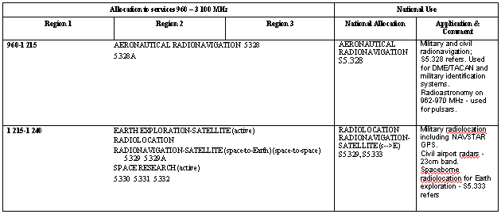

Allocation to services 960 – 3 100 MHz |  |  | National Allocation
Region 1 | Region 2 | Region 3 | National Allocation | Application & Comment
960-1 215 AERONAUTICAL RADIONAVIGATION 5.328
5.328A
1 215-1 240 EARTH EXPLORATION-SATELLITE (active)
RADIOLOCATION
RADIONAVIGATION-SATELLITE (space-to-Earth) (space-to-space) 5.329 5.329A
SPACE RESEARCH (active)
5.330 5.331 5.332
1 240-1 260 EARTH EXPLORATION-SATELLITE (active)
RADIOLOCATION
RADIONAVIGATION-SATELLITE (space-to-Earth) (space-to-space) 5.329 5.329A
SPACE RESEARCH (active)
Amateur
5.330 5.331 5.332 5.334 5.335
1 260-1 300 EARTH EXPLORATION-SATELLITE (active)
RADIOLOCATION
RADIONAVIGATION-SATELLITE (space-to-Earth) (space-to-space) 5.329 5.329A
SPACE RESEARCH (active)
Amateur
5.282 5.330 5.331 5.334 5.335 5.335A
1 300-1 350 AERONAUTICAL RADIONAVIGATION 5.337
RADIOLOCATION
RADIONAVIGATION SATELLITE (Earth-to-space)
5.149 5.337A
1 350-1 400  FIXED  MOBILE  RADIOLOCATION | 1 350-1 400  RADIOLOCATION
5.149 5.338 5.339 | 5.149 5.334 5.339
1 400-1 427 EARTH EXPLORATION-SATELLITE (passive)
RADIO ASTRONOMY
SPACE RESEARCH (passive)
5.340 5.341
1 427-1 429 SPACE OPERATION (Earth-to-space)
FIXED
MOBILE except aeronautical mobile
5.341
1 429-1 452  FIXED  MOBILE except aeronautical  mobile | 1 429-1 452  FIXED  MOBILE 5.343
5.341 5.342 | 5.341
1 452-1 492  FIXED  MOBILE except aeronautical  mobile  BROADCASTING 5.345  5.347  BROADCASTING-  SATELLITE 5.345 5.347 | 1 452-1 492  FIXED  MOBILE 5.343  BROADCASTING 5.345 5.347  BROADCASTING-SATELLITE 5.345 5.347
5.341 5.342 | 5.341 5.344
1 492-1 525  FIXED  MOBILE except aeronautical mobile | 1 492-1 525  FIXED  MOBILE 5.343  MOBILE-SATELLITE  (space-to-Earth) 5.348A | 1 492-1 525  FIXED  MOBILE
5.341 5.342 | 5.341 5.344 5.348 | 5.341 5.348A
1 525-1 530  SPACE OPERATION  (space-to-Earth)  FIXED  MOBILE-SATELLITE  (space-to-Earth) 5.351A  Earth exploration-satellite  Mobile except aeronautical  mobile 5.349 | 1 525-1 530  SPACE OPERATION  (space-to-Earth)  MOBILE-SATELLITE  (space-to-Earth) 5.351A  Earth exploration-satellite  Fixed  Mobile 5.343 | 1 525-1 530  SPACE OPERATION  (space-to-Earth)  FIXED  MOBILE-SATELLITE  (space-to-Earth) 5.351A  Earth exploration-satellite  Mobile 5.349
5.341 5.342 5.350 5.351  5.352A 5.354 | 5.341 5.351 5.354 | 5.341 5.351 5.352A 5.354
1 530-1 535  SPACE OPERATION  (space-to-Earth)  MOBILE-SATELLITE  (space-to-Earth) 5.351A 5.353A  Earth exploration-satellite  Fixed  Mobile except aeronautical mobile | 1 530-1 535  SPACE OPERATION (space-to-Earth)  MOBILE-SATELLITE (space-to-Earth) 5.351A 5.353A  Earth exploration-satellite  Fixed  Mobile 5.343
5.341 5.342 5.351 5.354 | 5.341 5.351 5.354
1 535-1 559 MOBILE-SATELLITE (space-to-Earth) 5.351A
5.341 5.351 5.353A 5.354 5.355 5.356 5.357 5.357A 5.359 5.362A
1 559-1 610 AERONAUTICAL RADIONAVIGATION
RADIONAVIGATION-SATELLITE (space-to-Earth) (space-to-space) 5.329A
5.341 5.362B 5.362C 5.363
1 610-1 610.6  MOBILE-SATELLITE  (Earth-to-space) 5.351A  AERONAUTICAL  RADIONAVIGATION | 1 610-1 610.6  MOBILE-SATELLITE  (Earth-to-space) 5.351A  AERONAUTICAL  RADIONAVIGATION  RADIODETERMINATION-  SATELLITE  (Earth-to-space) | 1 610-1 610.6  MOBILE-SATELLITE  (Earth-to-space) 5.351A  AERONAUTICAL  RADIONAVIGATION  Radiodetermination-satellite  (Earth-to-space)
5.341 5.355 5.359 5.363 5.364 5.366 5.367 5.368 5.369 5.371 5.372 | 5.341 5.364 5.366 5.367 5.368 5.370 5.372 | 5.341 5.355 5.359 5.364 5.366 5.367 5.368 5.369 5.372
1 610.6-1 613.8  MOBILE-SATELLITE  (Earth-to-space) 5.351A  RADIO ASTRONOMY  AERONAUTICAL  RADIONAVIGATION | 1 610.6-1 613.8  MOBILE-SATELLITE  (Earth-to-space) 5.351A  RADIO ASTRONOMY  AERONAUTICAL  RADIONAVIGATION  RADIODETERMINATION-SATELLITE (Earth-to-space) | 1 610.6-1 613.8  MOBILE-SATELLITE  (Earth-to-space) 5.351A  RADIO ASTRONOMY  AERONAUTICAL  RADIONAVIGATION  Radiodetermination-satellite  (Earth-to-space)
5.149 5.341 5.355 5.359 5.363 5.364 5.366 5.367 5.368 5.369 5.371 5.372 | 5.149 5.341 5.364 5.366 5.367 5.368 5.370 5.372 | 5.149 5.341 5.355 5.359 5.364 5.366 5.367 5.368 5.369 5.372
1 613.8-1 626.5  MOBILE-SATELLITE  (Earth-to-space) 5.351A  AERONAUTICAL  RADIONAVIGATION  Mobile-satellite (space-to-Earth) | 1 613.8-1 626.5  MOBILE-SATELLITE  (Earth-to-space) 5.351A  AERONAUTICAL  RADIONAVIGATION  RADIODETERMINATION-  SATELLITE  (Earth-to-space)  Mobile-satellite (space-to-Earth) | 1 613.8-1 626.5  MOBILE-SATELLITE  (Earth-to-space) 5.351A  AERONAUTICAL RADIONAVIGATION  Mobile-satellite (space-to-Earth)  Radiodetermination-satellite  (Earth-to-space)
5.341 5.355 5.359 5.363 5.364 5.365 5.366 5.367 5.368 5.369 5.371 5.372 | 5.341 5.364 5.365 5.366 5.367 5.368 5.370 5.372 | 5.341 5.355 5.359 5.364 5.365 5.366 5.367 5.368 5.369 5.372
1 626.5-1 660 MOBILE-SATELLITE (Earth-to-space) 5.351A
5.341 5.351 5.353A 5.354 5.355 5.357A 5.359 5.362A 5.374 5.375 5.376
1 660-1 660.5 MOBILE-SATELLITE (Earth-to-space) 5.351A
RADIO ASTRONOMY
5.149 5.341 5.351 5.354 5.362A 5.376A
1 660.5-1 668.4 RADIO ASTRONOMY
SPACE RESEARCH (passive)
Fixed
Mobile except aeronautical mobile
5.149 5.341 5.379 5.379A
1 668.4-1 670 METEOROLOGICAL AIDS
FIXED
MOBILE except aeronautical mobile
RADIO ASTRONOMY
5.149 5.341
1 670-1 675 METEOROLOGICAL AIDS
FIXED
METEOROLOGICAL-SATELLITE (space-to-Earth)
MOBILE 5.380
5.341
1 675-1 690  METEOROLOGICAL AIDS  FIXED  METEOROLOGICAL-  SATELLITE (space-to-Earth)  MOBILE except aeronautical  mobile | 1 675-1 690  METEOROLOGICAL AIDS  FIXED  METEOROLOGICAL-  SATELLITE (space-to-Earth)  MOBILE except aeronautical  mobile  MOBILE-SATELLITE  (Earth-to-space) | 1 675-1 690  METEOROLOGICAL AIDS  FIXED  METEOROLOGICAL-  SATELLITE (space-to-Earth)  MOBILE except aeronautical  mobile
5.341 | 5.341 5.377 | 5.341
1 690-1 700  METEOROLOGICAL AIDS  METEOROLOGICAL-  SATELLITE (space-to-Earth)  Fixed  Mobile except aeronautical mobile | 1 690-1 700  METEOROLOGICAL AIDS  METEOROLOGICAL-  SATELLITE (space-to-Earth)  MOBILE-SATELLITE  (Earth-to-space) | 1 690-1 700  METEOROLOGICAL AIDS  METEOROLOGICAL-  SATELLITE (space-to-Earth)
5.289 5.341 5.382 | 5.289 5.341 5.377 5.381 | 5.289 5.341 5.381
1 700-1 710  FIXED  METEOROLOGICAL-SATELLITE (space-to-Earth)  MOBILE except aeronautical  mobile | 1 700-1 710  FIXED  METEOROLOGICAL-  SATELLITE (space-to-Earth)  MOBILE except aeronautical  mobile  MOBILE-SATELLITE  (Earth-to-space) | 1 700-1 710  FIXED  METEOROLOGICAL-  SATELLITE (space-to-Earth)  MOBILE except aeronautical  mobile
5.289 5.341 | 5.289 5.341 5.377 | 5.289 5.341 5.384
1 710-1 930 FIXED
MOBILE 5.380 5.384A 5.388A
5.149 5.341 5.385 5.386 5.387 5.388
1 930-1 970  FIXED  MOBILE 5.388A | 1 930-1 970  FIXED  MOBILE 5.388A  Mobile-satellite (Earth-to-space) | 1 930-1 970  FIXED  MOBILE 5.388A
5.388 | 5.388 | 5.388
1 970-1 980 FIXED
MOBILE 5.388A
5.388
1 980-2 010 FIXED
MOBILE
MOBILE-SATELLITE (Earth-to-space) 5.351A
5.388 5.389A 5.389B 5.389F
2 010-2 025  FIXED  MOBILE 5.388A | 2 010-2 025  FIXED  MOBILE  MOBILE-SATELLITE  (Earth-to-space) | 2 010-2 025  FIXED  MOBILE 5.388A
5.388 | 5.388 5.389C 5.389D 5.389E 5.390 | 5.388
2 025-2 110 SPACE OPERATION (Earth-to-space) (space-to-space)
EARTH EXPLORATION-SATELLITE (Earth-to-space) (space-to-space)
FIXED
MOBILE 5.391
SPACE RESEARCH (Earth-to-space) (space-to-space)
5.392
2 110-2 120 FIXED
MOBILE 5.388A
SPACE RESEARCH (deep space) (Earth-to-space)
5.388
2 120-2 160  FIXED  MOBILE 5.388A | 2 120-2 160  FIXED  MOBILE 5.388A  Mobile-satellite (space-to-Earth) | 2 120-2 160  FIXED  MOBILE 5.388A
5.388 | 5.388 | 5.388
2 160-2 170  FIXED  MOBILE 5.388A | 2 160-2 170  FIXED  MOBILE  MOBILE-SATELLITE  (space-to-Earth) | 2 160-2 170  FIXED  MOBILE 5.388A
5.388 5.392A | 5.388 5.389C 5.389D 5.389E 5.390 | 5.388
2 170-2 200 FIXED
MOBILE
MOBILE-SATELLITE (space-to-Earth) 5.351A
5.388 5.389A 5.389F 5.392A
2 200-2 290 SPACE OPERATION (space-to-Earth) (space-to-space)
EARTH EXPLORATION-SATELLITE (space-to-Earth) (space-to-space)
FIXED
MOBILE 5.391
SPACE RESEARCH (space-to-Earth) (space-to-space)
5.392
2 290-2 300 FIXED
MOBILE except aeronautical mobile
SPACE RESEARCH (deep space) (space-to-Earth)
2 300-2 450  FIXED  MOBILE  Amateur  Radiolocation | 2 300-2 450  FIXED  MOBILE  RADIOLOCATION  Amateur
5.150 5.282 5.395 | 5.150 5.282 5.393 5.394 5.396
2 450-2 483.5  FIXED  MOBILE  Radiolocation  5.150 5.397 | 2 450-2 483.5  FIXED  MOBILE  RADIOLOCATION  5.150 5.394
2 483.5-2 500  FIXED  MOBILE  MOBILE-SATELLITE  (space-to-Earth) 5.351A  Radiolocation | 2 483.5-2 500  FIXED  MOBILE  MOBILE-SATELLITE  (space-to-Earth) 5.351A  RADIOLOCATION  RADIODETERMINATION-  SATELLITE  (space-to-Earth) 5..398 | 2 483.5-2 500  FIXED  MOBILE  MOBILE-SATELLITE  (space-to-Earth) 5.351A  RADIOLOCATION  Radiodetermination-satellite  (space-to-Earth) 5..398
5.150 5..371 5..397 5..398 5..399 5.400 5.402 | 5.150 5.402 | 5.150 5.400 5.402
2 500-2 520  FIXED 5.409 5.410 5.411  MOBILE except aeronautical mobile 5.384A  MOBILE-SATELLITE  (space-to-Earth) 5.351A 5.403 | 2 500-2 520  FIXED 5.409 5.411  FIXED-SATELLITE (space-to-Earth) 5.415  MOBILE except aeronautical mobile 5.384A  MOBILE-SATELLITE (space-to-Earth) 5.351A 5.403
5.405 5.407 5.412 5.414 | 5.404 5.407 5.414 5.415A
2 520-2 655  FIXED 5.409 5.410 5.411  MOBILE except aeronautical  mobile 5.384A  BROADCASTING-SATELLITE  5.413 5.416 | 2 520-2 655  FIXED 5.409 5.411  FIXED-SATELLITE  (space-to-Earth) 5.415  MOBILE except aeronautical  mobile 5.384A  BROADCASTING-SATELLITE  5.413 5.416 | 2 520-2 535  FIXED 5.409 5.411  FIXED-SATELLITE  (space-to-Earth) 5.415  MOBILE except aeronautical  mobile 5.384A  BROADCASTING-SATELLITE  5.413 5.416
 |  | 5.403 5.415A
2 535-2 655
FIXED 5.409 5.411
MOBILE except aeronautical mobile 5.384A
BROADCASTING-SATELLITE
5.413 5.416
5.339 5.403 5.405 5.412 5.418 5.418B 5.418C | 5.339 5.403 5.418B 5.418C | 5.339 5.418 5.418A 5.418B 5.418C
2 655-2 670  FIXED 5.409 5.410 5.411  MOBILE except aeronautical  mobile 5.384A  BROADCASTING-SATELLITE  5.413 5.416  Earth exploration-satellite  (passive)  Radio astronomy  Space research (passive) | 2 655-2 670  FIXED 5.409 5.411  FIXED-SATELLITE  (Earth-to-space)  (space-to-Earth) 5.415  MOBILE except aeronautical  mobile 5.384A  BROADCASTING-SATELLITE  5.413 5.416  Earth exploration-satellite  (passive)  Radio astronomy  Space research (passive) | 2 655-2 670  FIXED 5.409 5.411  FIXED-SATELLITE  (Earth-to-space) 5.415  MOBILE except aeronautical  mobile 5.384A  BROADCASTING-SATELLITE 5.413 5.416  Earth exploration-satellite  (passive)  Radio astronomy  Space research (passive)
5.149 5.412 5.420 | 5.149 5.420 | 5.149 5.420
2 670-2 690  FIXED 5.409 5.410 5.411  MOBILE except aeronautical mobile 5.384A  MOBILE-SATELLITE  (Earth-to-space) 5.351A  Earth exploration-satellite  (passive)  Radio astronomy  Space research (passive) | 2 670-2 690  FIXED 5.409 5.411  FIXED-SATELLITE  (Earth-to-space)  (space-to-Earth) 5.415  MOBILE except aeronautical  mobile 5.384A  MOBILE-SATELLITE  (Earth-to-space) 5.351A  Earth exploration-satellite  (passive)  Radio astronomy  Space research (passive) | 2 670-2 690  FIXED 5.409 5.411  FIXED-SATELLITE  (Earth-to-space) 5.415  MOBILE except aeronautical  mobile 5.384A  MOBILE-SATELLITE  (Earth-to-space) 5.351A  Earth exploration-satellite  (passive)  Radio astronomy  Space research (passive)
5.149 5.412 5.419 5.420 | 5.149 5.419 5.420 | 5.149 5.419 5.420 5.420A
2 690-2 700 EARTH EXPLORATION-SATELLITE (passive)
RADIO ASTRONOMY
SPACE RESEARCH (passive)

  - 5.421 5.422
2 700-2 900 AERONAUTICAL RADIONAVIGATION 5.337
Radiolocation

5.423 5.424
2 900-3 100 RADIONAVIGATION 5.426
Radiolocation

5.425 5.427

Attachment 2
QUESTIONNAIRE - PART II
(To be completed by Administrations only)
General Questions on National Spectrum Management
The following general questions on national spectrum management are based in part on the functional requirements of spectrum management described in the handbook on "National Spectrum Management". If you need additional space to answer the questions please continue on a separate sheet of paper.
1. What legal or regulatory texts govern your national spectrum management processes?
_______Federal Law 1973___________________________________________________
Are any actions planned to change these legal texts or regulations? YES__ NO__
2. Have you publicly available regulations and procedures for national spectrum management (e.g. radio services, license requirements etc.)? YES__ NO__
3. Do you have a national radio frequency spectrum allocation table? NO
4. Regulations for the technical characteristics of radiocommunications equipment
Do you specify that the technical characteristics of radiocommunications equipment must comply with certain requirements (often referred to as "equipment standards"), for example to avoid interference to other services and users? YES
- Do you develop these technical requirements or equipment standards on a national basis or use those developed by other administrations or international/regional standards organisations: National
- Do you have a procedure to ensure that radiocommunications equipment complies with the technical requirements, for example:
Type Approval: _Yes__; Manufacturers Declaration of Compliance: Yes__; Other Yes__
5. Spectrum re-deployment*
(* The term "redeployment" is used here to refer to a process of national scope in which an assessment is conducted 1) to determine if portions of spectrum can be identified that are in limited use; and 2) to determine if such spectrum segments can be reallocated for use in delivering radiocommunication services that have expanding spectrum requirements. Some countries co-operate on a regional basis to identify suitable spectrum segments that may be re-deployed to facilitate the introduction of new applications on a harmonised basis.)
- Has there been any spectrum redeployment* in your country or has a need for spectrum redeployment been identified? YES
- If so, do you have a method for achieving this redeployment in respective frequency bands and for given radiocommunication services? NO
- Please define the established method and describe the nature of the consultation, if any, with users regarding the potential costs resulting from the planned redeployment.
__________________________________________________________________
__________________________________________________________________
6. Spectrum management costs
- What is the cost of providing national spectrum management functions in your country (if there is more than one organisation or agency responsible for spectrum management please give the total costs if this information is available)? __________(Swiss Francs)
- What is the source of the funding required to accomplish these spectrum management functions?
__________________________MOC__________________________________________
____________________________________________________________________
7. Management of frequency assignment records.
- Does your administration have a system (manual or computerized) to keep and maintain records of national frequency assignments and spectrum use (usually known as a Data Base Management System (DBMS))? YES
- Is there a single national DBMS or separate DBMS(s) for different users (for example a DBMS for assignments to government users and separate DBMS for assignments to non-government users)? Single
What is the approximate size (at 2002) of your DBMS:
- number of frequency assignments _23,000 __________________
- number of licences 15,000
- Are these frequency assignment records made available to public? NO
- Is the DBMS computerized? YES
- What computerized DBMS do you use? Access and FoxPro
8. Co-ordination of frequency assignments with other countries:
- do you co-ordinate assignments to terrestrial stations YES
- do you co-ordinate assignments to space stations YES
- Notification of frequency assignments.
Do you notify to the ITU those frequency assignments that are required to be notified by the Radio Regulations ? YES
If not, please explain why and list any difficulties: _______________________________
10. Do you have a policy and planning function for national spectrum management (i.e. a national strategy for future use of the spectrum)? NO
11. Do you perform technical analyses of frequency assignment requests? NO
12 Do you perform radio monitoring of terrestrial radio services? YES

Fixed monitoring stations
- How many fixed monitoring stations do you have? _______Two________
- Please provide a brief list of the facilities available at your fixed monitoring stations (for example: receivers, spectrum analysers, direction finding equipment):
Receiver –9KHZ –1GHz , Spectrum analysers 10 KHz to 3.5GHz, DF 20 MHz—100MHz
- What is the upper frequency limit of your fixed monitoring stations 1000____ MHz
- What is the upper frequency limit of your fixed direction finding stations ___1000___ MHz

Mobile monitoring stations
- How many mobile monitoring stations do you have? TWO
- Please provide a brief list of the facilities available in your mobile monitoring stations (for example: receivers, spectrum analysers, direction finding equipment)
Receiver –20 MHz—500MHz and DF ,20MHz—1000MHz Receiver and DF_
- What is the upper frequency limit of your mobile monitoring stations ___1000___ MHz
- What is the upper frequency limit of your mobile direction finding stations 1--500 MHz & 2—1000MHz

Transportable monitoring stations
- How many transportable monitoring stations do you have?
- Please provide a brief list of the facilities available in your transportable monitoring stations (for example: receivers, spectrum analysers, direction finding equipment):
____One Receiver –20MHz—1000MHz__
What is the upper frequency limit of your transportable monitoring stations 1000____ MHz
- What is the upper frequency limit of your transportable direction finding stations ___ MHz
- Do you perform space monitoring NO
- Please provide a brief list of the facilities available at your space monitoring stations
___________________________________________________________________
- What tasks does your space monitoring station perform for GSO satellite monitoring?
- What tasks does your space monitoring station perform for non-GSO satellite monitoring?

Does your Administration participate in the International Monitoring Programme of ITU? YES ___ NO ___

Co-operation between Spectrum Management and Monitoring
Please indicate the amount of work (in percentages) performed by the monitoring service for:
- Frequency Management Department ________%
- Enforcement Department ___________ %
- License Department ____________ %
- Do you perform Inspections on Radio Stations YES__ NO__
- What inspection techniques are used by your administration to determine that users of the spectrum are complying with national or international requirements?
___________________________________________________________________
- What are the administrative procedures that determine your inspection policy (for example the number of inspections, type of notification provided prior to inspection, rules and regulations)?
___________________________________________________________________
- What measurement equipment does your administration use to perform technical measurements at an inspection?
___________________________________________________________________
- What technical parameters does your administration measure when inspecting a radio system?
___________________________________________________________________
- What station records does your administration review when inspecting a radio station?
___________________________________________________________________
14. Do you perform technical analyses of radio frequency interference complaints? YES
Do you have an established consultation process, involving Government and non-government organization, for resolving these complaints? YES
15. Use of computers for national spectrum management

General
- Do you use computers for national spectrum management? YES
- Type of computers PC(Deskpro)
- How many workstations: _10__ or personal computers (PCs): _________
- Operating system(s) ________WINDOW NT_____________________________________
- Does your spectrum management system operate within a Local Area Network (LAN)? YES
- Do you have access to the internet? YES
- Does your administration provide a web site on the internet to disseminate spectrum management information? NO
- If yes, please provide the address (URL) of the web site: __________________________
Windows Basic Spectrum Management System (WinBASMS)
- Are you aware that a Windows Basic Spectrum Management System is available from the ITU at no cost? YES
- Has your administration used WinBASMS? NO
- Has your administration had problems using WinBASMS? YES
- Please list all problems that were encountered using WinBASMS.
____How to load our database or IFL( format,…)
- Would you recommend using WinBASMS if the problems identified in (d) have been corrected? YES
- Do you need an enhanced spectrum management system if you answered no in (e)? YES

Advanced Automated Spectrum Management Systems (AASMS)
- Does your administration use an Automated Spectrum Management Systems (AASMS) NO
- Has your administration had problems using your AASMS YES__ NO__
- Please list all problems that were encountered using your AASMS
________________________________________________________________________
- How would you propose to change the AASMS to correct or overcome these problems (please describe)?
________________________________________________________________________
16. Organisation of spectrum management
- Please describe your country's spectrum management structure and enclose a copy of the organization chart. The following aspects are of particular interest:
- Is the spectrum management organisation a separate ministry, department or agency reporting directly to the government or is it part of a larger government department (for example, a department responsible for all telecommunications)?
- Is the responsibility for spectrum management contained within a single organisation or is it shared between separate organisations (for example, some administrations have separate organisations for regulatory matters and policy matters, other administrations have separate organisations for government users and non-government users)?
- Have there been recent changes in this organisational structure or are changes planned (for example to take account of any changes in your government's policy for telecommunications)?
- Number of specialist staff in national spectrum management? ____2______
- Number of support staff in national spectrum management? ___3_______
17. Do you use the ITU-R Handbooks and Reports on: NO
a) National Spectrum Management, version 1995 ?
b) Spectrum Monitoring, version 2002?
c) Computer-aided Techniques for Spectrum Management, version 1999?
d) Report SM.2012-1, Economic Aspects of Spectrum Management, version 2000?
18. Identification of problems experienced in national spectrum management.
Please use the following table to describe problems experienced by your administration in national spectrum management. This information will be used by the ITU, in particular ITU-R Study Group 1, to identify future areas of work, within the normal study programme, so that effort may be focused on the development of recommendations and reports for subjects where assistance is most needed.

Question | Please describe the spectrum management problem associated with the Question and the type of assistance that could be provided by the ITU.
Q1 | Interférence calculation
Q2 | Fées calculation
Q3
Q4
Q5
Q6
Q7
Q8
Q9
Q10
Q11
Q12
Q13
Q14
Q15
Q16
Q17

PART III
Attachment 3
QUESTIONNAIRE - PART III
(To be completed by administrations)
Information on the calculation of fees for frequency use

1 Introduction
ITU-D Question 21/2 (see Appendix 1), adopted by the World Telecommunication Development Conference (Istanbul, March 2002), aims to respond to one of the most pressing concerns of the majority of developing countries, particularly LDCs, which are experiencing difficulties in establishing a national frequency fee calculation model.
The Question was entrusted to the Joint Group on Resolution 9 (ITU-D Study Group 2 and ITU-R Study Group 1) in order to benefit from the experience it had acquired during the period 1998-2002 in mobilizing ITU-D and ITU-R expertise. It will lead inter alia to the establishment of a document structure bringing together the calculation formulas and frequency fee amounts applied by the countries for radiocommunication usages in the various frequency bands.
This questionnaire is thus being sent to administrations in order to collect the necessary data, which will be analysed in depth and reported on, with a view to the establishment by ITU of a database, to be accessible to all countries.
Generally speaking, Report ITU-R SM.2012-1, while it does not go into detail about the situation in each country, does describe several possible methods of administrative spectrum pricing and mentions the variables likely to be used to calculate frequency fees. It also considers the systems of assignment by public tender and of transferable rights to use the spectrum, in both of which frequency prices are set by the market.
Question 21/2 carries on from Report SM.2012-1, and the results of the work done under this Question will provide information on the real conditions in which frequency fees are implemented in all the countries that participated.
Administrations are therefore invited to answer this questionnaire as accurately as possible. However, the questionnaire has been designed to cover generally all possible cases. Your Administration is not necessarily required to reply to all questions but to mark applicable boxes. Should you find that there are other possible cases or other explanations, please do not hesitate to include them on a separate sheet with an appropriate cross-reference.

2 How to complete the questionnaire
The document contains questions that are to be found in both the body of the text and in the charts set out in APPENDIX 2, which concerns only frequency fees (the other charges are dealt with in question Q3).
In the charts, many of the questions require only a "yes" or "no" answer, and the questionnaire can serve as an aid to answering those questions. For the other questions, and when necessary, administrations are invited to write their replies on a separate document.
Additional explanations and a glossary intended to make it easier to answer the questions are given below.
The questionnaire was drawn up with a view to obtaining relatively specific replies that could be put to satisfactory use in the database. Numerous situations were envisaged and, as a rule, targeted questions drafted but, in spite of the questionnaire's length, it is quite likely that not all possible scenarios have been covered.
Administrations are therefore invited not only to respond to the questions asked, but also, as necessary, to describe any peculiarities of their system that the questionnaire does not cover. They are also invited to make any suggestions they consider pertinent to improve the content and the quality of the future database.

3 Questions

3.1 General questions

Q1
• Are there any legal texts on the establishment of frequency fees?
Reply: yes
• If yes, please indicate their references and the date on which they were last updated.
Reply: federal law 1973

Q2
• What procedure (regulatory, legislative, etc.) is used to review and update your system for setting frequency fees?
Reply:
• Are reviews conducted at pre-established regular intervals? If yes, please specify:
Reply:
• Does recourse to market mechanisms (auctions, calls for tenders) to screen applicants for spectrum access require that parliament enact legislation, that the government make a decision, or any other measure? Please specify.
Reply:

Q3
• Are the same approaches and principles used to set frequency fees for all users?
Reply: NO
• If yes, please complete the charts in APPENDIX 2.
• If no:
− please indicate the methods used to calculate fees or the scales applied to agencies that use frequencies for non-commercial activities;
related to bandwidth
− then, please complete the charts in APPENDIX 2 for the agencies that use frequencies for commercial activities.
Reply:

Q4
• In addition to direct frequency fees, certain administrations require the payment of additional spectrum-related charges (for example, for spectrum access, spectrum replanning, management of equipment using the frequencies).
Does your Administration require such payments?
Reply:
• If yes, please specify:
− the users concerned;
− the methods used to calculate the charges or the scales applied and the corresponding amounts.
Reply:

Q5
• To which institution(s) are the frequency fees and any additional charges collected paid?
Reply: ministry of finance

3.2 Exemption from payment of frequency fees

Q6
• Are any applications partially or completely exempted from the payment of frequency fees?
Reply:YES
• If yes, please specify:
− the applications concerned;
− their respective rate of exemption; 50%
− the method used to calculate the fees or the scale applied, if they differ from those indicated in rows 20 and 21 of the charts in APPENDIX 2.
Reply:

Q7
• Are any users partially or wholly exempted from the payment of frequency fees?
Reply:YES
• If yes, please specify:
− the users concerned; Civil Aviation, Brodcasting and Security
− their respective rate of exemption;
− the method used to calculate the fees or the scale applied, if they differ from those indicated in rows 20 and 21 of the charts in APPENDIX 2.
Reply:

3.3 The application of frequency fees
Administrations are invited to respond to the questions asked in charts A to E in APPENDIX 2, dealing respectively with the fixed, mobile, satellite and broadcasting services and other applications.
The charts comprise:
− horizontally, three sections corresponding respectively:
− [rows 1 to 21]: to the variables which may be used to set the fees and to the methods applied. This section contains shaded cells corresponding to non-relevant situations;
− [row 22]: to the explanations, grounds and objectives;
− [rows 23 to 25]: to recourse to market mechanisms, as the case may be;
− vertically, the various applications relating to the service considered.

3.3.1 Approaches and principles for setting frequency fees
To answer this part of ITU-D Question 21/2, please complete rows 1 to 21 of the five charts (A to E) in APPENDIX 2.
In each chart, for any given application:
• for the variables, administrations should reply:
− yes (by crossing out or deleting the letter "n") in the cells relating to the variables they use to set fees;
− no (by crossing out or deleting the letter "y") in the cells relating to the variables they do not use;
• under "methods used" (rows 20 and 21), administrations should indicate, separately and depending on the case, the formulas or scales used to calculate the amount of the fees, preceded by the references indicated in the corresponding cells. Administrations are invited to explain the formulas and scales they use and how they are implemented.
Note: An administration concerned by a cell in row 20 in respect of one application will not be concerned by the corresponding cell in row 21 in respect of the same application, and vice versa.
Example 1 Take Chart A ("fixed service") and the application "Radio relays".
• To establish the corresponding fees, if the administration uses the variables "bandwidth", "centre frequency", "number of transmitting stations" and "duration of authorization/licence", it should reply "yes" in the cells situated at the intersection of rows 1, 2, 10 and 13 with the column "Radio relay". In all other cells in that column, it should reply "no".
• To determine the amount of the fees:
− if the administration uses the following formula:
"Annual charge for a link = 100 x Δf/f ",
where Δf = bandwidth and f = centre frequency,
it could reply as follows:
"A1:
Annual charge for a link = 100 x Δf/f "
− if the administration uses no formula, it should append the corresponding scale under reference A7.

3.3.2 Explanations, grounds and objectives (row 22 in the charts)
For each of the cells in row 22, administrations are invited to provide information on the grounds for their choice, for the variables used to set the fees and for the methods applied to determine the amount of those fees.
Example 2 Following on from example 1, the administration could reply as follows:
"A13:
− the variable "bandwidth" was chosen to encourage economical use of the spectrum;
− the variable "centre frequency" was chosen to encourage the use of high frequencies;
− the variable "number of transmitting stations" was chosen to take account of spectrum and geographic occupancy;
− the variable "duration of authorization" was chosen in order to enable collection of a global amount corresponding to the total length of time the spectrum is occupied. It also reduces the risk of frequency hoarding and non-use."

3.3.3 Heading "Recourse to market mechanisms"
If the administration has had recourse to market mechanisms for a given application (for example, IMT-2000), it should specify whether it used auctions (row 23), calls for tenders (row 24) or comparative selection (beauty contests) (row 25). It should also indicate the total amount obtained and the total bandwidths auctioned off and allocated, respectively.
Note: An administration concerned by a cell in row 23 in respect of one application will not be concerned by the corresponding cell in rows 24 and 25 in respect of the same application, and vice versa.

3.3.4 Advantages and disadvantages of each approach

Q8
• What are the advantages and disadvantages of the approaches currently used by your Administration to establish the amount of frequency fees and any additional charges?
Reply:

4 Updating the ITU report and database on frequency fees and additional charges

Q9
• How often would you consider it most appropriate to update the report and the database: every 2 years, 3 years, 4 years, ...?
Reply:
• To that end, would your Administration be willing subsequently to complete a similar questionnaire at the regular interval it has indicated above?
Reply:3

5 Information concerning the questionnaire
France:
economic information M. Jean-Pierre HUYNH
Telephone : + 33 1 45 18 73 77
Fax : + 33 1 45 18 73 13
E-mail : huynh@anfr.fr
administrative information Mme Catherine DELTOUR
Telephone : + 33 1 45 18 73 95
Fax : + 33 1 45 18 73 13
E-mail : deltour@anfr.fr
Morocco: Mme Ilham GHAZI
Telephone : + 212 37 71 85 12
Fax : + 212 37 71 85 47
E-mail : ghazi@anrt.net.ma

PART III

APPENDICES

APPENDIX 1: Definition of ITU-D Question 21/2
APPENDIX 2: Charts to be completed (A to E)
APPENDIX 3: Glossary of terms used
Appendix 1

DEFINITION OF ITU-D QUESTION 21/2
Calculation of frequency fees

1 Statement of the situation or problem
The draft new Question dealt with here responds to one of the most pressing concerns of numerous developing countries, particularly LDCs, which are experiencing difficulties in elaborating a national frequency fee calculation model.
Furthermore, several regulatory frameworks place the frequency resource within the State domain. As a result, its use, which may well not be equitably distributed, must be properly remunerated as part of the rational management of public property. Techniques for sharing, segmentation, access to new frequencies and reorganization of the spectrum no longer suffice to guarantee effective management. The frequency spectrum therefore has to be optimized. This effort should, however, take into account the nature of the service to be provided, the band in question and the end user (consumer activities, etc.).
The optimization effort must be adapted to the new trends in the area of spectrum usage and sharing and must reflect the socioeconomic features of each country. It is particularly urgent when it comes to evaluating bands which are in high demand or may come to be so in the light of emerging technologies, as is the case with IMT-2000 systems in the 2 GHz band.
It should be borne in mind that the economic aspects of spectrum management are addressed in the ITU-D handbook on the economic, administrative and regulatory aspects of national spectrum management, as well as in Report ITU-R SM.2012, which describes, inter alia, the three main approaches to financing national spectrum management and the corresponding main advantages and disadvantages (financing from the national budget, through the collection of fees or charges for use of the spectrum, and by public tender). The report also presents the economic approaches used to promote national spectrum management (assignment through comparative assessment procedures; random assignment; assignment by public tender; transferable, flexible rights to use the spectrum; incentive pricing and concessionary charges, etc.).
Thus, the elaboration of a national frequency fee calculation model is a very complex matter and is the source of major difficulties for numerous developing countries and particularly LDCs for which the need is extremely urgent. The proposed Question will help to meet those concerns.

2 Question or issue proposed for study
The proposed study relates to the methods for calculating the various charges, fees, etc. that are levied on spectrum users. The points to be considered within the framework of this new Question are as follows:
a) Establishment in electronic format of a document structure bringing together the calculation formulas and frequency fee amounts applied by different countries for different radiocommunciation usages in the various frequency bands. This database will be made available to the ITU Member States and will require periodic updating.
b) Preparation of a report dealing with the following points:
• Analysis of the various methods, formulas and approaches currently applied by different countries for calculating frequency fees, accompanied by a comparative study clearly highlighting:
− approaches and principles relating to the calculation of frequency charges;
− the justifications and reasoning for each approach;
− how each approach contributes to fostering spectrum management and the effectiveness thereof;
− advantages and drawbacks of each approach (socioeconomic, technical and other considerations).
• Basic factors that may be taken into account when elaborating new formulas or reviewing existing ones.
• How to bring about consistency and complementarity between spectrum rearrangement processes and economic optimization of frequencies.

3 Expected outputs
An electronic document structure and links enabling users to have easy access to data on frequency fee calculation formulas for the users of the radio frequency spectrum in different countries. BDT is requested to coordinate participation with those countries who do not have access to the Web, providing them a hard copy upon request.
A report on the various frequency fee calculation formulas currently applied in different countries.

4 Required timing of the expected output
An initial version of the output is requested by mid-2003.
A regular update should subsequently be carried out.

5 Proposers/sponsors
This Question was submitted to WTDC-02 and has been recognized as being very important for the developing countries and LDCs, and as being urgent.

6 Source of required inputs
− Inputs are expected from spectrum managers (administrations, regulators), relating to:
− the structure of the information to be made available and the questionnaire(s) to be circulated to the Member States in order to gather the information to be entered into the database;
− analysis of the replies and of the report.
− Inputs are also expected from spectrum users (operators, etc.) that are subject to the fees in question, for analysis of the replies and of the report.
− Member States' replies to the questionnaire(s).

7 Target audience for the output
a) Indicate the target audience for the output in the following table:

 | Developed countries | Developing countries | LDCs
Telecom policy makers | x | x | x
Telecom regulators | x | x | x
Service providers (operators) | x | x | -
Manufacturers | - | - | -
b) Target audience for the study - who specifically will use the output?
The output could be particularly useful to frequency spectrum managers when it comes to identifying the basic elements to be taken into account in elaborating a national frequency fee calculation model for the various users of the radio frequency spectrum in the different frequency bands.
c) Proposed methods for implementing the output
The output will be made available to all Member States free of charge (documents on paper, on the Web and on CD-ROM). An ITU circular letter should be sent out informing the Member States of the results of this study and inviting them to use that output when elaborating their national model for optimizing the frequency spectrum.

8 Proposed method of handling this Question
Given that this Question, which is very important and urgent for the developing countries and particularly LDCs, touches also on the field of radiocommunications, and that ITU-R Study Group 1 has already accumulated expert experience on the matter, it is proposed that it be dealt with by the joint working group already set up for the implementation of Resolution 9 (ITU-D Study Group 2/ITU-R Study Group 1).
Meetings dealing specifically with this Question should be programmed by the joint working group during the period 2002-2003.

9 Coordination requirements for the study
Coordination between ITU-D and ITU-R is required and should be carried out within the framework of the joint working group on Resolution 9.
In addition, coordination with ITU-D Study Group 1 is necessary (Question 12/1).

Appendix 2
Chart A: FIXED service
 | APPLICATIONS  VARIABLES | Row  No. | Radio relay | Local radio loop  (incl. LMDS, MMDS) | Links between fixed stations  (incl. HF) | Local radio networks | Other application(s): please specify
Spectrum-related variables | bandwidth | 1 | y | y | y | y | y
Spectrum-related variables | number of channels | 1bis | y / n | y / n | y / n | y / n | y / n
Spectrum-related variables | centre frequency, or band position in the spectrum | 2 | y / n | y / n | y / n | y / n | y / n
Spectrum-related variables | exclusive / shared use | 3 | y / n | y / n | y / n | y / n | y / n
Variables relating to geographic coverage | surface area allocated | 4 | y / n | y / n | y / n |  | y / n
Variables relating to geographic coverage | distance between transmitter and receiver | 5 | y / n |  | y / n |  | y / n
Variables relating to equipment and infrastructure | transmitter power | 6 | y / n | y / n | y / n | y / n | y / n
Variables relating to equipment and infrastructure | antenna height | 7 | y / n | y / n | y / n |  | y / n
Variables relating to equipment and infrastructure | bit rate or capacity | 8 | y / n | y / n | y / n | y / n | y / n
Variables relating to equipment and infrastructure | transmitting beam angle | 9 | y / n |  |  |  | y / n
Variables relating to equipment and infrastructure | number of transmitting stations | 10 | y / n | y / n | y / n | y / n | y / n
Variables relating to equipment and infrastructure | number of receiving stations | 11 | y / n | y / n | y / n | y / n | y / n
Variables relating to equipment and infrastructure | degressivity | 12 | y / n | y / n | y / n | y / n | y / n
Socio-economic variables | duration of the authorization / licence | 13 | y / n | y / n | y / n | y / n | y / n
Socio-economic variables | population density | 14 |  | y / n | y / n | y / n | y / n
Socio-economic variables | total population covered | 15 |  | y / n |  |  | y / n
Socio-economic variables | geographic location | 16 | y / n | y / n | y / n | y / n | y / n
Socio-economic variables | operator's turnover | 17 |  | y / n | y / n |  | y / n
Socio-economic variables | Gross domestic product | 18 | y / n | y / n | y / n | y / n | y / n
Other variable(s): please specify |  | 19 | y / n | y / n | y / n | y / n | y / n
Appendix 2
Methods  used | calculation formulas and corresponding amounts | 20 | A1 | A2 | A3 | A4 | A5
Methods  used | scales | 21 | A6 | A7 | A8 | A9 | A10
Explanations and grounds, objectives |  | 22 | A11 | A12 | A13 | A14 | A15
Recourse to market mechanisms | auctions | 23 | A16 | A17 | A18 |  | A20
Recourse to market mechanisms | call for tenders | 24 | A21 | A22 | A23 |  | A25
Recourse to market mechanisms | comparative selection (beauty contests) | 25 | A26 | A27 | A28 |  | A30

Appendix 2
CHART B: MOBILE service
 | APPLICATIONS  VARIABLES | Row No. | 2G mobile systems | 3G mobile systems | Radio- messaging | Private independent networks | Operated independent networks | Citizen band  (CB) | RRI 446  (or family radio) | Other application(s): please specify
Spectrum-related variables | bandwidth | 1 | y | y | y | y | y | y | y | y / n
Spectrum-related variables | centre frequency, or band position in the spectrum | 2 | y / n | y / n | y / n | y / n | y / n | y / n | y / n | y / n
Spectrum-related variables | exclusive / shared use | 3 | y / n | y / n | y / n | y / n | y / n |  |  | y / n
Variables relating to geographic coverage | surface area allocated | 4 | y / n | y / n | y / n | y / n | y / n |  |  | y / n
Variables relating to geographic coverage | distance between transmitter and receiver | 5 |  |  |  | y / n | y / n |  |  | y / n
Variables relating to equipment and infrastructure | transmitter power | 6 |  |  |  | y / n | y / n | y / n | y / n | y / n
Variables relating to equipment and infrastructure | antenna height | 7 |  |  |  | y / n | y / n | y / n |  | y / n
Variables relating to equipment and infrastructure | bit rate or capacity | 8 | y / n | y / n |  | y / n | y / n |  |  | y / n
Variables relating to equipment and infrastructure | transmitting beam angle | 9 |  |  |  |  |  |  |  | y / n
Variables relating to equipment and infrastructure | number of transmitting stations | 10 | y / n | y / n | y / n | y / n | y / n | y / n | y / n | y / n
Variables relating to equipment and infrastructure | number of receiving stations | 11 | y / n | y / n | y / n | y / n | y / n |  |  | y / n
Variables relating to equipment and infrastructure | degressivity | 12 | y / n | y / n | y / n | y / n | y / n | y / n | y / n | y / n
Socio-economic variables | duration of the authorization / licence | 13 | y / n | y / n | y / n | y / n | y / n | y / n |  | y / n
Socio-economic variables | population density | 14 | y / n | y / n | y / n | y / n | y / n |  |  | y / n
Socio-economic variables | total population covered | 15 | y / n | y / n | y / n | y / n | y / n |  |  | y / n
Socio-economic variables | geographic location | 16 | y / n | y / n | y / n | y / n | y / n |  |  | y / n
Socio-economic variables | operator's turnover | 17 | y / n | y / n | y / n |  | y / n |  |  | y / n
Socio-economic variables | Gross domestic product | 18 | y / n | y / n | y / n | y / n | y / n |  |  | y / n
Other variable(s): please specify |  | 19 | y / n | y / n | y / n | y / n | y / n | y / n | y / n | y / n
Appendix 2
Methods  used | calculation formulas and corresponding amounts | 20 | B1 | B2 | B3 | B4 | B5 | B6 | B7 | B8
Methods  used | scales | 21 | B9 | B10 | B11 | B12 | B13 | B14 | B15 | B16
Explanations and grounds, objectives |  | 22 | B17 | B18 | B19 | B20 | B21 | B22 | B23 | B24
Recourse to market mechanisms | auctions | 23 | B25 | B26 | B27 | B28 | B29 |  |  | B32
Recourse to market mechanisms | call for tenders | 24 | B33 | B34 | B35 | B36 | B37 |  |  | B40
Recourse to market mechanisms | comparative selection (beauty contests) | 25 | B41 | B42 | B43 | B44 | B45 |  |  | B48

Appendix 2
Chart C: SATELLITE service
 | APPLICATIONS  VARIABLES | Row No. | VSAT | Earth stations | Satellite video reporting | Mobile satellite service | Satellite radiolocation | Other application(s): please specify
Spectrum-related variables | bandwidth | 1 | y / n | y / n | y / n | y / n | y / n | y / n
Spectrum-related variables | number of channels | 1bis | y / n | y / n | y / n | y / n | y / n | y / n
Spectrum-related variables | centre frequency, or band position in the spectrum | 2 | y / n | y / n | y / n | y / n | y / n | y / n
Spectrum-related variables | exclusive / shared use | 3 | y / n | y / n | y / n | y / n | y / n | y / n
Variables relating to geographic coverage | surface area allocated | 4 |  |  | y / n | y / n | y / n | y / n
Variables relating to geographic coverage | distance between transmitter and receiver | 5 |  |  |  |  |  | y / n
Variables relating to equipment and infrastructure | transmitter power | 6 | y / n | y / n | y / n |  |  | y / n
Variables relating to equipment and infrastructure | antenna diameter | 7 | y / n | y / n | y / n |  |  | y / n
Variables relating to equipment and infrastructure | bit rate or capacity | 8 | y / n | y / n | y / n | y / n | y / n | y / n
Variables relating to equipment and infrastructure | transmitting beam angle | 9 | y / n | y / n | y / n |  |  | y / n
Variables relating to equipment and infrastructure | number of transmitting stations | 10 | y / n | y / n | y / n | y / n |  | y / n
Variables relating to equipment and infrastructure | number of receiving stations | 11 | y / n | y / n |  | y / n | y / n | y / n
Variables relating to equipment and infrastructure | degressivity | 12 | y / n | y / n | y / n | y / n | y / n | y / n
Socio-economic variables | duration of authorization / licence | 13 | y / n | y / n | y / n | y / n | y / n | y / n
Socio-economic variables | population density | 14 | y / n | y / n | y / n | y / n | y / n | y / n
Socio-economic variables | total population covered | 15 |  |  |  | y / n | y / n | y / n
Socio-economic variables | geographic location | 16 | y / n | y / n | y / n | y / n | y / n | y / n
Socio-economic variables | operator's turnover | 17 | y / n | y / n | y / n | y / n | y / n | y / n
Socio-economic variables | Gross domestic product | 18 | y / n | y / n | y / n | y / n | y / n | y / n
Other variable(s): please specify |  | 19 | y / n | y / n | y / n | y / n | y / n | y / n
Appendix 2
Methods used | calculation formulas and corresponding amounts | 20 | C1 | C2 | C3 | C4 | C5 | C6
Methods used | scales | 21 | C7 | C8 | C9 | C10 | C11 | C12
Explanations and grounds, objectives |  | 22 | C13 | C14 | C15 | C16 | C17 | C18
Recourse to market mechanisms | auctions | 23 | C19 | C20 | C21 | C22 | C23 | C24
Recourse to market mechanisms | call for tenders | 24 | C25 | C26 | C27 | C28 | C29 | C30
Recourse to market mechanisms | comparative selection (beauty contests) | 25 | C31 | C32 | C33 | C34 | C35 | C36

Appendix 2
Chart D: BROADCASTING service
 | APPLICATIONS  VARIABLES | Row No. | Sound broadcasting |  |  |  | Television broadcasting
 | APPLICATIONS  VARIABLES | Row No. | Earth |  | Satellite |  | Earth |  | Satellite
 | APPLICATIONS  VARIABLES | Row No. | Analogue | Digital | Analogue | Digital | Analogue | Digital | Analogue | Digital
Spectrum-related variables | bandwidth | 1 | y / n | y / n | y / n | y / n | y / n | y / n | y / n | y / n
Spectrum-related variables | centre frequency, or band position in the spectrum | 2 | y / n | y / n | y / n | y / n | y / n | y / n | y / n | y / n
Spectrum-related variables | exclusive / shared use | 3 | y / n | y / n | y / n | y / n | y / n | y / n | y / n | y / n
Variables relating to geographic coverage | surface area allocated | 4 | y / n | y / n |  |  | y / n | y / n
Variables relating to geographic coverage | distance between transmitter and receiver | 5
Variables relating to equipment and infrastructure | transmitter power | 6 | y / n | y / n |  |  | y / n | y / n
Variables relating to equipment and infrastructure | antenna height | 7 | y / n | y / n |  |  | y / n | y / n
Variables relating to equipment and infrastructure | bit rate or capacity | 8 | y / n | y / n | y / n | y / n | y / n | y / n | y / n | y / n
Variables relating to equipment and infrastructure | transmitting beam angle | 9
Variables relating to equipment and infrastructure | number of transmitting stations | 10 | y / n | y / n |  |  | y / n | y / n
Variables relating to equipment and infrastructure | number of receiving stations | 11 | y / n | y / n | y / n | y / n | y / n | y / n | y / n | y / n
Variables relating to equipment and infrastructure | degressivity | 12 | y / n | y / n | y / n | y / n | y / n | y / n | y / n | y / n
Socio-economic variables | duration of authorization / licence | 13 | y / n | y / n | y / n | y / n | y / n | y / n | y / n | y / n
Socio-economic variables | population density | 14 | y / n | y / n | y / n | y / n | y / n | y / n | y / n | y / n
Socio-economic variables | total population covered | 15 | y / n | y / n | y / n | y / n | y / n | y / n | y / n | y / n
Socio-economic variables | geographic location | 16 | y / n | y / n | y / n | y / n | y / n | y / n | y / n | y / n
Socio-economic variables | operator's turnover | 17 | y / n | y / n | y / n | y / n | y / n | y / n | y / n | y / n
Socio-economic variables | Gross domestic product | 18 | y / n | y / n | y / n | y / n | y / n | y / n | y / n | y / n
Other variable(s): please specify |  | 19 | y / n | y / n | y / n | y / n | y / n | y / n | y / n | y / n
Appendix 2
Methods used | calculation formulas and corresponding amounts | 20 | D1 | D2 | D3 | D4 | D5 | D6 | D7 | D8
Methods used | scales | 21 | D9 | D10 | D11 | D12 | D13 | D14 | D15 | D16
Explanations and grounds, objectives |  | 22 | D17 | D18 | D19 | D20 | D21 | D22 | D23 | D24
Recourse to market mechanisms | auctions | 23 | D25 | D26 | D27 | D28 | D29 | D30 | D31 | D32
Recourse to market mechanisms | call for tenders | 24 | D33 | D34 | D35 | D36 | D37 | D38 | D39 | D40
Recourse to market mechanisms | comparative selection (beauty contests) | 25 | D41 | D42 | D43 | D44 | D45 | D46 | D47 | D48

Appendix 2
Chart E: other applications
 | APPLICATIONS  VARIABLES | Row No. | Radio amateur | Experimental networks | Low-range, low-power devices | Radio- navigation | Radio-  location | Weather service | Other application(s): please specify
Spectrum-related variables | bandwidth | 1 | y / n | y | y / n | y | y | y | y
Spectrum-related variables | centre frequency, or band position in the spectrum | 2 | y / n | y / n | y / n | y / n | y / n | y / n | y / n
Spectrum-related variables | exclusive / shared use | 3 |  | y / n |  | y / n | y / n | y / n | y / n
Variables relating to geographic coverage | surface area allocated | 4 |  | y / n |  | y / n | y / n | y / n | y / n
Variables relating to geographic coverage | distance between transmitter and receiver | 5 |  | y / n |  |  |  |  | y / n
Variables relating to equipment and infrastructure | transmitter power | 6 | y / n | y / n | y | y / n |  |  | y / n
Variables relating to equipment and infrastructure | antenna height | 7 | y / n | y / n |  |  |  |  | y / n
Variables relating to equipment and infrastructure | bit rate or capacity | 8 |  | y / n | y / n | y / n | y / n | y / n | y / n
Variables relating to equipment and infrastructure | transmitting beam angle | 9 |  | y / n |  | y / n |  | y / n | y / n
Variables relating to equipment and infrastructure | number of transmitting stations | 10 | y / n | y / n | y / n | y / n | y / n | y / n | y / n
Variables relating to equipment and infrastructure | number of receiving stations | 11 | y / n | y / n | y / n |  | y / n |  | y / n
Variables relating to equipment and infrastructure | degressivity | 12 | y / n |  | y / n | y / n | y / n | y / n | y / n
Socio-economic variables | duration of authorization / licence | 13 | y / n | y / n | y / n | y / n | y / n | y / n | y / n
Socio-economic variables | population density | 14 |  |  |  |  |  |  | y / n
Socio-economic variables | total population covered | 15 |  |  |  |  |  |  | y / n
Socio-economic variables | geographic location | 16 |  |  |  |  |  |  | y / n
Socio-economic variables | operator's turnover | 17 |  |  | y / n | y / n | y / n | y / n | y / n
Socio-economic variables | Gross domestic product | 18 |  |  |  |  |  |  | y / n
Other variable(s): please specify |  | 19 | y / n | y / n | y / n | y / n | y / n | y / n | y / n
Appendix 2
Methods used | calculation formulas and corresponding amounts | 20 | E1 | E2 | E3 | E4 | E5 | E6 | E7
Methods used | Scales | 21 | E8 | E9 | E10 | E11 | E12 | E13 | E14
Explanations and grounds, objectives |  | 22 | E15 | E16 | E17 | E18 | E19 | E20 | E21
Recourse to market mechanisms | auctions | 23 |  |  |  | E25 | E26 | E27 | E28
Recourse to market mechanisms | call for tenders | 24 |  |  |  | E31 | E32 | E33 | E34
Recourse to market mechanisms | comparative selection (beauty contests) | 25 |  |  |  | E38 | E39 | E40 | E41

Appendix 3
GLOSSARY

Term | Meaning
Exclusive/shared use | The utilization of a frequency band is "exclusive" when the beneficiary of the authorization is the only one to use that band. If several users utilize the same band, utilization is "shared".
Surface area allocated | Area within which the beneficiary of the authorization is authorized to use the frequency/frequencies allocated to it.  Example: the surface area allocated may be the entire national territory or only a part thereof.
Degressivity | An organization that uses n units of equipment (or n frequencies) benefits from "degressivity" in the fees due when the total fees it has to pay in respect of the n units of equipment (or n frequencies) is less than the product of:  [n] x [amount of the fees relating to one unit of equipment (or to one frequency)].
Duration of authorization/licence | The period during which the beneficiary of the authorization is authorized to use the frequency/frequencies it has been allocated.  Example: generally speaking, authorizations are valid for several years, although temporary authorizations, covering a period of months or less, may also be granted.
Population density | Density relative to surface area allocated.
Population covered | Number of inhabitants in the surface area allocated.
Operator's turnover | For a given application, generally the annual turnover obtained by the operator from the frequencies it has been allocated for that application.  Example: annual turnover obtained by a 2G mobile service operator.
Gross domestic product (GDP) | GDP of the economic agents (State, firms and households) within the surface area allocated.  The higher the GDP, the greater the potential turnover obtained from the commercial use of frequencies in the surface area allocated is likely to be.
Geographic location | Location of the surface area allocated within the national territory.  To take an extreme example, in a given country, the turnover that can potentially be derived from the commercial use of frequencies in and around the economic capital is greater than that which could be obtained in a desert area.
Management costs | The costs borne by the body managing the authorization granted for use of the frequencies.  In some countries, fees are broken down into frequency fees and management fees.
Additional charges | These are charges (for spectrum access, spectrum replanning, management, etc.) relating to spectrum occupancy only.
Auctions | In an auction, once the applicants have qualified, the price they bid (which corresponds to the fees for spectrum access and use of the frequencies) is the only criteria used in their selection.
Call for tenders | In bidding of this kind, the applicants' price bid (which corresponds to the fees for spectrum access and use of the frequencies) is just one of several selection criteria used (see below).
Comparative selection (beauty contest) | In bidding of this kind, the applicants are screened on the basis of various possible criteria (but not price), such as aptitudes and capacities, technical and business plans, proposed tariffs, commitment to covering the territory, availability and quality of service, etc.  Where spectrum access and frequency use are subject to a fee, the amount of that fee is not open to bidding by the applicants but rather imposed by the authorities.

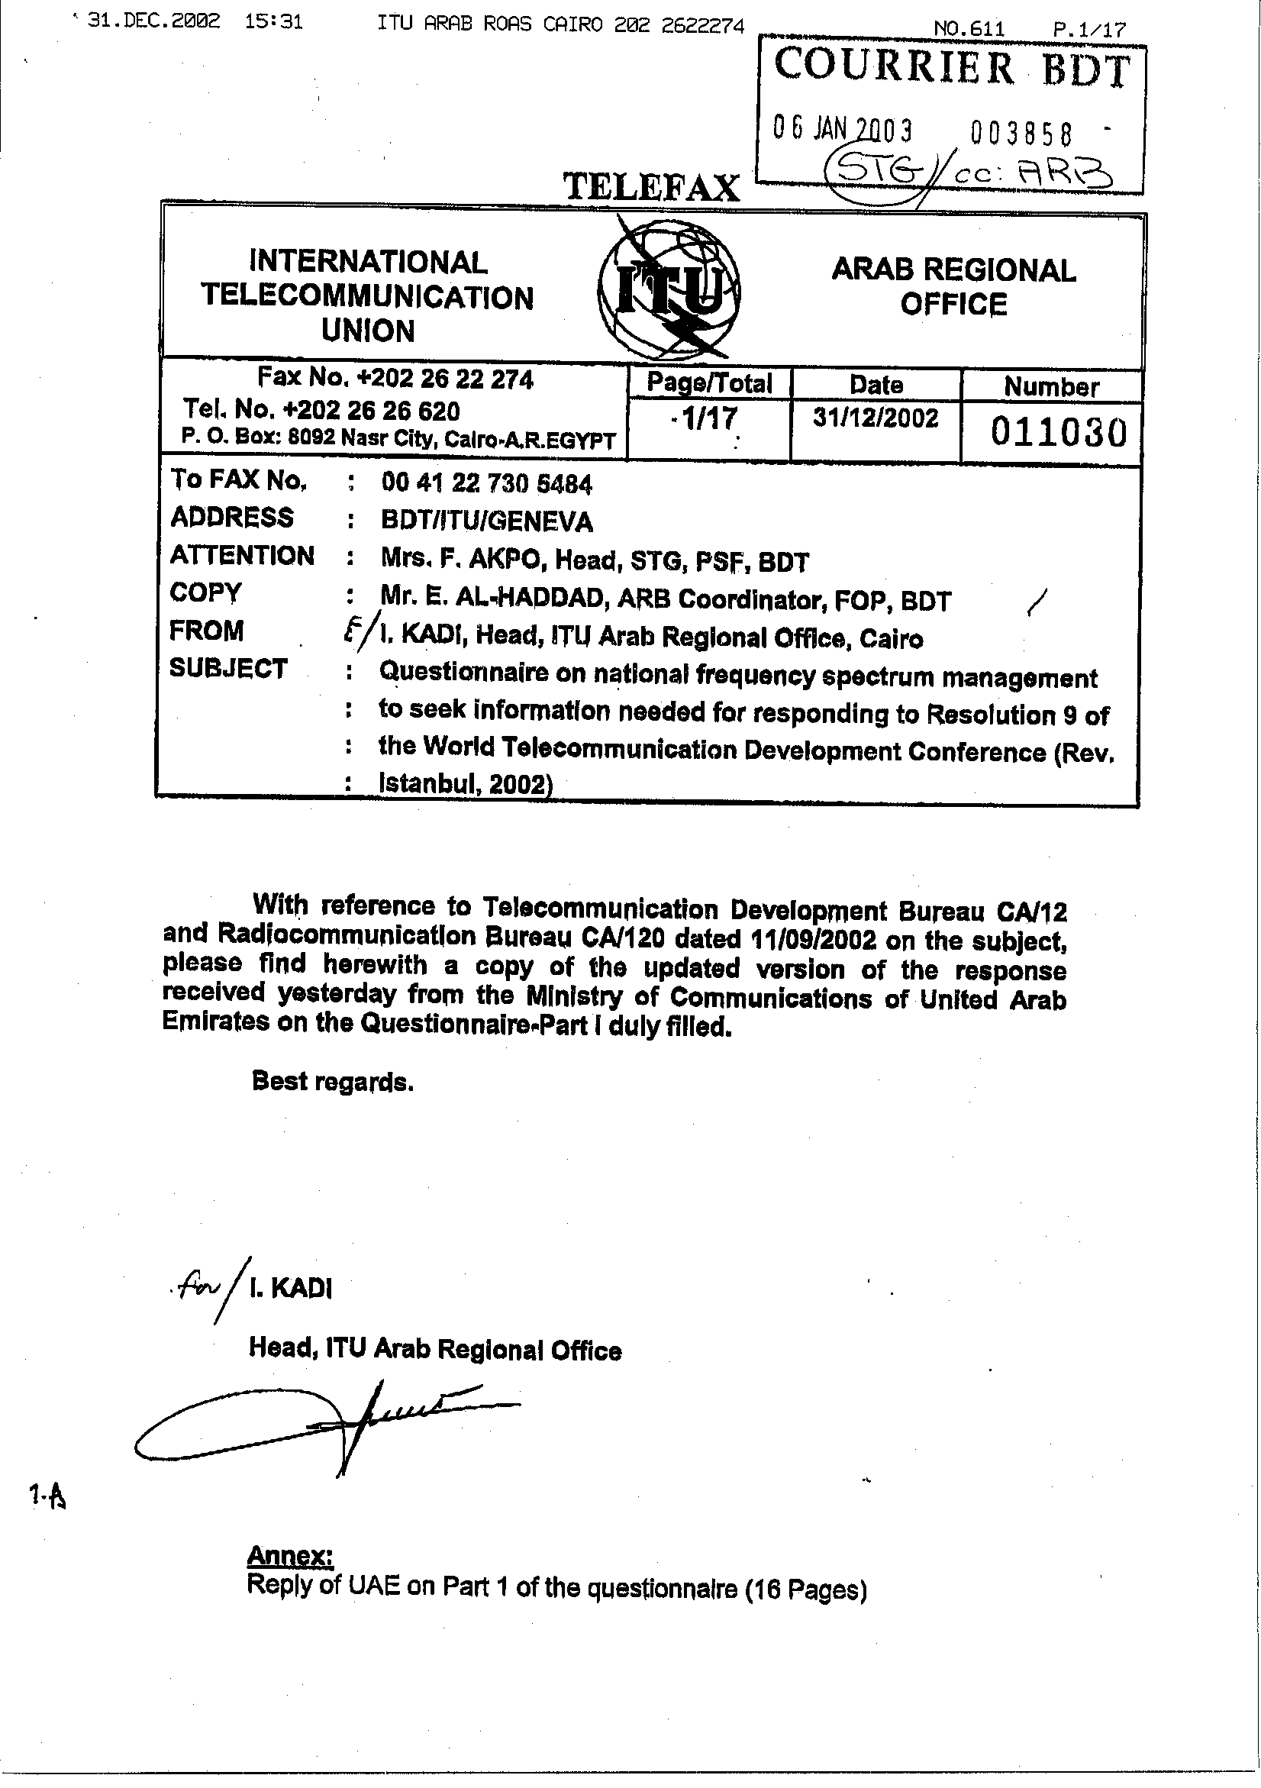
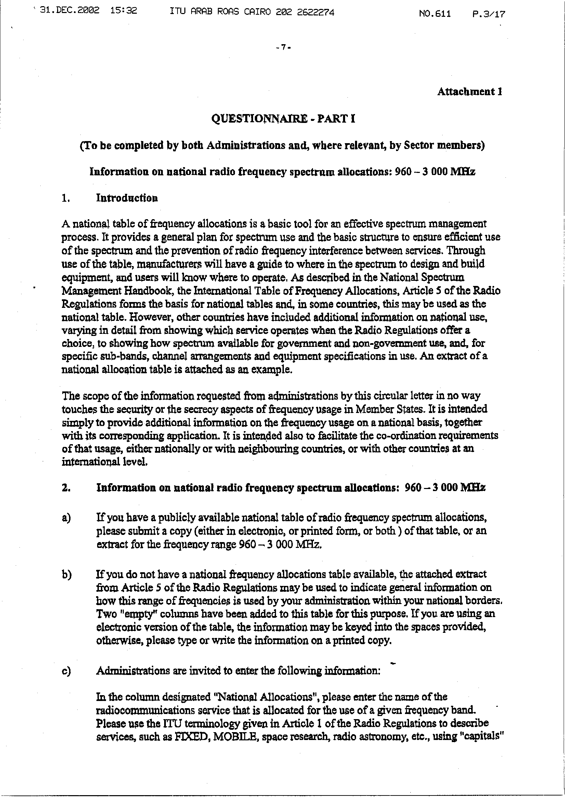
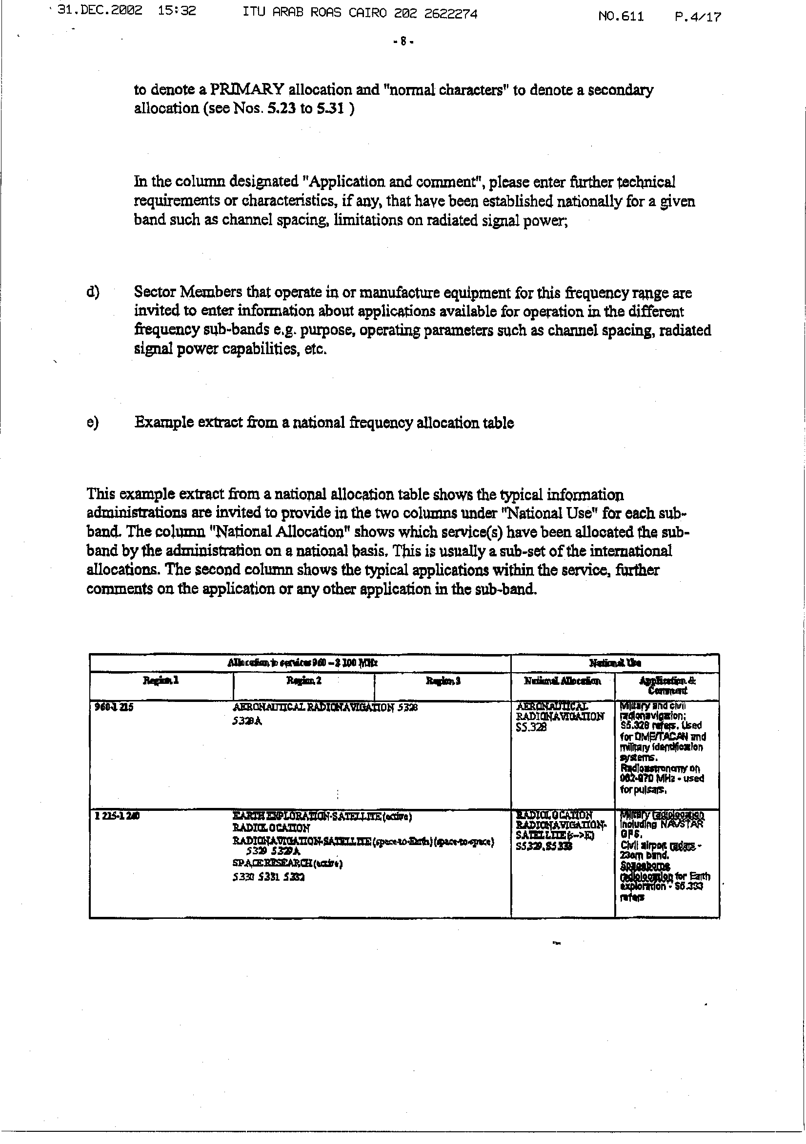
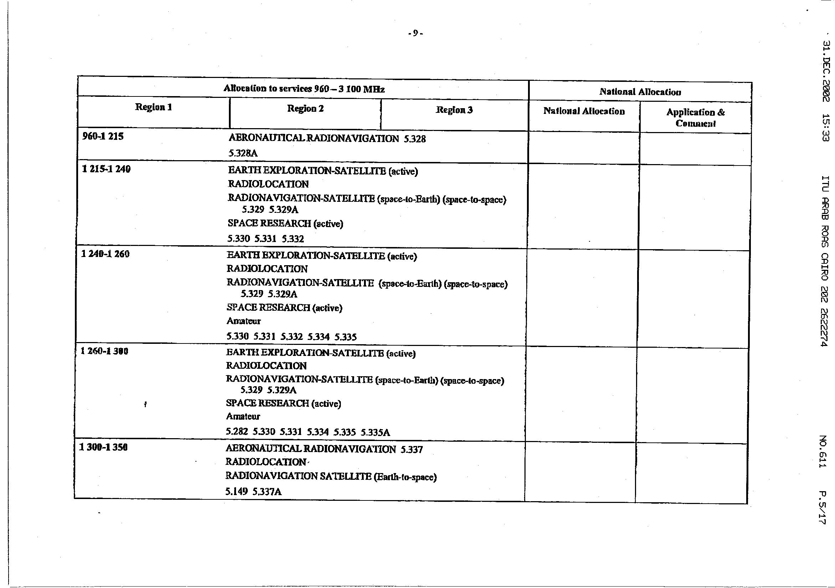
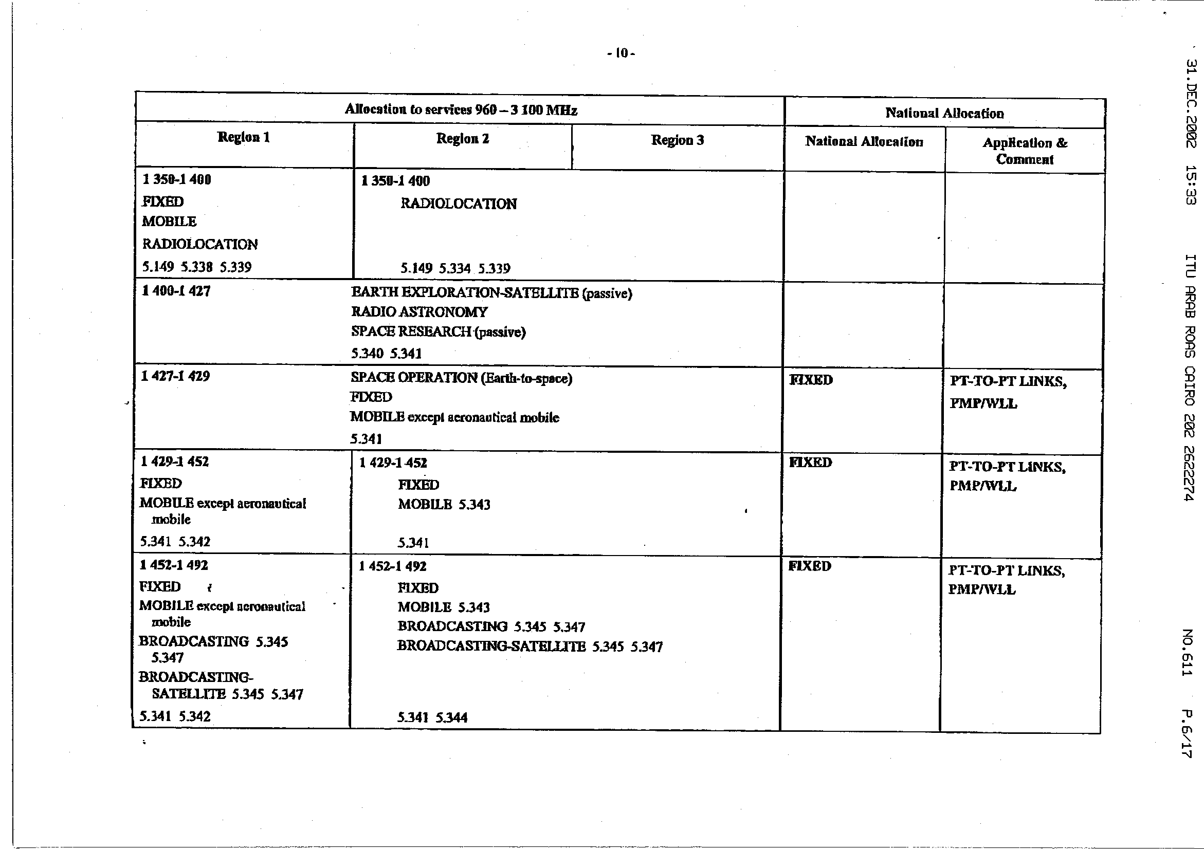
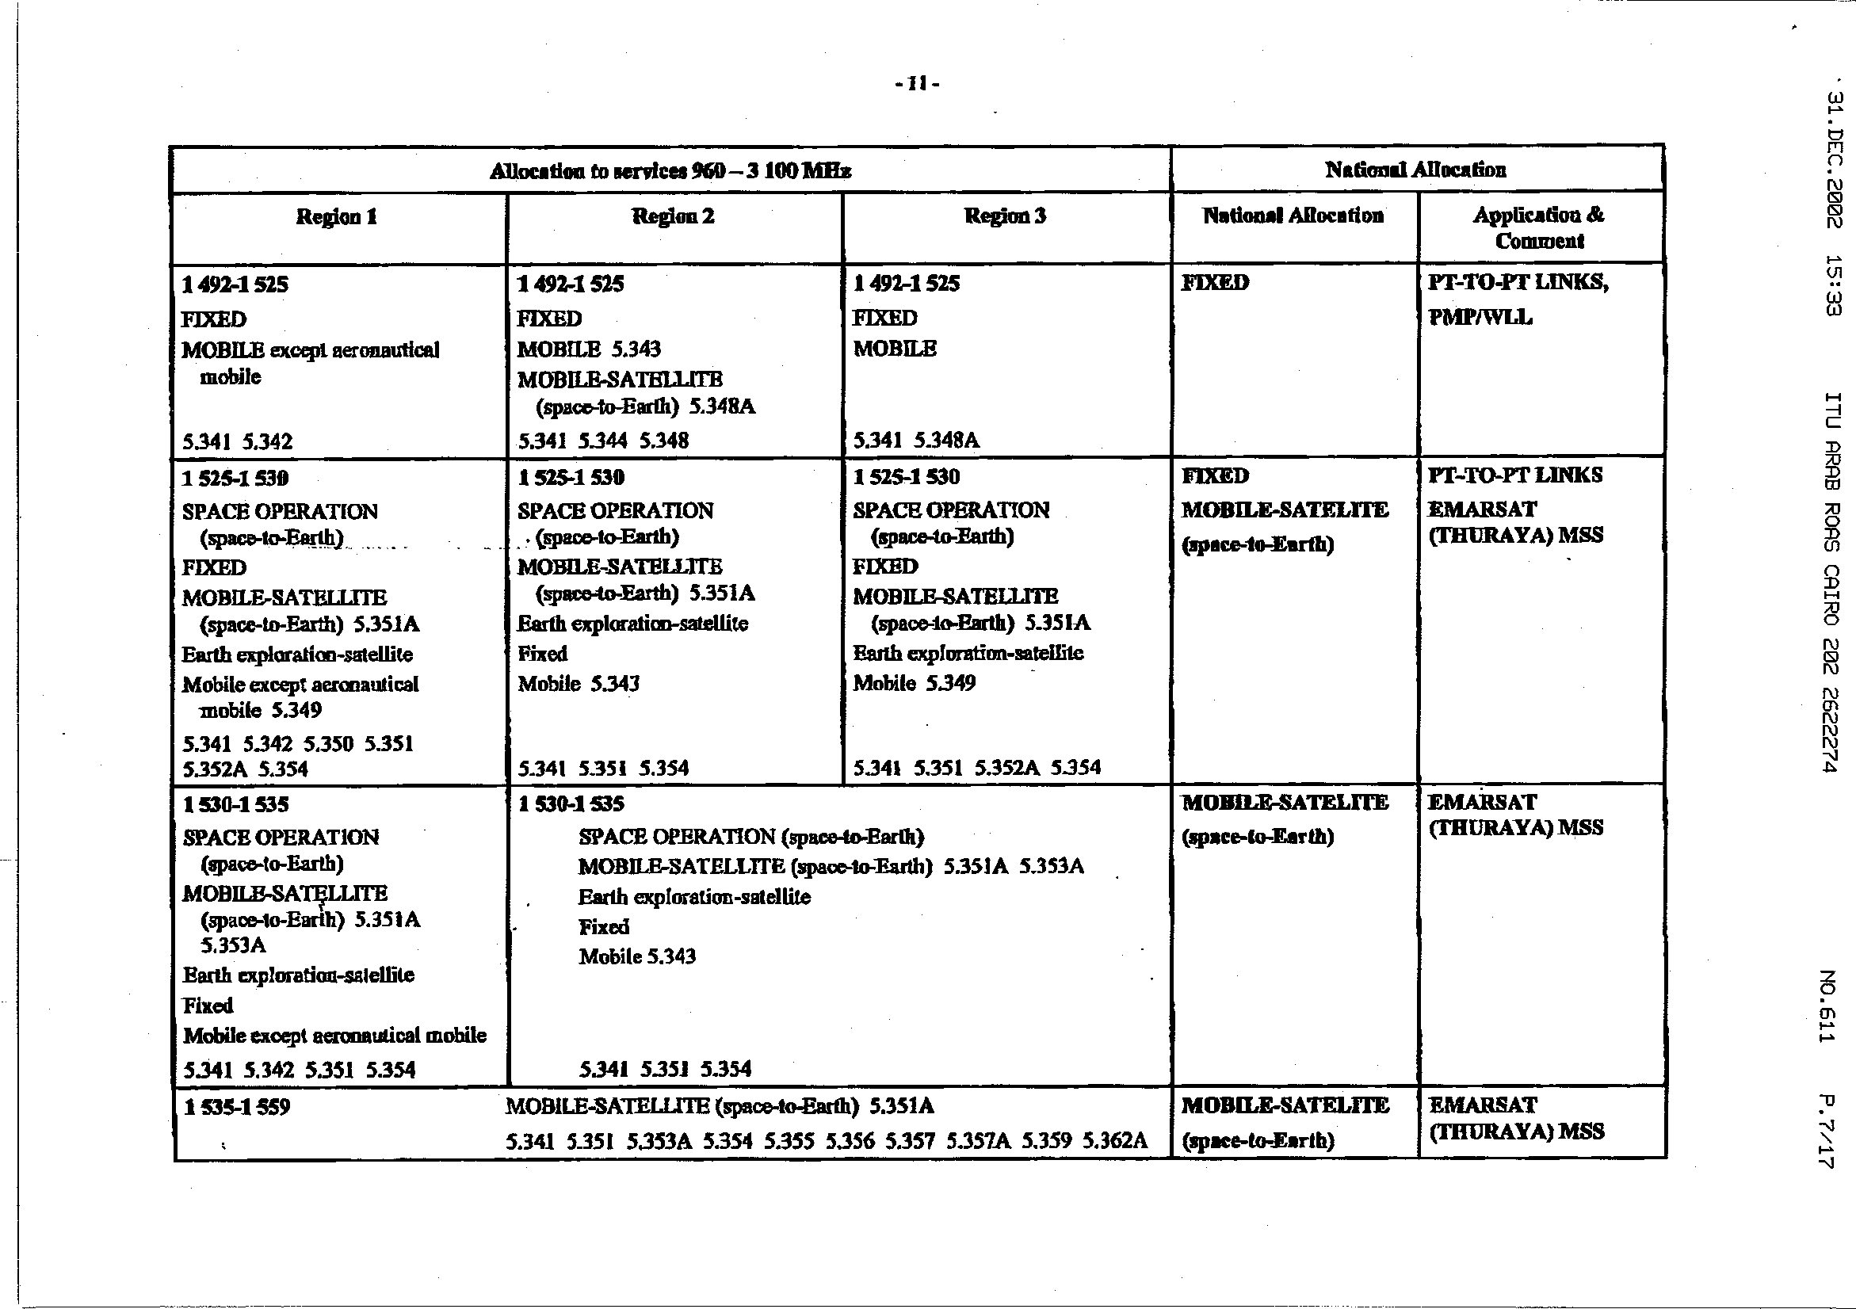
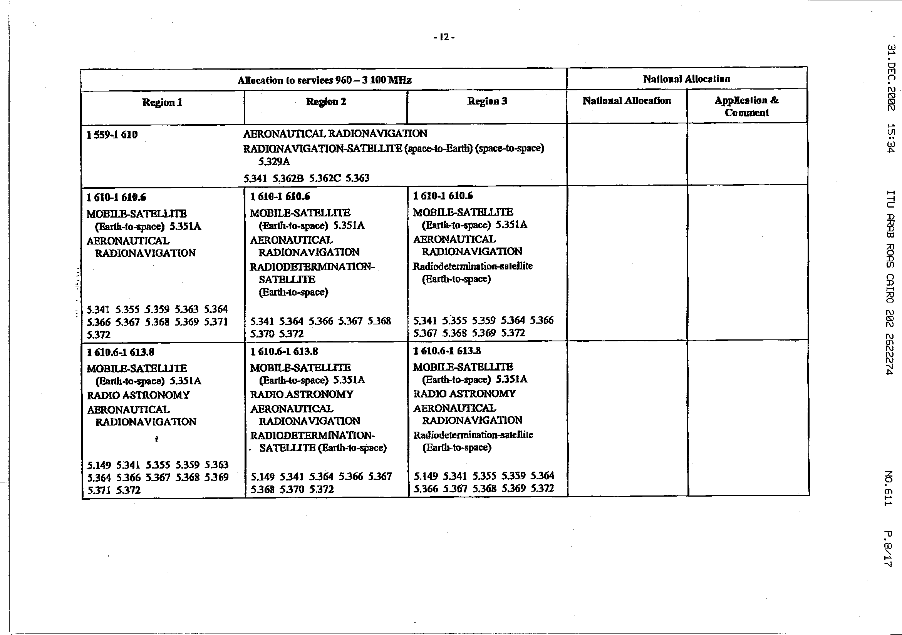
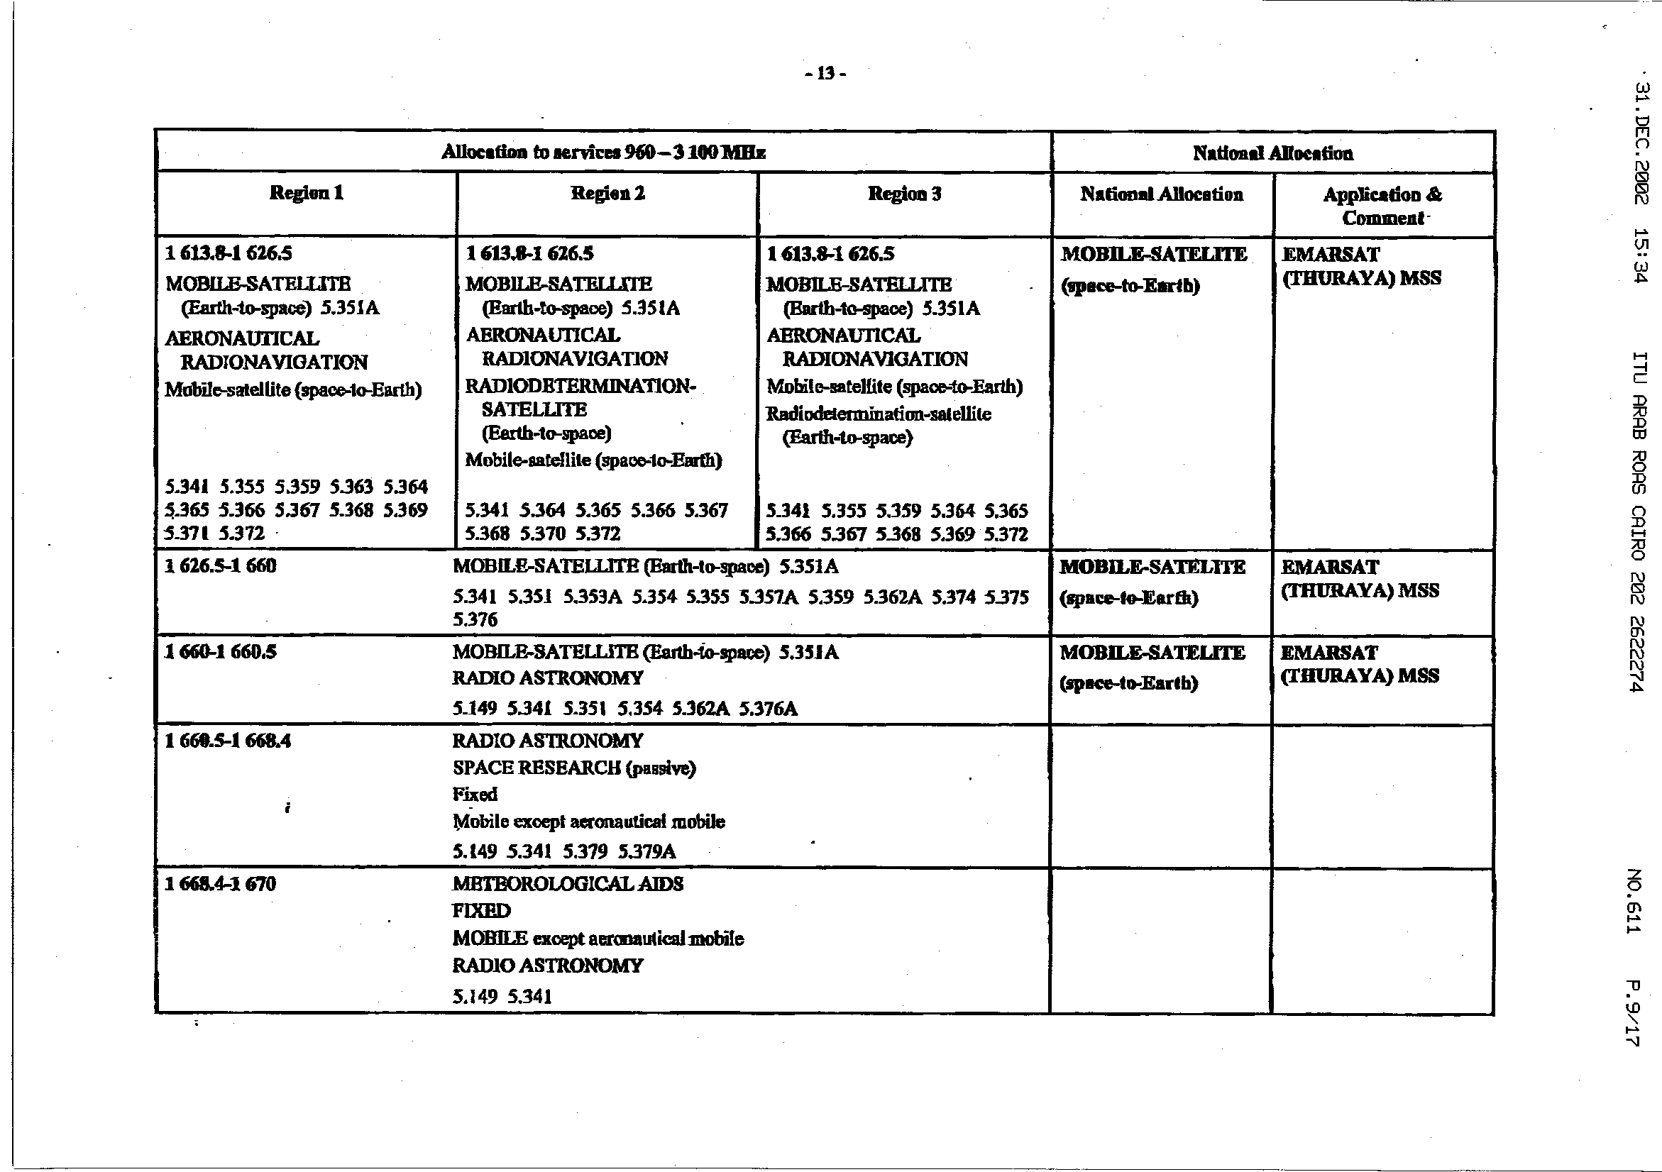
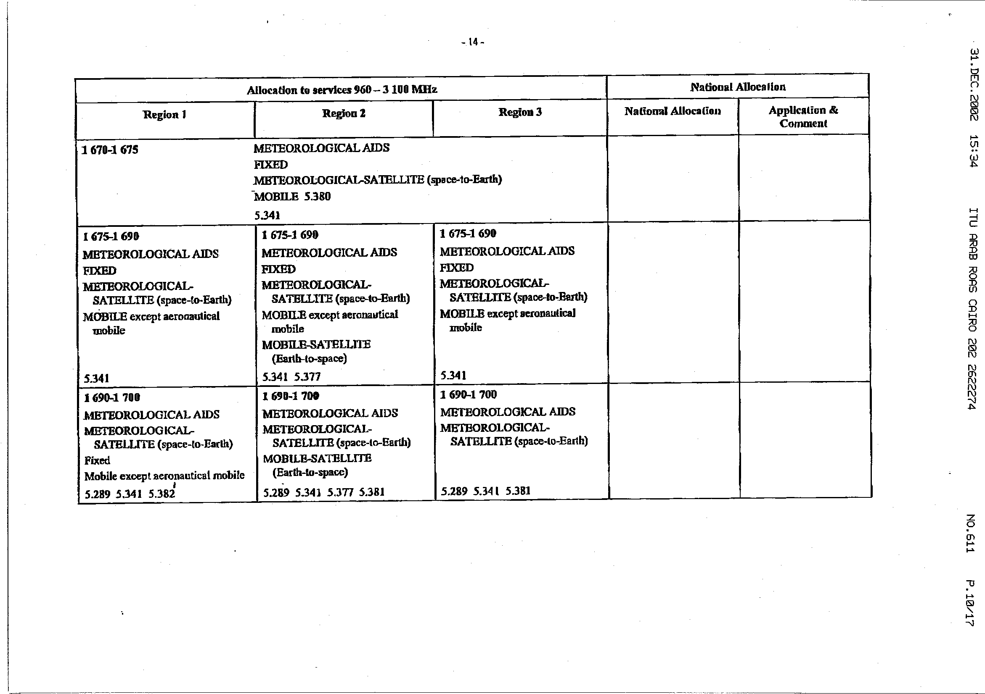
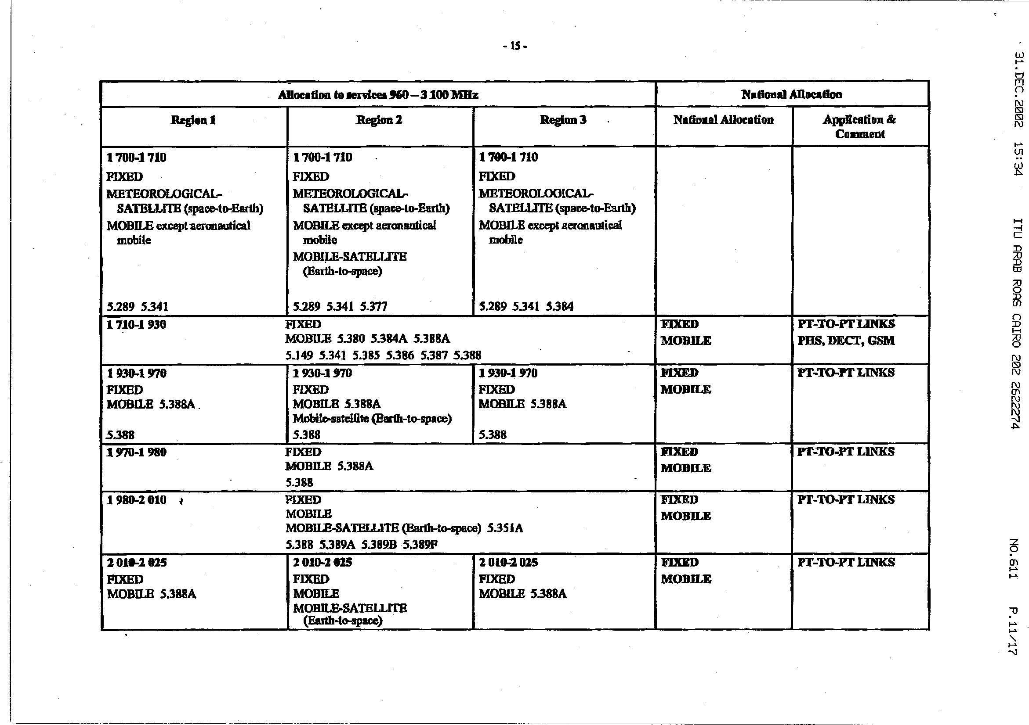
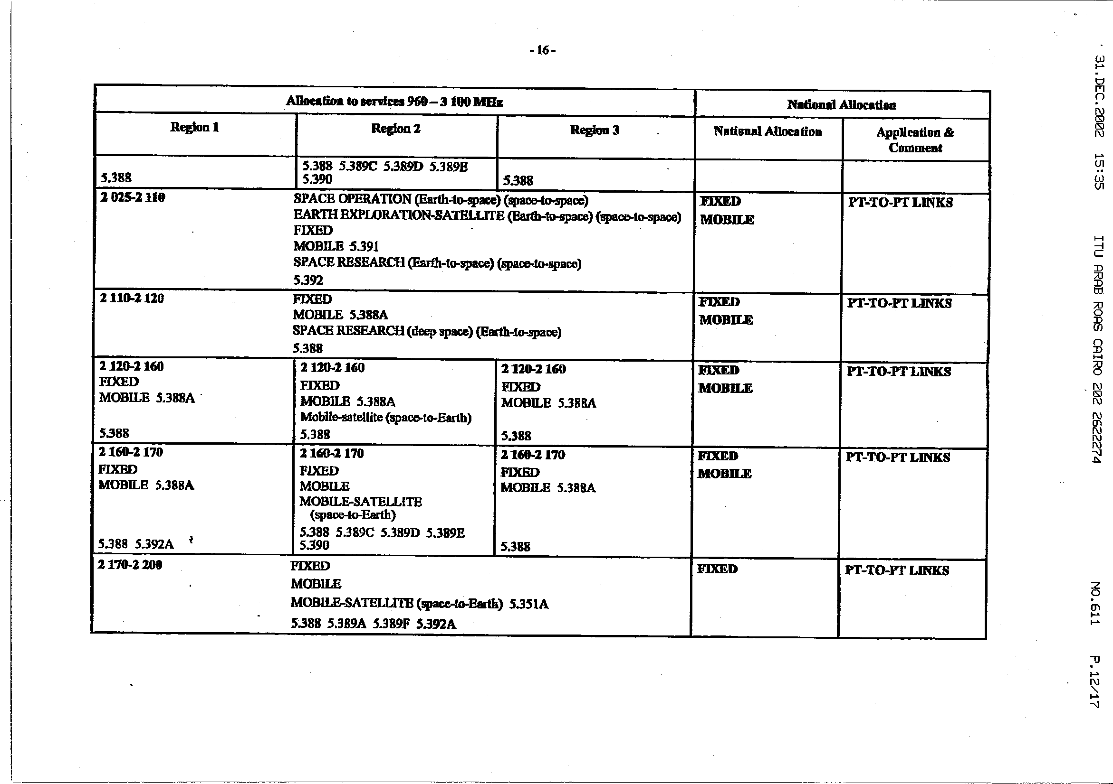
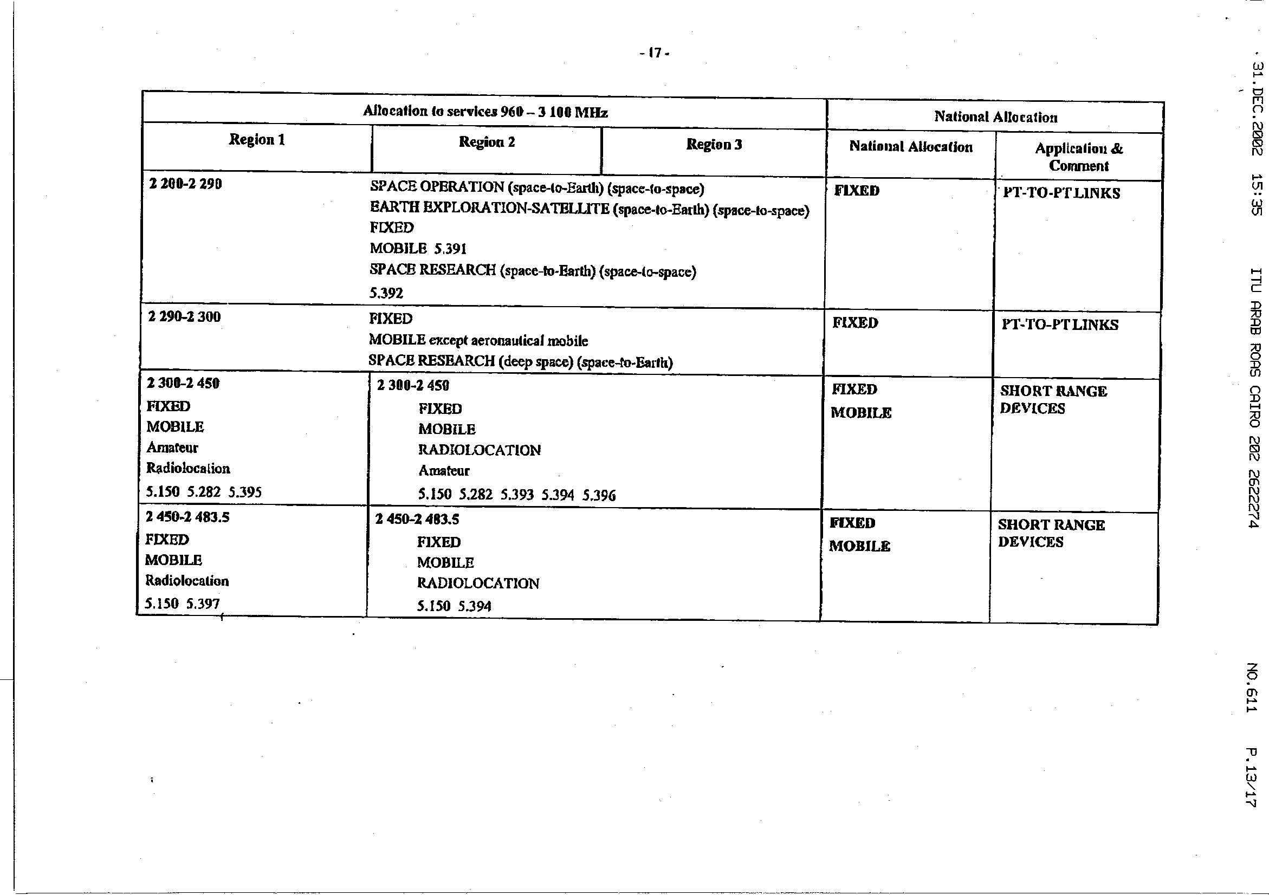
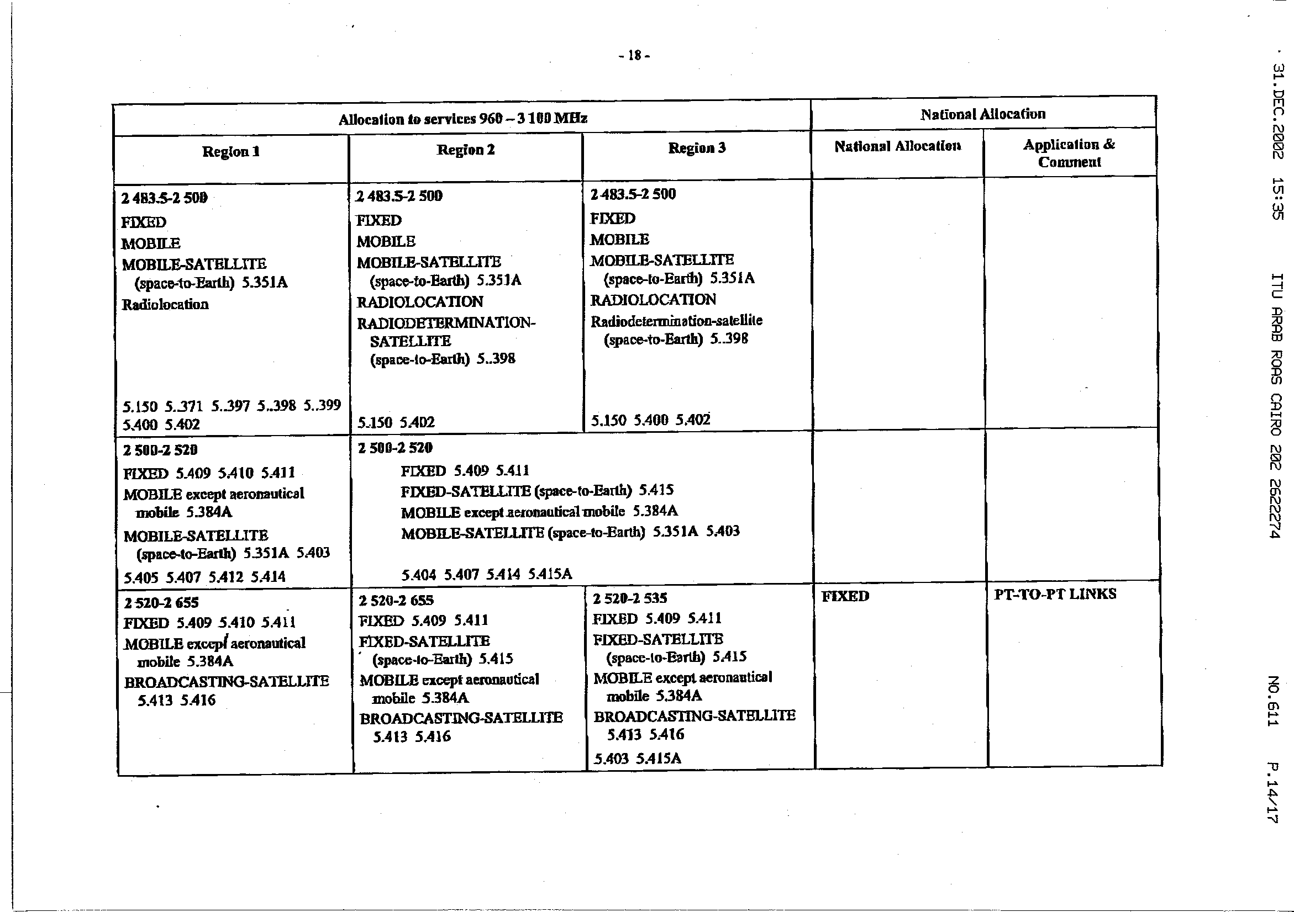
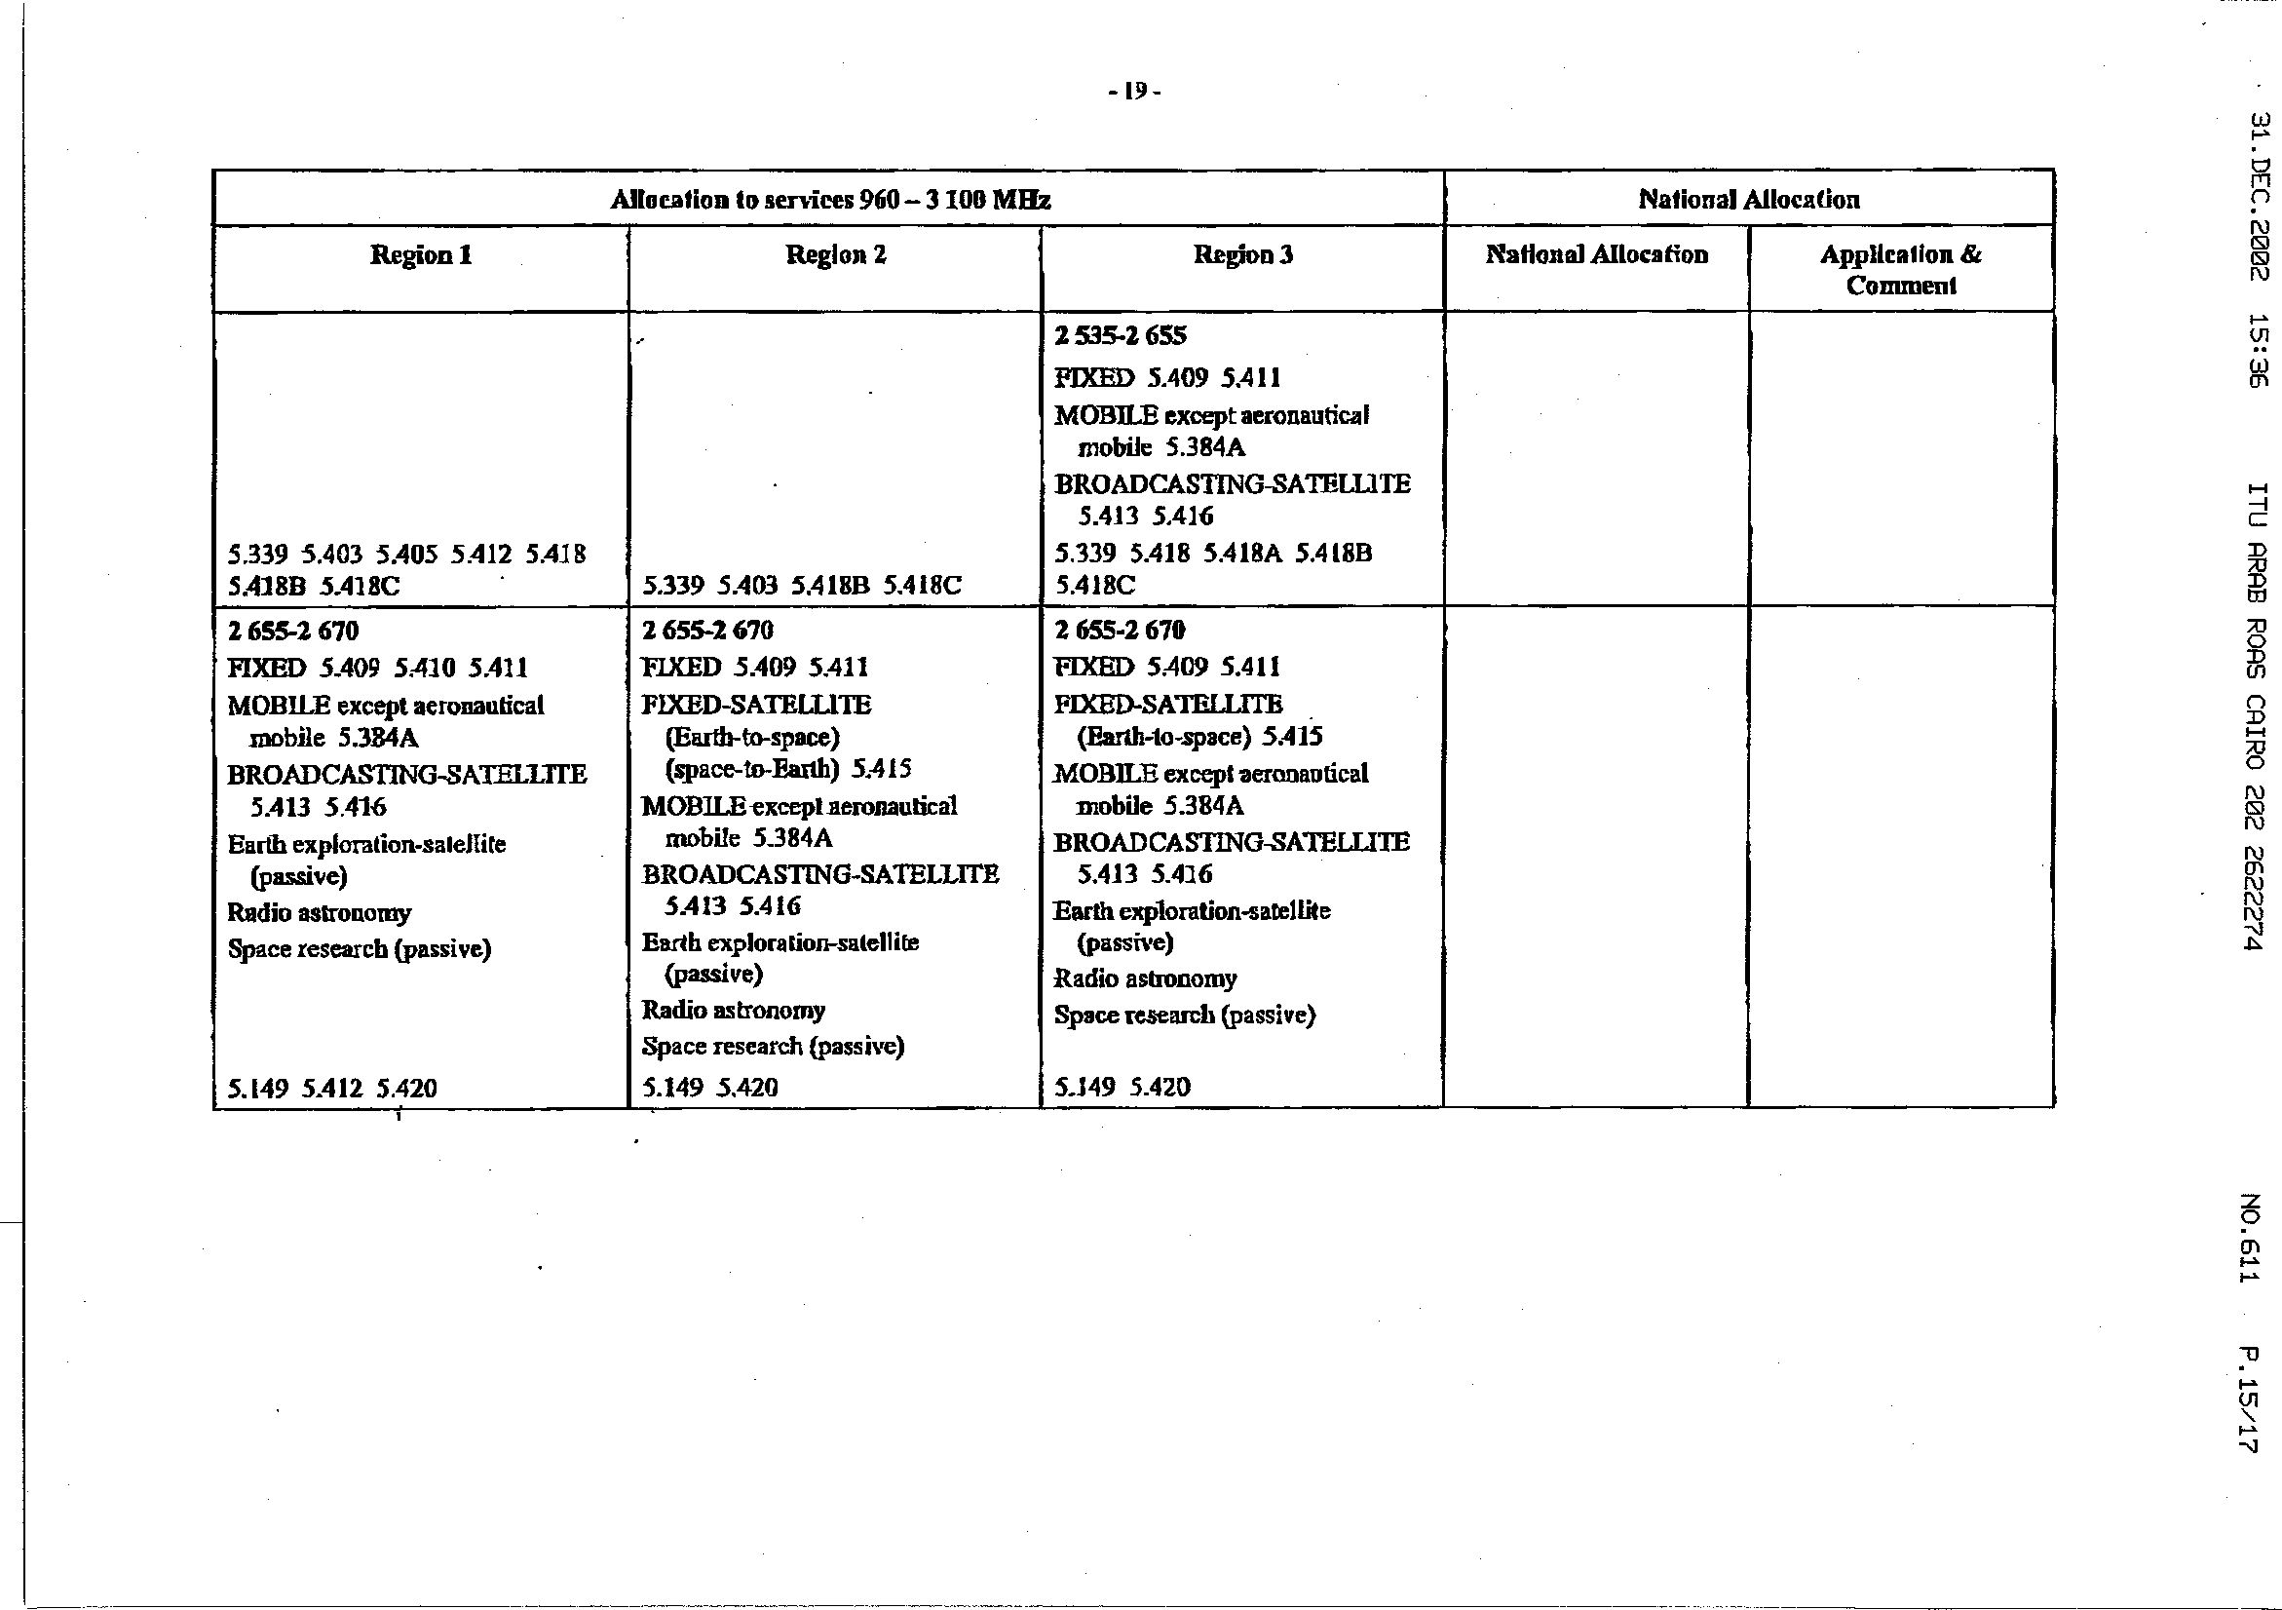
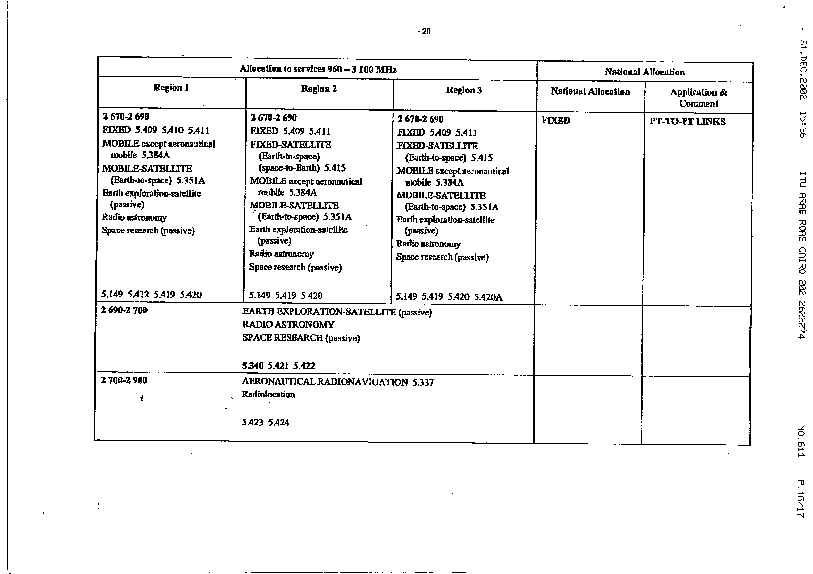
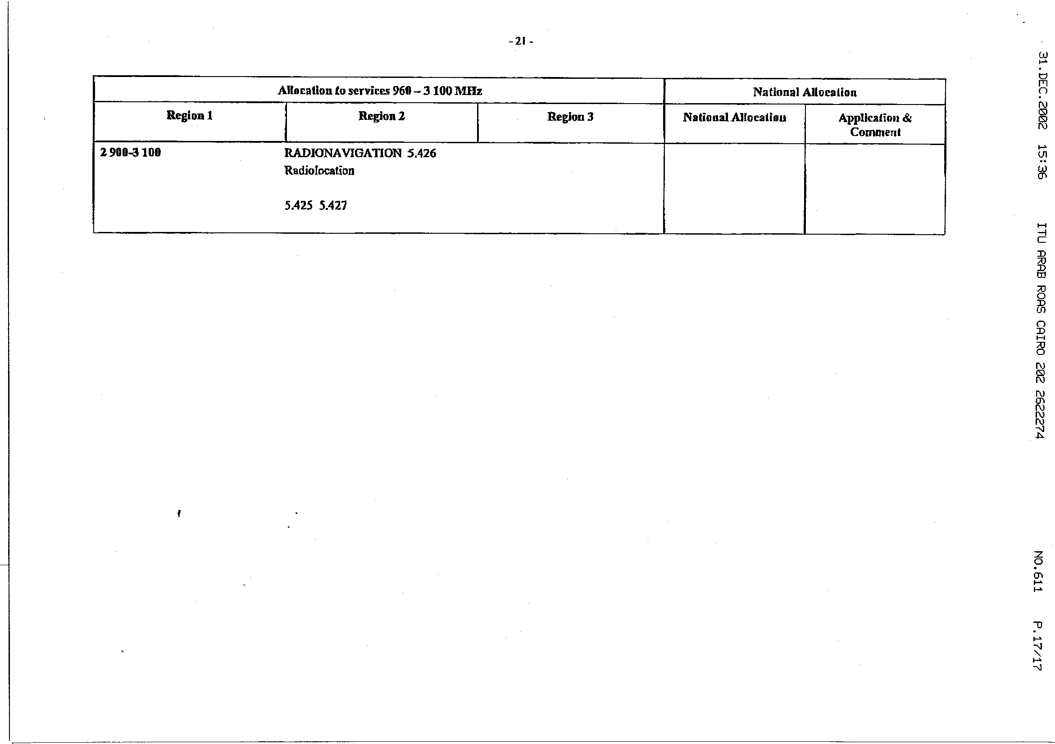

The National Spectrum Management Handbook is currently being updated. You are urged to contact Mr Robert Mayher, Chairman ITU-R Study Group 1 and the designated Rapporteur for revision of this Handbook if you have any comments that you wish included in this revision.

