FOCAL POINT REGARDING CORRESPONDENCE ON THIS QUESTIONNAIRE
(PARTS I, II AND III)

Please identify a focal point in your administration/organization who could provide a response to further correspondence regarding this questionnaire (see hereafter).

1. Mr./Ms GIRÃO FERNANDA
Family Name First Name

2. Country PORTUGAL

3. Name of the Administration : ANACOM-Autoridade Nacional das Comunicações

4. Title Deputy Director

5. Address Av José Malhoa, 12. 1099-017 Lisboa - Portugal

6. Tel.: 351.217122220 Fax: 351.21.7211006 E-Mail:fernanda.girao@anacom.pt

To be returned to:
ITU-D Study Groups Secretariat
Telecommunication Development Bureau
Fax: +41 22 730 54 84
E-Mail: devsg2@itu.int

Attachment 1
QUESTIONNAIRE - PART I
(To be completed by both Administrations and, where relevant, by Sector members)
Information on national radio frequency spectrum allocations: 960 – 3 000 MHz
1. Introduction
A national table of frequency allocations is a basic tool for an effective spectrum management process. It provides a general plan for spectrum use and the basic structure to ensure efficient use of the spectrum and the prevention of radio frequency interference between services. Through use of the table, manufacturers will have a guide to where in the spectrum to design and build equipment, and users will know where to operate. As described in the National Spectrum Management Handbook, the International Table of Frequency Allocations, Article 5 of the Radio Regulations forms the basis for national tables and, in some countries, this may be used as the national table. However, other countries have included additional information on national use, varying in detail from showing which service operates when the Radio Regulations offer a choice, to showing how spectrum available for government and non-government use, and, for specific sub-bands, channel arrangements and equipment specifications in use. An extract of a national allocation table is attached as an example.
The scope of the information requested from administrations by this circular letter in no way touches the security or the secrecy aspects of frequency usage in Member States. It is intended simply to provide additional information on the frequency usage on a national basis, together with its corresponding application. It is intended also to facilitate the co-ordination requirements of that usage, either nationally or with neighbouring countries, or with other countries at an international level.
2. Information on national radio frequency spectrum allocations: 960 – 3 000 MHz

- If you have a publicly available national table of radio frequency spectrum allocations, please submit a copy (either in electronic, or printed form, or both ) of that table, or an extract for the frequency range 960 – 3 000 MHz.
The Portuguese Frequency Allocation Table is at address http://www.anacom.pt/streaming/012_091uk.pdf?categoryId=30504&contentId=29653&field=ATTACHED_FILE at ANACOM´s internet page.

b) If you do not have a national frequency allocations table available, the attached extract from Article 5 of the Radio Regulations may be used to indicate general information on how this range of frequencies is used by your administration within your national borders. Two "empty" columns have been added to this table for this purpose. If you are using an electronic version of the table, the information may be keyed into the spaces provided, otherwise, please type or write the information on a printed copy.

c) Administrations are invited to enter the following information:
In the column designated "National Allocations", please enter the name of the radiocommunications service that is allocated for the use of a given frequency band. Please use the ITU terminology given in Article 1 of the Radio Regulations to describe services, such as FIXED, MOBILE, space research, radio astronomy, etc., using "capitals" to denote a PRIMARY allocation and "normal characters" to denote a secondary allocation (see Nos. 5.23 to 5.31 )
In the column designated "Application and comment", please enter further technical requirements or characteristics, if any, that have been established nationally for a given band such as channel spacing, limitations on radiated signal power;
d) Sector Members that operate in or manufacture equipment for this frequency range are invited to enter information about applications available for operation in the different frequency sub-bands e.g. purpose, operating parameters such as channel spacing, radiated signal power capabilities, etc.
- Example extract from a national frequency allocation table
This example extract from a national allocation table shows the typical information administrations are invited to provide in the two columns under "National Use" for each sub-band. The column "National Allocation" shows which service(s) have been allocated the sub-band by the administration on a national basis. This is usually a sub-set of the international allocations. The second column shows the typical applications within the service, further comments on the application or any other application in the sub-band.
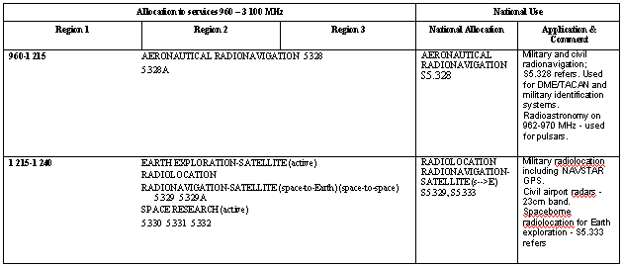

Allocation to services 960 – 3 100 MHz |  |  | National Allocation
Region 1 | Region 2 | Region 3 | National Allocation | Application & Comment
960-1 215 AERONAUTICAL RADIONAVIGATION 5.328
5.328A
1 215-1 240 EARTH EXPLORATION-SATELLITE (active)
RADIOLOCATION
RADIONAVIGATION-SATELLITE (space-to-Earth) (space-to-space) 5.329 5.329A
SPACE RESEARCH (active)
5.330 5.331 5.332
1 240-1 260 EARTH EXPLORATION-SATELLITE (active)
RADIOLOCATION
RADIONAVIGATION-SATELLITE (space-to-Earth) (space-to-space) 5.329 5.329A
SPACE RESEARCH (active)
Amateur
5.330 5.331 5.332 5.334 5.335
1 260-1 300 EARTH EXPLORATION-SATELLITE (active)
RADIOLOCATION
RADIONAVIGATION-SATELLITE (space-to-Earth) (space-to-space) 5.329 5.329A
SPACE RESEARCH (active)
Amateur
5.282 5.330 5.331 5.334 5.335 5.335A
1 300-1 350 AERONAUTICAL RADIONAVIGATION 5.337
RADIOLOCATION
RADIONAVIGATION SATELLITE (Earth-to-space)
5.149 5.337A
1 350-1 400  FIXED  MOBILE  RADIOLOCATION | 1 350-1 400  RADIOLOCATION
5.149 5.338 5.339 | 5.149 5.334 5.339
1 400-1 427 EARTH EXPLORATION-SATELLITE (passive)
RADIO ASTRONOMY
SPACE RESEARCH (passive)
5.340 5.341
1 427-1 429 SPACE OPERATION (Earth-to-space)
FIXED
MOBILE except aeronautical mobile
5.341
1 429-1 452  FIXED  MOBILE except aeronautical  mobile | 1 429-1 452  FIXED  MOBILE 5.343
5.341 5.342 | 5.341
1 452-1 492  FIXED  MOBILE except aeronautical  mobile  BROADCASTING 5.345  5.347  BROADCASTING-  SATELLITE 5.345 5.347 | 1 452-1 492  FIXED  MOBILE 5.343  BROADCASTING 5.345 5.347  BROADCASTING-SATELLITE 5.345 5.347
5.341 5.342 | 5.341 5.344
1 492-1 525  FIXED  MOBILE except aeronautical mobile | 1 492-1 525  FIXED  MOBILE 5.343  MOBILE-SATELLITE  (space-to-Earth) 5.348A | 1 492-1 525  FIXED  MOBILE
5.341 5.342 | 5.341 5.344 5.348 | 5.341 5.348A
1 525-1 530  SPACE OPERATION  (space-to-Earth)  FIXED  MOBILE-SATELLITE  (space-to-Earth) 5.351A  Earth exploration-satellite  Mobile except aeronautical  mobile 5.349 | 1 525-1 530  SPACE OPERATION  (space-to-Earth)  MOBILE-SATELLITE  (space-to-Earth) 5.351A  Earth exploration-satellite  Fixed  Mobile 5.343 | 1 525-1 530  SPACE OPERATION  (space-to-Earth)  FIXED  MOBILE-SATELLITE  (space-to-Earth) 5.351A  Earth exploration-satellite  Mobile 5.349
5.341 5.342 5.350 5.351  5.352A 5.354 | 5.341 5.351 5.354 | 5.341 5.351 5.352A 5.354
1 530-1 535  SPACE OPERATION  (space-to-Earth)  MOBILE-SATELLITE  (space-to-Earth) 5.351A 5.353A  Earth exploration-satellite  Fixed  Mobile except aeronautical mobile | 1 530-1 535  SPACE OPERATION (space-to-Earth)  MOBILE-SATELLITE (space-to-Earth) 5.351A 5.353A  Earth exploration-satellite  Fixed  Mobile 5.343
5.341 5.342 5.351 5.354 | 5.341 5.351 5.354
1 535-1 559 MOBILE-SATELLITE (space-to-Earth) 5.351A
5.341 5.351 5.353A 5.354 5.355 5.356 5.357 5.357A 5.359 5.362A
1 559-1 610 AERONAUTICAL RADIONAVIGATION
RADIONAVIGATION-SATELLITE (space-to-Earth) (space-to-space) 5.329A
5.341 5.362B 5.362C 5.363
1 610-1 610.6  MOBILE-SATELLITE  (Earth-to-space) 5.351A  AERONAUTICAL  RADIONAVIGATION | 1 610-1 610.6  MOBILE-SATELLITE  (Earth-to-space) 5.351A  AERONAUTICAL  RADIONAVIGATION  RADIODETERMINATION-  SATELLITE  (Earth-to-space) | 1 610-1 610.6  MOBILE-SATELLITE  (Earth-to-space) 5.351A  AERONAUTICAL  RADIONAVIGATION  Radiodetermination-satellite  (Earth-to-space)
5.341 5.355 5.359 5.363 5.364 5.366 5.367 5.368 5.369 5.371 5.372 | 5.341 5.364 5.366 5.367 5.368 5.370 5.372 | 5.341 5.355 5.359 5.364 5.366 5.367 5.368 5.369 5.372
1 610.6-1 613.8  MOBILE-SATELLITE  (Earth-to-space) 5.351A  RADIO ASTRONOMY  AERONAUTICAL  RADIONAVIGATION | 1 610.6-1 613.8  MOBILE-SATELLITE  (Earth-to-space) 5.351A  RADIO ASTRONOMY  AERONAUTICAL  RADIONAVIGATION  RADIODETERMINATION-SATELLITE (Earth-to-space) | 1 610.6-1 613.8  MOBILE-SATELLITE  (Earth-to-space) 5.351A  RADIO ASTRONOMY  AERONAUTICAL  RADIONAVIGATION  Radiodetermination-satellite  (Earth-to-space)
5.149 5.341 5.355 5.359 5.363 5.364 5.366 5.367 5.368 5.369 5.371 5.372 | 5.149 5.341 5.364 5.366 5.367 5.368 5.370 5.372 | 5.149 5.341 5.355 5.359 5.364 5.366 5.367 5.368 5.369 5.372
1 613.8-1 626.5  MOBILE-SATELLITE  (Earth-to-space) 5.351A  AERONAUTICAL  RADIONAVIGATION  Mobile-satellite (space-to-Earth) | 1 613.8-1 626.5  MOBILE-SATELLITE  (Earth-to-space) 5.351A  AERONAUTICAL  RADIONAVIGATION  RADIODETERMINATION-  SATELLITE  (Earth-to-space)  Mobile-satellite (space-to-Earth) | 1 613.8-1 626.5  MOBILE-SATELLITE  (Earth-to-space) 5.351A  AERONAUTICAL RADIONAVIGATION  Mobile-satellite (space-to-Earth)  Radiodetermination-satellite  (Earth-to-space)
5.341 5.355 5.359 5.363 5.364 5.365 5.366 5.367 5.368 5.369 5.371 5.372 | 5.341 5.364 5.365 5.366 5.367 5.368 5.370 5.372 | 5.341 5.355 5.359 5.364 5.365 5.366 5.367 5.368 5.369 5.372
1 626.5-1 660 MOBILE-SATELLITE (Earth-to-space) 5.351A
5.341 5.351 5.353A 5.354 5.355 5.357A 5.359 5.362A 5.374 5.375 5.376
1 660-1 660.5 MOBILE-SATELLITE (Earth-to-space) 5.351A
RADIO ASTRONOMY
5.149 5.341 5.351 5.354 5.362A 5.376A
1 660.5-1 668.4 RADIO ASTRONOMY
SPACE RESEARCH (passive)
Fixed
Mobile except aeronautical mobile
5.149 5.341 5.379 5.379A
1 668.4-1 670 METEOROLOGICAL AIDS
FIXED
MOBILE except aeronautical mobile
RADIO ASTRONOMY
5.149 5.341
1 670-1 675 METEOROLOGICAL AIDS
FIXED
METEOROLOGICAL-SATELLITE (space-to-Earth)
MOBILE 5.380
5.341
1 675-1 690  METEOROLOGICAL AIDS  FIXED  METEOROLOGICAL-  SATELLITE (space-to-Earth)  MOBILE except aeronautical  mobile | 1 675-1 690  METEOROLOGICAL AIDS  FIXED  METEOROLOGICAL-  SATELLITE (space-to-Earth)  MOBILE except aeronautical  mobile  MOBILE-SATELLITE  (Earth-to-space) | 1 675-1 690  METEOROLOGICAL AIDS  FIXED  METEOROLOGICAL-  SATELLITE (space-to-Earth)  MOBILE except aeronautical  mobile
5.341 | 5.341 5.377 | 5.341
1 690-1 700  METEOROLOGICAL AIDS  METEOROLOGICAL-  SATELLITE (space-to-Earth)  Fixed  Mobile except aeronautical mobile | 1 690-1 700  METEOROLOGICAL AIDS  METEOROLOGICAL-  SATELLITE (space-to-Earth)  MOBILE-SATELLITE  (Earth-to-space) | 1 690-1 700  METEOROLOGICAL AIDS  METEOROLOGICAL-  SATELLITE (space-to-Earth)
5.289 5.341 5.382 | 5.289 5.341 5.377 5.381 | 5.289 5.341 5.381
1 700-1 710  FIXED  METEOROLOGICAL-SATELLITE (space-to-Earth)  MOBILE except aeronautical  mobile | 1 700-1 710  FIXED  METEOROLOGICAL-  SATELLITE (space-to-Earth)  MOBILE except aeronautical  mobile  MOBILE-SATELLITE  (Earth-to-space) | 1 700-1 710  FIXED  METEOROLOGICAL-  SATELLITE (space-to-Earth)  MOBILE except aeronautical  mobile
5.289 5.341 | 5.289 5.341 5.377 | 5.289 5.341 5.384
1 710-1 930 FIXED
MOBILE 5.380 5.384A 5.388A
5.149 5.341 5.385 5.386 5.387 5.388
1 930-1 970  FIXED  MOBILE 5.388A | 1 930-1 970  FIXED  MOBILE 5.388A  Mobile-satellite (Earth-to-space) | 1 930-1 970  FIXED  MOBILE 5.388A
5.388 | 5.388 | 5.388
1 970-1 980 FIXED
MOBILE 5.388A
5.388
1 980-2 010 FIXED
MOBILE
MOBILE-SATELLITE (Earth-to-space) 5.351A
5.388 5.389A 5.389B 5.389F
2 010-2 025  FIXED  MOBILE 5.388A | 2 010-2 025  FIXED  MOBILE  MOBILE-SATELLITE  (Earth-to-space) | 2 010-2 025  FIXED  MOBILE 5.388A
5.388 | 5.388 5.389C 5.389D 5.389E 5.390 | 5.388
2 025-2 110 SPACE OPERATION (Earth-to-space) (space-to-space)
EARTH EXPLORATION-SATELLITE (Earth-to-space) (space-to-space)
FIXED
MOBILE 5.391
SPACE RESEARCH (Earth-to-space) (space-to-space)
5.392
2 110-2 120 FIXED
MOBILE 5.388A
SPACE RESEARCH (deep space) (Earth-to-space)
5.388
2 120-2 160  FIXED  MOBILE 5.388A | 2 120-2 160  FIXED  MOBILE 5.388A  Mobile-satellite (space-to-Earth) | 2 120-2 160  FIXED  MOBILE 5.388A
5.388 | 5.388 | 5.388
2 160-2 170  FIXED  MOBILE 5.388A | 2 160-2 170  FIXED  MOBILE  MOBILE-SATELLITE  (space-to-Earth) | 2 160-2 170  FIXED  MOBILE 5.388A
5.388 5.392A | 5.388 5.389C 5.389D 5.389E 5.390 | 5.388
2 170-2 200 FIXED
MOBILE
MOBILE-SATELLITE (space-to-Earth) 5.351A
5.388 5.389A 5.389F 5.392A
2 200-2 290 SPACE OPERATION (space-to-Earth) (space-to-space)
EARTH EXPLORATION-SATELLITE (space-to-Earth) (space-to-space)
FIXED
MOBILE 5.391
SPACE RESEARCH (space-to-Earth) (space-to-space)
5.392
2 290-2 300 FIXED
MOBILE except aeronautical mobile
SPACE RESEARCH (deep space) (space-to-Earth)
2 300-2 450  FIXED  MOBILE  Amateur  Radiolocation | 2 300-2 450  FIXED  MOBILE  RADIOLOCATION  Amateur
5.150 5.282 5.395 | 5.150 5.282 5.393 5.394 5.396
2 450-2 483.5  FIXED  MOBILE  Radiolocation  5.150 5.397 | 2 450-2 483.5  FIXED  MOBILE  RADIOLOCATION  5.150 5.394
2 483.5-2 500  FIXED  MOBILE  MOBILE-SATELLITE  (space-to-Earth) 5.351A  Radiolocation | 2 483.5-2 500  FIXED  MOBILE  MOBILE-SATELLITE  (space-to-Earth) 5.351A  RADIOLOCATION  RADIODETERMINATION-  SATELLITE  (space-to-Earth) 5..398 | 2 483.5-2 500  FIXED  MOBILE  MOBILE-SATELLITE  (space-to-Earth) 5.351A  RADIOLOCATION  Radiodetermination-satellite  (space-to-Earth) 5..398
5.150 5..371 5..397 5..398 5..399 5.400 5.402 | 5.150 5.402 | 5.150 5.400 5.402
2 500-2 520  FIXED 5.409 5.410 5.411  MOBILE except aeronautical mobile 5.384A  MOBILE-SATELLITE  (space-to-Earth) 5.351A 5.403 | 2 500-2 520  FIXED 5.409 5.411  FIXED-SATELLITE (space-to-Earth) 5.415  MOBILE except aeronautical mobile 5.384A  MOBILE-SATELLITE (space-to-Earth) 5.351A 5.403
5.405 5.407 5.412 5.414 | 5.404 5.407 5.414 5.415A
2 520-2 655  FIXED 5.409 5.410 5.411  MOBILE except aeronautical  mobile 5.384A  BROADCASTING-SATELLITE  5.413 5.416 | 2 520-2 655  FIXED 5.409 5.411  FIXED-SATELLITE  (space-to-Earth) 5.415  MOBILE except aeronautical  mobile 5.384A  BROADCASTING-SATELLITE  5.413 5.416 | 2 520-2 535  FIXED 5.409 5.411  FIXED-SATELLITE  (space-to-Earth) 5.415  MOBILE except aeronautical  mobile 5.384A  BROADCASTING-SATELLITE  5.413 5.416
 |  | 5.403 5.415A
2 535-2 655
FIXED 5.409 5.411
MOBILE except aeronautical mobile 5.384A
BROADCASTING-SATELLITE
5.413 5.416
5.339 5.403 5.405 5.412 5.418 5.418B 5.418C | 5.339 5.403 5.418B 5.418C | 5.339 5.418 5.418A 5.418B 5.418C
2 655-2 670  FIXED 5.409 5.410 5.411  MOBILE except aeronautical  mobile 5.384A  BROADCASTING-SATELLITE  5.413 5.416  Earth exploration-satellite  (passive)  Radio astronomy  Space research (passive) | 2 655-2 670  FIXED 5.409 5.411  FIXED-SATELLITE  (Earth-to-space)  (space-to-Earth) 5.415  MOBILE except aeronautical  mobile 5.384A  BROADCASTING-SATELLITE  5.413 5.416  Earth exploration-satellite  (passive)  Radio astronomy  Space research (passive) | 2 655-2 670  FIXED 5.409 5.411  FIXED-SATELLITE  (Earth-to-space) 5.415  MOBILE except aeronautical  mobile 5.384A  BROADCASTING-SATELLITE 5.413 5.416  Earth exploration-satellite  (passive)  Radio astronomy  Space research (passive)
5.149 5.412 5.420 | 5.149 5.420 | 5.149 5.420
2 670-2 690  FIXED 5.409 5.410 5.411  MOBILE except aeronautical mobile 5.384A  MOBILE-SATELLITE  (Earth-to-space) 5.351A  Earth exploration-satellite  (passive)  Radio astronomy  Space research (passive) | 2 670-2 690  FIXED 5.409 5.411  FIXED-SATELLITE  (Earth-to-space)  (space-to-Earth) 5.415  MOBILE except aeronautical  mobile 5.384A  MOBILE-SATELLITE  (Earth-to-space) 5.351A  Earth exploration-satellite  (passive)  Radio astronomy  Space research (passive) | 2 670-2 690  FIXED 5.409 5.411  FIXED-SATELLITE  (Earth-to-space) 5.415  MOBILE except aeronautical  mobile 5.384A  MOBILE-SATELLITE  (Earth-to-space) 5.351A  Earth exploration-satellite  (passive)  Radio astronomy  Space research (passive)
5.149 5.412 5.419 5.420 | 5.149 5.419 5.420 | 5.149 5.419 5.420 5.420A
2 690-2 700 EARTH EXPLORATION-SATELLITE (passive)
RADIO ASTRONOMY
SPACE RESEARCH (passive)

  - 5.421 5.422
2 700-2 900 AERONAUTICAL RADIONAVIGATION 5.337
Radiolocation

5.423 5.424
2 900-3 100 RADIONAVIGATION 5.426
Radiolocation

5.425 5.427

Attachment 2
QUESTIONNAIRE - PART II
(To be completed by Administrations only)
General Questions on National Spectrum Management
The following general questions on national spectrum management are based in part on the functional requirements of spectrum management described in the handbook on "National Spectrum Management". If you need additional space to answer the questions please continue on a separate sheet of paper.
1. What legal or regulatory texts govern your national spectrum management processes? Basic Telecommunications Law, Decree Laws and ANACOM Statutes. Can be found in ANACOM´s site in the address (http://www.anacom.pt/template16.jsp?categoryId=4654)
Are any actions planned to change these legal texts or regulations? YES_√_ NO__

2. Have you publicly available regulations and procedures for national spectrum management (e.g. radio services, license requirements etc.)? YES_√_ NO__
3. Do you have a national radio frequency spectrum allocation table? YES_√_ NO__

4. Regulations for the technical characteristics of radiocommunications equipment
Do you specify that the technical characteristics of radiocommunications equipment must comply with certain requirements (often referred to as "equipment standards"), for example to avoid interference to other services and users? YES_√_ NO__
- Do you develop these technical requirements or equipment standards on a national basis or use those developed by other administrations or international/regional standards organisations: National __Other _√_
- Do you have a procedure to ensure that radiocommunications equipment complies with the technical requirements, for example:
Type Approval: ___; Manufacturers Declaration of Compliance: _√__; Other ___
5. Spectrum re-deployment*
(* The term "redeployment" is used here to refer to a process of national scope in which an assessment is conducted 1) to determine if portions of spectrum can be identified that are in limited use; and 2) to determine if such spectrum segments can be reallocated for use in delivering radiocommunication services that have expanding spectrum requirements. Some countries co-operate on a regional basis to identify suitable spectrum segments that may be re-deployed to facilitate the introduction of new applications on a harmonised basis.)
- Has there been any spectrum redeployment* in your country or has a need for spectrum redeployment been identified? YES_√_ NO__

- If so, do you have a method for achieving this redeployment in respective frequency bands and for given radiocommunication services? YES__ NO_√_

- Please define the established method and describe the nature of the consultation, if any, with users regarding the potential costs resulting from the planned redeployment.
The solutions are applied on a case by case basis__________________________

6. Spectrum management costs

- What is the cost of providing national spectrum management functions in your country (if there is more than one organisation or agency responsible for spectrum management please give the total costs if this information is available)?

"The value of the ANACOM's costs with management spectrum is not available. It is only available the value of personnel costs, who accounted 4.304.059 Swiss Franc in 2001. This value represented 19,6% of total ANACOM's personnel costs." _ (Swiss Francs)
- What is the source of the funding required to accomplish these spectrum management functions?
Financed by fees/charges paid by all licensed operators._

7. Management of frequency assignment records.
- Does your administration have a system (manual or computerized) to keep and maintain records of national frequency assignments and spectrum use (usually known as a Data Base Management System (DBMS))? YES_√_ NO__
- Is there a single national DBMS or separate DBMS(s) for different users (for example a DBMS for assignments to government users and separate DBMS for assignments to non-government users)? Single_√_ Separate__
What is the approximate size (at 2002) of your DBMS:
- number of frequency assignments ___15512__________
- number of licences ___10524__________
- Are these frequency assignment records made available to public? YES__ NO_√_
- Is the DBMS computerized? YES_√_ NO__
- What computerized DBMS do you use? __ORACLE___
8. Co-ordination of frequency assignments with other countries:
- do you co-ordinate assignments to terrestrial stations YES_√_ NO__
- do you co-ordinate assignments to space stations YES_√_ NO__
- Notification of frequency assignments.
Do you notify to the ITU those frequency assignments that are required to be notified by the Radio Regulations ? YES_√_ NO__
If not, please explain why and list any difficulties: _______________________________
10. Do you have a policy and planning function for national spectrum management (i.e. a national strategy for future use of the spectrum)? YES_√_ NO__
11. Do you perform technical analyses of frequency assignment requests? YES_√_ NO__
12 Do you perform radio monitoring of terrestrial radio services? YES _√_NO __

Fixed monitoring stations
- How many fixed monitoring stations do you have? 4 monitoring centres (manned) and 11 remote fixed stations (unmanned)_______________
- Please provide a brief list of the facilities available at your fixed monitoring stations (for example: receivers, spectrum analysers, direction finding equipment):
Antenna systems, communications and measuring receivers, spectrum analysers, direction finders, decoders, audio recorders, TV receiver, FM/RDS analyser, modulation analyser.
- What is the upper frequency limit of your fixed monitoring stations _____2750_ MHz
- What is the upper frequency limit of your fixed direction finding stations ____2750_ MHz

Mobile monitoring stations
- How many mobile monitoring stations do you have? 2 DF units and 4 mobile monitoring units
- Please provide a brief list of the facilities available in your mobile monitoring stations (for example: receivers, spectrum analysers, direction finding equipment)
Antennas, measuring receivers, spectrum analyser, TV receiver, DF, RF power meter, frequency meter, radiocommunication monitor
- What is the upper frequency limit of your mobile monitoring stations ________50000_ MHz
- What is the upper frequency limit of your mobile direction finding stations _____1000_ MHz

Transportable monitoring stations
- How many transportable monitoring stations do you have? 0
- Please provide a brief list of the facilities available in your transportable monitoring stations (for example: receivers, spectrum analysers, direction finding equipment):
X_____________________________________________________________________
- What is the upper frequency limit of your transportable monitoring stations ___X_ MHz
- What is the upper frequency limit of your transportable direction finding stations __X_ MHz
- Do you perform space monitoring YES ___ NO _√__
- Please provide a brief list of the facilities available at your space monitoring stations
X___________________________________________________________________
- What tasks does your space monitoring station perform for GSO satellite monitoring? X
- What tasks does your space monitoring station perform for non-GSO satellite monitoring? X

Does your Administration participate in the International Monitoring Programme of ITU? YES ___ NO _√___

Co-operation between Spectrum Management and Monitoring
Please indicate the amount of work (in percentages) performed by the monitoring service for:
- Frequency Management Department __5__%
- Enforcement Department __85__ %
- License Department __10__ %
- Do you perform Inspections on Radio Stations YES_√_ NO__
- What inspection techniques are used by your administration to determine that users of the spectrum are complying with national or international requirements?
See Appendix 4 document, columns 1, 2, 3, 4 and 5.
- What are the administrative procedures that determine your inspection policy (for example the number of inspections, type of notification provided prior to inspection, rules and regulations)?
See Appendix 4 document, columns 4 and 5.
- What measurement equipment does your administration use to perform technical measurements at an inspection?
See Appendix 4 document, columns 8
- What technical parameters does your administration measure when inspecting a radio system?
See Appendix 4 document, columns 6 and 7.
- What station records does your administration review when inspecting a radio station?
See Appendix 4 document, columns 9.
14. Do you perform technical analyses of radio frequency interference complaints? YES_√_ NO__
Do you have an established consultation process, involving Government and non-government organization, for resolving these complaints? YES__ NO_√_
15. Use of computers for national spectrum management

General
- Do you use computers for national spectrum management? YES_√_ NO__
- Type of computers __PC´s______
- How many workstations: ___1___ or personal computers (PCs): __121_______
- Operating system(s) __Windows 2000 Pro______________________________________
- Does your spectrum management system operate within a Local Area Network (LAN)? YES_√_ NO__
- Do you have access to the internet? YES_√_ NO__
- Does your administration provide a web site on the internet to disseminate spectrum management information? YES_√_ NO__
If yes, please provide the address (URL) of the web site: _www.anacom.pt_______________
Windows Basic Spectrum Management System (WinBASMS)
- Are you aware that a Windows Basic Spectrum Management System is available from the ITU at no cost? YES_√_ NO__
- Has your administration used WinBASMS? YES__ NO_√_
- Has your administration had problems using WinBASMS? YES__ NO_√_
- Please list all problems that were encountered using WinBASMS.
X__________________________________________________________________
- Would you recommend using WinBASMS if the problems identified in (d) have been corrected? YES__ NO__
- Do you need an enhanced spectrum management system if you answered no in (e)? YES__ NO__

Advanced Automated Spectrum Management Systems (AASMS)
- Does your administration use an Automated Spectrum Management Systems (AASMS) YES__ NO_√_
- Has your administration had problems using your AASMS YES__ NO__
- Please list all problems that were encountered using your AASMS
_X_______________________________________________________________________
- How would you propose to change the AASMS to correct or overcome these problems (please describe)?
_X_______________________________________________________________________
16. Organisation of spectrum management
- Please describe your country's spectrum management structure and enclose a copy of the organization chart. The following aspects are of particular interest: See Appendix 5.
- Is the spectrum management organisation a separate ministry, department or agency reporting directly to the government or is it part of a larger government department (for example, a department responsible for all telecommunications)?
The spectrum management organisation is part of "ICP-ANACOM - the Portuguese telecommunications Regulatory Authority. According to point c), nº 1, of article 6º of ICP-ANACOM's Statute, approved by Decree-Law nr. 309/2001, of December the 7th, one of ICP-ANACOM's attributions consists of ensuring the management of radio spectrum namely involving its planning, granting of spectrum resources and its supervision as well as ensuring the coordination between civil, military and semi-military communications.
ICP-ANACOM is a public legal entity that has administrative and financial autonomy as well as own patrimony performing its role under the tutelage of Ministry of Economy. ICP-ANACOM is autonomous in its decision making, and needs no “ex ante” or “ex post” approval by the Government."
- Is the responsibility for spectrum management contained within a single organisation or is it shared between separate organisations (for example, some administrations have separate organisations for regulatory matters and policy matters, other administrations have separate organisations for government users and non-government users)? The ICP-ANACOM is responsible for the overall management of the spectrum; concerning aeronautical and maritime services there is a coordination procedure with the aeronautical authority and the maritime authority, respectively; there are also some bands whose management is delegated in the military authority.
- Have there been recent changes in this organisational structure or are changes planned (for example to take account of any changes in your government's policy for telecommunications)? No
- Number of specialist staff in national spectrum management? __39__
- Number of support staff in national spectrum management? __41__
17. Do you use the ITU-R Handbooks and Reports on:
a) National Spectrum Management, version 1995 ? Yes
b) Spectrum Monitoring, version 2002? Yes
c) Computer-aided Techniques for Spectrum Management, version 1999? Yes
d) Report SM.2012-1, Economic Aspects of Spectrum Management, version 2000? Yes

18. Identification of problems experienced in national spectrum management.

Please use the following table to describe problems experienced by your administration in national spectrum management. This information will be used by the ITU, in particular ITU-R Study Group 1, to identify future areas of work, within the normal study programme, so that effort may be focused on the development of recommendations and reports for subjects where assistance is most needed.

Question | Please describe the spectrum management problem associated with the Question and the type of assistance that could be provided by the ITU.
Q1
Q2
Q3
Q4
Q5
Q6
Q7
Q8
Q9
Q10
Q11
Q12
Q13
Q14
Q15
Q16
Q17

PART III
Attachment 3
QUESTIONNAIRE - PART III
(To be completed by administrations)
Information on the calculation of fees for frequency use

1 Introduction
ITU-D Question 21/2 (see Appendix 1), adopted by the World Telecommunication Development Conference (Istanbul, March 2002), aims to respond to one of the most pressing concerns of the majority of developing countries, particularly LDCs, which are experiencing difficulties in establishing a national frequency fee calculation model.
The Question was entrusted to the Joint Group on Resolution 9 (ITU-D Study Group 2 and ITU-R Study Group 1) in order to benefit from the experience it had acquired during the period 1998-2002 in mobilizing ITU-D and ITU-R expertise. It will lead inter alia to the establishment of a document structure bringing together the calculation formulas and frequency fee amounts applied by the countries for radiocommunication usages in the various frequency bands.
This questionnaire is thus being sent to administrations in order to collect the necessary data, which will be analysed in depth and reported on, with a view to the establishment by ITU of a database, to be accessible to all countries.
Generally speaking, Report ITU-R SM.2012-1, while it does not go into detail about the situation in each country, does describe several possible methods of administrative spectrum pricing and mentions the variables likely to be used to calculate frequency fees. It also considers the systems of assignment by public tender and of transferable rights to use the spectrum, in both of which frequency prices are set by the market.
Question 21/2 carries on from Report SM.2012-1, and the results of the work done under this Question will provide information on the real conditions in which frequency fees are implemented in all the countries that participated.
Administrations are therefore invited to answer this questionnaire as accurately as possible. However, the questionnaire has been designed to cover generally all possible cases. Your Administration is not necessarily required to reply to all questions but to mark applicable boxes. Should you find that there are other possible cases or other explanations, please do not hesitate to include them on a separate sheet with an appropriate cross-reference.

2 How to complete the questionnaire
The document contains questions that are to be found in both the body of the text and in the charts set out in APPENDIX 2, which concerns only frequency fees (the other charges are dealt with in question Q3).
In the charts, many of the questions require only a "yes" or "no" answer, and the questionnaire can serve as an aid to answering those questions. For the other questions, and when necessary, administrations are invited to write their replies on a separate document.
Additional explanations and a glossary intended to make it easier to answer the questions are given below.
The questionnaire was drawn up with a view to obtaining relatively specific replies that could be put to satisfactory use in the database. Numerous situations were envisaged and, as a rule, targeted questions drafted but, in spite of the questionnaire's length, it is quite likely that not all possible scenarios have been covered.
Administrations are therefore invited not only to respond to the questions asked, but also, as necessary, to describe any peculiarities of their system that the questionnaire does not cover. They are also invited to make any suggestions they consider pertinent to improve the content and the quality of the future database.

3 Questions

3.1 General questions

Q1
• Are there any legal texts on the establishment of frequency fees?
Reply: Yes
• If yes, please indicate their references and the date on which they were last updated.
Reply: Decree-Law no. 151-A/2000, of 20 July
Administrative Rule no. 667-A/2002, of 2 June

Q2
• What procedure (regulatory, legislative, etc.) is used to review and update your system for setting frequency fees?
Reply: Legislative procedure
• Are reviews conducted at pre-established regular intervals? If yes, please specify:
Reply: No
• Does recourse to market mechanisms (auctions, calls for tenders) to screen applicants for spectrum access require that parliament enact legislation, that the government make a decision, or any other measure? Please specify.
Reply: Yes
The modes of assignment to public telecommunications network operators, service providers for public use telecommunications and owners of private telecommunications networks are as follows:
- Full access;
- Public tender;
There are certain services/systems for which the respective modes of assignment are currently being defined; whenever, considered necessary, before selecting specific modes of assignment, Public Consultation may be held, to gather the opinion of market agents or other bodies.
The above modes of assignment do not apply to the use of the spectrum that is not subject to licensing, in particular short-range equipment (SRD), whose categories are listed in the Notice of 3 of July, published on DR no. 217/2001 (III series) of 18 of September.
These types of radio equipment are used in a wide range of different applications and are not specific to a single type of service. Such equipment operates on a non-interference and non-protection basis.

- Full Access
With the exception of personal radio (CB-Citizen Band) and amateur services, frequencies are assigned on a case-by-case basis, subject to project assessment and previous national or international co-ordination. International co-ordination is particularly important for satellite services.
Coordination is achieved on the basis of the current utilisation at the date of the request, from the same service or other services in the band under consideration, or in adjacent bands, what may cause situations of geographical sharing of frequencies and restrictions on the conditions of use of stations.
Whenever as a result of increased use of a specific frequency band, it proves to be impossible to successfully co-ordinate new types of use, ANACOM may close the access to the frequency band in question.
- Public Tender
This mode of assignment involves comparative assessment of various bids submitted for appraisal, on the basis of previously defined selection criteria.

Examples of this mode of assignment are: Pan-European services; the assignment of frequencies for Fixed Wireless Access (FWA).
- Legislative procedures associated with this mode of assignment (examples):
Administrative Rule no. 470-B/98, of 31 of July (Regulations of Public Tenders to grant licenses for the establishment and supply of Terrestrial Digital Audio Broadcasting (T-DAB);
Administrative Rule no. 70-C/98, of 31 of July (Regulations of commercial Exploitation of Terrestrial Digital Audio Broadcasting Networks

Q3
• Are the same approaches and principles used to set frequency fees for all users?
Reply: Yes
• If yes, please complete the charts in APPENDIX 2.
• If no:
− please indicate the methods used to calculate fees or the scales applied to agencies that use frequencies for non-commercial activities;
− then, please complete the charts in APPENDIX 2 for the agencies that use frequencies for commercial activities.
Reply:

Q4
• In addition to direct frequency fees, certain administrations require the payment of additional spectrum-related charges (for example, for spectrum access, spectrum replanning, management of equipment using the frequencies).
Does your Administration require such payments?
Reply: No
• If yes, please specify:
− the users concerned;
− the methods used to calculate the charges or the scales applied and the corresponding amounts.
Reply:

Q5
• To which institution(s) are the frequency fees and any additional charges collected paid?
Reply: ANACOM – Autoridade Nacional de Comunicações

3.2 Exemption from payment of frequency fees

Q6
• Are any applications partially or completely exempted from the payment of frequency fees?
Reply: Yes
• If yes, please specify:
− the applications concerned;
− their respective rate of exemption;
− the method used to calculate the fees or the scale applied, if they differ from those indicated in rows 20 and 21 of the charts in APPENDIX 2.
Reply:
The applications (completely exempted):
- SRD – Short Range Devices
- Fixed Satellite Service – Transportable Earth Stations
(e.g. SIT terminals, SUT terminals and VSAT terminals
- Mobile Satellite Services – Mobile Earth Stations
(e.g. Inmarsat terminals, EMS-PRODAT terminals, EMS-MSSAT
terminals, Thuraya terminals, SpaceCheckers-S-SMS terminals, Omnitracs-Eutelsat terminals and GMPCS terminals) .
- Land Mobile Service – PMR 446 equipment
- Citizen Band – CB equipment
- Broadcasting receivers (sound and TV)
- GPS receivers
- Scanners receivers

Q7
• Are any users partially or wholly exempted from the payment of frequency fees?
Reply: Yes
• If yes, please specify:
− the users concerned;
− their respective rate of exemption;
− the method used to calculate the fees or the scale applied, if they differ from those indicated in rows 20 and 21 of the charts in APPENDIX 2.
Reply:
Several customers (fire brigades, entities providing safety and life services, etc.) have a discount on frequency (spectrum) fees (70 %); the military users are exempted from payment of fees.

3.3 The application of frequency fees
Administrations are invited to respond to the questions asked in charts A to E in APPENDIX 2, dealing respectively with the fixed, mobile, satellite and broadcasting services and other applications.
The charts comprise:
− horizontally, three sections corresponding respectively:
− [rows 1 to 21]: to the variables which may be used to set the fees and to the methods applied. This section contains shaded cells corresponding to non-relevant situations;
− [row 22]: to the explanations, grounds and objectives;
− [rows 23 to 25]: to recourse to market mechanisms, as the case may be;
− vertically, the various applications relating to the service considered.

3.3.1 Approaches and principles for setting frequency fees
To answer this part of ITU-D Question 21/2, please complete rows 1 to 21 of the five charts (A to E) in APPENDIX 2.
In each chart, for any given application:
• for the variables, administrations should reply:
− yes (by crossing out or deleting the letter "n") in the cells relating to the variables they use to set fees;
− no (by crossing out or deleting the letter "y") in the cells relating to the variables they do not use;
• under "methods used" (rows 20 and 21), administrations should indicate, separately and depending on the case, the formulas or scales used to calculate the amount of the fees, preceded by the references indicated in the corresponding cells. Administrations are invited to explain the formulas and scales they use and how they are implemented.
Note: An administration concerned by a cell in row 20 in respect of one application will not be concerned by the corresponding cell in row 21 in respect of the same application, and vice versa.
Example 1 Take Chart A ("fixed service") and the application "Radio relays".
• To establish the corresponding fees, if the administration uses the variables "bandwidth", "centre frequency", "number of transmitting stations" and "duration of authorization/licence", it should reply "yes" in the cells situated at the intersection of rows 1, 2, 10 and 13 with the column "Radio relay". In all other cells in that column, it should reply "no".
• To determine the amount of the fees:
− if the administration uses the following formula:
"Annual charge for a link = 100 x Δf/f ",
where Δf = bandwidth and f = centre frequency,
it could reply as follows:
"A1:
Annual charge for a link = 100 x Δf/f "
− if the administration uses no formula, it should append the corresponding scale under reference A7.

3.3.2 Explanations, grounds and objectives (row 22 in the charts)
For each of the cells in row 22, administrations are invited to provide information on the grounds for their choice, for the variables used to set the fees and for the methods applied to determine the amount of those fees.
Example 2 Following on from example 1, the administration could reply as follows:
"A13:
− the variable "bandwidth" was chosen to encourage economical use of the spectrum;
− the variable "centre frequency" was chosen to encourage the use of high frequencies;
− the variable "number of transmitting stations" was chosen to take account of spectrum and geographic occupancy;
− the variable "duration of authorization" was chosen in order to enable collection of a global amount corresponding to the total length of time the spectrum is occupied. It also reduces the risk of frequency hoarding and non-use."

3.3.3 Heading "Recourse to market mechanisms"
If the administration has had recourse to market mechanisms for a given application (for example, IMT-2000), it should specify whether it used auctions (row 23), calls for tenders (row 24) or comparative selection (beauty contests) (row 25). It should also indicate the total amount obtained and the total bandwidths auctioned off and allocated, respectively.
Note: An administration concerned by a cell in row 23 in respect of one application will not be concerned by the corresponding cell in rows 24 and 25 in respect of the same application, and vice versa.

3.3.4 Advantages and disadvantages of each approach

Q8
• What are the advantages and disadvantages of the approaches currently used by your Administration to establish the amount of frequency fees and any additional charges?
Reply:

4 Updating the ITU report and database on frequency fees and additional charges

Q9
• How often would you consider it most appropriate to update the report and the database: every 2 years, 3 years, 4 years, ...?
Reply:
• To that end, would your Administration be willing subsequently to complete a similar questionnaire at the regular interval it has indicated above?
Reply:

5 Information concerning the questionnaire
France:
economic information M. Jean-Pierre HUYNH
Telephone : + 33 1 45 18 73 77
Fax : + 33 1 45 18 73 13
E-mail : huynh@anfr.fr
administrative information Mme Catherine DELTOUR
Telephone : + 33 1 45 18 73 95
Fax : + 33 1 45 18 73 13
E-mail : deltour@anfr.fr
Morocco: Mme Ilham GHAZI
Telephone : + 212 37 71 85 12
Fax : + 212 37 71 85 47
E-mail : ghazi@anrt.net.ma

PART III

APPENDICES

APPENDIX 1: Definition of ITU-D Question 21/2
APPENDIX 2: Charts to be completed (A to E)
APPENDIX 3: Glossary of terms used
APPENDIX 4: Inspection of Radio Stations
APPENDIX 5: Spectrum Management Structure
APPENDIX 6: Spectrum Fees
Appendix 1

DEFINITION OF ITU-D QUESTION 21/2
Calculation of frequency fees

1 Statement of the situation or problem
The draft new Question dealt with here responds to one of the most pressing concerns of numerous developing countries, particularly LDCs, which are experiencing difficulties in elaborating a national frequency fee calculation model.
Furthermore, several regulatory frameworks place the frequency resource within the State domain. As a result, its use, which may well not be equitably distributed, must be properly remunerated as part of the rational management of public property. Techniques for sharing, segmentation, access to new frequencies and reorganization of the spectrum no longer suffice to guarantee effective management. The frequency spectrum therefore has to be optimized. This effort should, however, take into account the nature of the service to be provided, the band in question and the end user (consumer activities, etc.).
The optimization effort must be adapted to the new trends in the area of spectrum usage and sharing and must reflect the socioeconomic features of each country. It is particularly urgent when it comes to evaluating bands which are in high demand or may come to be so in the light of emerging technologies, as is the case with IMT-2000 systems in the 2 GHz band.
It should be borne in mind that the economic aspects of spectrum management are addressed in the ITU-D handbook on the economic, administrative and regulatory aspects of national spectrum management, as well as in Report ITU-R SM.2012, which describes, inter alia, the three main approaches to financing national spectrum management and the corresponding main advantages and disadvantages (financing from the national budget, through the collection of fees or charges for use of the spectrum, and by public tender). The report also presents the economic approaches used to promote national spectrum management (assignment through comparative assessment procedures; random assignment; assignment by public tender; transferable, flexible rights to use the spectrum; incentive pricing and concessionary charges, etc.).
Thus, the elaboration of a national frequency fee calculation model is a very complex matter and is the source of major difficulties for numerous developing countries and particularly LDCs for which the need is extremely urgent. The proposed Question will help to meet those concerns.

2 Question or issue proposed for study
The proposed study relates to the methods for calculating the various charges, fees, etc. that are levied on spectrum users. The points to be considered within the framework of this new Question are as follows:
a) Establishment in electronic format of a document structure bringing together the calculation formulas and frequency fee amounts applied by different countries for different radiocommunciation usages in the various frequency bands. This database will be made available to the ITU Member States and will require periodic updating.
b) Preparation of a report dealing with the following points:
• Analysis of the various methods, formulas and approaches currently applied by different countries for calculating frequency fees, accompanied by a comparative study clearly highlighting:
− approaches and principles relating to the calculation of frequency charges;
− the justifications and reasoning for each approach;
− how each approach contributes to fostering spectrum management and the effectiveness thereof;
− advantages and drawbacks of each approach (socioeconomic, technical and other considerations).
• Basic factors that may be taken into account when elaborating new formulas or reviewing existing ones.
• How to bring about consistency and complementarity between spectrum rearrangement processes and economic optimization of frequencies.

3 Expected outputs
An electronic document structure and links enabling users to have easy access to data on frequency fee calculation formulas for the users of the radio frequency spectrum in different countries. BDT is requested to coordinate participation with those countries who do not have access to the Web, providing them a hard copy upon request.
A report on the various frequency fee calculation formulas currently applied in different countries.

4 Required timing of the expected output
An initial version of the output is requested by mid-2003.
A regular update should subsequently be carried out.

5 Proposers/sponsors
This Question was submitted to WTDC-02 and has been recognized as being very important for the developing countries and LDCs, and as being urgent.

6 Source of required inputs
− Inputs are expected from spectrum managers (administrations, regulators), relating to:
− the structure of the information to be made available and the questionnaire(s) to be circulated to the Member States in order to gather the information to be entered into the database;
− analysis of the replies and of the report.
− Inputs are also expected from spectrum users (operators, etc.) that are subject to the fees in question, for analysis of the replies and of the report.
− Member States' replies to the questionnaire(s).

7 Target audience for the output
a) Indicate the target audience for the output in the following table:

 | Developed countries | Developing countries | LDCs
Telecom policy makers | x | x | x
Telecom regulators | x | x | x
Service providers (operators) | x | x | -
Manufacturers | - | - | -
b) Target audience for the study - who specifically will use the output?
The output could be particularly useful to frequency spectrum managers when it comes to identifying the basic elements to be taken into account in elaborating a national frequency fee calculation model for the various users of the radio frequency spectrum in the different frequency bands.
c) Proposed methods for implementing the output
The output will be made available to all Member States free of charge (documents on paper, on the Web and on CD-ROM). An ITU circular letter should be sent out informing the Member States of the results of this study and inviting them to use that output when elaborating their national model for optimizing the frequency spectrum.

8 Proposed method of handling this Question
Given that this Question, which is very important and urgent for the developing countries and particularly LDCs, touches also on the field of radiocommunications, and that ITU-R Study Group 1 has already accumulated expert experience on the matter, it is proposed that it be dealt with by the joint working group already set up for the implementation of Resolution 9 (ITU-D Study Group 2/ITU-R Study Group 1).
Meetings dealing specifically with this Question should be programmed by the joint working group during the period 2002-2003.

9 Coordination requirements for the study
Coordination between ITU-D and ITU-R is required and should be carried out within the framework of the joint working group on Resolution 9.
In addition, coordination with ITU-D Study Group 1 is necessary (Question 12/1).

Appendix 2
Chart A: FIXED service
 | APPLICATIONS  VARIABLES | Row  No. | Radio relay | Local radio loop  (incl. LMDS, MMDS) | Links between fixed stations  (incl. HF) | Local radio networks  (LANs ?) | Other application(s): please specify
Spectrum-related variables | bandwidth | 1 | y | y | y | n | y / n
Spectrum-related variables | number of channels | 1bis | y | y | y | n | y / n
Spectrum-related variables | centre frequency, or band position in the spectrum | 2 | n | n | y | n | y / n
Spectrum-related variables | exclusive / shared use | 3 | n | n | n | n | y / n
Variables relating to geographic coverage | surface area allocated | 4 | n | n | n |  | y / n
Variables relating to geographic coverage | Distance between transmitter and receiver | 5 | y |  | y |  | y / n
Variables relating to equipment and infrastructure | transmitter power | 6 | n | n | n | n | y / n
Variables relating to equipment and infrastructure | Antenna height | 7 | n | n | n |  | y / n
Variables relating to equipment and infrastructure | bit rate or capacity | 8 | n | n | n | n | y / n
Variables relating to equipment and infrastructure | transmitting beam angle | 9 | n |  |  |  | y / n
Variables relating to equipment and infrastructure | number of transmitting stations | 10 | y | y | y | n | y / n
Variables relating to equipment and infrastructure | number of receiving stations | 11 | n | n | n | n | y / n
Variables relating to equipment and infrastructure | degressivity | 12 | n | n | n | n | y / n
Socio-economic variables | Duration of the authorization / licence | 13 | n | n | n | n | y / n
Socio-economic variables | population density | 14 |  | n | n | n | y / n
Socio-economic variables | total population covered | 15 |  | n |  |  | y / n
Socio-economic variables | geographic location | 16 | n | n | n | n | y / n
Socio-economic variables | operator's turnover | 17 |  | n | n |  | y / n
Socio-economic variables | Gross domestic product | 18 | n | n | n | n | y / n
Other variable(s): please specify |  | 19 | y / n | y / n | y / n | n | y / n
Appendix 2
Methods  used | calculation formulas and corresponding amounts  (see the attached document at appendix 6) | 20 | A1 | A2 | A3 | A4  LANs - exempt | A5
Methods  used | Scales | 21 | A6 | A7 | A8 | A9 | A10
Explanations and grounds, objectives |  | 22 | A11 | A12 | A13 | A14 | A15
Recourse to market mechanisms | auctions | 23 | A16 | A17 | A18 |  | A20
Recourse to market mechanisms | call for tenders | 24 | A21 | A22 | A23 |  | A25
Recourse to market mechanisms | comparative selection (beauty contests) | 25 | A26 | A27 | A28 |  | A30

Appendix 2
CHART B: MOBILE service
 | APPLICATIONS  VARIABLES | Row No. | 2G mobile systems | 3G mobile systems | Radio- messaging | Private independent networks | Operated independent networks | Citizen band  (CB) | RRI 446  (or family radio)  PMR 446 ? | Other application(s): please specify
Spectrum-related variables | Bandwidth | 1 | n | n | n | y | y / n | n | n | y / n
Spectrum-related variables | centre frequency, or band position in the spectrum | 2 | n | n | n | y | y / n | n | n | y / n
Spectrum-related variables | exclusive / shared use | 3 | n | n | n | y | y / n |  |  | y / n
Variables relating to geographic coverage | surface area allocated | 4 | n | n | n | y | y / n |  |  | y / n
Variables relating to geographic coverage | distance between transmitter and receiver | 5 |  |  |  | n | y / n |  |  | y / n
Variables relating to equipment and infrastructure | transmitter power | 6 |  |  |  | n | y / n | n | n | y / n
Variables relating to equipment and infrastructure | antenna height | 7 |  |  |  | n | y / n | n |  | y / n
Variables relating to equipment and infrastructure | bit rate or capacity | 8 | n | n |  | n | y / n |  |  | y / n
Variables relating to equipment and infrastructure | transmitting beam angle | 9 |  |  |  |  |  |  |  | y / n
Variables relating to equipment and infrastructure | number of transmitting stations | 10 | y | y | y | y | y / n | n | n | y / n
Variables relating to equipment and infrastructure | number of receiving stations | 11 | n | n | n | n | y / n |  |  | y / n
Variables relating to equipment and infrastructure | Degressivity | 12 | n | n | n | n | y / n | n | n | y / n
Socio-economic variables | duration of the authorization / licence | 13 | n | n | n | n | y / n | n |  | y / n
Socio-economic variables | population density | 14 | n | n | n | n | y / n |  |  | y / n
Socio-economic variables | total population covered | 15 | n | n | n | n | y / n |  |  | y / n
Socio-economic variables | geographic location | 16 | n | n | n | y | y / n |  |  | y / n
Socio-economic variables | operator's turnover | 17 | n | n | n |  | y / n |  |  | y / n
Socio-economic variables | Gross domestic product | 18 | n | n | n | n | y / n |  |  | y / n
Other variable(s): please specify |  | 19 | y / n | y / n | y/ n | y / n | y / n | y / n | y / n | y / n
Appendix 2
Methods  used | calculation formulas and corresponding amounts  (see the attached document at appendix 6) | 20 | B1 | B2 | B3 | B4 | B5 | B6  exempt | B7  PMR 446exempt | B8
Methods  used | Scales | 21 | B9 | B10 | B11 | B12 | B13 | B14 | B15 | B16
 |  |  |  |  |  |  |  |  |  |  | scales
Explanations and grounds, objectives |  | 22 | B17 | B18 | B19 | B20 | B21 | B22 | B23 | B24
Recourse to market mechanisms | Auctions | 23 | B25 | B26 | B27 | B28 | B29 |  |  | B32
Recourse to market mechanisms | call for tenders | 24 | B33 | B34 | B35 | B36 | B37 |  |  | B40
Recourse to market mechanisms | comparative selection (beauty contests) | 25 | B41 | B42 | B43 | B44 | B45 |  |  | B48

Appendix 2
Chart C: SATELLITE service
 | APPLICATIONS  VARIABLES | Row No. | VSAT | Earth stations | Satellite video reporting  SNG ? | Mobile satellite service | Satellite radiolocation | Other application(s): please specify
Spectrum-related variables | Bandwidth | 1 | y | y | n | n | y / n | y / n
Spectrum-related variables | number of channels | 1bis | y | y | n | n | y / n | y / n
Spectrum-related variables | centre frequency, or band position in the spectrum | 2 | n | y | n | n | y / n | y / n
Spectrum-related variables | exclusive / shared use | 3 | n | n | n | n | y / n | y / n
Variables relating to geographic coverage | surface area allocated | 4 |  |  | n | n | y / n | y / n
Variables relating to geographic coverage | distance between transmitter and receiver | 5 |  |  |  |  |  | y / n
Variables relating to equipment and infrastructure | transmitter power | 6 | n | n | n |  |  | y / n
Variables relating to equipment and infrastructure | antenna diameter | 7 | n | n | n |  |  | y / n
Variables relating to equipment and infrastructure | bit rate or capacity | 8 | n | n | n | n | y / n | y / n
Variables relating to equipment and infrastructure | transmitting beam angle | 9 | n | n | n |  |  | y / n
Variables relating to equipment and infrastructure | number of transmitting stations | 10 | n | y | y | n |  | y / n
Variables relating to equipment and infrastructure | number of receiving stations | 11 | n | n |  | n | y / n | y / n
Variables relating to equipment and infrastructure | Degressivity | 12 | n | n | n | n | y / n | y / n
Socio-economic variables | duration of authorization / licence | 13 | y | n | y | n | y / n | y / n
Socio-economic variables | population density | 14 | n | n | n | n | y / n | y / n
Socio-economic variables | total population covered | 15 |  |  |  | n | y / n | y / n
Socio-economic variables | geographic location | 16 | n | n | n | n | y / n | y / n
Socio-economic variables | operator's turnover | 17 | n | n | n | n | y / n | y / n
Socio-economic variables | Gross domestic product | 18 | n | n | n | n | y / n | y / n
Other variable(s): please specify |  | 19 | y / n | y / n | y / n | y/ n | y / n | y / n
Appendix 2
Methods used | calculation formulas and corresponding amounts  (see the attached document at appendix 6) | 20 | C1 | C2 | C3 | C4  exempt | C5 | C6
Methods used | Scales | 21 | C7 | C8 | C9 | C10 | C11 | C12
Explanations and grounds, objectives |  | 22 | C13 | C14 | C15 | C16 | C17 | C18
Recourse to market mechanisms | Auctions | 23 | C19 | C20 | C21 | C22 | C23 | C24
Recourse to market mechanisms | call for tenders | 24 | C25 | C26 | C27 | C28 | C29 | C30
Recourse to market mechanisms | comparative selection (beauty contests) | 25 | C31 | C32 | C33 | C34 | C35 | C36

Appendix 2
Chart D: BROADCASTING service
 | APPLICATIONS  VARIABLES | Row No. | Sound broadcasting |  |  |  | Television broadcasting
 | APPLICATIONS  VARIABLES | Row No. | Earth |  | Satellite |  | Earth |  | Satellite
 | APPLICATIONS  VARIABLES | Row No. | Analogue | Digital | Analogue | Digital | Analogue | Digital | Analogue | Digital
Spectrum-related variables | Bandwidth | 1 | n | n | y / n | y / n | n | y / n | y / n | y / n
Spectrum-related variables | centre frequency, or band position in the spectrum | 2 | y | y | y / n | y / n | y | y / n | y / n | y / n
Spectrum-related variables | exclusive / shared use | 3 | n | n | y / n | y / n | n | y / n | y / n | y / n
Variables relating to geographic coverage | surface area allocated | 4 | n | n |  |  | n | y / n
Variables relating to geographic coverage | distance between transmitter and receiver | 5
Variables relating to equipment and infrastructure | transmitter power | 6 | y | y |  |  | y | y / n
Variables relating to equipment and infrastructure | antenna height | 7 | n | n |  |  | n | y / n
Variables relating to equipment and infrastructure | bit rate or capacity | 8 | n | n | y / n | y / n | n | y / n | y / n | y / n
Variables relating to equipment and infrastructure | transmitting beam angle | 9
Variables relating to equipment and infrastructure | number of transmitting stations | 10 | y | y |  |  | y | y / n
Variables relating to equipment and infrastructure | number of receiving stations | 11 | n | n | y / n | y / n | n | y / n | y / n | y / n
Variables relating to equipment and infrastructure | Degressivity | 12 | n | n | y / n | y / n | n | y / n | y / n | y / n
Socio-economic variables | duration of authorization / licence | 13 | n | n | y / n | y / n | n | y / n | y / n | y / n
Socio-economic variables | population density | 14 | n | n | y / n | y / n | n | y / n | y / n | y / n
Socio-economic variables | total population covered | 15 | n | n | y / n | y / n | n | y / n | y / n | y / n
Socio-economic variables | geographic location | 16 | n | n | y / n | y / n | n | y / n | y / n | y / n
Socio-economic variables | operator's turnover | 17 | n | n | y / n | y / n | n | y / n | y / n | y / n
Socio-economic variables | Gross domestic product | 18 | n | n | y / n | y / n | n | y / n | y / n | y / n
Other variable(s): please specify |  | 19 | y / n | y / n | y / n | y / n | y / n | y / n | y / n | y / n
Appendix 2
Methods used | calculation formulas and corresponding amounts  (see attached document at appendix 6) | 20 | D1 | D2 | D3 | D4 | D5 | D6 | D7 | D8
Methods used | scales | 21 | D9 | D10 | D11 | D12 | D13 | D14 | D15 | D16
Explanations and grounds, objectives |  | 22 | D17 | D18 | D19 | D20 | D21 | D22 | D23 | D24
Recourse to market mechanisms | auctions | 23 | D25 | D26 | D27 | D28 | D29 | D30 | D31 | D32
Recourse to market mechanisms | call for tenders | 24 | D33 | D34 | D35 | D36 | D37 | D38 | D39 | D40
Recourse to market mechanisms | comparative selection (beauty contests) | 25 | D41 | D42 | D43 | D44 | D45 | D46 | D47 | D48  GSM  UMTS  FWA  T-DAB  DVB-T

Appendix 2
Chart E: other applications
 | APPLICATIONS  VARIABLES | Row No. | Radio amateur | Experimental networks | Low-range, low-power devices | Radio- navigation | Radio-  location | Weather service | Other application(s): please specify
Spectrum-related variables | bandwidth | 1 | n | y / n | n | n | n | y / n | y / n
Spectrum-related variables | centre frequency, or band position in the spectrum | 2 | n | y / n | n | n | n | y / n | y / n
Spectrum-related variables | exclusive / shared use | 3 |  | y / n |  | n | n | y / n | y / n
Variables relating to geographic coverage | surface area allocated | 4 |  | y / n |  | n | n | y / n | y / n
Variables relating to geographic coverage | distance between transmitter and receiver | 5 |  | y / n |  |  |  |  | y / n
Variables relating to equipment and infrastructure | transmitter power | 6 | n | y / n | n | n |  |  | y / n
Variables relating to equipment and infrastructure | antenna height | 7 | n | y / n |  |  |  |  | y / n
Variables relating to equipment and infrastructure | bit rate or capacity | 8 |  | y / n | n | n | n | y / n | y / n
Variables relating to equipment and infrastructure | transmitting beam angle | 9 |  | y / n |  | n |  | y / n | y / n
Variables relating to equipment and infrastructure | number of transmitting stations | 10 | n | y / n | n | n | n | y / n | y / n
Variables relating to equipment and infrastructure | number of receiving stations | 11 | n | y / n | n |  | n |  | y / n
Variables relating to equipment and infrastructure | degressivity | 12 | n |  | n | n | n | y / n | y / n
Socio-economic variables | duration of authorization / licence | 13 | n | y / n | n | n | n | y / n | y / n
Socio-economic variables | population density | 14 |  |  |  |  |  |  | y / n
Socio-economic variables | total population covered | 15 |  |  |  |  |  |  | y / n
Socio-economic variables | geographic location | 16 |  |  |  |  |  |  | y / n
Socio-economic variables | operator's turnover | 17 |  |  | n | n | n | y / n | y / n
Socio-economic variables | Gross domestic product | 18 |  |  |  |  |  |  | y / n
Other variable(s): please specify |  | 19 | y / n | y / n | y / n | y / n | y / n | y / n | y / n
Appendix 2
Methods used | calculation formulas and corresponding amounts  (see the attached document at appendix 6) | 20 | E1 | E2 | E3  exempt | E4 | E5 | E6 | E7
Methods used | Scales | 21 | E8 | E9 | E10 | E11 | E12 | E13 | E14
Explanations and grounds, objectives |  | 22 | E15 | E16 | E17 | E18 | E19 | E20 | E21
Recourse to market mechanisms | auctions | 23 |  |  |  | E25 | E26 | E27 | E28
Recourse to market mechanisms | call for tenders | 24 |  |  |  | E31 | E32 | E33 | E34
Recourse to market mechanisms | comparative selection (beauty contests) | 25 |  |  |  | E38 | E39 | E40 | E41

Appendix 3
GLOSSARY
Term | Meaning
Exclusive/shared use | The utilization of a frequency band is "exclusive" when the beneficiary of the authorization is the only one to use that band. If several users utilize the same band, utilization is "shared".
Surface area allocated | Area within which the beneficiary of the authorization is authorized to use the frequency/frequencies allocated to it.  Example: the surface area allocated may be the entire national territory or only a part thereof.
Degressivity | An organization that uses n units of equipment (or n frequencies) benefits from "degressivity" in the fees due when the total fees it has to pay in respect of the n units of equipment (or n frequencies) is less than the product of:  [n] x [amount of the fees relating to one unit of equipment (or to one frequency)].
Duration of authorization/licence | The period during which the beneficiary of the authorization is authorized to use the frequency/frequencies it has been allocated.  Example: generally speaking, authorizations are valid for several years, although temporary authorizations, covering a period of months or less, may also be granted.
Population density | Density relative to surface area allocated.
Population covered | Number of inhabitants in the surface area allocated.
Operator's turnover | For a given application, generally the annual turnover obtained by the operator from the frequencies it has been allocated for that application.  Example: annual turnover obtained by a 2G mobile service operator.
Gross domestic product (GDP) | GDP of the economic agents (State, firms and households) within the surface area allocated.  The higher the GDP, the greater the potential turnover obtained from the commercial use of frequencies in the surface area allocated is likely to be.
Geographic location | Location of the surface area allocated within the national territory.  To take an extreme example, in a given country, the turnover that can potentially be derived from the commercial use of frequencies in and around the economic capital is greater than that which could be obtained in a desert area.
Management costs | The costs borne by the body managing the authorization granted for use of the frequencies.  In some countries, fees are broken down into frequency fees and management fees.
Additional charges | These are charges (for spectrum access, spectrum replanning, management, etc.) relating to spectrum occupancy only.
Auctions | In an auction, once the applicants have qualified, the price they bid (which corresponds to the fees for spectrum access and use of the frequencies) is the only criteria used in their selection.
Call for tenders | In bidding of this kind, the applicants' price bid (which corresponds to the fees for spectrum access and use of the frequencies) is just one of several selection criteria used (see below).
Comparative selection (beauty contest) | In bidding of this kind, the applicants are screened on the basis of various possible criteria (but not price), such as aptitudes and capacities, technical and business plans, proposed tariffs, commitment to covering the territory, availability and quality of service, etc.  Where spectrum access and frequency use are subject to a fee, the amount of that fee is not open to bidding by the applicants but rather imposed by the authorities.

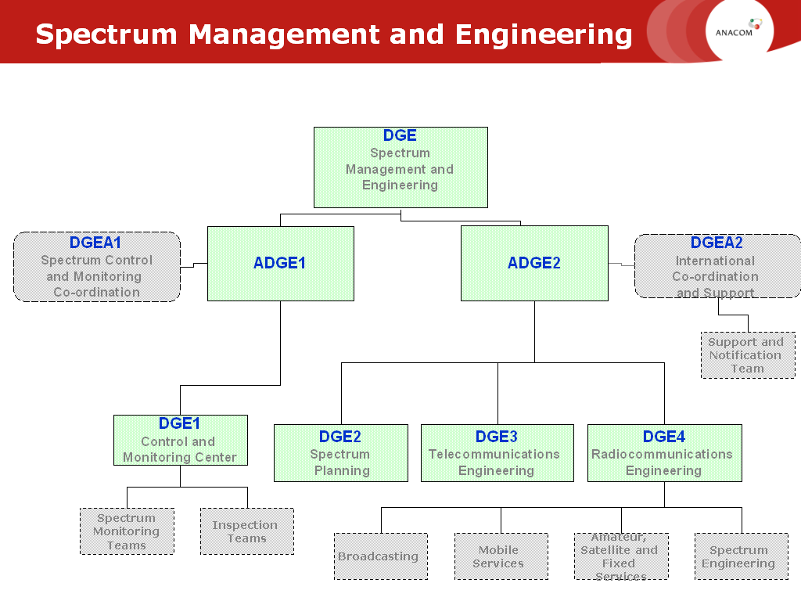

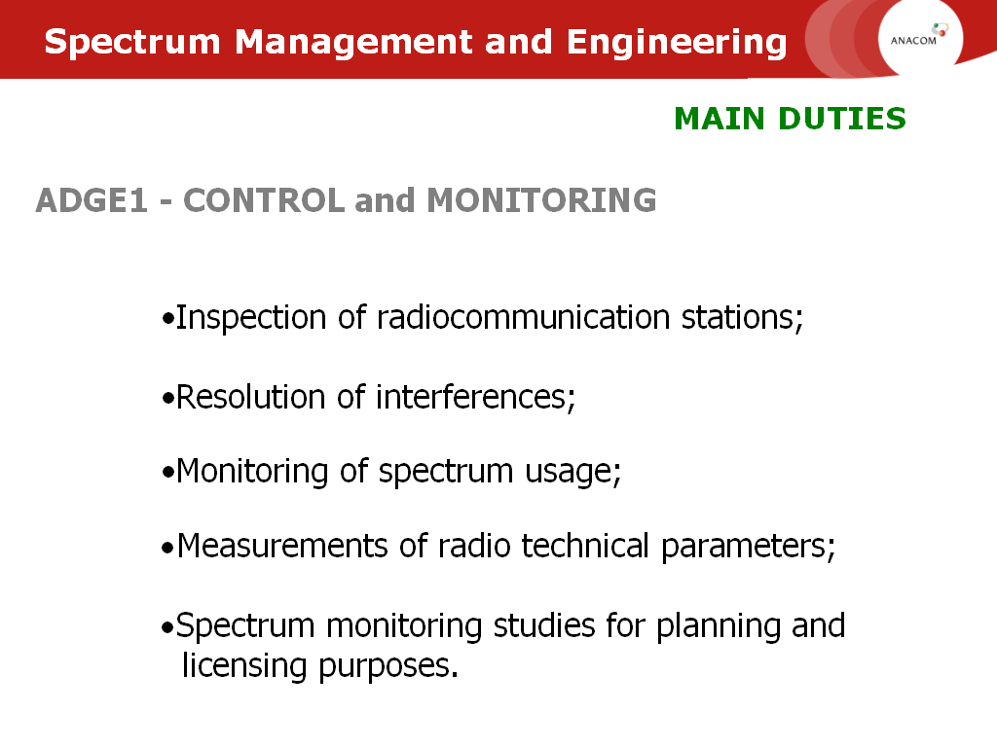
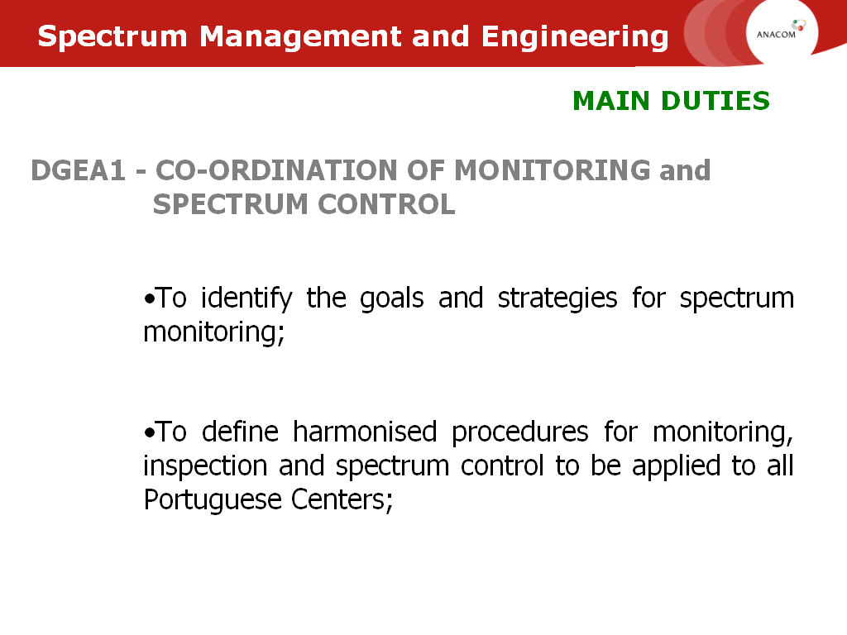

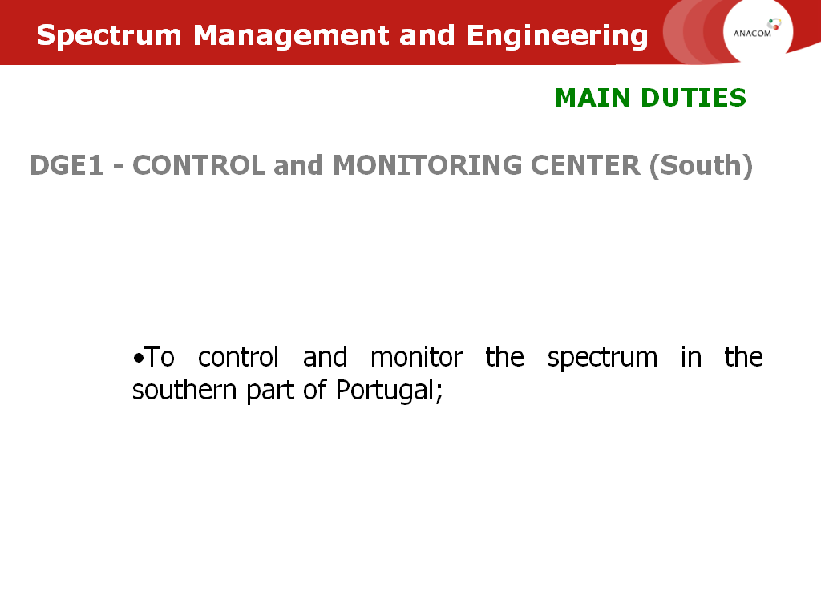
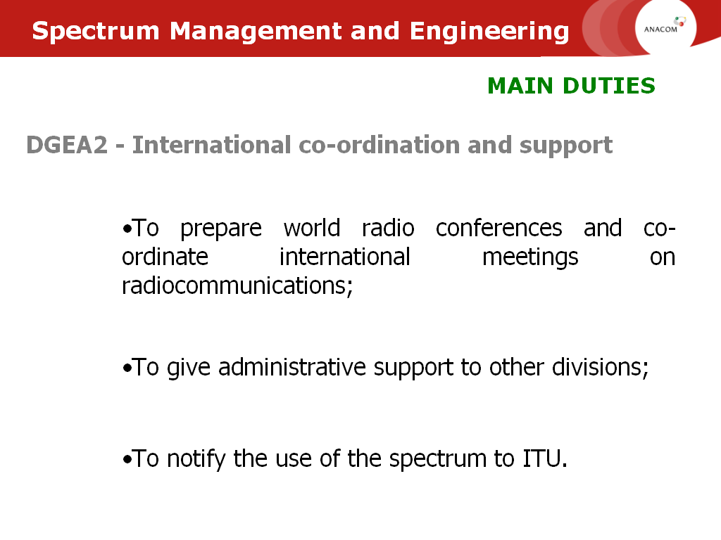

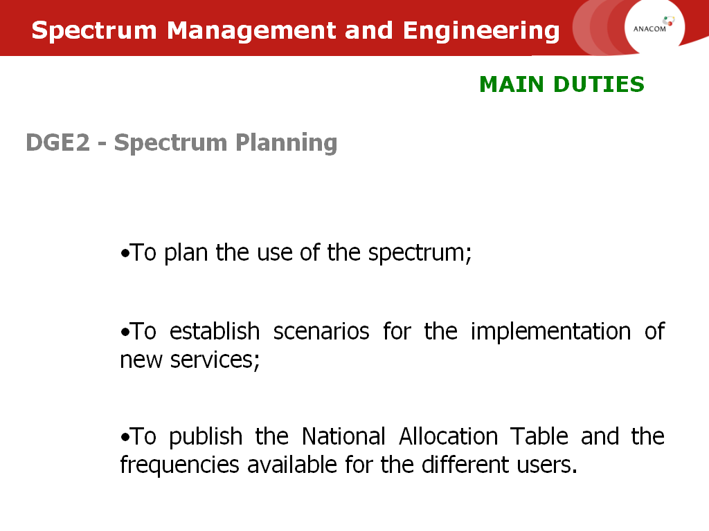
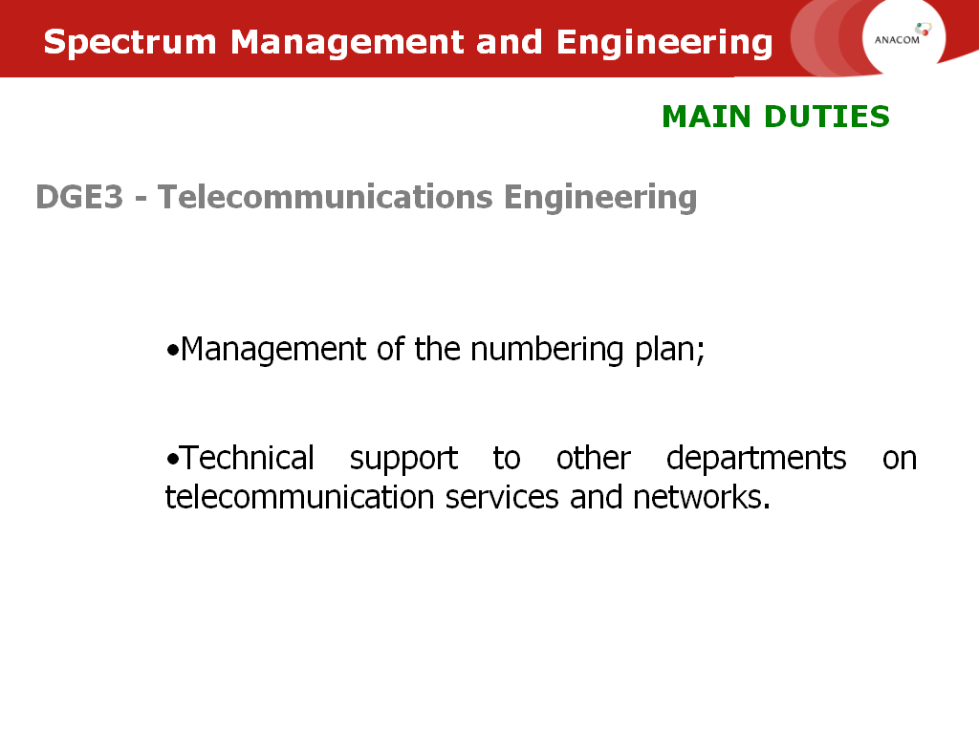

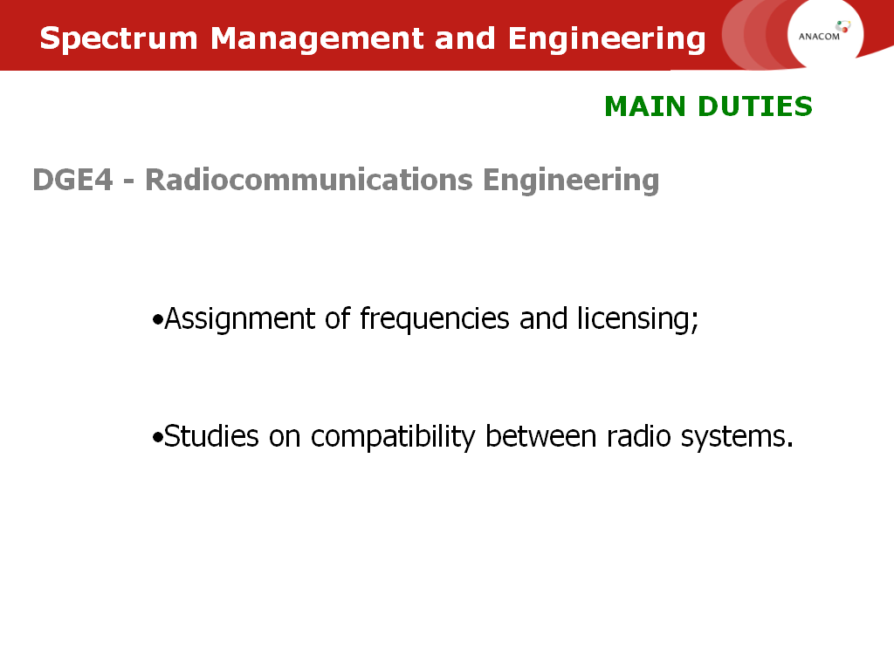
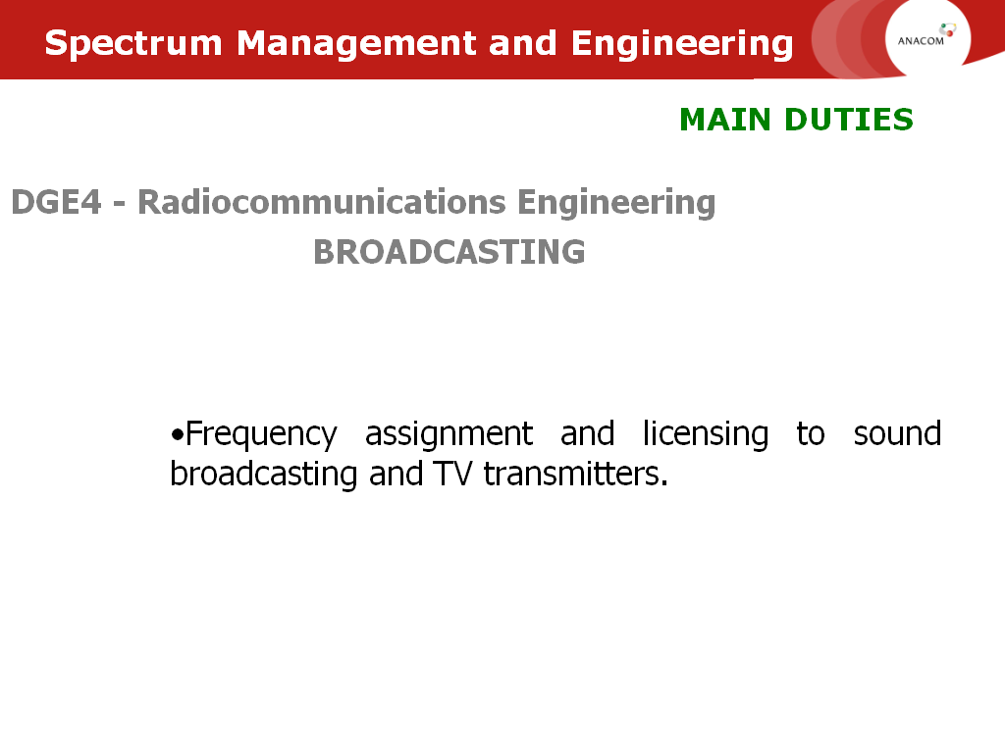

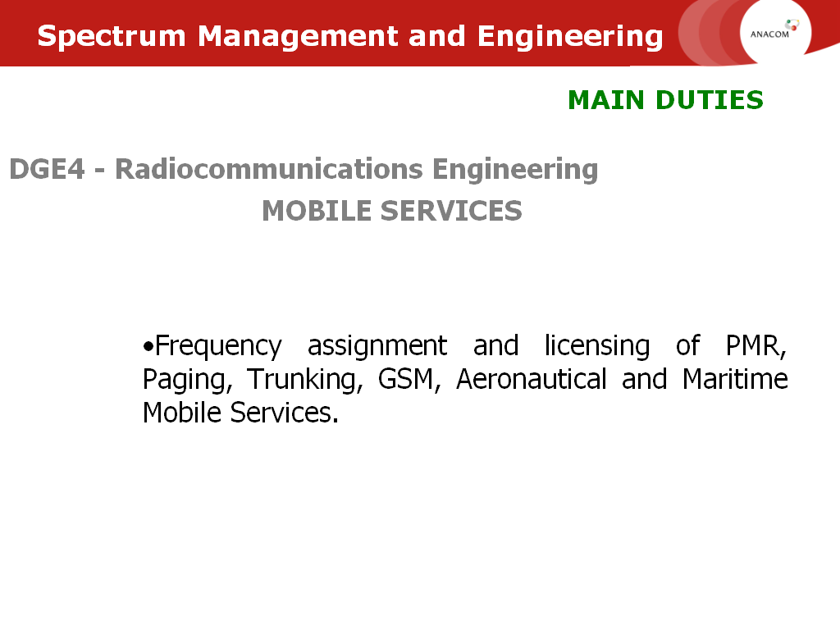
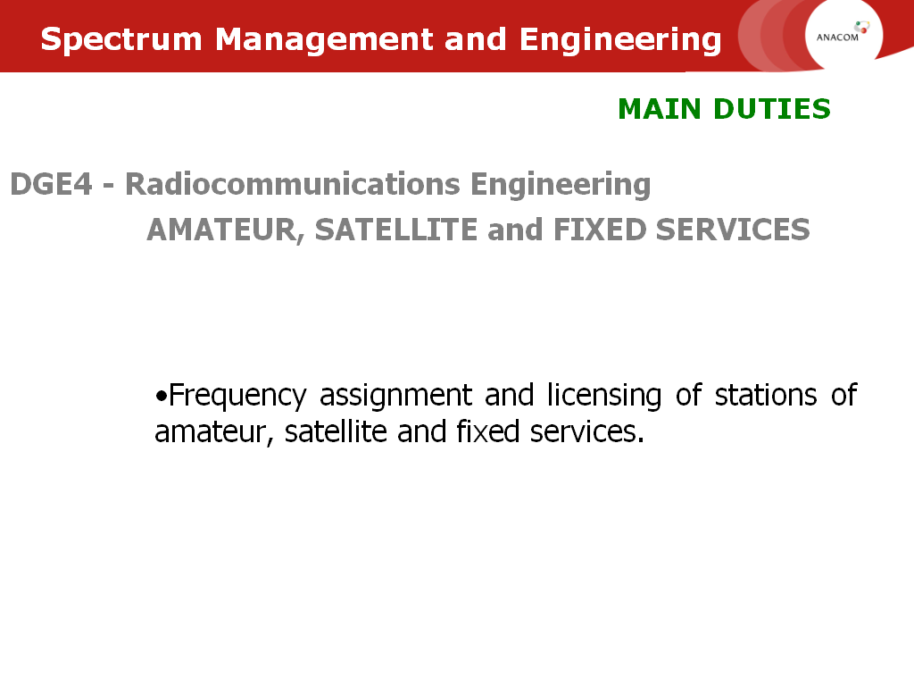

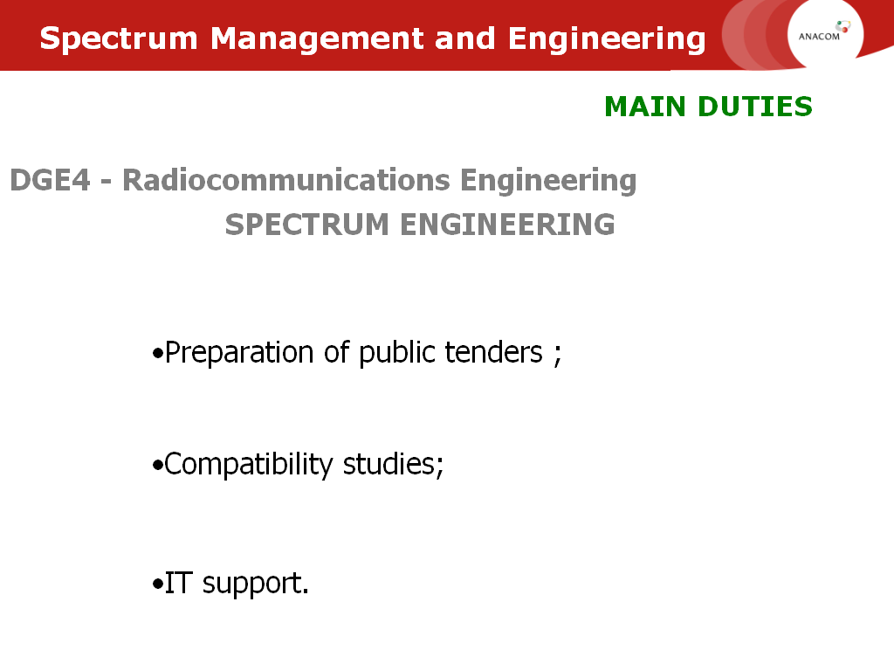
Radiocommunications Services
Stations and Networks

Spectrum Fees
The Government, through the Minister of Social Equipment, orders the following according to the provisions of no. 7 of article 19 of Decree-Law no. 151-A/2000, of 20 of July:
1.Fees applicable to radio communications contained in the appendix and forming part of this Administrative Rule are hereby approved.
2.The amounts stipulated in Administrative Rule no. 462/98, of 30 of July apply to the fees for the Amateur service and the amounts stipulated in the same Administrative Rule apply to the fees for the Personal Radio Service - Citizen's Band (CB) with the wording that was given by Administrative Rule no. 329/2000, of 9 of June.
3.A reduction of 70% applies to usage fees for those radio communications amateurs considered physically impaired, as stipulated in Administrative Rule no. 394/98, of 11 of July, which remains in force.
4.A reduction of 70% is to be applied to usage fees for organisations referred to in no. 5 of article 19 of Decree-Law no. 151-A/2000, of 20 of July
5.In the case of temporary licences covered by article 13 of Decree-Law no. 151-A/2000, of 20 of July, the amount of usage fees to be charged is calculated as follows:
Applicable biannual fee x (number of days licence is valid/180 days)
6.Administration fees and radioelectric spectral usage fees are payable in advance, and in the case of the latter, biannually, in January and July, with the exception of amounts of 250 Euros or less, which will be payable annually in January as from 1st of January 2002.
7. The period of time from the date of issue of the licence until the first payment should be accounted for proportionally.
8.Changes have been made to nº. 1 of Administrative Rule no. 465-A/99, of the 25th of June, which now reads as follows:
"1. The use of each block of frequencies reserved for Fixed Wireless Access (FWA) is subject to the payment of annual fees as in the following table:

Frequency bands | T_{i}
1880 - 1900 MHz | € 29 920
3600 - 3800 MHz | € 304 260
24.5 GHz – 26.5 GHz | € 304 260
27.5 – 29.5 GHz | € 611 020
Regarding frequency bands 3600 -3800 MHz and 24.5 - 26.5 GHz, the following formula applies if new additional base stations have been installed in regions A and or B during the previous year:

T_{i} = € 304 260 [1 - 0,45 (ΔEB_{A}/ ΔEB)_{i-1} - 0,30 (ΔEB_{B}/ ΔEB)_{i-1}]

Where:
T_{i}: annual spectrum fee applicable in the year i;
ΔEB_{A}: number of new base stations additionally installed by the operator/service provider in the zone A in the year i-1;
ΔEB_{B}: number of new base stations additionally installed by the operator/service provider in the zone B in the year i-1;
ΔEB: number (total) of new base stations additionally installed by the operator/service provider in the country during the year i-1;
Zone A: includes the districts in the following units of level 3 of the Nomenclature of Territorial Units for Statistical Purposes (NUTS), established by Decree-Law no. 46/89, of the 15 of February, in the wording given by Decree-Law no. 163/99, of the 13 of May:
Minho-Lima; Cávado; Ave; Tâmega; Entre Douro e Vouga; Douro; Alto Trás-os-Montes;
Pinhal Interior Norte; Pinhal Interior Sul; Dão-Lafões; Baixo Alentejo;
Região Autónoma dos Açores; Região Autónoma da Madeira.
Zone B: includes the districts in the following units of level 3 of the Nomenclature of Territorial Units for Statistical Purposes (NUTS), established by Decree-Law no. 46/89, of the 15 of February, in the wording given by Decree-Law no. 163/99, of the 13 of May:
Baixo Vouga; Baixo Mondego; Pinhal Litoral; Serra da Estrela; Beira Interior Norte;
Beira Interior Sul; Cova da Beira; Oeste; Médio Tejo; Lezíria do Tejo;
Alentejo Litoral; Alto Alentejo; Alentejo Central.
9.The following are hereby revoked:
- Administrative Rule no. 462/98, of 30 of July, with exception to the part applicable to the Amateur Service and the Personal Radio Service - Citizen's Band (CB);
- b) Administrative Rule no. 38/98, of 26 of January.
10. This Administrative Rule comes into force on the very day of its publication.

APPENDIX
Radiocommunications fees
Administrative fees
charge Code fee
12108 Licensing of station/network..……………………………………...…….............. € 10
12109 Alteration to or copy of radio license..................…........…..………….……......... € 5
12110 Transfer of a radio license..….....….....................................….…..…………....… € 5
12111 Registration fee (CB users)………………...................………….……..………… € 10

Spectrum fees
1 - Private radiocommunications
  - Land mobile service
Charge Code spectrum fee
21160 radio network ..............................................................................……..…......….. U * P
Where:
U is the number of spectrum tariff units;
P is the price of the spectrum tariff unit;
The number of spectrum tariff units (U) is given by the following expression:
U = A x L x C x N
Where:
- A - geographical coverage (area = km²⁾
A (km²) | coverage
29599 | National
11310 | Cellular – cells with 60 km cell radius
2827 | Cellular – cells with 30 km cell radius
707 | Cellular – cells with 15 km cell radius

- L - bandwidth (kHz)
L (kHz) | Bandwidth
12,5 | VHF (80 e 160 MHz) e UHF (440/470 MHz)
20,0 | VHF (40 MHz)
25,0 | VHF (80 e 160 MHz) e UHF (450/470 MHz)
- C - operating mode (simplex, semi-duplex ou duplex)
C | Channel
1 | simplex
2 | semi-duplex ou duplex

- N - number of channels (assigned frequencies).
The Price of the spectrum tariff unit (P) is given by the expression:

P = V_{B} x F

where:
- V_{B} is the base value of the spectrum tariff unit
(for the timebeing V_{B} = € 0,000669476
- F is the factor which measure the technical, economic and social impacts associated with the business developed by the private or public operator
F is given by the expression:

F = W₁ x W₂ x W₃ x W₄ x W₅
where:

- W₁ - coefficient for public or private radio networks

W1 | Type of service/network
1.0 | Public network
1.2 | Private network

- W₂ - coefficient for congestion of the frequency band, taking into account the site location of the network.

W₂ | Degree of congestion
0,95 | non-congested
1,00 | congested
1,20 | Heavily congested

- W₃ - coefficient for demand of channels in a specific frequency band
(different prices per frequency band, function of the correlation between offer/demand conditions) For the time being W₃ = 1.

- W₄ - coefficient for the economic potential associated with the business developed by the costumer
(For the time being W₄ = 13.0321)

- W₅ - coefficient which reflects the social development within different country regions

W₅ | Country regions
1.81 | Class A | Grande Lisboa, Grande Porto
1.54 | Class B | Baixo Vouga, Pinhal Litoral, Baixo Mondego, Entre Douro e Vouga, Península de Setúbal, Região do Algarve
1.00 | Class C | Ave, Alentejo Litoral, Oeste, Cávado, Lezíria do Tejo, Médio Tejo
0.79 | Class D | Região dos Açores, Beira Interior Sul, Região da Madeira, Alto Alentejo, Alentejo Central, Minho Lima, Douro, Pinhal Interior Norte
0.60 | Class E | Cova da Beira, Beira Interior Norte, Dão-Lafões, Pinhal Interior Sul, Baixo Alentejo, Tâmega, Alto Trás-os-Montes, Serra da Estrela

    - - Land mobile service - shared channels
1.1.1.1 - Channels - national coverage (Sfn = channel spectrum fee)

The spectrum fee applicable to each one of the networks that shares a national channel depends on the corresponding number of mobile stations according to the following scale:

Number of mobile stations (ML) per network | Spectrum fee
ML < 5 | 1/30 * Sfn
06 < ML ≤ 10 | 1/15 * Sfn
11 < ML ≤ 20 | 1/10 * Sfn
21 < ML ≤ 35 | 1/5 * Sfn
ML > 35 | 1/2 * Sfn

1.1.1.2 - Cellular channels (Sfc = cellular channel spectrum fee)
The spectrum fee applicable to each of the networks that share a cellular channel depends on the corresponding number of mobile stations according to the following scale:

Number of mobile stations (ML) per network | Spectrum fees
ML < 5 | 1/10 * Sfc
06 < ML ≤ 10 | 1/7 * Sfc
11 < ML ≤ 20 | 1/3 * Sfc
21 < ML ≤ 35 | 1/2 * Sfc
ML > 35 | Sfc

  - - Maritime mobile service
1.2.1 - VHF Frequency bands (metric waves)
Coast station:

Charge  code | fee  P   ≤  0,1 | Charge  code | Taxa  0,1 <   P ≤ 1 |  | Charge  code |  | fee  1 < P ≤  5 |  | Charge  code |  | fee  5 < P ≤ 10 |  | Charge  code |  | fee  10 < P ≤ 25
21 201 | € 4 | 21 202 | € 8 | 21 203 |  | € 11 |  | 21 204 |  | € 13 |  | 21 205 |  | € 16

1.2.2 - MF (hectometric waves) and HF (decametric waves) frequency bands
Coast station:
Charge  code | fee  P   ≤  10 | Charge  code | fee  10 <  P ≤ 25 | Charge  code | fee  25 <  P ≤ 50 | Charge  code | fee  P > 50
21 231 | € 41 | 21 232 | € 55 | 21 233 | € 68 | 21 234 | € 117

1.3 - Aeronautical mobile service
1.3.1 - VHF Frequency bands (metric waves)
Aeronautical station:
Cod.  Taxa | Taxa  P   ≤  0,1 | Cod.  Taxa | Taxa  0,1 <  P ≤ 1 | Cod.  Taxa | Taxa  1 <  P ≤ 5 | Cod.  Taxa | Taxa  5 <  P ≤ 10 |  | Cod.  Taxa | Taxa  10 <  P ≤ 25
21301 | € 4 | 21302 | € 8 | 21303 | € 11 | 21304 | € 13 | 21305 |  | € 16

1.4 – Fixed Service
1.4.1 - Monovia Fixed links (Monovia).
(for a minimum of Nk = 10)
Charge Code spectrum fee
21401 uni-directional fixed links .....……......................…………..………….. € 8 * Nk
21402 bi-directional fixed links (*) ............…..........…………......………… € 2 * (1 + 4Nk)
(*) The spectrum fees for fixed stations, associated with transportable base stations are calculated on the basis of the application of the following values for the coefficient Nk:
a) Nk=30 km for stations operating on VHF bands;
b) Nk=15 km for stations operating on UHF bands;

1.4.2 - Fixed links (Multivia)
(for a minimum of Nk = 10 and a maximum of Nk = 80 (*)
charge Code spectrum fee

21403 uni-directional fixed links.....……..…................................................ € 4 * Nk * Nm
21404 bi-directional fixed links .................................................................... € 8 * Nk * Nm
21405 fixed links (temporary use) .........................................................…... € 81 * Nm
21406 fixed links (temporary use – frequency bands above 15 GHz) .......... € 40 * Nm

(*) Applicable exclusively to fixed links over the sea.
NB. - For fixed links operating in frequency bands above 15 GHz, Nk = 5 is considered the minimum applicable.
1.5 – Radiodetermination Service

charge Code spectrum fee
21501 radiodetermination stations ..........…………......…………..….............................. € 98

1.6 – Miscellaneous Installations

charge code spectrum fee
21603 Station for utilitarian and recreational purposes, operating on bands including frequency to be used for ISM applications in accordance with Radio Regulations... € 7

charge code spectrum fee
21604 Stations for telecontrol, telemetry, telealarms, data transmission over non harmonised frequencies and output power between 200 mw < P < 5 w (for each transceiver, with a minimum value of mK = 10) ………………………………………… € 1,00 (2 + Nk)

1.7 Mobile Satellite Services
1.7.1 Mobile Earth Stations
Charge code spectrum fee
21701 Connections to space segment – satellite (Hub/Gateway station) .... € 4 536,00 * Nm

21702 Connections to space segment – satellite (Mobile earth station - terminal) ... € 5,00

1.8 Fixed Satellite Service
1.8.1 Earth stations

charge code spectrum fee
21803 Connections to space segment – satellite (permanent carriers)
- applications not involving video transmission, with a typical bandwidth
of up to 3 MHz ………………………………………………...… € 4 536,00 * Nm
21804 Connections to space segment – satellite (occasional carriers)
- applications not involving video transmission, with a typical bandwidth
of up to 3 MHz ………………………………….………….……. € 2 035 * Nm

21805 Connections to space segment – satellite
(shared TDMA carriers) .....……..……………………................ € 203 * Nm

21806 Connections to space segment – satellite (permanent carriers)
- applications with a typical bandwidth between 6 and 36 MHz and
others applications involving video transmission ......…............. € 2 268 * Nm

21807 Connections to space segment – satellite (occasional carriers)
- applications with a typical bandwidth between 6 and 36 MHz and
others applications involving video transmission .........…..…........ € 407 * Nm

1.8.2 - VSAT earth stations
Connections to space segment – satellite (HUB station or terminal):

charge. code | Bandwidth (Nm) | Spectrum fee
21815 | Nm < 200 kHz | € 50
21808 | 200 kHz  ≤ Nm < 2 MHz | € 127
21809 | 2 MHz  ≤ Nm < 18 MHz | € 1 271
21810 | Nm ≥ 18 MHz | € 7 631

1.8.3 - SNG earth stations - Coverage of events

Charge Code spectrum fee

21811 Connections to space segment – satellite
(permanent licensing – occasional use) ...................................……….... € 1 271

Connections to space segment – satellite (temporary licensing):
Charge  code | Period of use |  | Spectrum fee
21812 | up to 7 days | € 254
21813 | up to 14 days |  | € 432
21814 | More than 14 days |  | € 432  plus € 101 for each additional week (*)

(*) A supplementary charge of € 101 shall be made for each additional seven day period of use, notwithstanding the operating time of the corresponding earth station
2 - Public radio communications
2.1 Land Mobile Service
2.1.1 UHF frequency bands (decimetric waves)
Base station:
charge  code | fee  P   ≤   | charge  code | fee  1 <  P  ≤ 5 | charge  code | fee  5 <  P  ≤ 10 | charge  code | fee  10 <  P ≤ 25 | charge  code | fee  25 < P ≤ 50 | charge  code | fee  P  > 50
22101 | € 6 | 22102 | € 16 | 22103 | € 22 | 22104 | € 28 | 22105 | € 34 | 22106 | € 68

Charge code spectrum fee
22107 Mobile station ............................................................................................... € 3,50
Note: Spectrum fees 22101 to 22107 also apply to cellular systems for fixed applications on a local network level

2.2 - Mobile service with shared resources
2.2.1 - VHF frequency bands (decimetric waves)
Base station:
charge  code | Fee  P  ≤  1 | charge  code | Fee  1< P ≤ 5 | charge  code | Fee  5< P   ≤  10 | charge  code | Fee  10 <  P   ≤   25 | charge  code | Fee  25 <  P  ≤   50 | charge  code | Fee  P  > 50
22201 | € 6 | 22202 | € 16 | 22203 | € 22 | 22204 | € 28 | 22205 | € 34 | 22206 | € 68

Charge Code spectrum fee

22207 Mobile station .................................................................................................... € 3,50

2.3 Multi-user mobile service
2.3.1 VHF frequency bands (decimetric waves)
Base station:
charge  code | Taxa  P ≤ 0,1 | charge  code | Taxa  0,1< P ≤ 1 | charge  code | Taxa  1<P ≤ 5 | charge  code | Taxa  5 < P ≤10 | charge  code | Taxa  10< P ≤ 25 | charge  code | Taxa  25<P ≤50 | charge  code | Taxa  P  > 50 
22301 | € 6 | 22302 | € 16 | 22303 | € 25 | 22304 | € 31 | 22305 | € 37 | 22306 | € 43 | 22307 | € 86

Charge code spectrum fee
22308 Mobile station ....................................…................................................................ € 4

2.4 Maritime Mobile Service
2.4.1 VHF frequency bands (metric waves)

coast station:
charge  code | Fee  P   ≤   0,1 | charge  code | Fee  0,1 < P   ≤  1 | charge  code | Fee  1 <  P ≤ 5 | charge  code | Fee  5 < P ≤ 10 | charge  code | Fee  10  < P   ≤ 25
22401 | € 2 | 22402 | € 4 | 22403 | € 5 | 22404 | € 7 | 22405 | € 8

2.4.2 - MF frequency bands (hectometric waves) e HF frequency bands (decametric waves)
coast station:
charge  code | Fee  P  ≤ 10 | charge  code | Fee  10 < P  ≤ 25 | charge  code | Fee  25 < P  ≤ 50 | charge  code | Fee  P > 50
22431 | € 21 | 22432 | € 28 | 22433 | € 35 | 22434 | € 60

2.5 Paging Services
2.5.1 VHF frequency bans (metric waves)

charge code spectrum fee
22501 Base station .......................................................................................................... € 58
2.6 Fixed Service
2.6.1 Fixed links (Multivia)
(for a minimum of Nk = 10 and a maximum of Nk = 80 (*)
Charge Code spectrum fee
22601 uni-directional microwave links .........……………………….......... € 1 * Nk * Nm
22602 bi-directional microwave links ...........….……………..……........... € 3 * Nk * Nm
22603 Tansportable microwave links ...............….................……….………........ € 34 * Nm
22606 Transportable microwave links (bands more than 15 GHz).……… ………. € 17 * Nm
(*) Applicable exclusively to fixed links over the sea.
NB. For fixed links operating in frequency bands above 15 GHz Nk = 5 is considered the
minimum applicable.

2.6.2 Fixed links (Monovia)
(for a minimum of Nk = 10)

charge Code spectrum fee
22604 uni-directional microwave links .....................................……........……..... € 3 * Nk

22605 bi-directional microwave links ........................................................... € 1 * (1 + 4 Nk)

2.6.3 – Point-to-multipoint links
(MMDS - Multipoint Microwave Distribution System)

charge code spectrum fee
22607 uni-directional microwave links ...................................................................... € 8 * Nm
2.7 Fixed Satellite Service
2.7.1 Earth stations
SHF frequency bands (centimetric waves) e EHF frequency bands (millimetric waves)
Charge code spectrum fee

22701 Connections to space segment – satellite (permanent carriers)
- applications not involving video transmission, with a typical bandwidth
of up to 3 MHz ………………………………………………...… € 2 763 * Nm

22702 Connections to space segment – satellite (occasional carriers)
- applications not involving video transmission, with a typical bandwidth
of up to 3 MHz ………………………………………………….. € 1 239 * Nm

22703 Connections to space segment – satellite
(shared TDMA carriers) .....……………………..….....………....... € 123 * Nm

22704 Connections to space segment – satellite (permanent carriers)
- applications with a typical bandwidth between 6 and 36 MHz and
others applications involving video transmission ......…..……....... € 1 381 * Nm

22705 Connections to space segment – satellite (occasional carriers)
- applications with a typical bandwidth between 6 and 36 MHz and
others applications involving video transmission ..........…………....... € 247 * Nm

2.7.2 - VSAT earth stations
Connections to space segment – satellite (Hub/Gateway station or terminal):
Charge  code | Bandwidth (Nm) | Spectrum fee
22713 | Nm < 200 kHz | € 30
22706 | 200 kHz ≤ Nm < 2 MHz | € 77
22707 | 2 MHz  ≤ Nm < 18 MHz | € 775
22708 | Nm ≥ 18 MHz | € 4 649

2.7.3 SNG earth stations
Coverage of events
Charge code spectrum fee

22709 Connections to space segment – satellite
(permanent licensing – occasional use) ……………............ € 775

Connections to space segment – satellite (temporary licensing):
Charge  code | Period of use | Spectrum fee
22710 | Up to 7 days | € 154
22711 | Up to 14 days | € 263
22712 | More than 14 days | € 263  plus € 61,00 for each additional week (*)

(*) A supplementary charge of € 61 shall be made for each additional seven day period of use,
notwithstanding the operating time of the corresponding earth station

2.8 – Broadcasting Service (Sound)
2.8.1 - VHF frequency bands (metric waves)

for each transmitter operating in frequency modulation (FM):
charge code | Fee  P <   200 W | charge code | Fee  200 W  ≤ P < 1 kW | charge code | Fee  1 kW  ≤ P < 5 kW | charge code | Fee  P  ≥ 5 kW
22801 | € 47 | 22802 | € 114 | 22803 | € 143 | 22804 | € 171

2.8.2 - LH frequency bands (long wave), MF frequency bands (medium wave) and
HF frequency bands (short wave)
for each transmitter operating in amplitude modulation (AM):
charge code | Fee  P  < 1 kW | charge code | Fee  1 kW  ≤ P <  20 kW | charge code | Fee  P  ≥ 20 kW
22805 | € 143 | 22806 | € 171 | 22807 | € 257

2.9 - Broadcasting Service (Television)
2.9.1 - Broadcasting stations (BT)
2.9.1.1 - VHF frequency bands (metric waves) e UHF frequency bands (decimetric waves)

for each transmitter
Charge code | Taxa  P   ≤ 1 kW | Charge code | Taxa  1 kW < P  ≤ 10 kW | Charge code | Taxa  10 kW < P  ≤  100 kW | Charge code | Taxa  100 kW <  P ≤ 500 kW | Charge code | Taxa  P >  500 kW
22901 | € 39 | 22902 | € 49 | 22903 | € 61 | 22904 | € 67 | 22905 | € 73

2.9.2 Reporting Video Service
Portable microwave links for television coverage of occasional events
charge code spectrum fee
22907 for a period of 24 hours ..................................……………………………... € 401
22908 for a period of 48 hours..................................…………………………....…. € 883
22909 for a period of 72 hours...................…..…………………………………...... € 1 406
22910 for a period of 96 hours.........................…………………………………….... € 2 008

2.10 Satellite Mobile Services
2.10.1 Earth mobile stations
charge code spectrum fee
22714 Connections to space segment – satellite
(Hub station) ..............…..………………………………..………….... € 2 763 * Nm
22715 Connections to space segment – satellite
(mobile earth station - terminal) ....................….................………..…... € 3

2.11 Broadcasting Service - Terrestrial Digital Audio Broadcasting
2.11.2.1 VHF frequency bands (metric waves)

for each transmitter:
charge code | Fee  P  < 100 W | charge code | Fee  100 W ≤ P < 500 W | charge code | Fee  500 W ≤ P <1 kW | charge code | Fee  P ≥ 1 kW
22808 | € 142 | 22809 | € 284 | 22810 | € 687 | 22811 | € 859

Explanatory Notes
1 - The following abbreviations are used on the table of charges:
P - apparent radiated power in watts, with the exception of broadcasting service, for which fees are charged on units of kilowatt power;
Nk - number of kilometres of microwave links;
Nm - number of megahertz of the frequency band occupied.
- - In the cases of charges in numbers 21403, 21404, 21405, 21406, 22601, 22602, 22603 and 22606, please note the following definitions:
a) Fixed links for public use communications are those that are designed for the transport of telecommunications information for public use or open supply of transmission capacity to duly authorised organisations;
b) Fixed links for private use communications are those that are designed for the transport of information exclusively for own personal use.

The National Spectrum Management Handbook is currently being updated. You are urged to contact Mr Robert Mayher, Chairman ITU-R Study Group 1 and the designated Rapporteur for revision of this Handbook if you have any comments that you wish included in this revision.

