TO ADMINISTRATIONS OF MEMBER STATES OF ITU
AND MEMBERS OF THE DEVELOPMENT SECTOR
INTERNATIONAL TELECOMMUNICATION UNION
Telecommunication Development Bureau
Administrative Circular CA/31 |  |  | 15 February 2002
Ref: | CA/31 STG
Contact: | Fidélia Akpo
Tel: | +41 22 730 5439
Fax: | +41 22 730 5484
E-mail: | devsg2@itu.int
Subject: |  | Report of the fourth meeting of ITU-D Study Group 2  (Caracas (Venezuela), 10-14 September 2001)

Dear Madam/Sir,
In agreement with the Chairman of Study Group 2, I have pleasure in sending you the report of the fourth meeting of Study Group 2, which was held in Caracas from 10 to 14 September 2001 (Document 2/REP/036).
I should be grateful if you would let me have your comments, if possible before 11 March 2002 so that we may finalize the report.
Yours faithfully,
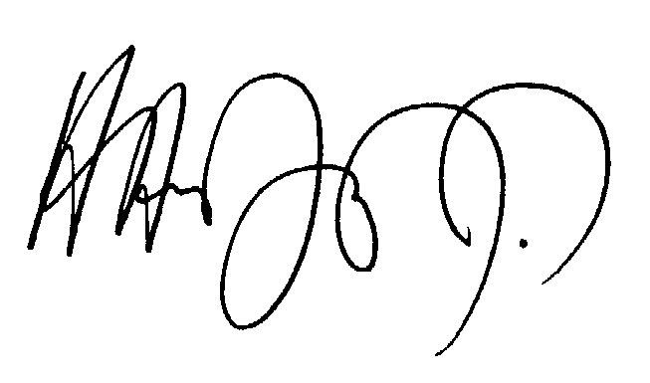
Hamadoun I. TOURÉ
Director, BDT

Annex: 1

Distribution:
– Administrations of Member States of ITU;
– ITU-D Sector Members;
– United Nations and its specialized agencies;
– ITU-D Study Group 2 Focal Points;
– ITU distribution list.

