INTERNATIONAL TELECOMMUNICATION UNION
Telecommunication
Development Bureau
Administrative Circular CA/30 Geneva, 7 February 2002

Ref: | CA/30 STG
Contact: | Fidélia Akpo
Tel: | +41 22 730 5439
Fax: | +41 22 730 5484
E-Mail: | devsg1@itu.int and devsg2@itu.int

Subject: | Approval in the interval between two World Telecommunication Development Conferences of new and revised recommendations of the ITU-D Study Groups 1 and 2

To Administrations of Member States of the ITU

Dear Sir/Madam,

1. Following the consultation conducted through Administrative Circular CA/25 of 12 October 2001, I am pleased to inform you that more than 70 per cent of the responses received approve the following new and revised recommendations:

- New Recommendation ITU-D 14 on Universal service policies
- New Recommendation ITU-D 15 on Models and methods to determine the cost of national telecommunication services
- New Recommendation ITU-D 16 on Tariff rebalancing and cost-oriented tariffs
- New Recommendation ITU-D 17 on Sharing of facilities in rural and remote areas
- Revised Recommendation ITU-D 6 on Appropriate low-cost technology options for the provision of telecommunications in rural and remote areas
- Revised Recommendation ITU-D 7 on Planning and implementation of national telecommunication development plans for rural and remote areas
- Revised Recommendation ITU-D 8 on Promotion of the application of telecommunication facilities for developing various sectors in rural and remote areas
- Revised Recommendation ITU-D 9 on Appropriate regulatory structures as a means of encouraging the extension of telecommunication services to remote and rural areas
- Revised Recommendation ITU-D 10 on Options available for financing rural and remote telecommunication programmes and projects
- Revised Recommendation ITU-D 11 on Impact of telecommunications in health-care and other social services

2. Therefore, in accordance with § 5.3 of section 4 of the Appendix to Resolution 4 (WTDC-98), the recommendations are considered approved. The list of the recommendations will be included in the next ITU Notification. They will be available on the ITU Website in English, French and Spanish. Those who do not have access to the Web, are invited to send their request for a hard copy to the Study Group Secretariat.
Yours faithfully,

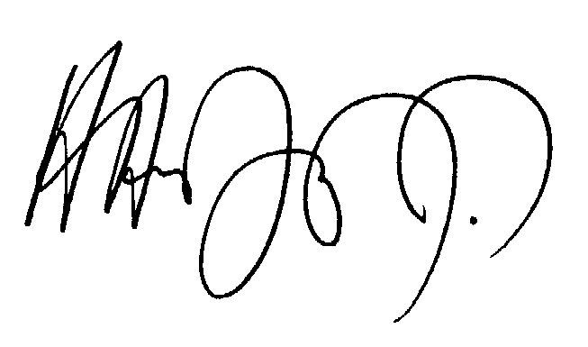
Hamadoun I. TOURÉ
Director

Distribution:
– Administrations of Member States of ITU
– United Nations and its specialized agencies
– ITU distribution list

