INTERNATIONAL TELECOMMUNICATION UNION
Telecommunication Development Bureau
Administrative Circular CA/26 |  |  | 24 October 2001
Ref: | PSF/STG
Contact: | Fidélia Akpo
Tel: | +41 22 730 5439
Fax: | +41 22 730 5484
E-mail: | devsg1@itu.int
Subject: |  | Draft Final Report on ITU-D Question 15/1:  Technology transfer and informatization

To Administrations of Member States of the ITU
and members of the Development Sector

Dear Sir/Madam,
When the results of the studies on Question 15/1 were considered at the fourth and last meeting of ITU-D Study Group 1 held in Caracas (Venezuela) from 3 to 7 September 2001, some discussions were held regarding the draft Final Report on "Technology transfer and informatization". The meeting decided that the Secretariat would send the Draft Report to all Member States and ITU-D Sector Members requesting for comments within one month in order to finalize the document for publication.
Accordingly, I have the pleasure to send you herewith a copy of the Draft Final Report on Question 15/1 and would welcome any comment or observation you might wish to make. The material will serve to the Rapporteur, Mr. Trimech, and to the Co-Rapporteur, Mr. Torres, to amend and finalize the Report.
In order to facilitate the work and to better reflect the opinions you may wish to express, I would be grateful if you would formulate your comments and observations in a way that could be easily inserted in the existing text. If you wish to use the electronic version which is on the ITU Web site (http://www.itu.int/ITU-D/study_groups/SGP_1998-2002/SG1/Documents/DocList.html) please indicate your proposed modifications with revision marks.
I would therefore be grateful to receive your written comments and suggestions by 16 November 2001. They will immediately be sent to the Rapporteur and Co-Rapporteur and they will be inserted, together with the comments formulated at the Rapporteur's Group meeting in Caracas, in the revised version of the Final Report.
Thank you very much for your co-operation and understanding.
Yours faithfully,

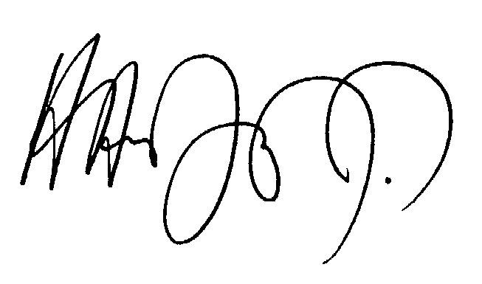
Hamadoun I. Touré
Director

Distribution:
– Administrations of Member States of the ITU
– ITU-D Sector Members
– Contact points for ITU-D Question 15/1

Annex: Document 1/173

