INTERNATIONAL TELECOMMUNICATION UNION
TELECOMMUNICATION  DEVELOPMENT BUREAU  ITU-D STUDY GROUPS | Document 2/189-E  23 August 2000  Original: English only  DELAYED
THIRD MEETING OF STUDY GROUP 1: GENEVA, 11 - 15 SEPTEMBER 2000
THIRD MEETING OF STUDY GROUP 2: GENEVA, 18 - 22 SEPTEMBER 2000

FOR INFORMATION

Question 14/2: Fostering the application of telecommunication in health care. Identifying and documenting success factors for implementing telemedicine

STUDY GROUP 2

SOURCE: JAPAN

TITLE: THE FUTURE OF TELEMEDICINE IMPLEMENTATION

________
Abstract:
In this document several problems related to the implementation of telemedicine services have been analysed and some proposals on how to overcome them have been presented. At the moment Internet could be a most suitable telecommunication platform for telemedicine. The document also mentions that training of telemedicine experts is equally important for developed and developing countries and that there is no progress without qualified people.

_____

1 Objective
The objective of this paper is to identify problems that could obstruct implementation of telemedicine in the future, and to suggest ways to resolve these problems.
2 Existing problems
2.1 Difficulties involved in promoting communications between medical facilities
Medical facilities participating in telemedicine test projects are not using communication channels reserved for such exchange at the anticipated rate. These communications channels are designed exclusively for teleconsultation and teleconferences. However, hospitals that have traditionally resolved problems without external help rarely find the need to communicate with other institutions. Past cases demonstrate that telecommunications service providers cannot expect hospitals to increase communications with other hospitals by supplying them with telephone circuits based on the goals and desires of the telecommunications service providers.
Many hospitals have a star-shaped network of public telephone circuits. Patients, medical suppliers, doctors, nurses, and support facilities radiate from the hospital in such networks. Meanwhile, communications networks that connect medical facilities do so on a point-to-point basis, connecting only several stations (hospitals). Calls occur far less often with this type of networks. Many past projects for increasing communications among medical facilities have failed to produce good results because they ignored call occurrence rates and the network topology.
2.2 Uncooperative clinicians
Uncooperative doctors represent the most significant obstacle to telemedicine. Doctors in urban areas and busy clinicians show a strong tendency to refuse to cooperate. One study found adherence to self-opinion increased in the following order -- servicemen, paramedics, nurses, then medical doctors. That is, doctors were the least cooperative. Past cases suggest that telemedicine projects led by military officers advance smoothly, but those directed by doctors always end up running into problems.
2.3 Absence of high-speed circuits
High-speed digital circuits (public circuits) such as those used for the integrated services digital network (ISDN) are indispensable for transmitting X-ray pictures and images used for diagnosis. However, they are still unavailable in developing countries. Even in industrialized nations, such circuits have yet to reach remote rural regions, and where they are found, they are very expensive. It is difficult for medical institutions to foot such bills. There are only two ways to secure high-speed circuits. Countries can solve the problem by adopting universal service, the system established by the U.S. Federal Communications Commission (FCC). Alternately, they can reserve special circuits for exclusive medical (or educational) use. Future implementation of telemedicine is difficult because both courses of action require huge investments.
3 Analysis and proposals
3.1 Scenario for realizing successful communications among medical institutions
3.1.1 Medical communication and its characteristics
Satellite-based communications services have only been able to connect major stations on different continents on a point-to-point basis. Even companies like Motorola and NEC have never networked very small aperture terminals (VSATs) in a way that allows dynamic topologies over time. Communications among medical facilities have the following characteristics, which must be kept in mind when we select circuit designs.
1. Small-scale radio stations
2. Low numbers of calls
3. Call concentrations within specific periods (for example, the hours before noon)
4. Dispersion of a large number of stations over a wide area
5. Relatively small data volumes
6. Demand spike following emergencies
3.1.2 Barriers to the promotion of communications among medical institutions
Medical doctors dislike the concept of teleconsultation for a number of reasons. They popularly attribute their aversion to the following three factors:
1. Insufficient image quality for diagnosis
2. Lack of time for teleconsultation
3. Personal policies against teleconsultation
These three factors have acted as barriers to telemedicine, especially communication among medical facilities. Medical institutions in urban areas provide medical treatment of higher levels. They also maintain high walls. Meanwhile, medical institutions in remote rural regions tend to be more open to exchange. These tendencies exist because: (1) people who work in medical services want to unite experts for economic reasons; and (2) doctors working in the countryside and remote areas take a stronger interest in advanced medicine, because information is hard to come by.
I believe telemedicine projects have a better chance of succeeding in locales such as remote rural areas, isolated islands, and developing nations, rather than in urban areas. Generally speaking, urban hospitals demand circuits that offer greater speed and diagnostic images of higher quality. Demand for circuit speed and picture quality fall in rural locations. It is not easy to offer mutual consultation services to medical facilities in Tokyo, because they demand that service providers transmit Super High Definition (SHD) images via gigabit circuits. In one successful test case, Kyoto Prefectural University of Medicine exchanged SHD pictures with the affiliated Yosanoumi Hospital using asynchronous transfer mode (ATM) circuits (at speeds of 156 Mbps) (Figure 1). In the North Pacific, the Pacific Basin Medical Association & Western Pacific Health Net is using teleconsultation on patient transfers that rely on analog circuits and modems transferring pictures taken by digital camera and uploaded by PCs. This network provides information and helps to answer questions at the Hawaii Tripler Medical Center’s website operated by the U.S. Army.
3.2 Requirements for successful teleconsultation
3.2.1 Second-opinion centers
Clinicians in urban areas and medical specialists who provide consultation have virtually no time to spare. This is the second factor obstructing successful implementation of teleconsultation. Hospitals can reduce clinician responsibilities by establishing a new department in charge of teleconsultation. Picture-based medical diagnosis employing X-rays, computerized tomography (CT) and magnetic resonance imaging (MRI) is already provided commercially in Japan using ISDN circuits and the store-and-forward data-transfer system. This is an extremely cost-effective and efficient system in cases where patients can wait about 24 hours for diagnosis. Let me give an example. Secom, a Tokyo security service company, operates a second-opinion center profitably by hiring only five radiologists and asking them to examine 60,000 pictures a year for diagnosis. Forty-seven local (prefectural) governments in Japan are now operating their second-opinion centers only for emergency services. These centers provide diagnoses based on electrocardiograms transmitted via analog circuits. People engaged in emergency medical service determine whether to send patients to hospitals in ambulances, and how to transport patients from one emergency hospital to another, based on their diagnoses. In my opinion, the success or failure of teleconsultation depends on the “presence of a second-opinion center and its isolation from general clinical service” and “efficient provision of high-level diagnosis.”

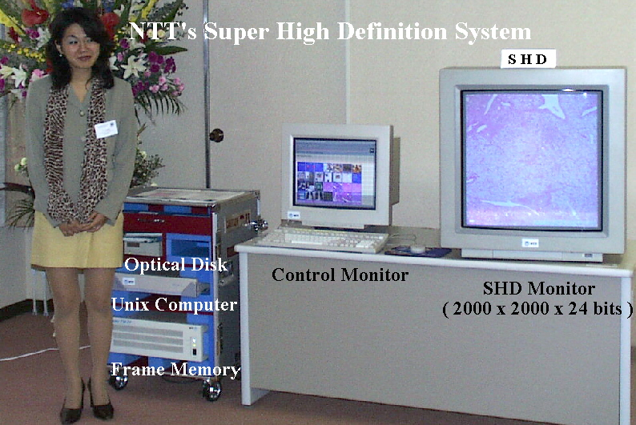
Figure 1: NTT’s SHD system
3.2.2 Proposal barring hiring uncooperative doctors
Many clinicians are unwilling to cooperate in telemedicine projects. Resolving this problem is extremely difficult under present conditions. Medical doctors have diverse personal opinions and policies, with many not even recognizing the need for teleconsultation. Many are computerphobic and have no experience with computers. These people have never used videophones or gone onto the Internet. They belong to the past. People have long allowed them to justify their backwardness by saying that they became doctors to treat patients, not to use computers. In my view, more than half of the physicians practicing around the world today can be considered to be computer-illiterate. This must change. Computer illiteracy is a serious problem. The only solution is to teach computer use slowly. Medical treatment depends entirely on data such as clinical histories, inspection records, and X-ray images. Medical doctors must realize that computerization of their routines is inevitable to help reduce medical expenses and raising the efficiency of social systems.
I believe facilities whose teleconsultation reply rates are low should be excluded from the reduced communications expenses universal service enables when implemented. I think the measure will act as an extremely effective penalty. For example, this penalty will increase annual public circuit expenses by 3 million U.S. dollars (about 300 million yen) for the 1,000-bed Tokai University Hospital. I came up with the figure by assuming that universal service reduces costs by 90 percent. I think medical institutions that hire uncooperative doctors should be penalized; they should pay higher communications expenses. Hospitals can reduces costs by choosing not to hire such physicians. I would like to add that people who cannot share their information with others should not become clinicians. Our information-oriented society cannot allow such doctors to practice.
3.3 Separate satellites and separate circuits
3.3.1 Examination of economic factors
Telemedicine requires significant communications expenses. High cost is another factor obstructing the successful implementation of telemedicine. There are only two ways to reduce communications expenses: The first is to adopt universal service. The second is to provide separate circuits for telemedicine. The only nation that has already established universal service is the U.S. The only way for other countries to realize telemedicine at low cost is to reserve circuits exclusively for the service. Let me illustrate this point with examples. In the South Pacific, people who call domestic numbers can reduce telephone charges 88 percent by using separate satellite (PanAmSAT) circuits. Likewise, international callers in the North Pacific can lower their costs 33 percent by using satellite circuits. In my view, the sum of hardware and other initial expenses and running costs (communication expenses) is appropriate for economic evaluation. Separate circuits become cheaper as communication rates increase. Separate satellite circuits are clearly more economical for telemedicine providers who require broadcast capacity and who wish to handle diagnostic pictures.
3.3.2 Concrete designs for teaching nursing essentials and public hygiene
Providing pictures using CD-ROMs, videotapes, and the Internet has limits. It is difficult for us to control our own education. Compulsory attendance drives most schools. Classroom-type instruction is an extremely effective education method, because it allows many people to discuss a common topic and to listen to diverse opinions. Real-time instruction allows participants to share not just knowledge, but their personal impressions, allowing a balanced information exchange between people involved in public hygiene in remote rural areas and on isolated islands and people in urban areas, and maintaining uniformity in epidemiological research. Figure 2 shows how to design classroom-type programs for instruction involving public hygiene and nursing essentials, and how to broadcast such instruction real time by satellite-hookup. It is essential for broadcasters to give viewers a chance to ask questions and hear answers. They must ensure that viewers adequately comprehend programs, and perceive information as flowing in both directions.
3.3.3 Concrete designs for facilitating communications among medical facilities
A combination of cellular phones, microwave equipment, and specially-reserved satellite circuits is effective for communications among medical facilities located in remote rural areas and on isolated islands. I illustrated this proposal in Figure 3. Microwaves can only cover communications within line-of-sight distance -- about 20 kilometers to 40 kilometers. Therefore, the system relays microwaves in a serial manner. Communications failure does not occur because digital data is used.
Satellite circuits are effective for communications with medical institutions located more than 200 kilometers away. This system is based on a star-shaped network. I propose it for communications among medical facilities in developing nations. The system enables hospitals in rural towns and villages without an adequate number of telephone lines to provide medical service around the clock by supplying physicians, nurses, and other medical workers with cellular phones.
4. Examination
4.1 Effective use of media other than the Internet
The number of Internet users continues to increase at a remarkable rate all over the world. Teleconsultation is already available on the Internet. For example, physicians in North Pacific islands centering on the U.S. Associated Pacific Islands (USAPI) offer consultation services to patients at a jointly-maintained website. However, as Figure 4 shows, the volume of data that travels the worldwide web is three times greater than data reaching destinations on a point-to-point basis. Teleconsultation costs more per bit when the service is provided on the Net. Accessing the Internet for teleconsultation is not a practical option for medical workers in remote rural areas, because it generally takes a lot of time to transmit data using a public circuit. For example, it took one such doctor 42 minutes to transmit a diagnostic chest X-ray using a 19.2-kbps modem. Table 1 lists some of the factors that prevent the Internet from becoming a popular telemedicine medium. The Internet is not the only medium for telemedicine. I believe integration of the Internet with real-time transmission is indispensable for promoting communication among medical institutions.

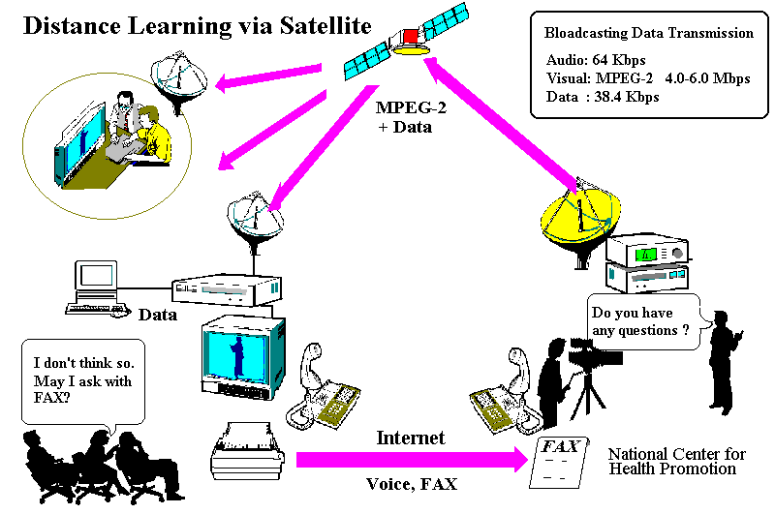
Figure 2: A satellite-based distance learning system for public health and for assisting people with data handicaps

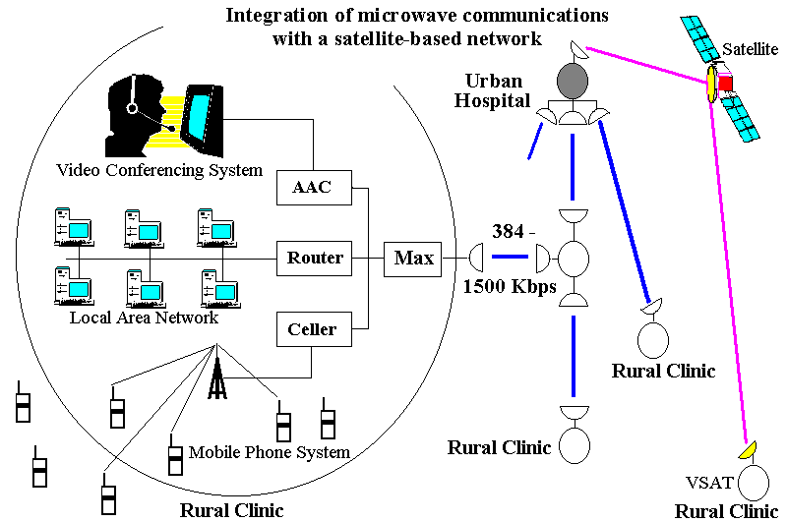
Figure 3: Integration of microwave communications with a satellite-based network

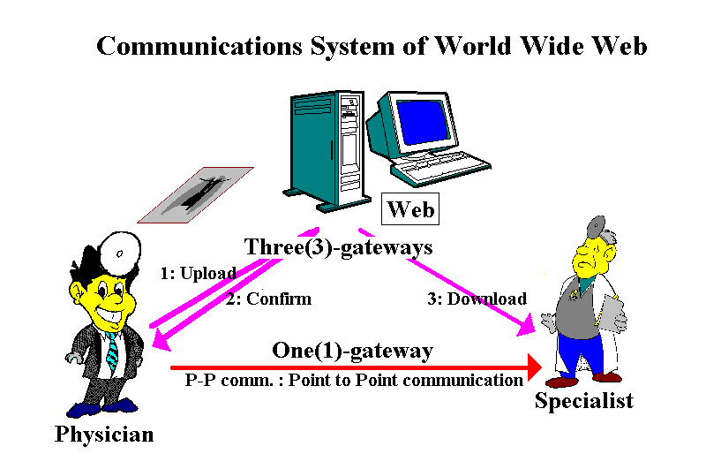
Figure 4: Problems presented by the Internet Worldwide Web (Gateway)

Commentary on World Wide Web for Telemedicine
- Currently, over 50% of doctors and medical staff are effectively computer illiterate.
- There is no established framework of laws and regulations governing telemedicine practices across national borders and boundaries.
3) Funding bodies and organizations have yet to evaluate the net value of telemedicine.
4) Clinical diagnoses and operational evaluations pertaining to the image quality of X-rays which are captured with digital camera and compressed with JPEG or to delays in diagnosis and/or triage of emergency patients caused by store and forward data transmission have yet to be conducted.
5) The current telecommunication infrastructure in developing countries hinders the introduction of telemedicine, by forcing reliance on available telephone lines and low data speed.
6) Telecommunication fees for remote/rural areas and isolated islands are high. The current system (i.e., "Universal Service Obligation") should be looked into or renegotiated by ITU-D, since telecommunication fees are outside the jurisdiction and scope of responsibility of Medical fee.

Table 1: Commentary on World Wide Web for Telemedicine

4.2 Provision of assistance to people with data handicaps
I asked the ITU-D and the WHO to assist with high-resolution broadcasts designed to teach nursing and public hygiene essentials to residents of remote rural regions and isolated islands, who do not know how to use computers. Medical doctors lead and influence national medical policies. However, telemedicine does not belong to doctors alone. Until now, telemedicine projects have assisted experiments performed by wealthy physicians. From now, I believe the ITU-D and the WHO must assist people with data handicaps and individuals who support them through telemedicine projects. People with data handicaps include health nurses working in isolated islands, young people unaware of the terrible consequences of AIDS, islanders unable to keep up with rapid dietary changes, those with mental or physical handicaps experiencing discrimination, and those who support activities for the handicapped in small communities. The ITU-D and the WHO should help them in ways in which computers and the Internet cannot.
I believe these two international organizations should offer programs that explain preventive medicine, support activities for nursing at home, explain the risks of fast food, and support activities for the handicapped and women in a plain manner to computer illiterates as quickly as possible. In so doing, the two organizations must remember to shoulder responsibilities such as content production, and bear burdens such as connection fees.
* Public hygiene programs
-- AIDS education programs designed for young people
-- Programs warning against diabetes
* Nutritional programs
-- Programs warning against diabetes
-- Programs for preventing high-blood pressure and heart disease
* Programs designed for resolving various problems within communities
Cases of discrimination against people performing certain jobs, violation of the basic rights of women, and discrimination against the handicapped tend to emerge more often in remote rural regions and on isolated islands. To prevent these cases, the small communities must procure programs designed to resolve misunderstandings. I believe they also need programs that explain psychological care for victimized individuals.
4.3 Provision of assistance to programs designed for training telemedicine specialists
Telemedicine test projects have been undertaken by many nations. However, there remain only a few specialists or individuals who can act as core project members. I think the lack of capable personnel explains the premature termination of most projects. Education and personnel recruitment are two of the most important preconditions for telemedicine. They hold the key to “successful” implementation of telemedicine. I believe telemedicine requires promotional experts, software application specialists, instructors in charge of doctors and nurses, and telemedicine courses for training such instructors at ITU collaboration centers or universities. We cannot implement telemedicine without a sufficient number of capable workers.
4.4 Ultimate decisions by patients
Public administrators wish to increase communication among medical institutions in order to make medical service more efficient. On this particular point, patients do not necessarily agree. They find it preferable to see doctors face to face. They remain unaware of the nature of direct patient care (DPC) using communications circuits and teleconsultation. They don’t know whether these are good or not. It must ultimately be the patients who determine whether to use telemedicine. We must leave them room to make their decision. Doctors and public administrators should not force telemedicine upon patients, DPC in particular. DPC must be provided at the request of the patient. I would like to add before closing that communications service providers remember this: Patients are not computers. They are human beings with emotions.
Acknowledgments
This paper owes a significant debt to instruction provided by Dr. Kiyoshi Kurokawa, the Dean of Tokai University School of Medical, Dr. Tsukasa Ashihara, Professor of Kyoto Prefectural University of Medicine, Dr. Yoshihiro Takashima of the International Medical Center of Japan, Mr. Teisuke Inagaki of NTT, Mr. Yasuhiro Hoshino of NEC, and Mr. Hiroshi Juzoji of Telemedicine Society of Japan. I would like to acknowledge their assistance.
References
1. Gary Shannon: The Atlantic Rim Telemedicine Summit, Telemedicine J., 1997, 269-296pp.
2. Scott Norton et al.: Telemedicine in Micronesia, Telemedicine J., 1996, 225-231pp.
3. Isao Nakajima et al.,: Evaluation of new assistance in medical treatment and health care in the countries around Pacific ocean using communications satellite. SINFHOS 1990.
4. Stuart Kingan et al.,: The Applications Technology Satellite networks : twenty years of distance education in the Pacific basin. IFIP 1990, 989-996pp.
5. Isao Nakajima et al.: Emergency medical care information system via telecommunications satellite "SAKURA-2". MEDINFO IFIP-IMIA 1986, 343-347pp.
6. Isao Nakajima, Yuhwsuke Sawada, et al..; Telemedicine in Asia-Pacific on PARTNERS project, AIAA 1998,#1283.
7. Wright D. Telemedicine delivery to developing countries. Journal of Telemedicine and Telecare 1997;3(1):76-78.
8. Adeyinka MB. Fundamentals of Modern Telemedicine in Africa. Meth Inform Med 1997;36:95-98.
9. Rovetta A, Falcone F, Sala R, Elena M. Telehealth in Africa. Studies in health information technology 1997;39:277-285.
10. Wootton R. The possible use of telemedicine in developing countries. Journal of Telemedicine and Telecare 1997;3(1):23-26.
11. Mitka M. Developing Countries Find Telemedicine Forges Links to More Care and Research. JAMA 1998;280:1295-1296.
12. Falsone JJ, Moidu K, Sheehan CA, et al. Is Telemedicine Justifiable? Connecticut Medicine 1998;62(7):423-427.
13. Puskin DS, Sanders JH. Telemedicine Infrastructure Development. Journal of Medical System 1995;19(2):125-130.
14. Wright D. and Androuchko L. Telemedicine and developing countries. Journal of Telemedicine and Telecare 1996;2(2):63-70.
15. Peters LJ,Peters DP. Telehealth.PartII.A total system approach. ASHA 1998 Spring;40(2):31-33.
- Yellowlees P. How not to develop telemedicine systems. Telemed Today 1997 May-jun;5(3):6-7,17.
- Lobley D. The economics of telemedicine. Journal of Telemedicine and Telecare 1997;3(3):117-125.
18. Norton SA, Floro C, Bice SD, et al. Telemedicine in Micronesia. In:Morens D, Patel M, O’Leary M, eds. Public Health Surveillance in the Pacific. Noumea Cedex, New Caledonia: Secretariat of the Pacific Community,1998:81-90.

__________

