INTERNATIONAL TELECOMMUNICATION UNION
TELECOMMUNICATION  DEVELOPMENT BUREAU  ITU-D STUDY GROUPS | Document 2/176-E  1 August 2000  Original: English only
THIRD MEETING OF STUDY GROUP 1: GENEVA, 11 - 15 SEPTEMBER 2000
THIRD MEETING OF STUDY GROUP 2: GENEVA, 18 - 22 SEPTEMBER 2000

FOR ACTION

Question 16/2: Preparation of Handbooks for developing countries

STUDY GROUP 2

SOURCE: RAPPORTEUR FOR QUESTION 16/2

TITLE: HANDBOOK ON NEW TECHNOLOGIES AND NEW SERVICES: GENERAL INTRODUCTION AND FASCICLE 1

________
Action required: Participants are invited to send their comments to BDT Secretariat by May 2001 at the latest. After inclusion of the comments received, Fascicle 1 will be published in 2001.
Action demandée: La version française sera transmise dès que disponible aux participants concernés (probablement en avril 2001). Les participants sont invités à transmettre leurs commentaires au Secrétariat du BDT au plus tard un mois après réception. Après inclusion des amendements reçus le Fascicule 2 sera publié en 2001.
Acción solicitada: La versión en español será transmitida cuando sea disponible a los participantes interesados (probablemente en el mes de abril del año 2001). Se invita a los participantes a transmitir los comentarios a la Secretaria de la BDT a más tardar un mes después de su recepción. Después de la inclusión de las enmiendas recibidas, el fascículo 1 será publicado en 2001.

ITU-D

Study Group 2
Question 16/2

HANDBOOK
“NEW TECHNOLOGIES AND NEW SERVICES”

Geneva, July 2000

Note for the attention of the reader

This Handbook has been prepared by many volunteers from different Administrations and companies. They provided examples of their products, systems, models and case studies.
The mention of specific companies or products does not imply any endorsement or recommendation by the ITU.

PREFACE

1 HISTORICAL BACKGROUND
In World development towards a Global Information Society (GIS) and Global Information Economy (GIE), the telecommunications sector is expected to play a major role as a leading industry in the 21st century. To meet the requirements of the 21st century and to close the communication gap between the industrialised and developing countries the sharing of knowledge in telecommunications technology and services is a very important step. This was recognised by the first World Development Telecommunication Conference held in Buenos Aires, 21-29 March 1994 and also confirmed by the second World Telecommunication Development Conference held in Valetta, 28 – 1 April 1998, which established two Study Groups:
- Study Group 1: dealing with telecommunications development strategy and policies.
- Study Group 2: dealing with development and management of telecommunication services and networks.
The particular Question 2/2 in the first Study period and Q 16/2 in the present study period of Study Group 2 has the objective to prepare new Handbooks or revise the existing ones to spread knowledge and know-how in these fields. The Handbook “NEW TECHNOLOGIES AND NEW SERVICES” is one way to realise this objective.

2 PURPOSE OF THE HANDBOOK
The rapid development of telecommunications from technological to market aspects brings with it everyday new products, equipment, systems, networks and services. It is somewhat ambitious to attempt that this Handbook will comprise all aspects of telecommunications matters and fulfil the needs off all players in the telecommunications arena.
The aim of the Handbook is to provide a survey of technology and services taking place in the changing telecommunications environment, by presenting the general characteristics and capabilities that various networks and services offer on the market, not dealing with technical details that are the subjects of standardisation. The reviewed technologies and services are in general compliant with the ITU Recommendations.
The Handbook also touches on gender issues in the preparation and introduction of new services.

3 WHY THE HANDBOOK IS NECESSARY?
The telecommunication sector has gone through radical changes in the last decade, driven by an increasingly global and liberalised market in which the control of network capabilities has become a strategic competitive factor to satisfy increased customer requirements. The fast evolution of network intelligence is mainly driven by the convergence between telecommunications and information technology developing various multimedia services. Due to that, telecommunication networks are becoming and will become increasingly complex and challenging to implement and operate. Moreover, it will be more and more important to possess the competence necessary to integrate high capacity and intelligent solutions into the existing networks to meet end-user and cost efficiency requirements.
Three most important requirements that have to be met by the improvement of the existing or new-planed networks are:

more capacity,
- more power, and
- greater efficiency.
To summarise these driving forces, and also to provide a basis for the subject of the Handbook, we can say that:
- With insufficient capacity network operators can not satisfy the users demands, even for the universal service and especially for new and high quality services. However, to optimise an investment appropriate planning of new technologies, creating more possibilities in the telecom networks, should be used.
- Possibilities of new technologies to build up more intelligent capabilities in telecom equipment will give more power to network operators and service providers in generating new value added services and increasing Intelligent Network traffic. Estimation of customer’s needs is a powerful tool to win competition, but only if it is done in time.
- Development of new network management concepts, comprising operation, administration, maintenance and planning, leads to better operational efficiency and maintenance organisation decreasing operational cost. An objective picture of network elements, networks, services and business will improve day-to-day operations and network performance thus fulfilling customers’ expectation for higher quality of service as the target.
These reasons have been the leading ideas in developing the material of this Handbook.

4. WHO SHOULD READ THE HANDBOOK?
The Handbook is convenient to everybody having the interest in telecommunications but it is specially recommended to managers, and planning and technical experts of incumbent telecom operators and national regulators of telecom companies. Managers should use this information to overview or develop concepts for long term strategies. Technical managers and experts should extract the deployment of networks that will support the new and global services expected by the 21st century users. Regulators, especially newly established ones, should be supported to create an environment in which innovations by various players can be encouraged without applying constraints other than those needed to create productive competition. Other players will, also, benefit from the prepared material for improvement of their market access.
References listed in fascicles of the Handbook should enable readers to get more information about the subject.

5. HOMOGENEITY
Many people have contributed to this Handbook which has been edited by Mrs N Gospic assisted by Messrs B Moore and J Magill. The chapters and subchapters vary in scope and level of detail which is to be expected in such a Handbook and reflects the different nature of the contributions.
It represents a snapshot of the development of networks and services as at the time of issue. it is therefore not a complete picture but provides guidelines and many references for further study.

It is anticipated that the Handbook will be updated as the technologies evolve.

6. ACKNOWLEDGEMENTS
the following contributors are thanked for their support in preparing this Handbook:
Mr. S. Berman (Bell Lab, Lucent)
Mr. Bhatnagar, ABU
Mr. G. Cayla (Lucent Technologies)
Mr. L. Chae Sub, Chairperson, ITU-T, WP 1/13
Mr. J. Costa, Nortel Networks
Mr. Distler, France
Mr. Embro, Erisson
Mr. J.C. Faure (BDT)
Mr. M. Ghazal, Lebanon, Rapporteur of Question 2/2 and later 16/2
Dr. N. Gospic,, as BDT Consultant
Mr. C. Hyde, ICO Global Communications
Dr. M. Jankovic
Mr. H. Jieping, China
Mr. R. Katic
Mr. N. Kisrawi, Chairperson of ITU-D Study Group 2
Mr. J. Magill, Probe Communications, as BDT Consultant
Mr. P. Mège, Thomson
Mr. B. Moore, Charter Telecomms Consultants Ltd., as BDT Consultant
Mr. A. Nehme, Ericsson
Dr. B. Odadic
Mr. F. Rahe, Alcatel
Dr. I. Reljin
Mr. Savchuk (Ukrainian Institute)
Mr. Y. Shmaliy, Ukraine
Mr. R. Simic (Ukrainian Institute)
Mr. P. Touré, BDT
Mr. W. Widl, Sweden
Ms. B. Wilson, BDT
Mr. M. Zaragoza, BDT
Ms. F. Akpo, BDT

EXECUTIVE SUMMARY

1. INTRODUCTION
Having regard to future technical and operational trends in telecommunication services, the developing countries need to know about the latest advances made by the international community in this regard, in order to pass on the benefits to their own nationals.
The developing countries must keep abreast of developments and achievements in the application of new technologies in telecommunication networks, in order to pass on the benefits of this progress to their users.
The Handbook on new technologies and new services has been prepared taking into account these two statements of the Valetta Conference held in 1998.

2. HANDBOOK STRUCTURE
The complexity of telecommunications matters, and the different groups of readers, require the handbook structure to follow a certain pedagogical way. It is intended that the reader will be able to easily find information on a certain part of a subject. The structure is also adapted to the fast changes in telecommunications and to the situation that some subjects are still under study.
The handbook consists of four parts, which are prepared as separate Fascicles:
FASCICLE 1:
“ NEW TECHNOLOGIES SUPPORTING NEW NETWORKS
FASCICLE 2:
“DIGITAL NETWORKS AND SERVICES”
FASCICLE 3:
“IP BASED NETWORKS AND SERVICES”
FASCICLE 4:
“RADIO AND TV NETWORKS AND SERVICES”
Each chapter is self contained (and in some cases subchapters are self contained) in order to simplify updating of the text.
The mention of specific companies in this Handbook does not imply any endorsement or recommendation by the ITU.
In each fascicle there is a Chapter 1 dealing with a general review and links to other fascicles. Relevant ITU-T standards and publications are referenced in each of chapters. Also, some of the important standards from other standardisation organisations are listed. In some chapters useful examples are annexed in order to amplify the subject matter.
A brief content of the fascicles as part of the handbook is given below. The detailed table of contents is shown in the beginning of each fascicle.

FASCICLE 1: “NEW TECHNOLOGIES SUPPORTING NEW
NETWORKS”

The content of this fascicle is divided into the following Chapters:
- Introduction
- New transport media technologies
- Optical fibre cables
- Digital Radio-Relay Technologies
- Mobile Communication Systems
- Satellite Systems
- Digital switching systems
- New signalling systems and SS No 7
- Synchronisation techniques and methods
- Digital transmission
- ATM Technology
Chapter 1, Introduction and general review, discusses the need to implement new technologies in order to introduce new services and be competitive on the market with capacities and quality.
Chapter 2, New transport media technologies, deals with main considerations when deploying optical, digital, and radio, and satellite technologies.
Chapter 3, Digital switching systems, deals with technologies for circuit and packet switching and SPC switching system organisation.
Chapter 4, New signalling systems and SS No 7, includes necessary specifications for new digital networks.
Chapter 5, Synchronisation techniques and methods, explains implementation of synchronisation in new digital networks.
Chapter 6, Digital transmission systems, deals with PDH, SDH, WDM and xDSL techniques with reference to most important standards and implementation examples.
Chapter 7, ATM Technology, includes ATM transport, switching and cell format, operation and maintenance and signalling and traffic management of ATM networks.

FASCICLE 2 “ DIGITAL NETWORKS AND SERVICES”

Fascicle 2 is composed of eight chapters, annexes and test cases:

Introduction
- Digital network and services
  - PSTN
  - ISDN
  - IN
  - Packet switched network
  - Frame Relay
  - ATM based networks
  - Interworking between networks
  - Type of New services
  - Future trends
  - ITU-T standards
Annex 2a China case study
- Mobile digital cellular networks and Services
- Access network
- Network and service management
- Planning aspects
A

nnex 6A Alcatel’ approach for network planning for developing countries
Annex 6B Strategy for Local Information Infrastructure
- Human resources aspects
Annex 7A Innovative knowledge transfer - example
- Financial and economic aspects
Annex 8A Guidelines for bilateral negotiations of transitional arrangements towards cost-orientation, 1999 to 2001*
Chapters 2, 3, and 4 deal with different network technologies and structure and related services, emphasising their main characteristics and requirements for new architectures and interworking. Chapter 2 is divided in 10 subchapters dealing with particular fixed networks e.g. PSTN, ISDN, IN, Packet switched network, Frame relay, ATM based networks, Services and ITU-T standards for relating subjects. Development of China Telecommunications is included as Annex 2A.
Chapter 5 deals with Service and Network Management based on the introduction of the TMN concept.
Chapter 6 offers the guidelines for network planning with annexes as examples.
Chapter 7 is concerned with development of human resources being capable to implement new technologies and new services and
Chapter 8 deals with financial and economic aspects in developing the new networks and services.

FASCICLE 3 “DIGITAL IP BASED NETWORKS AND SERVICES”
The Fascicle 3 is composed as follows:
- Table of Contents
- Introduction and Definitions
- Internet protocol (IP)
- E-Commerce
- TeleInternet services for Tel-E-Commerce
Chapter 2 is based on dramatic grow of Internet subscribers, new services and IP based networks. It deals with basic definitions for E-Mail, WWW, Arpanet and Hyperlinks.
Chapter 3 deals with Internet protocol-IP characteristics, IP packet structure, IP address, Voice over IP and Ipv4 and Ipv6.
Chapter 4 explains E-Commerce as a new data service realising the vision of the Global Information Economy.

Chapter 5 deals with new IP architecture and applications of TeleINternet Services with reference to ITU publications.
Fascicle 3 is an initial introduction to the subject and further revision and expansion will be required.

FASCICLE 4 “RADIO AND TELEVISION NETWORKS AND SERVICES”

This Fascicle contains five chapters:
1. Introduction
2. Digital Audio Broadcasting
3. Digital Television Broadcast Services
4. Strategies for Digital Television Broadcasting
5. Data Broadcasting
Chapter 1 deals with general introduction about radio and television networks and services.
Chapter 2 summarizes benefit of audio digital broadcasting introducing different services and digital audio systems. It is manly dealing with Terrestrial digital audio broadcasting system (T-DSB).
Chapter 3 lists advantages of digital TV transmission, both Standard Definition Television and High Definition Television. The Chapter discusses the structure of digital television system, digital satellite broadcasting, digital terrestrial broadcasting, planning aspects, different standards and networks and services.
Chapter 4 deals with strategies for digital television broadcasting emphasizing the needs in transition from analog to digital systems. The chapter identifies planning criteria for different systems, networks and services.
Chapter 5 “Data broadcasting” exploits new development area for broadcasters in competitive environment. Data broadcasting services are defined with requirements for data systems. The chapter deals in more details with data broadcasting over terrestrial systems using broadband wireless, multichannel multipoint distribution system, ISDN, cable TV distribution and some examples for multimedia broadcasting.

HOW TO MAKE USE OF THE HANDBOOK
To make a use of the Handbook, it is necessary to understand the changes in the managing of the telecommunication business. Three categories are very important for successful management of telecommunication:
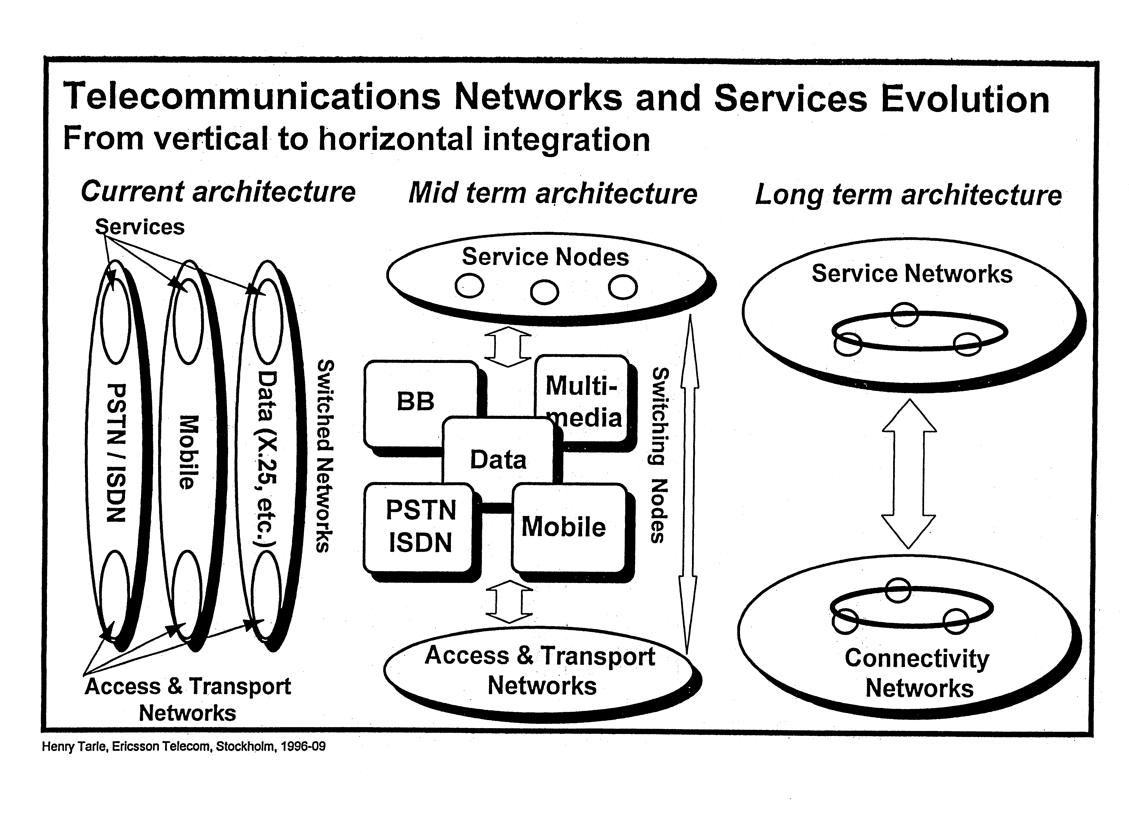 Figure Telecommunications networks and services evolution
(From Vertical to Horizontal Integration)

HOW TO READ THE HANDBOOK?
The following charts are aimed at facilitating the reading of the Handbook for different groups of readers:

For telecom operator and regulator managers

For broadcast managers and operator staff
YES
NO
Read
F.1
F.4 Ch 1
Do you know
new technologies
YES
NO
Read
F.4 Ch 2
Do you know
digital audio
broadcasting
YES
NO
Read
F.4 Ch 3
Do you know
digital TV
broadcast services
YES
NO
Do you know
about data broadcasting
Are you involved in formulation of Digital TV strategies
Read
F.4 Ch 5
YES
Read
F.4 Ch 4

For planers and technical managers

For broadcast managers and operator staff
Do you know new technologies

Read
F.1
F.4. Ch 1
NO
YES
Do you know digital audio broadcasting
Read
F.4. Ch2.
NO
YES
Do you know digital TV

Read
F.4. Ch 5
NO

_________

