 | INTERNATIONAL TELECOMMUNICATION UNION
 | TELECOMMUNICATION  DEVELOPMENT BUREAU  ITU-D STUDY GROUPS | Document 1/195-E  12 July 2001  Original: English
FOURTH MEETING OF STUDY GROUP 1: CARACAS (VENEZUELA), 3 - 7 SEPTEMBER 2001
FOURTH MEETING OF STUDY GROUP 2: CARACAS (VENEZUELA), 10 - 14 SEPTEMBER 2001
FOR INFORMATION

Question 8/1: Establishment of an independent regulatory body

STUDY GROUP 1

SOURCE: UNITED STATES OF AMERICA

TITLE: CONNECTING THE GLOBE: A REGULATOR'S GUIDE TO BUILDING A GLOBAL INFORMATION COMMUNITY

________
Abstract:
“Connecting the Globe: a Regulator's Guide to Building a Global Information Community" is a manual designed to highlight some of the main issues confronting regulators.
It describes in general terms how many of the issues confronting regulators are handled in the U.S., and it focuses primarily on the role of the regulator.
Appendices include information on FCC regulatory and application fees, sample applications for satellite space and earth station authorizations, VSAT license applications as well as a glossary and index of telecom terms.
This document is being submitted as background information to the Question 8/1 and it only contains the table of contents of the Guide.
Copies of the entire manual can be found at (web site: fill in please) in English, French, and Spanish. Additionally, a limited number of hard copies are available at this meeting."

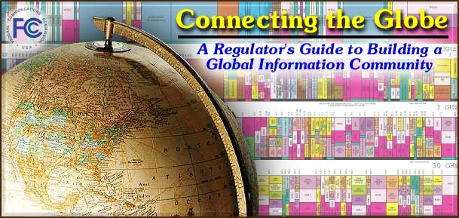
News Release | Chairman Kennard's Remarks | Word97 - zipped | Adobe Acrobat
CONTENTS
TITLE PAGE
FOREWORD
I. REGULATORY CHALLENGES AND OPPORTUNITIES
Establishing and Maintaining Regulatory Independence
Regulation and National Goals
Essential Functions of the Regulator
Overcoming Resistance
II. THE U.S. MODEL
The Federal Communications Commission
The U.S. Department of Commerce
The U.S. Department of State
The Office Of the U.S. Trade Representative
State Regulatory Agencies
III. COMPONENTS OF THE REGULATORY PROCESS AND ORGANIZATION OF THE FCC
Characteristics
FCC Proceedings
Licensing
Enforcement
The Organization of the FCC
Budget
Useful Internet Links
IV. THE FCC AND THE PUBLIC TRUST
Standards of Ethical Conduct
Conflicts of Interest
Post -Employment Limitations
Financial Disclosure
V. COMPETITION IN TELECOMMUNICATIONS SERVICES
Benefits of Competition
Policy Goals to Achieve Competitive Markets
Effects of Competition in the Telecommunications Sector
Building a Telecommunications Sector as a Part of Economic Development
Methods of Introducing Competition in the Telecommunications Sector
Interconnection, The Key to Competitive Success
Regulatory Tools for Protecting Against the Exercise of Market Power During The Transition to Competition
VI. UNIVERSAL SERVICE
Universal Service and Universal Access Defined
Principles of Universal Service and Universal Access
Universal Service Funding
Distributing Universal Service Support
Conclusion
Further Information
VII. SPECTRUM ALLOCATION, ASSIGNMENT AND ENFORCEMENT
Spectrum Management
Spectrum Allocation
Public Interest Considerations
Market-Based Approach to Licensing
Financing for Spectrum Management
Spectrum Monitoring and Enforcement
Useful Internet Links
VIII. REGULATING SATELLITE NETWORKS: PRINCIPLES AND PROCESS
What is a Satellite Network?
Licensing of Space Stations
Satellite System Coordination
The ITU Coordination Process
The INTELSAT Coordination Process
ITU Conferences and Study Group Meetings
Satellite Cost Recovery and Due Diligence
Satellite Earth Stations
IX. THE INTERNET
Overview
Ensuring a Truly Global E-Commerce Marketplace
A Hands-Off Approach
Principles to Promote Internet Infrastructure
Policies to Foster Internet Services
Conclusion
Further Information
GLOSSARY
APPENDICES (Adobe Acrobat Format)
Organizational Structure
Fees at the FCC
FCC Form 312
INDEX (Adobe Acrobat Format)

_____________

