 | INTERNATIONAL TELECOMMUNICATION UNION
 | TELECOMMUNICATION  DEVELOPMENT BUREAU  ITU-D STUDY GROUPS | Document 1/194-E  Document 2/249-E  30 June 2001  Original: French
FOURTH MEETING OF STUDY GROUP 1: CARACAS (VENEZUELA), 3 - 7 SEPTEMBER 2001
FOURTH MEETING OF STUDY GROUP 2: CARACAS (VENEZUELA), 10 - 14 SEPTEMBER 2001
Reference: Document AFR/034-E
FOR ACTION

Question 8/1: Establishment of an independent regulatory body

Question 9/1: Impact of the introduction and utilization of new technologies on the regulatory environment of telecommunications

Question 10/1: Regulatory impact of the phenomenon of convergence within the telecommunications, broadcasting, information technology and content sectors

Question 11/2: Examine digital broadcasting technologies and systems, including cost/benefit analyses, assessment of demands on human resources, interoperability of digital systems with existing analogue networks, and methods of migration from analogue to digital technique

STUDY GROUPS 1 AND 2

SOURCE: THALES COMMUNICATIONS (FRANCE)

TITLE: NATIONAL RADIO/VIDEO MONITORING SYSTEM

________
Action required:
Participants' attention is drawn to the provisions that may be adopted under national law for the management and monitoring of radio and television emissions.
Abstract:
This contribution sets out principles for a radio/video monitoring system, from which guidelines could be drawn.
CONTENTS
1 Introduction
2 Structure of a national radio/video monitoring network
2.1 General
2.2 Network architecture
3 Technical description of the network
3.1 Receiving station
3.2 Operating centre
3.3 National radio/video operating centre
4 Examples of human-computer interfaces

1 Introduction
Telecommunication monitoring is an important role of the State which is usually assigned to a national telecommunication agency (NTA) (regulator), although in some cases the audiovisual sector is overseen and regulated by a separate regulatory body owing to its special features.
As the body responsible for telecommunication monitoring, and in addition to the other activities assigned to it, then by law, the regulator(s) is/are responsible for radio spectrum monitoring within the national territory as regards the technical and legal aspects of radiocommunication services, including radio and television broadcasting. As far as the legal aspects are concerned, the use of communication channels by operators must obviously be closely monitored by the regulator(s) in accordance with the regulations established by law and clearly stipulated in the texts of licences and concessions.
For the radio and television broadcasting services, and with a view to fulfilling the legal requirements pertaining to those services, the national regulator responsible for the audiovisual sector might decide to establish a system of radio/video monitoring stations (automatic or otherwise) for receiving, coding/decoding, recording and analysis of audio and video broadcasts of all types within the national territory.
Although this document discusses only wireless radio and television broadcasting, the same principles are directly applicable to cable and satellite television and Web broadcasting. (Video = TV + audio; Radio = sound broadcasting.)

2 Structure of a national radio/video monitoring network

2.1 General
Taking into account the principles set forth in § 1 above, the approach described in this document is based on the principle of using the most recent sound and image processing technologies, i.e.:
• MPEG coding;
• TCP/IP protocol;
• HTML/Web technology.
The major advances made in the use of the TCP/IP protocol (the pan-network standard adopted for information (signals), TV and radio broadcasting) in the establishment of modern telecommunication networks are reflected accordingly. By applying this protocol, this type of network can evolve in the face of emerging new technologies without rendering existing technologies obsolete.
Taking into account the above criteria, the proposed system has the following characteristics:
• client/server distributed architecture;
• Web (Internet and intranet) and transaction servers;
• TCP/IP network, using Multicast (point-to-multipoint), Unicast (point-to-point), streaming, push-pull and COM/DCOM interfaces.

2.2 Network architecture
The video and/or radio signals received by radio signal receiving stations (RS) (automatic or otherwise) are transmitted to one or several operating centres (OC) (administrative divisions) which can be managed by a national coordination and operating centre (NC) for the whole territory. The architecture of the radio/video monitoring network is therefore comparable to that of a radio spectrum management and technical monitoring network for radiocommunication services as
recommended by ITU. It should also be noted that where a country already has a radio spectrum monitoring network, that network can be used as the basis on which to develop the radio/video monitoring network, with optimum cost effectiveness being ensured by using an interface between the two systems.
Figure 1 below shows the typical architecture of a national radio/video monitoring network using a national WAN (IP) network.
NC, national
radio/video
monitoring
centre

National WAN-IP
network
RS
RS
RS
RS
RS
RS
RS
SP
OC
OC

figure 1
Typical architecture of a national radio/video monitoring network

3 Technical description of the network
In view of the increasing number of available channels (audio and video) and associated data (metadata) and in order to enable real-time selection for analysis and storage purposes, a new generation of tools offering an extended range of performances is required, including:
• the means for systematically analysing a large volume of information;
• redistribution on the network of selected and enriched data.
This requires specialized programmes such as:
• primary automated data capture and storage software with pre-indexing and authentication system;
• a staggered analysis phase enabling a documentary database to be compiled;
• administration, redistribution and broadcasting of contents over an IP network.
This type of network enables:
• simultaneous real-time digitization of multiple video and audio sources in MPEG;
• the automatic insertion of metadata to permit time-stamping and authentication;
• data accessibility by means of a single method, regardless of the type of data involved, (text, image, sound, etc.);
• simultaneous consultation and selection in real-time and staggered time from multiple local or remote operator workstations;
• the addition of multimedia data to archived data (concept of associated annotations);
• the creation of programmes in playlist form;
• data distribution on IP or push networks, in pull;
• exportation via different media, e.g. VHS, DVD-ROM, etc., or re-broadcasting over IP (push);
• remote administration of user profiles and a set of services.
The system is based on the principle of shared intelligence, meaning that an operator, wherever located, can assign resources (information) throughout the network through the receiving stations (RS) and operating centres (OC) constituting the national network. The levels of operator use are determined by the national radio/video monitoring centre (NC). Each site behaves like a website (WWW), and together the sites form an extranet (private Internet).

3.1 Receiving station (RS)
The radio and video signal receiving stations set up within the national territory are modular and adaptable according to the number of radio and video programmes to be received for processing. Below is a diagram of the architecture of an automatic receiving station, defined as such on account of the absence of operator workstations. Such a station can be transformed into an operating centre (OC) (see § 3.2).

GPS and time
RS 232
Application server
Ethernet Com.
SWITCH
RS
NC
Disk
RF server
CEthernet.
Antenna system
TV/Radio
Tuner server
Encoding
server

Input/output
auxiliaires
Transcoding server
MPEG >> H 323
Video server
Server
d’enregistrement
Encoding
server

figure 2
Receiving station (RS)
The primary functions of a receiving station are as follows:

3.1.1 Omnidirectional and multiband antenna system providing:
• reception of television signals in horizontal polarization from VHF and UHF sources;
• reception of AM and FM radio signals in vertical polarization with the possibility of wideband sweeping between 150 kHz and 1.5 GHz.
Amplifiers and antenna distribution systems are supplied according to the number of channels received.

3.1.2 RF server providing reception and decoding of signals from the antenna system
The RF server comprises:
• TV tuner server(s) for reception of up to eight TV signals and demodulation of the signals for transmission to the TV codec (encoding) server(s) using bi-tuner cards;
• radio tuner server(s), the signals being sent to the radio codec (encoding) server(s) in the same way as for the TV servers.
NOTE - The TV and radio tuners have user-definable parameters.
• Video codec (encoding) server.
This server can receive up to six MPEG-1 encoding cards: TV/audio codec.
Each TV/audio codec is capable of digitizing and compressing the video signal with sound in MPEG-1 at 24 images per second at a bit rate of 1.2 Mbit/s, and can transmit that information in multicast to the video server. Moreover, each codec is capable of simultaneously transmitting a degraded signal for local or remote surveillance.
The MPEG flow degradation can be set to 2, 8 or 15 images per second while maintaining synchronous sound.
The audio and video codecs embed the time-stamping data and authentication marks in the MPEG frame.
• Radio codec server (encoding)
Each codec server can receive up to six MPEG radio encoding cards. Each card can encode two stereo or four mono channels.
Radio codecs digitize sound in MPEG-1 Layer II at a stereo bit rate of 128 kbit/s, the quality of which is sufficient for recognition and reference purposes.
Radio codecs embed the time-stamping data and authentication marks (one per codec) in the MPEG frame (see below).
• File marking/authentication
A marking function is incorporated in the TV and radio codec servers. The marking data are associated with the recorded flow. The information is therefore constant through the entire recording, selection, indexing and consultation process.
The concept of data authentication is based on the possibility of inserting metadata in the titles of MPEG-1 files. The metadata contain the time-stamping and location provided by the GPS system or the future GALILEO system, together with identification of the codec used for encoding. By means of this simple and incontestable authentication principle it is possible not only to determine when and where a recording was made but also to identify the codec used.
• Auxiliary input/output server (optional)
This optional server comprises:
− four analogue auxiliary inputs connected to the codecs dedicated to the TV tuner inputs;
− two analogue outputs with dedicated codecs,
and can also handle information from other systems such as CATV, MMDS, DVD, etc.

3.1.3 Video server (recording)
The video server stores and provides access to the radio and video/sound data from the RF server.
All the captured data are recorded with a common time reference (time-stamping) on hard disks (configured as a RAID array).
The video server uses a cache memory, which means that:
− the operator of a receiving station can consult a radio/video source during recording without interrupting the recording process (date search, pause, fast forward/rewind, scrub, jog);
− several operators can consult the same source at the same time;
− at the command of the platform administrator, the cache memory can automatically recycle itself when its capacity has been filled by erasing the oldest unused recordings. Those items which have been selected and used by the operator (in/out markers) are stored in the database and saved on the operator's workstation, thereby freeing up disk space in the cache memory.
− cache memories can be split up into several independent units (signatures) in order to enhance the system's performance in terms of capacity and number of simultaneous connections (evolutions).
Several recording modes are possible:
• Parallel mode: the proposed system can capture data from several stations simultaneously. The system is therefore equivalent to a virtual distribution matrix operating on the same basic principles as a switched multicast compatible IP network (IGMP).
• Series mode: at the RF server, the receivers can be programmed with an adjustment sequence enabling them to tune in to different frequencies over time. A single processing channel can thus process several stations sequentially over time. Changes in frequency generate an index in the database to facilitate operator searches and appear as markers on the time-lines.
• Series/parallel mode: the combination of the two previous processes is straightforward. A task sequencer/agenda enables all the processes to be automated according to the current task.

3.1.4 Application server
The application server enables the flow of data to be routed to the operating centres and the national radio/video monitoring centre. Transcoding is only used in the event of limitations due to the network bit rate. The transcoding function enables flows to be obtained in real-time. A remote operator views (listens to) the various MPEG flows (direct flow in the case of radio and video codecs or results of searches of recordings made on the video server) by means of transcoding, using the programme's functionality.

3.1.5 Network switch
The network switch enables management of the switched Ethernet network and WAN connections.
This type of switch is common to all receiving stations and operating centres. A modular architecture enables them to be configured with WAN access. The switch embeds the switched Ethernet access management functions for all platform equipment connected to the network. The switch routes TCP/IP packets over the networks to remote addresses.
The technical characteristics of the switch might be, for example:
• number of 100 Mb/s switched Ethernet accesses: 20;
• possibility of obtaining 12 extra access points to permit capacity increases;
• number of ATM access ports: one 2 Mb/s dissymmetrical E1/G703 access;
• number of frame relay access ports: one 256 kb/s V35 access.

3.1.6 Communication with the operating centre
The administration of a receiving station takes place over the IP network from the operating centre on which it depends. By means of the network and the automatic data capture and recording units, then, the information can be used by the operating centre operator in total transparency.
NOTE - Transportable stations.
Transportable stations comprise the following equipment:
• a set of TV and radio antennas;
• a carrying case containing a TV and radio reception calculator incorporating a TV tuner card and a radio tuner card identical to those used in TV and radio tuner servers;
• a carrying case for digitization and coding of the analogue signal and its transmission to different communication networks;
• a camera connected to a fixed land network microphone;
• a carrying case for data transmission over Inmarsat or between satellite systems.
The following diagram shows the architecture of a transportable station:

Inmarsat carrying case
(transmission)

Satellite
antenna

Digitization and coding
case

Tuner
Radio receiver

TV receiver calculator

Antenna
Antenna

TV reception case

WAN network

OR
Video
Microphone

3.2 Operating centre
The difference between an automatic receiving station and an operating centre is the permanent physical presence of operators for the processing of information sent to an operating centre by one or more receiving stations. The structure of an operating centre is therefore identical to that of a receiving station with the addition of processing facilities (see § 3.1).
Those facilities are as follows:
• application server for management of data exchange and the audio/video database. This server operates as a video server for managing the storage of data in RAID;
• workstations including peripheral operating equipment.
Regional offices

RS
RS
RS 232
Application server
C
Ethernet om.
Ethernet Com.
SWITCH
WAN 2 Mbit/s
ISDN 256 Kbit/s
Portable
platform
RS
NC
ISDN 256 Kbit/s
SCSI
DAT saver
1 or 2 workstations
Operator workstation
Operator workstation
Disk
RF server
CEthernet
VHS
Antenna system
TV/Radio/Scanner
2 tuner servers
1 server
Printer
jet d ’encre
Input/output
1 server for transaction management, BDD
Work stations
GPS & time
1 or 2 servers

figure 3
Typical architecture of an operating centre (OC)
As shown above, many of the operating centre functions are identical to those of a receiving station, namely:
• antenna system (see § 3.1.1);
• RF server as in § 3.1.2 with the addition of peripheral equipment such as video recorder(s) or printer(s);
• video servers (§ 3.1.3) and application servers (§ 3.1.4) are combined to form a relational database;
The functionalities of the basic components not described in § 3.1 are described below.

3.2.1 Sound/video database
The application server also comprises an audio/video database structured around Microsoft SQL, the files generated by the receiving station capture servers being archived in the video server or on any other medium. The database records a single index per time-stamp, whatever the formats generated or associated usages. The database maintains the overall coherence of the audio/video, media, usage sequence.
The HCIs (human-computer interactions) associated with the multimedia database provide intuitive tools to compile thematic catalogues corresponding to the different tasks decided on by the national centre or local operator. It is possible, for example, "on the fly" and during encoding, to define input/output points (pre-mounting CUT) and to print, script and index everything according to crossed criteria such as channel name (frequency), advertisement, TV news programme, subtitled film, interview, etc.
It is also possible to enrich the documentation by associating data from any source (HTML pages, data processing, various types of scan, graphics, etc.) with the encoded audio/video documents.
The database (one per receiving station site and national centre) is the resource structure for all communication and searches between the different sites (and within the sites).
The structure of the database is automatically saved in a DAT player run by the NT server Back-up Exec programme.

3.2.2 Workstations
The multimedia workstations (PC type) receive all the multimedia applications, namely:
• virtual television and radio tool;
• virtual video recorder and tape recorder tool;
• non-linear publishing tool;
• audio/video database search tool common to all other tools;
• format conversion tool for multimedia files such as Graphics File Converter (for video files) and Sound Forge (for audio files);
• tool for capturing TV and radio programmes broadcast over the Web (WebScope).
Finally, the workstations receive the following Internet/intranet communication software:
• Internet Explorer for Internet and intranet access.
• Microsoft Exchange for use of e-mail and sending faxes.
To permit the publication of reports on the services examined and of administrative reports, as well as the following up of identified irregularities, each workstation is equipped with a Microsoft Office suite.
In the framework of national harmonization at the regulator level, these workstations can accommodate software that enables them to interface with the national frequency management system:
• in order to be able to generate monitoring tasks;
• as a tool for researching and updating the national database.
Operation
At operating centre level and from the workstations:
• consultation of the operating centre database on a 100 Mbit/s switched LAN Ethernet, from all workstations;
• viewing and listening to audio/video documents on the operating centre video server using a 100 Mbit/s LAN Ethernet from all workstations.
Real-time viewing and listening to sources currently being captured and recording of tasks by the operating centre are effected by means of a 100 Mbit/s LAN Ethernet from all workstations.
Consultation by the operating centre of the databases of the national radio/video monitoring centre is effected by means of an HTTP browser and HTML pages, spreadsheets and Story Boards over a WAN IP network. On the same network, MPEG mini-images are broadcast in multicast mode.
From the operating centre, it is remotely controlled by the receiving station(s).
Remote configuration of the automatic data capture and recording units with the task sequencer/agenda parameters of the current task is carried out over the network. Real-time viewing of the sources during capture and recording is effected over the network in H323 quality, as is the remote administration of the different resources and repatriation of the files.
All administrative operations of a receiving station's units can be carried out remotely using software such as PC Anywhere or Carbon Copy.
The task sequencer/agenda for the current task initializes the receiving station's automatic data capture and recording units and is remotely loaded by the operating centre operators.
The operating centre operators can view the captured flows in real time and can also search the cache memory during recording. They can index video segments in the regional office's database with the same ergonomics as if operating locally. For all these operations, the information is viewed in real time. Finally, once their task has been completed, the operators can repatriate the indexed MPEG files (local high-quality storage) to their local databases.
Furthermore, one operating centre can interrogate another for the purpose of:
• consulting databases using an HTTP browser and HTML pages;
• real-time viewing of the sources of the data captured and recorded via the network;
• broadcasting of the mini-MPEG images in multicast mode for "la Ronde" surveillance system;
• repatriation of files.

3.3 National radio/video monitoring centre (NC)

3.3.1 Architecture
The architecture of the national radio/video monitoring centre is described in Figure 4 below.

RS
OC
Radio/video monitoring and transcription station + NRN administration
WAN
Data save
Radio/video monitoring and transcription station
Server
Disk
1 cache
memory media server
Printer
OC
OC
RS
RS
RS
Ethernet Com.
Switch
Radio/video monitoring station
SCSI
Base server
de données
Web server
Serveur de transaction
Radio/video monitoring and transcription station
1 video
processing server
The operator workstations are non-dedicated
et permettent un grande souplesse d’utilisation

figure 4
National radio/video monitoring centre

3.2.2 Functions of the national radio/video monitoring centre
The national radio/video monitoring centre performs the following functions:
− supervision of the national radio/video monitoring network (NRN);
− insertion of captions in video clips;
− real-time reception of video from primary platforms;
− transcription;
− use of the portable platform;
− processing of subliminal images (scene change);
− other services.
Of the national centre's various workstations, one is specifically dedicated to supervising the whole system (system administrator workstation). From this workstation, the functions on any workstation can be configured, according to available resources. In the event of the regulator wanting to add workstations or resources (hardware) in the future, all that is required is a simple reconfiguration carried out from the administrator workstation.
Supervision of the national system
The supervision station of the national system has the following tools:
A system administration tool structured around:
− HP Openview Network Node Manager network administrator programme;
− Windows NT administrative functions.
HP Openview Network Node Manager permits centralized management of the TCP/IP network.
As regards supervision of the various servers, all the RF and video server resources operate under an NT service running on each of the machines which enables e-mail messages to be sent (SMPT server) from any platform to a designated administrator address notifying of possible failures. This functionality simplifies system maintenance (diagnostics).
Windows NT enables ten user categories to be defined in accordance with Annex 6 to the technical specifications.
For each of these user categories, the available system software and functions are defined.
The tool permits the definition of groups (in the NT sense) corresponding to each of the defined user categories:
• Granting of rights (read, write, execute, delete, permission, ownership) for the different programmes or functions of the system;
• Definition of as many users (in the NT sense) as operators (or caps);
• Allocation of the defined users to their respective groups.
Tool for task definition by the national centre
The national centre is equipped with a software module enabling it to prepare the radio and TV programme monitoring tasks of each of the receiving stations and to process the results of those tasks.
The task definition functions can be accessed both by the NRN national centre supervisor workstation (centralized operating mode) and on the primary platform workstations (decentralized operating mode).
In both cases, programming can either be manual or automatic.

4 Examples of human-computer interfaces (HCI)
Monitoring
This HCI enables a group of audio and/or video channels to be selected from all available channels and to be viewed on a configurable mosaic. In order to optimize network traffic and workstation resources while maintaining synchronous and coherent sound, bit rates of two or eight images per second may be used.
By means of this functionality it is possible, for example, to record a channel at 25 images per second (in the cache memory) and view it in multicast mode at two images per second. The operator can analyse the cache memory contents at 25 images per second (Unicast) at any time.
Indexing
Once a channel has been selected on the mosaic, an authorized operator can analyse the contents of the associated cache memory in order to extract sequences to be indexed in the catalogues already established (crossed criteria). The data is automatically time-stamped and the operator may, as
necessary, entitle, script and index each selection. These entries generate spreadsheets in the database which are associated with one or more key mini-images (Story Board) automatically or manually generated by the operator.
Intranet browser
This HCI, symmetrical to the previous one, enables an authorized operator to consult the catalogues created by capture operators. The operator can compile montages (CUT montage), which can be copied onto different media in standard file form (*.mpg) (CD-ROM, DVDRAM) or exported in conventional EDL form.
Internet browser
This HCI is intended for website visitors and has identical functions to those of the above-mentioned Internet browser, but with restricted rights and a degraded audio/video quality to permit compatibility with WWW Internet channels (RealMedia). The catalogues consulted are the same as those created for the services described above (with managed access). During the catalogue capture/creation stage, each sequence is transcoded into RealMedia, with the database indexing a single spreadsheet with two format references, namely RealMedia for Internet customers and MPEG for Intranet customers.

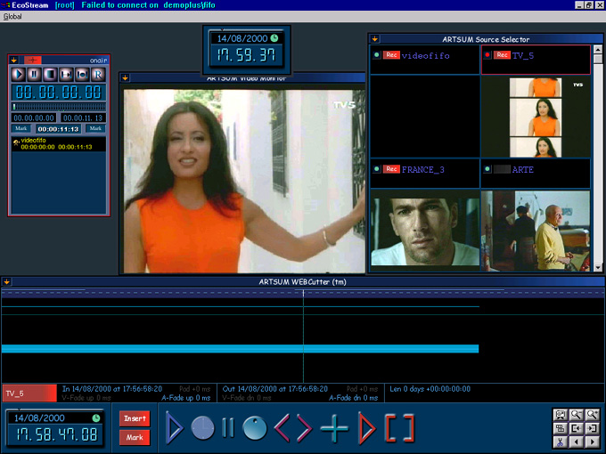
Display of video channels at 2, 8 and 24 images per second. The sound remains synchronous
Playlist during publication
Time-stamping
Cache memory search
Time-line display
Standard time-line and its transport functions: play, stop, jog, etc.
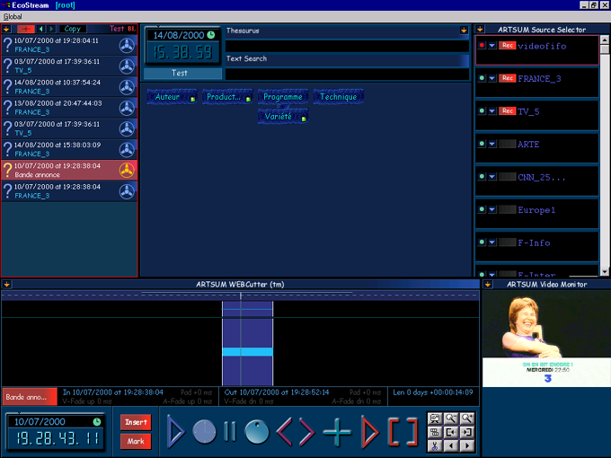
Selected channel
Available TV and/or audio channels
Search results:
Documents corresponding to current searches (crossed search)

Item currently displayed
Database criteria
(thesaurus of current catalogue)
Display of document selected from time-line

Transport tools: locators, jog, pause, etc.
Display of selected item
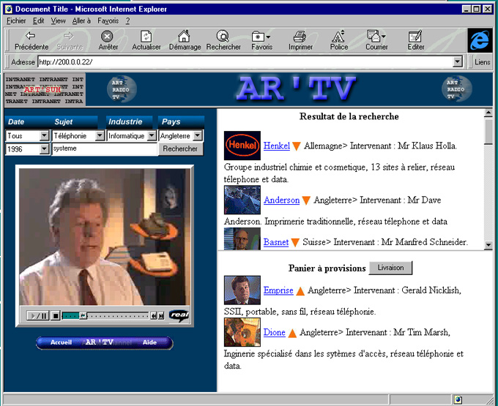
Indexed document selection criteria: thesaurus and catalogues
Conventional reader
Display in Real or MPEG4
Selection basket
Downloading of saved items for exporting or broadcasting
Display link

Selection/
deselection link
Search results:
Documents corresponding to current searches
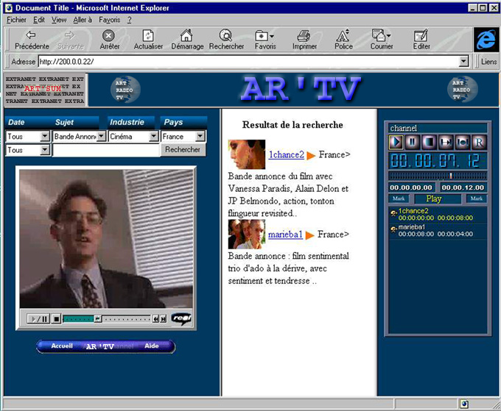
Conventional reader
Viewing in Real or MPEG4
Programming tool for broadcasting lists (EDL) that can be compiled into a single file for exporting or be broadcast over any medium:
− recasting over IP;
− broadcasting over an
analogue output.
Search results:
documents corresponding to current searches
Indexed documents selection criteria: thesaurus and catalogues

