 | INTERNATIONAL TELECOMMUNICATION UNION
 | TELECOMMUNICATION  DEVELOPMENT BUREAU  ITU-D STUDY GROUPS | Document 1/188-E  11 July 2001  Original: French
FOURTH MEETING OF STUDY GROUP 1: CARACAS (VENEZUELA), 3 - 7 SEPTEMBER 2001
FOURTH MEETING OF STUDY GROUP 2: CARACAS (VENEZUELA), 10 - 14 SEPTEMBER 2001
FOR ACTION

Question 12/1: Tariff policies, tariff models and methods of determining the cost of national telecommunication services

STUDY GROUP 1

SOURCE: TELECOMMUNICATION DEVELOPMENT BUREAU (BDT)

TITLE: A METHOD FOR DETERMINING TARIFFS AND RATES FOR NATIONAL AND INTERNATIONAL TELEPHONE SERVICES

________
Action required:
Participants are invited to give their comments on this contribution.
Abstract:
This chapter describes a procedure whereby operators and regulators in developing countries, including those which do not necessarily have detailed data regarding their costs, can calculate tariffs that are orientated towards or based on the costs of telephone services, as determined from assessing the resources consumed by their activities.

1 Objective
This chapter describes a procedure whereby operators and regulators in developing countries, including those which do not necessarily have detailed data regarding their costs, can calculate tariffs that are orientated towards or based on the costs of telephone services, as determined from assessing the resources consumed by their activities.

2 Basic concepts

2.1 The concept of cost
The principles used are taken from ITU-T Recommendation D.600R. The procedure is based on the Enhanced Fully Distributed Costing (EFDC) method. Taking as a basis the principles of activity-based costing, the procedure is applied in such a way that all the costs incurred for each service offered, and only those costs, are attributed to the service in question. The unit cost of the service is the total cost divided by the volume.

2.2 Base costs
The method involves a descending attribution of costs. The accounts of the network operator are therefore used as the main source of costing data. However, in order to take into account the natural evolution of the cost of the equipment considered in the marketplace, historic amortization costs are updated to the corresponding replacement value.

2.3 Guiding principles
The guiding principles are those enumerated in Recommendation D.600R, namely: transparency, practicability, causality, efficiency, contribution to common costs, present value of costs and objectivity. Illustration of the present chapter has been done using an autonomous "client-server" type application, in accordance with § 2.4 of Recommendation D.600R, used by BDT to aid those countries requesting it.

3 Services considered
The method is applied to calculating the tariffs for a "homogeneous" telephone network such as the fixed network; the resulting tariffs are endogenous tariffs that do not take into account interconnection charges for connecting to other networks.

3.1 Telephone services
The telephone services considered are the following:
• Local (urban) traffic: This is traffic that remains within so-called local (urban) tariff zones, but which may move over several exchanges within a given geographical area (e.g. a telephone call within the city of Geneva). The model considers a single local (urban) tariff. If in fact several local tariffs exist, the result given by the model represents their weighted average value.
• Trunk (interurban) traffic: This is traffic between two communities situated in different local (urban) tariff zones (e.g. a telephone call between the city of Geneva and the city of Zurich). The model considers a single trunk (interurban) tariff. If in fact several trunk (interurban) tariffs exist, the result given by the model represents their weighted average value.
• Outgoing international traffic: The tariff for outgoing international traffic is the average tariff calculated on the basis of endogenous costs. To determine the tariff applicable to the end user, the settlement rates for outgoing international traffic must be added.
• Incoming international traffic: The tariff for incoming international traffic is the incoming settlement charge (including the international segment).
• Outgoing subregional traffic: The tariff for outgoing subregional traffic is the average tariff calculated on the basis of endogenous costs. To determine the tariff applicable to the end user, the settlement rates for outgoing traffic to the subregion must be added.
• Incoming subregional traffic: The tariff for incoming subregional traffic is the settlement charge applicable to countries in the subregion.
• International transit traffic:
− international to international;
− international to subregion;
− subregion to international; and
− subregion to subregion.
• Interconnection traffic (coming from a separate network within the same country - e.g. the mobile network):
− Incoming national, one-way, transit: Interconnection traffic received, for which the recipients are situated within the tariff zone of the interconnection point;
− Incoming national, round-trip, transit: Interconnection traffic received, for which the recipients are situated outside the tariff zone of the interconnection point;
− Outgoing national: Traffic generated locally and directed to subscribers to other interconnected national networks. To determine the tariff applicable to the end user, the interconnection charge levied by other local operators must be added.
− National, transit: Traffic between other national operators travelling by way of a third party's network. To determine the tariff applicable to the requesting operator, the interconnection charge levied by other local terminating operators must be added.
− Incoming international, for other local operators: To determine the tariff applicable to the requesting operator, the termination charge levied by other local operators must be added. Until the matter of the identification of the terminating network is resolved, a weighted average of this charge and the charge for incoming international terminating traffic is used to determine the basis for the settlement charge.
− Outgoing international, from other local operators.

3.2 Network components
Recommendations D.140 and D.150 provide that it is possible to determine the cost of the international segment. Although the model is "services-orientated", it does allow the costs of network segments to be determined, as follows:
• international transmission;
• international switching;
• national transmission;
• national switching; and
• access network.

3.3 Non-telephone services
In accordance with the principle of causality, the costs of non-telephone (non-voice) services must be identified and removed from overall costs. This is generally a straightforward procedure in low-teledensity networks. However, if difficulties should arise in this regard, a cost deduction factor can be reckoned on the basis of the proportion of non-telephone revenues (this approximation assumes that prices are cost-orientated).

4 Structure of the telecommunication network

4.1 Organization of the network
The network can be structured as illustrated in Figure 1.
Given the degree to which the national economy of many African countries is centred on the national capital, Recommendation D.600R makes what happens in that location particularly visible.
Figure 1
Structure of the network

4.2 Delimitation of the network
Three boundaries are considered in the network model in Figure 1:
• Boundary with other local operators: This boundary determines the location of interconnection services. The interconnection charges that are calculated take only endogenous costs into account; they do not take account of the special agreement regarding the physical link.
• Boundary with the subregion: This boundary delimits the endogenous costs incurred for offering subregional calls.
• Boundary with the international zone: This includes international half-circuits, and sets the boundary for endogenous costs for outgoing international calls.

5 Considerations regarding available costs
The objective of practicability imposes limitations in regard to the level of detail of the data that a model considers. The ability to adapt the model to the specific situation of different countries is essential. However, objective costs cannot be calculated without sufficiently detailed cost data.
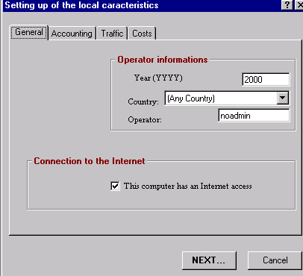

5.1 Analytical cost accounting
Where analytical cost accounting is available, it should be possible to obtain detailed information regarding amortization, operating costs and maintenance.
Accordingly, the following data should be provided: annual amortization for the equipment (telecommunications and electrical power), structures and miscellaneous investments, in the areas of switching (national and international), transmission (national and international), the access network and investments in structures.
The amortization period calculated for each network segment will be a weighted average of the amortization periods of the elements of which it is composed.
Example: National switching
If:
D_{c} is the amortization period for the switching equipment
M_{c} is the corresponding amount of amortization
D_{b} is the amortization period for the structures
M_{b} is the corresponding amount of amortization
D_{e} is the amortization period for the electrical-power equipment
M_{e} is the corresponding amount of amortization
D_{a} is the amortization period for other investments relating to the national switching system
M_{a} is the corresponding amount of amortization
Then:
$D=\frac{M_{c}\text{.}D_{c}+M_{b}\text{.}D_{b}+M_{e}\text{.}D_{e}+M_{a}\text{.}D_{a}}{M_{c}+M_{b}+M_{e}+M_{a}}$

5.2 General accounting
If cost information is available only from general accounting records, a good knowledge of the network's cost structure may make it possible to carry out an initial attribution of overall amortization and operating charges with respect to the network's various segments.

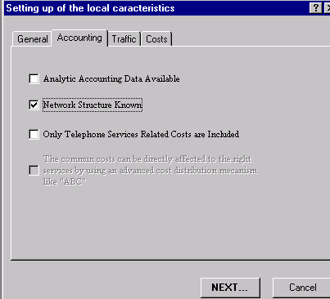

5.2.1 The network's fixed assets and cost structure
The cost structure can be calculated on the basis of information regarding net fixed investment in the network's various segments. The segments considered are international transmission, international switching, national transmission, national switching and the access network. Other investments that cannot be classified according to these four segments are then added.
It frequently happens that this information cannot be drawn directly from the subaccounts in the general accounting records. In this case, a more detailed analysis may be necessary (often requiring inspection in the field): for example, the separation of fixed investment in international switching from fixed investment in national switching, the attribution of fixed investment in technical structures to the various segments, the attribution of fixed investment in electrical-power equipment to the various segments, and so forth.
The cost structure is indicated by the relative value of net fixed investment in each segment of the network, as a proportion of total net fixed investment.

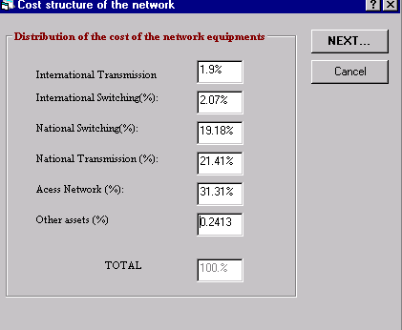

5.2.2 Charges
The general accounting records provide subaccounts in regard to charges. The following subaccounts must be identified in particular:
a) Purchases and variations in stock: Purchases of merchandise; purchases of raw materials and associated supplies; purchases of stocks of raw materials and inputs; purchases of packaging; other purchases; variations in stocks of merchandise; variations in stocks of raw materials and associated supplies; variations in stocks of other supplies.
b) Transport: Transport for purchases other than plant and equipment; transport for sales; transport for the account of third parties; transport of staff; courier and delivery services; other transport charges.
c) Outside services: Subcontracting; rental, leasing and associated charges; payments on leases and similar agreements; maintenance, upkeep and repair; insurance premiums; studies; research and documentation; advertising; publications; public relations; telecommunication charges; bank charges; intermediaries' and consultants' honoraria; staff training charges; royalties in respect of patents, licences and computer software, and similar charges; sundry subscriptions and financial assistance; payments to outside personnel; other outside charges.
Payments in respect of settlement charges and interconnection charges must not be included because these are exogenous charges.
d) Taxes (other than income taxes): Direct taxes; indirect taxes; registration fees; tax penalties and fines; other taxes and levies.
e) Other charges: Losses on accounts receivable from customers and other debtors; share of earnings on joint ventures; cancelled share of earnings in respect of partial execution of agreements covering several fiscal years; accounting values of current transfers of fixed investments; sundry charges.
f) Personnel charges: Direct remuneration paid to personnel; lump-sum indemnities paid to personnel; social charges; remuneration and social charges of individual operators; remuneration transferred to outside personnel; other social charges.
g) Financial and similar charges: Interest paid on loans; interest on leases and similar agreements; discounts granted; other interest (advances received and creditor deposits, blocked current accounts, interest on commercial and sundry debts); discounted commercial paper; exchange losses; losses on transfers of securities; losses on financial risks; financial provisioning charges.
Given that financial charges are a component of the cost of capital, they must be clearly identified so as to prevent any double counting.
h) Allocation for amortization: Operating amortization; financial amortization (e.g. premium on redemption of securities).
i) Allocation for provisions: Operating provisions, financial provisions.
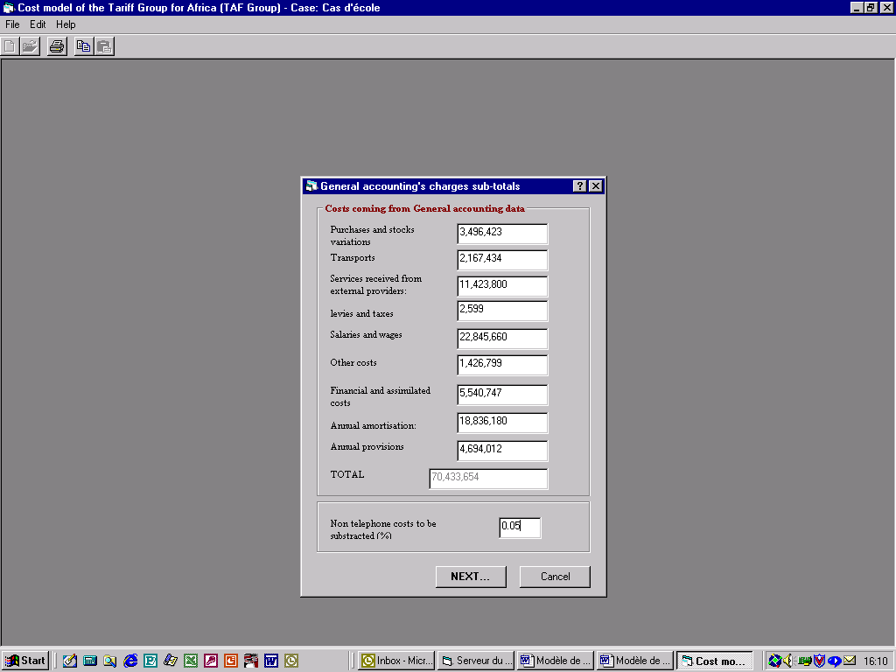

5.2.3 Deduction of charges
The charges described in § 5.2.2 may not be generated solely by the telephone service. In that case, non-telephone charges must be individually identified and deducted. This is generally a straightforward procedure in low-teledensity networks. However, if difficulties should arise in this regard, a cost deduction factor can be reckoned on the basis of the proportion of non-telephone revenues (this approximation assumes that prices are cost-orientated).

6 Traffic data
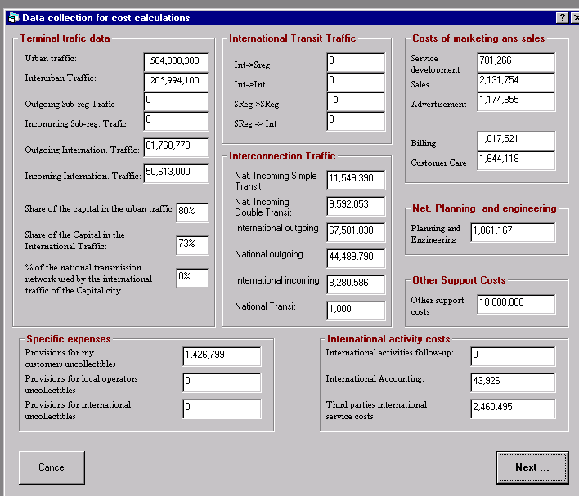

6.1 Traffic data required
For the services listed in § 3.1, traffic data must be provided within minutes. It may happen, however, that domestic traffic data are not available within minutes, unlike international traffic (including subregional traffic) which benefits from the international system of exchange of accounts. Interconnection traffic data must also be available within minutes. If such data are not available in a timely fashion, the model must offer one or more ways to estimate the traffic in the domestic service.
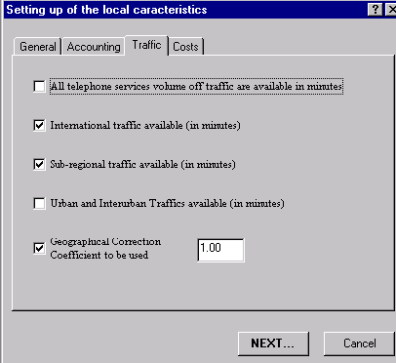

6.2 Estimation methods
Where it is necessary to make estimates for missing traffic data, three methods can be used: estimation by extrapolation from observations; estimation based on a matrix of affinities determined from the national traffic matrix; and estimation by revenues generated. To minimize any skewing, the values thus observed must be considered in relation to known traffic values (e.g. outgoing national traffic or outgoing international traffic).

6.2.1 By extrapolation from observations
The traffic may be observed by taking data recorded on call tickets over a specific period of time (usually a week). The call tickets must show the number of the calling party, the number of the called party and the duration of the call. The point-to-point matrix determined from these data is used as the basis for extrapolation.

6.2.2 By affinity matrix
If it is not possible to observe the traffic by means of call tickets, a traffic matrix in busy-hour erlangs may be used to determine coefficients of affinity which are then considered in relation to outgoing national traffic or outgoing international traffic. However, this method is not as precise as the method described in § 6.2.1.

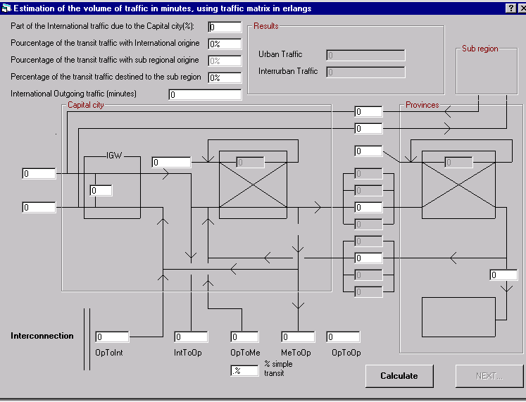

6.2.3 By revenue generated
If the international traffic and the interconnection traffic are known in minutes, it is also possible to take advantage of the fact that the turnover for billed traffic includes revenue from the following sources: domestic traffic, outgoing international traffic and outgoing national traffic. If the average price per minute and the volume of outgoing traffic are known, the turnover for domestic traffic can be determined.
From analysis of the matrix of national traffic and internal exchange traffic, the distribution of domestic traffic between local (urban) traffic and trunk (interurban) traffic can be determined.
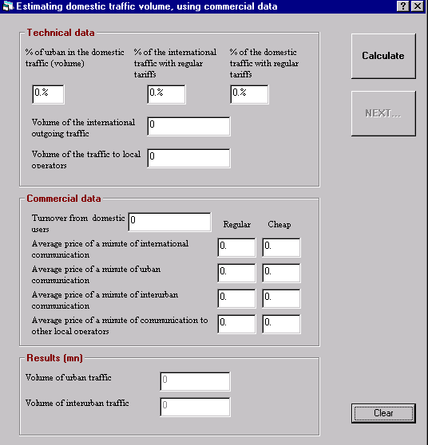

7 Cost attribution of components
The following diagram illustrates the attribution of costs:
Figure 2
Cost allocation diagram
The steps in the cost attribution process are as follows:
a) Attribution of general support costs (other functions)
Following the principles of activity-based costing, part of the costs common to both commercial and technical functions is indirectly attributed. The part that cannot be attributed in this way is held for subsequent attribution to services.
b) Attribution of the cost of associated functions (commercial functions)
Certain costs recorded at the commercial level may be attributed to network segments (e.g. international transit charges paid to third parties are attributed to the cost of international transmission). Other commercial charges, after the portion corresponding to non-telephone services is removed, are attributed to services according to their particular nature (e.g. the costs of billing and after-sales service are attributed to the operator's outgoing subscriber calls - in other words, to the local (urban), trunk (interurban), outgoing international, outgoing subregional and outgoing national services).
c) Attribution of the cost of network segments
The cost of network segments is attributed to services, pro rata, on the basis of equivalent traffic (see: 7.1.1).
If:
E_{j} is the network segment having rank j
C_{j} is the cost of the network segment having rank j
T_{i} is the traffic for the service having rank i among those using the segment E_{j}
T_{j} is the total traffic travelling on the network segment having rank j
Then:
The part of the cost of the segment having rank j attributed to the service S_{i} is indicated by the relationship
$C_{\text{ji}}=C_{j}∗\frac{T_{i}}{T_{j}}$ ;
and the network's share of the cost of the service S_{i} is therefore equal to:
$\sum_{j=1}^{m}{C_{\text{ji}}}$

7.1 Geographical correction

7.1.1 Justification
The costs of the network's various segments are attributed to services on the basis of relative traffic. Because there are different economies of scale between the capital and outlying areas, the unit cost of traffic with respect to a particular piece of equipment is higher if that equipment is installed away from the capital.
The geographical correction coefficient enables this skewing to be corrected by basing the aforementioned attribution on equivalent traffic rather than on actual traffic.
The equivalent traffic for a given service is reckoned as the actual traffic multiplied by the geographical correction coefficient.

7.1.2 Determination
The services subject to geographical correction are those relating to outlying areas.
Let C_{c} be the reference cost in the capital, and T_{c} be the traffic in the capital;
Let C_{p} be the reference cost in the outlying area, and T_{p} be the traffic in the outlying area;
Let T_{ep} be the equivalent traffic in the outlying area and Γ be the geographical correction coefficient.
To eliminate any skewing in the attribution of costs in respect of network segments, the following relationship must be verified:
$\frac{C_{p}}{T_{\text{ep}}}=\frac{C_{c}}{T_{c}}$
This implies that:
$T_{\text{ep}}=T_{c}∗\frac{C_{p}}{C_{c}}$
Now, by definition:
T_{ep} = γ*T_{p}
Thus
$Γ∗T_{p}=T_{c}∗\frac{C_{p}}{C_{c}}$
And hence, the geographical correction coefficient:
$Γ=\frac{T_{c}∗C_{p}}{T_{p}∗C_{c}}$
In practice, the switching costs in the capital and in outlying areas will be used. The individual internal traffic matrices for the exchanges give the total traffic for each exchange (local, transit, incoming, outgoing).

7.2 Direct costs
There should be no difficulty in associating direct costs with the corresponding services.

7.3 Indirect costs

7.3.1 Network costs
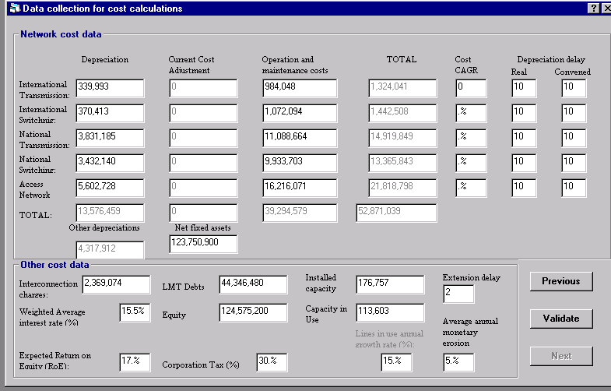

7.3.1.1 Amortization
The amortization in question is operating amortization. The network segments as described above (§ 3.2) are the main source of annual provisions for amortization. Nevertheless, the enterprise needs to invest in its other functions (e.g. computers necessary for the management information system) in order to carry on its activities. These fixed investments need to be taken into account as well.

7.3.1.2 Adjustment to current costs
In so far as possible, the operator must endeavour to take current costs into account, within the limits set by national tax legislation. By the same token, allowance must be made for currency depreciation when reassessing assets.
Example:
An item of equipment is purchased for 10 million in year 0.
The equipment is subject to linear amortization over 10 years.
However, its market price drops by 8 per cent each year.
The amortization allowance in year 2 will be:
10 000 000 × (1 – 0.08)²/10 = 846 400 instead of 1 000 000.
Important: To take account of falling currency rates, assets may be reassessed in a stable international currency such as SDRs. The resulting amount is converted into the local currency using the average exchange rate for the year.
When all the costs are expressed in local currency, the amount of the adjustment of current costs can be estimated using the following formula:
$\text{ACC}=\text{AMO}∗\left[\frac{{\left(1+δ\right)}^{D/2}}{{\left(1−ε\right)}^{D/2}}−1\right]$
where:
ACC is the adjustment to current costs
AMO is the amortization allowance
δ is the average annual growth rate in the price of equipment
ε is the average annual rate of currency depreciation
D is the amortization period.
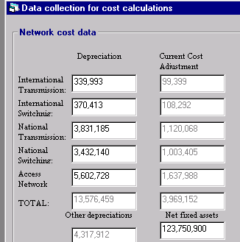

7.3.1.3 Taking account of the amortization period
The amortization period in accounts is governed by a policy that is rigorously monitored by government authorities. However, when the cost of services is being determined, the actual amortization period may need to be adjusted vis-à-vis the amortization period for accounting purposes. The effect of such an adjustment is twofold:
a) The annual provision for amortization will have to be adjusted accordingly; and
b) The figures for net fixed investment will also have to be corrected.

7.3.1.4 Rental of outside networks
The international network is often accessed through shared technical infrastructure such as the INTELSAT network or international submarine cables. In the case of a direct link between two operators, the system of cost sharing on the basis of half-circuits is applied, and the costs of circuit leasing are then taken into account. If there is no direct link, the connection is done on a transit basis via a third party. Transit costs must be taken into account in just the same way as circuit leasing costs.
Important: In no case should settlement charges paid to operators for terminal traffic be taken into account.

7.3.1.5 Operation and maintenance
As a rule, information on operating and maintenance charges can be obtained through field visits. By and large, these charges consist of personnel costs and the cost of inputs. As a first approximation, the model attributes total operating and maintenance charges to the various segments on the basis of the cost structure if the accounting system does not permit otherwise. This apportioning must be adjusted, however, when particular costs have been determined.

7.3.2 Functional support costs

7.3.2.1 Technical support
Certain technical costs must be added to network operating and maintenance charges, particularly the cost of engineering work and studies where these functions are performed by the enterprise itself. (Where these functions are performed by service providers outside the enterprise, in the context of managing a project for example, the associated costs are considered fixed investment, in just the same way the project itself.)

7.3.2.2 Commercial support
Charges in respect of commercial support are marketing expenses, including:
a) Costs incurred for commercial studies in connection with the introduction of new telephone products.
b) Costs in connection with the sale of telephone services, incurred at the point of sale.
c) Advertising costs.
d) The cost of the commercial information system and billing system, plus the cost of after-sales service.

7.3.3 Cost of capital
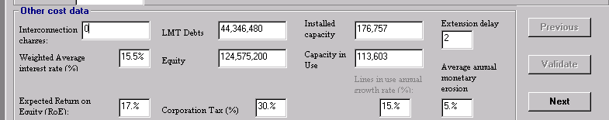
The cost of capital is taken as an overall figure for all telephone services as a whole. The before-tax cost of capital is expressed as the following relationship:
$γ_{T}=\frac{D}{D+E}∗i+\frac{E}{D+E}∗σ_{T}$
where:
D is the amount of medium- and long-term debt
E is equity
i is the average interest rate
σ_{T} is the before-tax return on capital.
Consequently, the after-tax cost of capital is expressed as the relationship:
$γ=\frac{D}{D+E}∗i(1−τ)+\frac{E}{D+E}∗σ$
where:
τ is the rate of profit tax
σ is the after-tax return on capital.
To neutralize the effect of taxes on the real costs of services, the second relationship is used.
For tariff purposes, this is applied with respect to the total amount of net fixed investment in order to determine the absolute value of the cost of capital.

7.3.3.1 Average rate of interest
The average rate of interest can be determined by calculating the weighted average value on borrowings during the previous five years. For tariff purposes, it is preferable to use the evolution of the money rate on the international market in the telecommunication sector, and to take into account the risk factor for the country in question.

7.3.3.2 Return on capital
The after-tax return on capital can be calculated on the basis of net earnings, using the following relationship:
$σ=\frac{B}{E}$
where:
B is the net profit
E is equity.
For tariff purposes, it is preferable to use the evolution of the rate of return on capital on the international market in the telecommunication sector, and to take into account the risk factor for the country in question.

7.3.3.3 Taking into account the monetary erosion in the determination of interest rate and equity return in local currencies
When the loans are carried out in hard currencies with their associated interest rates, and if the local currency undergoes significant evolutions in regards to SDR (see calculation of monetary erosion), the average interest rate considered in the calculation of the costs must be corrected to reflect this situation. It is the same for the return on equity when based on the international market.
Ultimately, it is a question of applying an inflation risk factor on the cost of capital.
The formula below makes it possible to calculate the interest rate " i " taking into account the risk of inflation according to various parameters:
$i=\frac{nε\left[1+\frac{\left(n+1\right)}{2}i_{F}\right]−1+\frac{1}{{\left(1+ε\right)}^{n}}}{n−\frac{1}{ε}\left[1−\frac{1}{{\left(1+ε\right)}^{n}}\right]}$
where:
n = average duration of the loans
ε = compound average value of annual monetary erosion
i_{F} = annual interest rate free of inflation risk
For the determination of the Return on Equity in an inflationary environment, one considers that the difference between i and i_{F} is exclusively ascribable to the market and represents the for risk premium. Then:
$σ=σ_{F}+\left(i−i_{F}\right)$
Where
σ_{F} ₌ return, free of inflation risk, required for the market
Example:
This telecommunication services provider borrows on the international market at the interest rate of 8.5% over 10 years. In addition, the international shareholders discount a return on equity of 13.5% in hard currencies. But the currency of the country loses 7.5% of its value every year.
Then the calculation of the costs in local currency will take into account the following rates: 18.68% and 23.68% for the interest rate and the return on equity respectively.

7.4 Common costs
Common costs are those which are associated with the general structure of the enterprise, and have no direct causal functional relationship to services. These costs are borne equitably by all the services that the enterprise offers, including non-telephone services. By and large, these costs pertain to functions such as general management and administration, finance and accounting, human resources, supplies and logistics, the management information system, and so forth.

7.5 Special costs
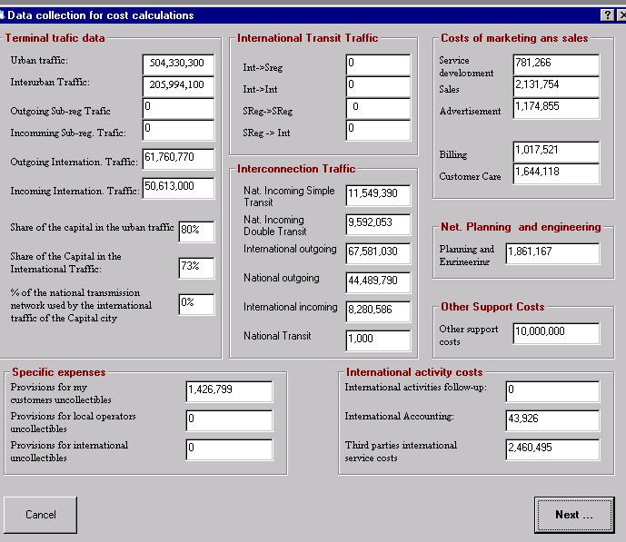
Certain costs must be dealt with in a particular way because of their relative importance, and must be apportioned in the fairest way possible. This is particularly the case with respect to the following:
a) Provisions for doubtful balances owed by subscribers: These are attributed to outgoing subscriber calls.
b) Provisions for doubtful balances owed by local operators: These are attributed to termination and transit services provided to local operators.
c) Provisions for doubtful balances owed by international operators: These are attributed to termination and transit services provided to international operators.
d) Charges incurred for managing relations with operators (distinguishing between local and international operators): These are attributed to all types of calls with operators of the kind in question.
e) International services provided by third parties (e.g. leasing of circuits on satellite systems or submarine cables, maintenance and right-of-way agreements, paid transit, etc.): These are attributed to international transmission.
f) National transit offered by local operators: These are attributed to national transmission.
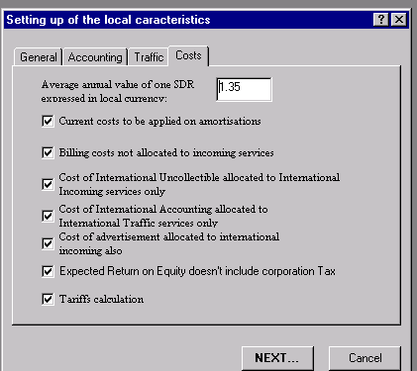

7.6 Spare capacity and inefficiency costs
Operators must verify that idle capacity is not the result of an inefficient use of resources. To this end, they must ensure that all available capacity is used within a period compatible with good replenishment practices.
If:
λ is the compound annual rate of growth
K₀ is the current capacity
N is the appropriate replenishment period
K is the spare capacity
Then inefficient capacity is given by the following expression:
$$K^{'}=\text{Max}\left[0;ΔK−K_{0}∗\left({\left(1+λ\right)}^{N}−1\right)\right]$$
If K' is positive, the corresponding cost share is deducted from the cost of K₀ + ΔK.
If K' is equal to zero, there is no idle capacity.
If there is idle capacity, the corresponding investment cost must be reduced by K'/(K₀ + ∆K).
Example:
A network has a total capacity of 200.
There are at present 150 subscribers.
The compound annual growth rate in the number of subscribers is 15 per cent.
The replenishment period is three years.
Then: = 0, and there is no idle capacity.
If the growth rate were 5 per cent, this would result in K' = 26.36, in which case the cost would have to be reduced by 26.36/200 = 13.18 per cent to take account of the idle capacity.
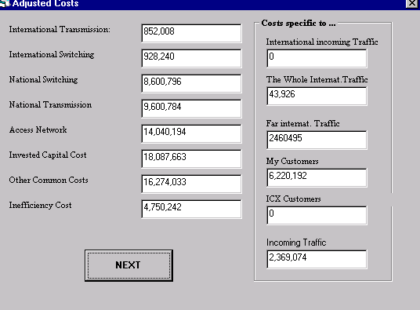

8 Cost of services
The costs calculated at this stage are different from tariffs in that they do not include any components specific to tax policy or to State policies with respect to universal service obligations.
They cannot be compared directly with the tariffs in effect.
Nevertheless, these costs are the basis for all further calculations that will lead eventually to the determination of tariffs that are cost-orientated and tariffs that are cost-based.
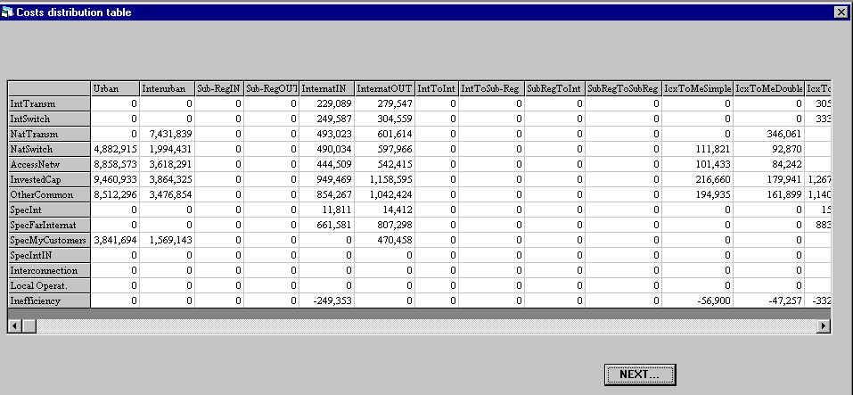

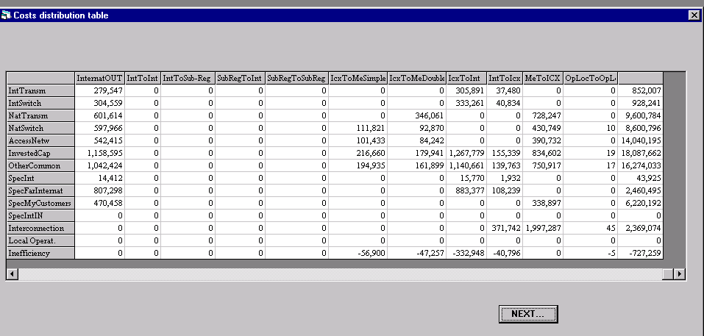

8.1 Telephone services cost
With costs being attributed to services as indicated above, the unit cost for each service is defined as being equal to the total cost of the service divided by its actual traffic.

8.2 Interconnection costs
With costs being attributed to services as indicated above, the unit cost for each service is defined as being equal to the total cost of the service divided by its actual traffic.

8.3 Network components cost
The unit cost of each network segment is determined by dividing the consolidated value for the segment after step 2 of the attribution process by the traffic T_{j}.
Recommendation D.140 requires that the contribution of the different segments to the cost of an incoming international call be given; accordingly, the calculation can also be done at the level of this service.
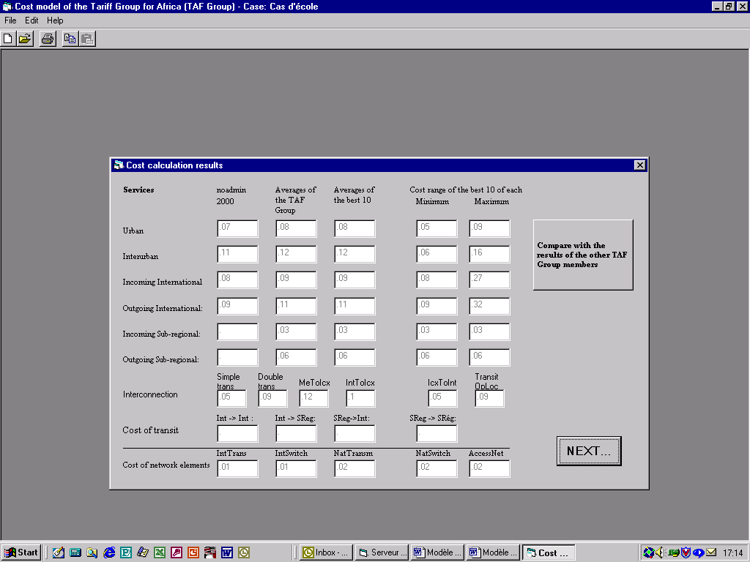

8.4 Reference (benchmark) costs
The TAF model provides for a "client-server" structure in order to be able, among other things, to generate reference values for costing services in real time.
The costs of services calculated as indicated above, as well as other useful data, are encrypted and forwarded, if the operator so desires, to a database that can be accessed using the TCP/IP protocol.
This database calculates the weighted averages of default values for the cost structure and weighted averages of service costs. The latter operation is also done for the 10 best costs for each service.
The information on the weighted averages of service costs is sent back for comparison.
NOTE - Because the use of a server requires the standardization of monetary units, the cost data transmitted to the server are automatically converted into SDRs before sending, and the cost data produced by the server, expressed in SDRs, are automatically converted back to the national unit of currency before being displayed.

9 Profit tax
Profit tax is one of the factors that needs to be taken into account, in addition to costs, in setting tariffs. The amount of profit tax must be calculated and attributed to the services offered, pro rata with respect to turnover, on the basis of costs.
If:
σ_{T} is the before-tax return on capital
σ is the after-tax return on capital
τ is the rate of profit tax
E is equity
Φ is the amount of profit tax
Then gross profit is expressed by the following relationships:
E*$σ_{T}$ (1)
E*$σ$ + Φ (2)
Moreover,
$σ$=$σ_{T}$(1-$τ$) (3)
(1) = (2) => Φ= E*$σ_{T}$ – E*$σ$ (4)
(3) and ( 4) => Φ=$E∗\frac{σ}{1−τ}−E∗σ$ provided τ # 1 !
Hence the absolute value of profit tax is:

$$Φ=Eσ\frac{τ}{1−τ}$$

10 Universal service obligations

10.1 Definition
Universal service obligations encompass the following requirements:
• Availability of services everywhere, all the time.
• Accessibility of services to all segments of the population (e.g. persons with disabilities).
• Affordability of services to the poorest segments of the population
In developing countries, the requirement of accessibility seems to be of lower priority, given that individual needs are not yet generally met for the population as a whole.

The requirements of availability and affordability, however, have high priority. They make it necessary for infrastructure to be installed (even in unprofitable geographical areas), while at the same time requiring that tariffs be kept low for domestic services.

10.2 Contributions to universal service
Contributions to universal service on principle required in order to defray charges associated with the requirement of accessibility. These contributions are usually expressed as a percentage of turnover.
If:
ρ_{USO}% is the contribution percentage
Φ is the profit tax
$c_{\text{si}}$ is the unit cost for the service S_{i}
T_{i} is the traffic for the service S_{i}
Then:
$$\text{USO}=ρ_{\text{USO}}\left(Φ+\sum_{i}{c_{\text{si}}T_{i}}\right)$$

10.3 Access deficit
The requirements of availability and affordability are closely tied to the use of the network. If the authorities oppose the rebalancing of tariffs, these requirements will lead to an access shortfall that must be made up on an equitable basis by all operators using the network in question.
The costs of idle capacity due to inefficiency must be excluded from the access shortfall.
Before calculating the access shortfall, one key fact must be taken into consideration. The subscribers of the operator concerned bear only the charges for local lines and subscription rentals. These payments must be allocated (in advance) to the services offered to them – i.e. local (urban), trunk (interurban), outgoing international, outgoing subregional and outgoing national services – and must be deducted from their cost.
These payments can be estimated by means of the following relationship:
$\text{PA}=\left(Δ\text{Parc}∗\text{TRacc}+\text{RdV}∗\text{NAbé}∗\text{12}\right)$
The amount PA can be allocated at the unit price for the services in question according to the relationship:
$${\text{pa}}_{\text{si}}=\text{PA}∗\frac{c_{\text{si}}}{\sum_{j=1}^{7}{c_{\text{sj}}T_{\text{sj}}}}$$
where:
T_{si} is the traffic for the service having the rank i among the seven services listed above
C_{si} is the unit cost for the service having the rank i among the seven services listed above.
Consequently,
$c_{\text{si}}^{'}=c_{\text{si}}−{\text{pa}}_{\text{si}}$
The access shortfall is therefore given by the following relationship:
$$D=T_{\text{URBAN}}∗\left(c_{\text{URBAN}}^{'}−p_{\text{URBAN}}\right)+T_{\text{INTERURBAN}}∗\left(c_{\text{INTERURBAN}}^{'}−p_{\text{INTERURBAN}}\right)−\text{IneffDom}$$
where:
IneffDom is the portion of domestic traffic included within inefficiency costs, if any exist
T_{URBAN} is local (urban) traffic
P_{URBAN} is the current price of local (urban) traffic.

11 Cost-orientated tariffs
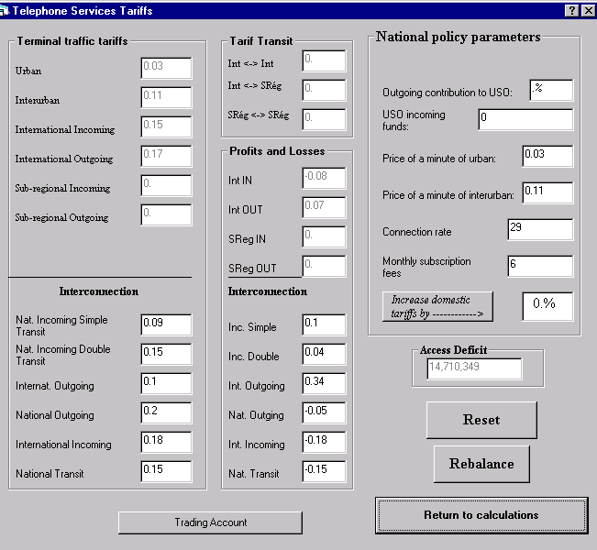

11.1 Attribution of profit tax
Profit tax is attributed to all the services offered, pro rata with respect to turnover, on the basis of costs.
$$ϕ_{\text{si}}=Φ∗\frac{c_{\text{si}}}{\sum_{j=1}^{n}{c_{\text{sj}}T_{\text{sj}}}}$$

11.2 Attribution of universal service obligations

11.2.1 Contribution to universal service
The contribution to universal service may take the form of an amount paid into a fund. Depending on national policies in this regard, such contributions may or may not be reflected in tariffs. If they are reflected, they are distributed amongst the various services, pro rata with respect to turnover, on the basis of inherent costs.

$${\text{uso}}_{\text{si}}=\text{USO}∗\frac{c_{\text{si}}}{\sum_{j=1}^{n}{c_{\text{sj}}T_{\text{sj}}}}$$

11.2.2 Access deficit
The access deficit must be attributed to all "m" services that are not subject to price constraints on the part of the authorities – in other words, all services except local (urban) and trunk (interurban) services.

$$d_{\text{si}}=D∗\frac{C_{\text{si}}}{\sum_{j=1}^{m}{C_{\text{sj}}T_{\text{sj}}}}$$
The tariffs determined according to the process described above are not balanced, as a rule, because the decision by the authorities causes urban and interurban communications prices to be below costs. The tariffs are cost-orientated, however.

12 Cost-based tariffs
To obtain tariffs based on costs, the tariffs have to be rebalanced.

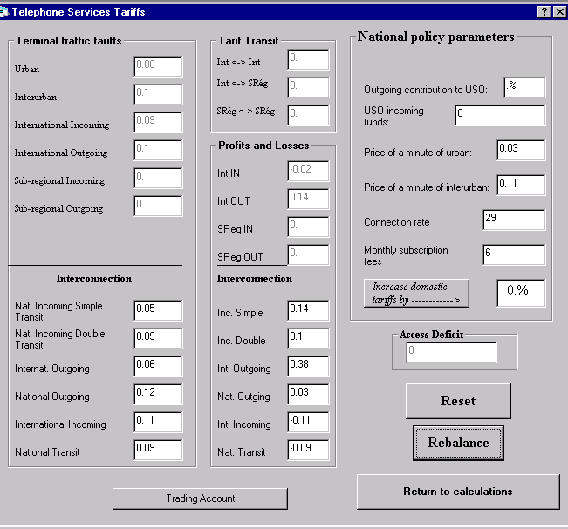

12.1 Tariff rebalancing
Tariff rebalancing consists of gradually eliminating the access shortfall. This can be achieved by adjusting several variables:
• Increasing the prices for local (urban) and trunk (interurban) services.
• Increasing monthly subscription charges.
• Increasing the local line charge (limited impact).
• Obtaining a multi-year subsidy to offset the cost of universal service obligations (unlikely in significant amounts).

12.2 Considerations with respect to elasticity
The costing model makes it possible to calculate costs and to derive tariffs from them. Nevertheless, a sudden change in tariffs may be expected to have an impact on traffic demand, which will in turn affect costs and tariffs. Several iterations may be necessary to locate the point at which tariffs stabilize. Accordingly, the consideration of elasticity lies beyond the scope of this paper.

13 Consideration of exogenous costs
The costs and tariffs calculated according to the procedure described in this paper are endogenous: in other words, they do not include settlement charges (for outgoing international calls) or interconnection charges (paid to other local operators). To determine the tariffs and charges applicable to the caller, exogenous charges of this kind must be added to the endogenous tariffs so as to form a coherent whole.

______________

Recommendation D.600R defines subregional traffic as "traffic exchanged between countries near to one another via terrestrial transmission media shared with trunk (interurban) traffic".
For the purposes of Recommendation D.600R, any city where an international transit switching centre is located is a "capital". If more than one city falls within this definition, the individual data for all such cities are added together.
The current cost of an item is defined as what the item would cost if it were purchased now.
The rate will be negative if the price falls.
If 1 SDR is worth C₀ in year 0 and C_{n} in year n, then $ε=1−{\left(\frac{C_{0}}{C_{n}}\right)}^{\frac{1}{n}}$ Depreciation is positive when the currency is devalued.
N represents the objective amount of time necessary (in years) for the network's capacity to be increased, taking into account exogenous time periods relating to access to loans or the obtaining of foreign exchange. If it is assumed that the supply must be available before the demand arises, then N = 1 + average exogenous time period.

