 | INTERNATIONAL TELECOMMUNICATION UNION
 | TELECOMMUNICATION  DEVELOPMENT BUREAU  ITU-D STUDY GROUPS | Document 1/174-E  6 June 2001  Original: English
FOURTH MEETING OF STUDY GROUP 1: CARACAS (VENEZUELA), 3 - 7 SEPTEMBER 2001
FOURTH MEETING OF STUDY GROUP 2: CARACAS (VENEZUELA), 10 - 14 SEPTEMBER 2001
FOR INFORMATION

Question 14/1: The role of telecommunications in social and cultural development, including the protection and promotion of indigenous culture and identity

STUDY GROUP 1

SOURCE: INICTEL, PERU

TITLE: INICTEL - ASHÁNINKA NATIVE COMMUNITY MUTUAL SUPPORT AGREEMENT

________
Abstract:
This document mentions the signing of a Mutual Support Agreement between INICTEL and the Asháninka Native Community on 30 March 2001. This agreement will give rise to multiple activities in professional training, Internet accessibility, project proposals, etc., specially intended for native people.

_____

On 30 March 2001 at INICTEL headquarters in Lima a Mutual Support Agreement between INICTEL and the Asháninka Native Community was signed. Representatives of this Community, headed by the Asháninka Chief, and the General Director of INICTEL signed the document that will give rise to multiple activities in professional training, Internet accessibility, project proposals, etc., specially intended for native people.
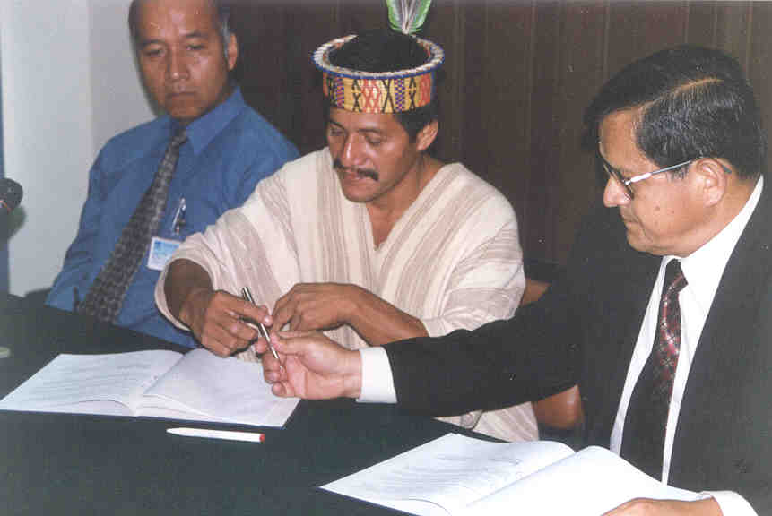
The Asháninka Community is one of a hundred native communities that exist in Latin America. Like many others, this community has multiple needs in communication, Internet accessibility, training and health. With this agreement INICTEL will be able to develop - together with the native people - many activities with special emphasis in the communication area.

Picture (from right to left): Ing. Pedro Valdivia, Lic. Gerado Castro (Asháninka Chief), Ing. Milton Rios (coordinator)

__________

