 | 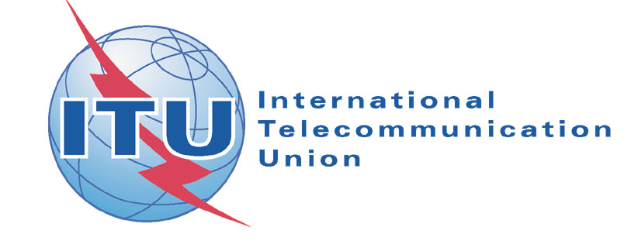  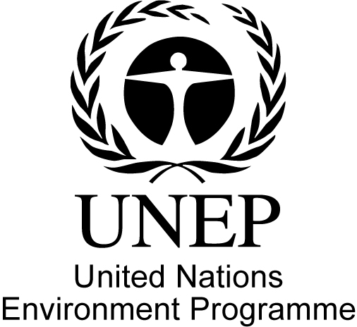
Consultation on facilitation of WSIS Action Line: C7 e-Environment

21 May 2008

Room C2, International Telecommunication Union, Geneva (Switzerland)
9.30 - 12.30

Purpose of the meeting: to provide an opportunity for stakeholders to review progress achieved to date in relation to WSIS Action Line: C7 e-Environment and outline priorities for future action and collaboration in this regard.
The three areas covered by this Action Line are: (a) using and promoting ICTs as an instrument for environmental protection and the sustainable use of natural resources; (b) actions, projects and programmes for sustainable production, consumption and environmentally safe disposal and recycling of discarded hardware and components used in ICTs; (c) establishing monitoring systems, using ICTs, to forecast and monitor the impact of natural and man-made disasters, particularly in developing countries, least developed countries and small economies.

Agenda
0930- 0945 | Opening  - Welcome: Mr. Houlin ZHAO, Deputy Secretary General, ITU  - Opening remarks by the Chair: Mr. Arthur LEVIN, Head, Corporate Governance and Membership Division, ITU
0945 - 1030 | Session 1: ICTs for environmental protection & sustainable use of natural resources  - Delivering low carbon solutions for a low carbon economy, Dr. Kilaparti RAMAKRISHNA, Senior Advisor, Environmental Law and Conventions, UN Environment Programme  - Japanese initiatives on climate change, Mr. Yuji NAKAMURA, First Secretary, Permanent Mission of Japan to the International Organizations in Geneva  - ICTs & climate change, Dr. Tim KELLY, Head, Standardization Policy Division, ITU-T
1030 – 1115 | Session 2: Sustainable production, consumption & e-waste  - The contribution of ICT to climate change mitigation, Mr. Simon MULCAHY, Associate Director & Head, Information Technology Industries, World Economic Forum  - Global e-Sustainability Initiative, Dr. Luis NEVES, Head, Sustainable Development and Environment, Deutsche Telekom  - ICT resource-efficiency and e-waste, Dr. Guido SONNEMANN, Programme Officer, Division of Technology Industry and Economics, United Nations Environment Programme
1130 – 1215 | Session 3: Early warning & disaster response systems  - Disaster prevention monitoring in a vulnerable environment, Mr. Mahabir PUN, Vice Chairman, Nepal Research and Education Network  - Managing & moving weather, water & climate information in the 21st century, Dr. Jean-Michel RAINER, Director, Information System Branch, World Meteorological Organization  - Role of ICT in disaster management, Dr. Cosmas ZAVAZAVA, Head, Least Developed Countries, Small Island Developing States & Emergency Telecommunications, ITU-D
1215 - 1230 | Concluding remarks

