ANNEX 3

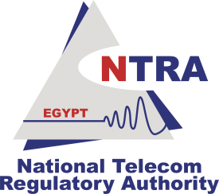 | Expert Level Training on Telecom Network Cost Modeling for Regulators in Arab States Region  Giza-Egypt, 2-6 September 2012 | 

HOTEL RESERVATION FORM
(to be submitted before 15 August 2012)
(CAPITAL LETTERS)
1. Mr. / Mrs.
(Family name) (First name)
2. Country :

3. Address :

4. Tel.:__________________ Fax: __________________ E-mail :

PLEASE SEND DIRECTLY TO THE HOTEL CHOOSEN

5. Specify name of hotel
Hotel Fax No.
Booking of a single room
Booking of a double room
from to
for nights

6. Arrival Date :
Day: _____________ Time : _________________ Flight No. : ________________
7. Departure date :
Day : ____________ Time : _________________ Flight No. : _______________

Date : Signature :

To be returned before 15/08/2012, to: to:  ---------------------------------------------------------------------------------------  cc:  (only for reception at the airport) | the hotel choosen  ---------------------------------------------------------------------------  Mrs. Maha BADR  NTRA, Egypt  Tel: +202 35 34 41 08  Fax: +202 35 34 41 55 / 104  E-mail : mahab@tra.gov.eg

