E-GOVERNANCE INITIATIVES – INDIA

“The Government would implement a comprehensive programme to accelerate e-governance at all levels of the Government to improve efficiency, transparency and accountability at the Government-Citizen Interface.” – Hon’ble Prime Minister’s Declaration on Independence Day - 15th August 2002.

India has been harnessing the benefits provided by the Information & Communication Technologies (ICT) to provide integrated governance, reach to the citizens faster, provide efficient services and citizen empowerment through access to information. The aim is to redefine governance in the ICT age to provide SMART GOVERNANCE. Several significant initiatives have been taken at the Centre and the State level in this direction.

At the Central level, the government has extensively promoted the use of IT in managing its internal processes and has drawn up a ‘Minimum Agenda of e-Governance’. Further Ministries / departments have provision of 2 to 3 percent of their annual budgets to be spent on IT related activities. The government has enacted IT Act 2000 which provides legal status to the information and transactions carried on the net.

Several State Governments have also taken various innovative steps to promote e-Governance and have drawn up a roadmap for IT implementation and delivery of services to the citizens on-line. The applications that have been implemented are targeted towards providing G2B, G2C and B2C services with emphasis on use of local language. The prominent sites where information can be accessed have been indicated at Annexure. An illustrative list with details of some significant e-governance initiatives / projects implemented is given below.

Project: Bhoomi
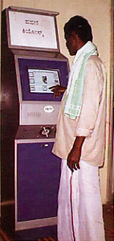
Description: The Department of Revenue in Karnataka State has computerized 20 million records of land ownership of 6.7 million farmers in the State. Previously, farmers had to seek out the Village Accountant to get a copy of Record of Rights, Tenancy and Crops (RTC) – a document needed for many tasks such as obtaining bank loans. There were delays and harassment. Bribes had to be paid. Today, for a fee of Rs. 15, a printed copy of the RTC can be obtained online at computerized land record kiosks (Bhoomi centers) in 177 taluk offices. This system works with the software called “BHOOMI” designed fully in-house by National Informatics Center, Bangalore. The Department of Information Technology, Govt. of India has embarked upon a major programme to rollout Land Records Computerisation in several States of the country.

End Users/Beneficiaries: Rural People

State where Implemented: Karnataka

Awards/Appriciation: Silver CAPAM award 2002

www.revedept-01.kar.nic.in/Bhoomi/Importance.htm

Project: e-Seva (electronic Seva)

Description: Launched on the 25th of August 2001, electronic seva (e-Seva) is the improved version of the TWINS project launched in 1999, in the twin cities of Hyderabad and Secunderabad in Andhra Pradesh. There are currently 36 eSeva centres spread across the twin cities of Hyderabad and Secunderabad and Ranga Reddy district, operating from 8:00 am to 8:00 pm every day and between 9:30 am and 3:30 pm on holidays. 70 centers are in operation at different municipalities covering thirteen districts. eSeva centres offer 118 different services like payment of utility bills/taxes, registration of births/deaths, registration of applications for passports , issue of births/deaths certificates, filing of Sales Tax returns, Trade licenses of MCH, B2C services like payments of Tata Teleservices, Reliance, sale of Airtel Magic cards. These services can be availed at any counter in the centre and at any place in the city. 21 more services like railway reservations, TTD services, bill payments of Airtel, Hutch etc. are in the pipe line. Though the e-Seva had a very lukewarm response from the citizens, the initiative has picked up tremendous confidence on the way and has so far netted a thumping collection of close to Rs 2,000 crore (February-end 2003) from a meagre collection of Rs 43 lakh in August 2001.The government has rolled out the project to other parts of the state, including rural areas like the West Godavari district.

End Users/Beneficiaries: Populace

State where Implemented: Andhra Pradesh (Hyderabad and Secunderabad and Ranga Reddy district)

www.esevaonline.com; www.ap-it.com/eseva.html; www.westgodavari.org

Project: CARD
Description: The Computer-aided Administration of Registration Department - CARD in Andhra Pradesh is designed to eliminate the maladies affecting the conventional registration system by introducing electronic delivery of all registration services. CARD was initiated to meet objectives to demystify the registration process, bring speed, efficiency, consistency and reliability, substantially improve the citizen interface etc. Six months following the launch of the CARD project, about 80% of all land registration transactions in AP were carried out electronically. Since 60% of the documents, Encumbrance Certificates (ECs) and certified copies relate to agricultural properties, the success of the CARD project has great benefit for the rural farming community. CARD is operational at 387 Sub-registrar offices in the entire state of Andhra Pradesh since 1998.

End Users/Beneficiaries: Populace

State where Implemented: Andhra Pradesh

http://www.ap-it.com/cards.html

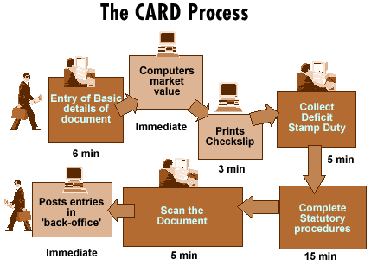

Project: FRIENDS
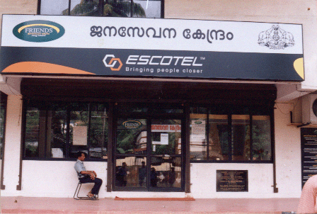
Description: Fast, Reliable, Instant, Efficient Network for the Disbursement of Services is part of the Kerala State IT Mission. FRIENDS counters handle 1,000 types of payment bills originating out of various PSUs. The payments that citizens can make include utility payments for electricity and water, revenue taxes, license fees, motor vehicle taxes, university fees, etc. Firewalls safeguard data from manipulation. The application has provisions for adding more modules and for rolling back incorrect entries without affecting the database even at the user level. One important feature of FRIENDS is a provision for adding more modules and a queue management system.

End Users/Beneficiaries: Populace

State where Implemented: Kerala

http://www.friendscentre.net/
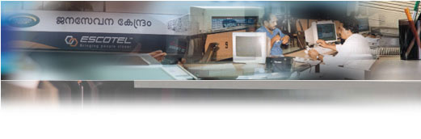

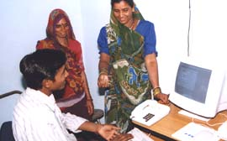
Project: Gyandoot
Description: The Gyandoot project was initiated in January 2000 by a committed group of civil servants in consultation with various gram panchayats in the Dhar district of Madhya Pradesh. Gyandoot is a low cost, self-sustainable, and community-owned rural Intranet system (Soochnalaya) that caters to the specific needs of village communities in the district. Thirty-five such centres have been established since January 2000 and are managed by rural youth selected and trained from amongst the unemployed educated youth of the village. They run the Soochanalayas (organised as Kiosks) as entrepreneurs (Soochaks); user charges are levied for a wide range of services that include agricultural information, market information, health, education, women’s issues, and applications for services delivered by the district administration related to land ownership, affirmative action, and poverty alleviation. Kiosks are connected to the Intranet through dial-up lines, which are soon to be replaced by wireless connections using CorDECT technology. The Soochanalayas have been equipped with Pentium multimedia colour computer along with dot matrix printers. The user interface is menu based with information presented in the local Hindi language and the features of the Gyandoot software are continuously being updated.

End Users/Beneficiaries: Rural People

State where Implemented: Madhya Pradesh

Awards/Appreciation: Stockholm Challenge Award 2002; CSI National IT Award

www.gyandoot.nic.in

CERT-IN (Indian Computer Emergency Response Team)

Description: The Indian Computer Emergency Response Team (CERT-In) has been established by the Department of Information Technology to be a part of the international CERT community. It has a mandate to respond to computer security incidents reported by the entire computer and networking community in the country alongwith creating security awareness among the Indian cyber-community. "To enhance the security of India’s Communications and Information Infrastructure through proactive action and effective collaboration."
CERT will:

- Serve as a central point for responding to computer security incidents and provide a reliable, trusted, 24-hour referral contact for emergencies.
- Increase awareness and understanding of Information security and computer security issues among Indian cyber user community.
- Alert the community on latest security threats in the form of advisories, vulnerability notes and incident notes.
- Serve as a coordination center among organisations to solve computer security issues.
http://www.cert-in.org.in/

Project: VidyaVahini
Description: This portal provides the opportunity for schools, teachers and students all across the nation, to express and share their creative and academic potential via the internet. The portal aims at creating such an environment by providing facilities for Content Development, Content Deployment and collaboration.




Shiksha India is a non- profit organization launched in December 2001 to equip schools with the 5 Cs: Computers, Connectivity, Coaching (teacher Training), Content and models of Commercial sustainability. Its mission is to spread better education, uniform quality of education across India to develop their creativity and problem solving skills. By providing computer literacy, Shiksha strives to increase the earning capacity, reduce information arbitrage in rural India and promote entrepreneurship.

Shiksha India is working in partnership with The Ministry of Information Technology in the project Vidya Vahini and Ministry of Human Resources under the CLASS scheme which aims to connect 60.000 schools (approximately 20 million students) across the country in next five years.

http://www.vidyavahini.ernet.in/content/shiksha.htm

Controller of Certifying Authorities (CCA)
Description: Controller of Certifying Authorities (CCA) as the “Root” Authority certifies the technologies,infrastructure and practices of all the Certifying Authorities licensed to issue Digital Signature Certificates.
CCA is an organization, which issues public key certificates. Controller is the Root certifying authority responsible for regulating Certifying Authorities (CAs). The role of CCA is for secure e-Commerce and e-Governance. It must be widely known and trusted,must have well defined Identification process before issuing the certificate, must have well defined methods of assuring the identity of the parties to whom it issues certificates, must confirm the attribution of a public key to an identified physical person by means of a public key certificate, always maintains online access to the public key certificates issued, provides online access to all the certificates issued, provides online access to the list of certificates revoked, displays online the license issued by the Controller, displays online approved Certification Practice Statement (CPS) and must adhere to IT Act/Rules/Regulations and Guidelines.
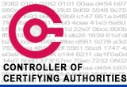


http://www.cca.gov.in/index.jsp

Project: LOK MITRA (Integrated Citizen Service Centre / e-Kiosks ICSC)
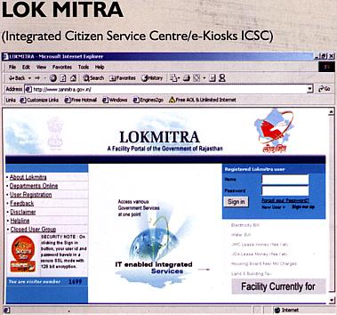
Description: Lok Mitra is the first of its own kind of Electronic service in the state of Rajasthan. It aims to deploy Information Technology for the benefit of the masses. It is a one-stop, citizen friendly computerized centre located in the heart of the city at Government Hostel, Jaipur. This has provided relief to a common man as he gets efficient services through IT driven interfaces at a single window.
It is an e-governance project in which the computer server is linked to different Departmental servers through Dedicated Leased Line & Dial-up Network with multiple e-counters, which can handle all services. It has facility of making payments through Internet using Credit Card.

End Users/Beneficiaries: Populace

State where Implemented: Rajasthan

http://www.rajasthan.gov.in/it/eg/lokmitra.shtm; http://www.lokmitra.gov.in

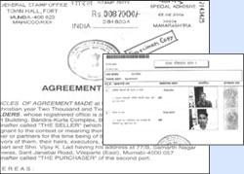
Project: STAMPS & REGISTRATION SOFTWARE
Description: The Stamps and Registration Department of a State is typically one of the top revenue earners for any Government. Stamp & Registration software provides efficient government citizen interface, and also enables enhanced revenue earnings for the Stamps and Registration operation. The heart of this application consists of the Registration and Valuation module. Other modules are the Networking and Scanning modules that enable exchange of information securely across departments, and "electronic copying" of the registered documents thereby enabling return of the original document within few minutes of presentation.
The stipulated turnaround time is approximately 25 minutes; 15 minutes for registration and 10 minutes for scanning the document (Before getting computerized, it used to take many hours and sometimes days). The project after being successfully run for IGR, Maharashtra in Pune sites, is being proposed to be implemented in BOT (Build Operate Transfer) basis with participation from private parties.

End Users/Beneficiaries: Populace

State where Implemented: Maharashtra

www.mahaigr.org

Project: SETU- A bridge for facilitation between Citizen & Government
Description: Harnessing the benefits of Information Technology for effective and transparent functioning of the administration is one of the core focus areas of the IT policy of the Government of Maharashtra. IT offers the possibility of making routine interactions faster, smoother and transparent.
The Integrated Citizen Facilitation Centres (SETU) is an approach in this direction. At present there are multiple points of interaction between the citizen and individual departments spread over so many different Government offices. A one-stop service center for all such routine matters must be made available.
The Integrated Citizen Facilitation Centres (SETU) is to work on these very basic needs of the citizens and reorienting our administrative processes accordingly. The aim is to lay the foundation for e-governance, create visible impact of the intention of the Government in this direction, and facilitate the interaction of the citizens with the Government to make it more transparent, pleasant and satisfying.

To create foundation for citizen centric e-governance, at district headquarters & subsequently at taluka headquarters
- Single window clearance of 83 important certificates (includes renewal of leases, permits & licenses)
- Quick redressal of public grievances
- Common registry of letters, petitions for all sections of the office.
- On line pendency monitoring of all above
- To provide services after office hours & on holidays also in order to save Time, Money & Energy of the public.

End Users/Beneficiaries: Populace

State where Implemented: Maharashtra

http://setu.maharashtra.gov.in

Project: JAN MITRA
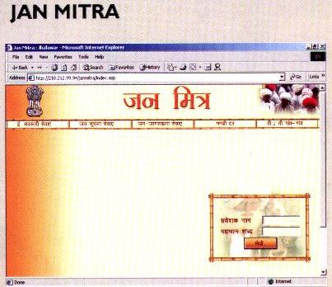
Description: Jan Mitra is an Integrated e-platform through which rural population of Rajasthan can get desired information and avail services related to various government departments at kiosks near their doorsteps. To achieve this end, a system has been integrated using IT tools. This project has been successfully implemented on pilot basis in Jhalawar, Rajasthan. Jhalawar is the first district among five project location districts in India, where the project has been implemented before schedule.

Services
- E-Governance Services
Public Grievance Redressal System, Online Submission of Application forms and Land & Revenue Records.
- Public Information Services
- Ongoing Development Works, Public Distribution System, BPL List, Electricity Priority Connection List, Drinking Water Resources, Village Schemes, Citizen Charters and Immovable Property rates
- Public Awareness Services
- Health Information, Agriculture information, Education information and Animal Husbandry Information
- Agriculture Mandi Rates Daily Mandi rates and Weekly / Monthly Mandi rates
- Village to Village Services Gram Haat and Event Information
- Messaging Services e-mail Facility across Departments / Kiosks and Broadcasting of Bulletin.
- MIS for District Collectorate and District level officers for effective monitoring of information flow.

End Users/Beneficiaries: Rural People

State where Implemented: Rajasthan

http://www.rajasthan.gov.in/it/eg/Janmitra.shtm

Project: DRISHTEE-Connecting India Village by Village
Description: Drishtee's software platform enables e-governance and provides information about and access to education and health services, market-related information, and private information exchanges and transactions. Drishtee offers its network platform to any service provider who wishes to market its range of services to rural India by plugging their application in with Drishtee's s/w offered directly at the village level. Thus, the Drishtee offering is wide in scope and highly scalable. It aims to be the 'window to the world' for Indian villagers. Drishtee services not only provide financial benefits in terms of reduced costs and increased incomes, but also other social benefits like access to education and health information. Drishtee kiosks provide viable employment opportunities for unemployed rural youths and help stem rural-urban migration.
Drishtee is an organizational platform for developing IT enabled services to rural and semi-urban populations through the usage of state-of-the-art software. Using a tiered franchise and partnership model, Drishtee is capable of enabling the creation of approximately 50,000 Information Kiosks all over India within a span of six years. These kiosks would potentially serve a market of 500 million people, with aggregate discretionary purchasing power of Rs. 100 billion (Rs. 10,000 crores). In less than two years, Drishtee has successfully demonstrated its concept in over 90 kiosks across five Indian states. It is a state-of-the-art software which facilitates communication and information interchange within a localized intranet between villages and a district center. This communication backbone has been supplemented by a string of rural services for example, Avedan, Land Records, Gram Daak (mailing software), Gram Haat (virtual market place), Vaivahiki (Matrimonial), Shikayat (online grievance redressal), Mandi Information System and a host of other customized services.
These services are provided through Drishtee in a village (or a group of villages) by a local villager, who owns the kiosk after having it financed through a Govt. sponsored scheme. The employment thus generated leads to a new breed of IT literate generation (45,000 kiosk owners by 2003) who can pay for their meager loans (not more than 75K) with their earnings (reasonable to high) and become a role model for the younger generation.

End Users/Beneficiaries: Rural and semi-urban people

States where Implemented: Haryana, Punjab, Madhya Pradesh, Gujarat, Orissa

Awards/Appreciation: Social Enterprising Award 2002

http://www.drishtee.com

Project: WebCITI (Web based Citizen-IT Interface)
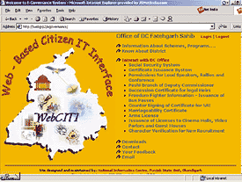
Description: An e-Governance project for building citizen-IT interface for services offered by district administration at Fatehgarh Sahib in Punjab and also provides complete workflow automation in District Commissioner’s office. WebCITI provides web based interface to citizens seeking services from district administration. These include issuance of certificates such as death/birth, caste, rural area etc; licenses such as arms license, permission for conferences/rallies etc and benefits from socio-economic schemes. The Project has been appropriately funded by Govt of Punjab and has been executed through NICSI/NIC-Punjab State Unit. WebCITI has been augmented with DialCITI (Dialup based Citizen-IT Interface) to provide status as well as procedural information through telephone. It further extends the cause of providing efficient, transparent & quick information to the citizens. One can have information on any services or status of his case or application on phone. One can also find information about various schemes and procedures, status of one’s application etc. through web Interface available through select intranet counters at developmental block / revenue tehsil and kiosks.

End Users/Beneficiaries: Population (Rural and Urban)

State where Implemented: Punjab (Fatehgarh Sahib)

Project: AARAKSHI
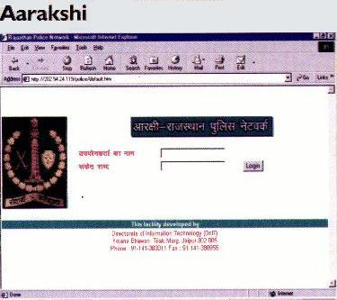
Description: Aarakshi is an Intranet based system that has been develped and implemented for Jaipur City Police. This innovative system enables the city police officers to carry out on-line sharing of crime & criminal data bases, carry out communication and perform monitoring activities.
The Software provides a facility to update & perform queries on database of:
- FIRs.
- Latest News of criminals & Crimes.
- Telephone Directory of Police Officers.
- Messaging.
- Instructions of Police Control Room on Real Time basis.
- Habitual offenders details along with photo gallery.
- Description of criminals.
- Missing Persons.
- Police Personnel.
- Property Details.
- Numbered / Unnumbered property.
- Vehicle theft / Seizure.
- Cultural Propert.

End Users/Beneficiaries: Jaipur police Officials

State where Implemented: Rajasthan

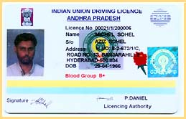
Project: FAST - Transport Department Automated
Description: The ‘Fully Automated Services of Transport’ is another e-governance project implemented in the cities of Andhra Pradesh. The objective of FAST is to make the transport department citizen friendly in its functioning and provide SMART services to the public. It is intended to build comprehensive database and provide on-line services to the public covering all gamut of services of Transport Department like Issue of Driving Licenses, Registration of Motor Vehicles, Issue Permits, Collection of Motor Vehicle Taxes, etc. All the offices in the state would have inter-connectivity through APSWAN.
It is decided to take up computerization process in two phases. In phase I, Regional Transport offices of Secunderabad, Vijayawada and Chittoor have been covered on pilot basis. The remaining offices are to be covered in the second phase. However, a less powerful central server is to be located at the office of the Transport Commissioner for the purpose of inter-connectivity between these three RTO offices.

End Users/Beneficiaries: Populace

State where Implemented: Andhra Pradesh

www.aptransport.org

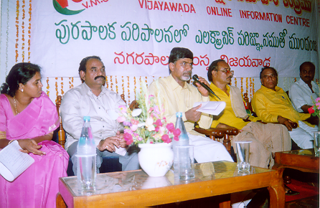
Project: VOICE (Vijayawada Online Information Centre)
Description: Launched in June 1998 and implementation was completed in December 1999 to deliver municipal services such as building approvals, and birth and death certificates, to the people of Vijayawada. It also handles the collection of property, water and sewerage taxes. The VOICE system uses five kiosks located close to the citizens. These are linked to the back end processes in the municipal offices through a wide area network. The application has helped reduce corruption, made access to services more convenient, and has improved the finances of the local government.
Shri Chandrababu Naidu, Chief Minister, Andhra Pradesh addressing at VOICE Inauguration
End Users/Beneficiaries: Populace

State where Implemented: Andhra Pradesh

www.ap-it.com/voice.html

Project: MUDRA (MUnicipal corporation towards Digital Revenue Administration)
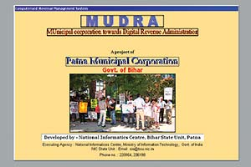
Description: The system will be useful for the Holding owners, Tax collectors, officials at headquarter levels and Circle levels. They will have total picture of tax collection that will help the decision makers to take suitable decision for further improvement. It is designed to computerize the over all functions of tax collection system of Patna Municipal Corporation.
Revenue management is the key to economic stability and development of urban infrastructure. In order to discharge its function properly and cater to the requirements of economic development, the Municipal Corporation and its Municipalities have to generate adequate resources. The basic objectives of this software, developed and implemented by NIC Bihar State Unit includes bringing improvement to the quality of service being offered to the citizens and at the same time, it will also become possible for the first time to track all kinds of defaulters on payment of taxes due. This will assist the Municipal Corporation in acting quickly and well in time and is expected to have a very positive impact on the total revenue that is currently being collected by the Municipal Corporation.

End Users/Beneficiaries: Officials of Municipal Corporation

State where Implemented: Bihar

http://informatics.nic.in/egov.htm#1

Project: KHAJANE (Online Treasury System)
Description: The online treasury project, KHAJANE, computerises all the 216 treasury offices in Karnataka and is connected to a central server at the State Secretariat through VSAT (Very Small Aperture Terminal). It provides regular updates regarding the State expenditure and receipts to the central server. KHAJANE in Sanskrit means treasury.
KHAJANE aims to bring about a more transparent and accountable system of financial transactions and also discipline in operations and management, resulting in efficiency and cost savings for the government. This system eliminates duplication of data entry and maintenance of individual treasuries and enables uniform replication of modified data at the central server.
KHAJANE monitors stocks for stamps and safe custody articles in the state. It also addresses pension payment details for treasury to retired Government staff and social welfare schemes started by the government.

End Users/Beneficiaries: State treasury department

State where Implemented: Karnataka

http://www.karnataka.com/govt/khajane.shtml

Project: eCops (e-Computerised Operations for Police Services)

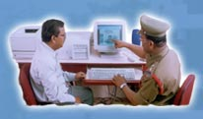
Description: Launched on the 17th of July 2002, as part of the VISION 2020, the state's focus on modernization of police administration takes the shape of eCOPS. It will help police stations reduce paperwork and automate the maintenance of registers, report generation, data analysis, planning and co-ordination, enable the speedy detection of crime and monitor prosecutions. For citizens, the project will lead to online interaction with the police department over the Internet. The central Oracle database of crime records is hosted at the DGP’s office in Hyderabad. This database records information such as FIR (First Information Report) crime detail form, arrest/court surrender, chargesheet and case disposal reports.

End Users/Beneficiaries: Populace

State where Implemented: Andhra Pradesh

www.apstatepolice.org

Project: OLTP (OnLine Transaction Processing)
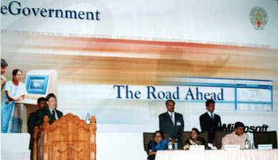
Description: Launched in the year 2002, the project connects 16 government departments in Andhra Pradesh on a single network. All government records and transaction procedure details at the district will be centrally stored and managed on a single Oracle9i database. The project seeks to serve the Government department users and citizens in ten villages of Shadnagar mandal, one village each in Bijnepally and Jadcherla Mandals, Mahaboobnagar District. Citizens in these pilot locales will be able to conduct government department service transactions efficiently through specially designed internet-enabled kiosks. These transactions can be carried out in English as well as Telugu interfaces. These services include access to information such as income verification and income certificates of citizens, land cultivation details, agriculture marketing, tele-veterinary services, registration of small farmers, birth and death records, house numbering, first information reports, occupation details of residents, drinking water details and irrigation sources, etc. Future plans include replication across 1125 mandals of the state in a phased manner.
During the occasion of the visit of Mr. Bill Gates, Chairman and Chief Software Architect of Microsoft Corporation, the Government of Andhra Pradesh launched yet another e-initiative for its citizens in rural areas, OLTP – Online Transaction Processing – thus extending the benefit of information technology to the common man.

End Users/Beneficiaries: Rural People

State where Implemented: Andhra Pradesh

www.ap-it.com

Project: TARAhaat - Achieving Connectivity for the Poor Case Study
Description: This project, named "TARAhaat" after the all-purpose haat (meaning a village bazaar), comprises a commercially viable model for bringing relevant information, products and services via the Internet to the unserved rural market of India from which an estimated 50% of the national income is derived.
TARAhaat combines a mother portal, TARAhaat.com, supported by franchised networks of village cybercafes and delivery systems to provide a full range of services its clients. The subsidiary units include:
- TARAdhaba - will provide the villager connectivity and access to a new world.
- TARAbazaar - will provide access to products and services needed by rural households, farmers, and industries.
- TARAvan - will deliver goods ordered.
- TARAdak - will connect the rural families to the daughter married far off and to the son posted on the front.
- TARAguru - a decentralized university will provide mentoring and consultancy to village-based mini- enterprises.
- TARAscouts / TARAreporter - will collect relevant information for the portal.
- TARAvendor - will run the store that will cater to products available at Tarabazaar.
- TARAcard - will enable the villager to order goods and services on credit.

End Users/Beneficiaries: Rural People

http://www.tarahaat.com/tara/home

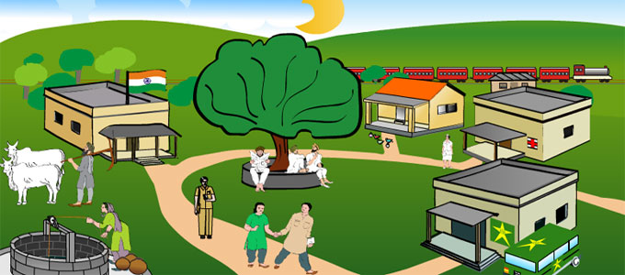

Project: Lok Mitra
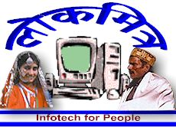
Description: The Lok Mitra project was formally dedicated to the people of Hamirpur in Himachal Pradesh as a pilot phase on the 8th of May 2001. The services offered include information about vacancies, tenders, market rates, matrimonial services, village e-mail. An interesting feature is that citizens can use the IT enabled system as a grievance redress system. The LokMitra INTRANET set up in the district Hamirpur consists of two Pentium-III-based Servers (Under WindowsNT), with 4 Pentium-III-based Client systems and a Router, set up in a LAN using HUB, in a separate room at the Deputy Commissioner office, Hamirpur, named as LokMitra
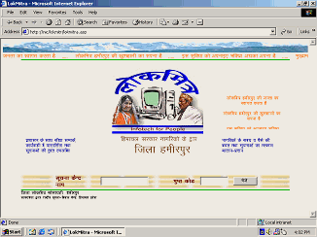
Soochnalaya. A total of 25 panchayats have been identified for setting up Citizen Information Centres. The project will be extended to cover all the districts of Himachal Pradesh.

End Users/Beneficiaries: Villagers

State where Implemented: Himachal Pradesh

www.himachal.nic.in/lokmitra.htm

Project: Mahiti Shakti
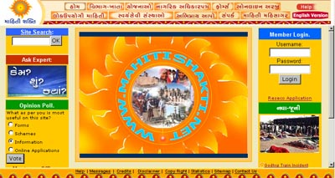
Description: Launched in 2001, the portal http://www.mahitishakti.net/operates like a single window through which the citizens can access information related to all aspects of the government’s functioning, various benefit schemes and services ranging from obtaining ration cards to getting sanction for old age pension. Anyone who wishes to avail the benefit has to go to his/her nearest designated STD/ISD kiosk, submit the necessary documents to the Info Kiosk owner and fill in the required form online. For online submission of application, the Info Kiosk owner charges Rs. 10 for the application form and Rs 20 for submission. The taluks of Halol, Kalol, Santrampur, Jambughoda, Ghogamba, Kahmpur, Lunawada, Morwa and Shahera have such info-kiosks.

End Users/Beneficiaries: Populace

State where Implemented: Gujarat

Project: Warana Wired Villages
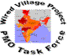
Description: The key objective of the project has been to utilise IT to increase the efficiency and productivity of the existing sugar cane cooperative enterprises by setting up of a state-of-the-art computer communications network. This provides agricultural, medical, and educational information in the local language to villages around Warana Nagar in the Kolhapur and Sangli Districts of Maharashtra. In order to maintain long-term sustainability, 6 months back Warana switched over to the CorDECT technology from the VSAT technology, with 6 or 7 connections already in place. The next 3 months will witness the deployment of the corDECT WLL in 60 more villages.

End Users/Beneficiaries: Villagers

State where Implemented: Maharashtra

www.mah.nic.in/warana; http://www1.worldbank.org/publicsector/egov/warana.htm


Project: Community Information Center
Description: On 22 August 2002, the Prime Minister dedicated to the people of the eight North-Eastern states a new structure of localised governance called Community Information Centres. Each is well-equipped with modern infrastructure, including one server, five client systems, a VSAT, laser printer, a dot matrix printer, modem, LAN hub, TV, webcam and two UPS’. Each center has two CIC operators as managers and for providing services to the public. Basic services to be provided by CICs include Internet access and e-mail, printing, data entry and word processing and training for the local populace. Most CICs charge nominal amounts from users for services, which helps them to meet day-to-day running expenses. To ensure future financial sustainability of this enterprise, it is proposed to use the Community Information Centers for e-entertainment. CIC program was initiated by the Department of Information Technology, Govt. of India and set up at 487 Blocks of the eight North-Eastern states viz. Arunachal Pradesh, Assam, Manipur, Meghalaya, Mizoram, Nagaland, Sikkim and Tripura.

End Users/Beneficiaries: General People

States where Implemented: Arunachal Pradesh, Assam, Manipur, Meghalaya, Mizoram, Nagaland, Sikkim and Tripura

http://arunachalpradesh.nic.in/cic/cicap.htm

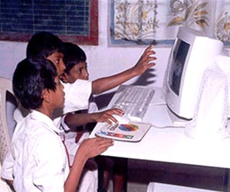
Project: Community Learning Center Project
Description: Set up between March and July 2001, the Community Learning Centre (CLC) is a joint initiative between the Azim Premji Foundation (APF) and the State government of Karnataka. The government contributes towards hardware and other related expenses per CLC and the Foundation take care of management and the training of Young India fellows (YIFs) who manage the CLCs. Each CLC is housed in a separate room in the school and is equipped with five to eight computers. The CLCs are used to enhance classroom learning during school hours. In the first phase in 2001, 35 CLCs were launched in Bangalore, Kolar and Mandya districts. In the second phase beginning 2002, 55 CLCs were inaugurated across 11 districts within one month and in the third phase, 135 CLCs are scheduled to begin operations in 2003.

End Users/Beneficiaries: Students

State where Implemented: Karnataka

www.azimpremjifoundation.org/html/clc.htm

Project: Dairy Information Services Kiosk
Description: The DISK application targeted at the booming dairy sector has been tested for two milk collection societies by the Indian Institute of Management Ahmedabad’s e-governance center. The project consists of two basic components—an application running at the rural milk collection society that could be provided Internet connectivity and a portal at the district level serving transactional and information needs of all members. DISK has helped in the automation of the milk buying process at 2,500 rural milk collection societies and has been pilot tested in two co-operative villages of Amul dairy in Kheda district. Software called AkashGanga has been developed with special features to enable speedier collection of milk and faster disbursement of payments to dairy farmers.

End Users/Beneficiaries: Rural People

State where Implemented: Gujarat

http://www.iimahd.ernet.in/egov/disk.htm

Project: GramSampark
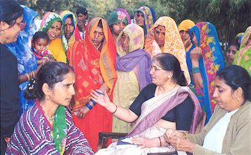
Description: ‘Gramsampark’ is a flagship ICT product of the state of Madhya Pradesh. A complete database of available resources, basic amenities, beneficiaries of government programmes and public grievances in all the 51,000 villages of Madhya Pradesh can be obtained by accessing the website. Gramsampark has three sections-Gram Paridrashya (village scenario), Samasya Nivaran (grievance redress) and Gram Prahari (village sentinel). An eleven-point monitoring system has been put in place whereby programmes are monitored village-wise every month. Four more programmes are under the monitoring system, which includes untouchability-eradication, women’s empowerment, water conservation and campaigns for sanitation.

End Users/Beneficiaries: Villagers

State where Implemented: Madhya Pradesh

www.mp.nic.in/gramsampark/

Project: Akshaya
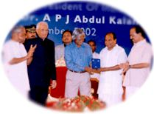
Description: As part of Kerala’s ambitious e-literacy campaign, Akshaya e-Centers are being set up throughout Kerala. These centers will initially provide e-literacy to one member from every household and act as ICT dissemination nodes and ITeS delivery points in every village. All Akshaya e-Centres will have Internet connectivity and will be networked with a centralized operating center. Implementation of the first phase of the project is on in Malappuram district. The second phase involves setting up of over 6,000 e-centers in all districts, expected to be over by December 2004.
His Excellency, the President of India Dr. A.P.J Abdul Kalam inaugurating Akshaya on 18th Nov. 2002
End Users/Beneficiaries: Populace

State where Implemented: Kerala

www.akshaya.net/proj.htm

Project: Headstart
Description: Headstart provides computer-enabled education and basic computer skills for all students in 6000 Jan Shiksha Kendras of Madhya Pradesh. Madhya Pradesh has 6500 Jan Shiksha Kendras (cluster resource centres) located in Middle School premises in 48 districts. Headstart will equip every Jan Shiksha Kendra in the state with computer hardware and multimedia software. It repositions the JSK as a media unit capable of providing computer-aided education for the children of the middle school in which the JSK is located and familiarization to computers to all children in primary schools through simple demos and games to excite their imagination. Among primary schools, EGS school children will come first. For being able to manage this, teachers with a Math or Science background preferably, will be trained across the state through the decentralised training capabilities of the Bhoj Open University.

End Users/Beneficiaries: Students

State where Implemented: Madhya Pradesh

www.bhojvirtualuniversity.com/it/headstart.htm

Project: Saukaryam
Description: Launched in the year 2002, Saukaryam, the pilot project of the Municipal Corporation of Visakhapatnam is now being implemented in other parts of the state of Andhra Pradesh as a model e-governance initiative for local governments. Online payment of Municipal dues has been taken up as its first sub-project and other services include, Online Tracking of Building plan Status, Online Filing and Settlement Of Complaints & Grievances, Online Registration of Births and Deaths, Instant Issuance of Birth and Death Certificates, Online Tracking of Garbage Lifting. Every service extended by the city corporation is being extended online. The Saukaryam model has seen the deployment of ICTs in a context where the Municipal Corporation of Vishakapatnam had no resources for computerization.

End Users/Beneficiaries: Populace

State where Implemented: Andhra Pradesh

www.saukaryam.org

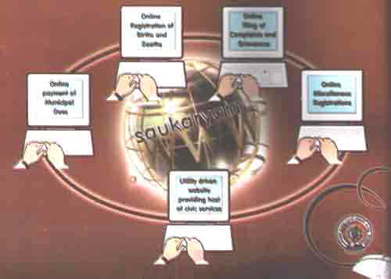

Project: E-Chaupal
Description: started by ITC’s international Business Division as a cost-effective alternative supply chain system to deal directly with the farmer to buy products for exports is getting transformed into a meta market for rural India. The tobacco giant has already set up over 700 choupals covering 3,800 villages in four states — which include Madhya Pradesh, Uttar Pradesh, Karnataka and Andhra Pradesh — dealing with products ranging from soya bean, coffee, acquaculture and wheat.
It is a unique web-based initiative in Central India and caters to Soya growers regarding all information, products and services required in Soya farming. The Soya kiosks facilitate supply of high quality farm inputs and purchase of Soya at the doorsteps of the villagers. The project has started 23 tele-centers in Hoshangabad district of Madhya Pradesh.

End Users/Beneficiaries: Villagers

State where Implemented: Madhya Pradesh

Annexure

List of Prominent websites

http://www.mit.gov.in/
http://www.nic.in/
http://www.dotindia.com/
http://www.darpg.nic.in/
http://www.agricoop.nic.in/
http://www.rural.nic.in/
http://www.commerce.nic.in/
http://www.cdacindia.com/
http://www.cmcltd.com/
http://www.eis.ernet.in/
http://www.rajasthan.gov.in/it/it.asp
http://www.maharashtra.gov.in/english/dit/hrShow.php
http://it.delhigovt.nic.in/
http://www.mp.nic.in/dit/
http://www.ap-it.com
http://chdit.nic.in/
http://bihar.nic.in/ITS/ITScenario.htm
http://www.gujaratindia.com/Initiative/Initiative2.htm
http://haryanait.nic.in/
http://himachal.nic.in/infotech/
http://www.bangaloreit.com/
http://www.keralaitmission.org
http://meghdit.nic.in/
http://orissagov.nic.in/ITdept/itmain.htm
http://www.doitpunjab.gov.in/
http://www.tn.gov.in/department/IT.htm
http://tripura.nic.in/itin3.htm
http://upgov.up.nic.in/infotech/
http://southgoa.nic.in/itindistrict.htm
http://andaman.nic.in/itpolicy.htm
http://chips.nic.in/
http://pondicherry.nic.in/open/depts/infotec/welcome.html
http://www.itwb.org
http://www.ap-it.com/principlesegovernment.pdf
http://www.ap-it.com/egovtoppchan.pdf
http://www.iimahd.ernet.in/~egov/links.htm
http://www.rajcomp.net/
http://www.bangaloreit.com/html/egovern/egovern.htm
http://www.himachal.nic.in/lokmitra2.htm
http://www.tiruvaruronline.com
http://www.indiachi.com/archive1.htm

