Fixed-Mobile Interconnection:

The Case of India

This case study has been prepared by Lara Srivastava of the Strategies and Policy Unit of the International Telecommunication Union (ITU) and Sidharth Sinha of the Indian Institute of Management. This study is part of a series of Telecommunication Case Studies produced under the New Initiatives program of the Office of the Secretary General of the ITU. The fixed-mobile interconnection case studies program is under the direction of Dr. Tim Kelly <tim.kelly@itu.int>, Coordinator, Strategies and Policy Unit, ITU, and is managed by Lara Srivastava <lara.srivastava@itu.int>. Other country case studies on fixed-mobile interconnection in Finland, India, Mexico and Uganda, can be found at <http://www.itu.int/interconnect>. This study is based on field research conducted between 27 March and 7 April 2000, as well as on various reports, articles and electronic correspondence. The authors are grateful to the numerous people who provided input to the report, particularly T.V. Ramachandran, Harsha Singh and T.H Chowdary (for a list of people and organizations who participated in the field research, see Annex 1). The opinions expressed in this study are those of the authors and do not necessarily reflect the views of the International Telecommunication Union, its membership or the Indian Government.

CONTENTS

1. Welcome to the Subcontinent 6
1.1. Geography and Demographics 6
1.2. Human Development 6
1.3. Political Economy 7
2. The Growth of the Indian Telecommunications Sector 7
2.1. Historical Perspective 7
2.2. Basic Services 8
2.2.1. Network Development 8
2.2.2. Introduction of Competition 11
2.2.3. Tariff Structure 11
2.3. Trends in PSTN and International Traffic 14
2.4. Restructuring the Regulatory Framework 15
2.4.1. Recent Reforms 15
2.4.2. Regulatory Trends 17
3. THE Evolution of Mobile 18
3.1. Licensing Mobile 18
3.2. Market Structure 19
3.3. Growth of Mobile Services 21
3.4. Trends in Usage and Traffic 26
3.5. Interconnection Issues 26
3.6. Future Developments 27
4. Tariff Reform and Interconnection 28
4.1. Restructuring Mobile Tariffs 28
4.2. Fixed-Mobile Interconnection 29
4.2.1. Points of Interconnection 30
4.2.2. Access Charges 30
4.3. The Proposal for a Calling Party Pays (CPP) Regime 31
4.3.1. TRAI’s CPP Consultation and Order 31
4.3.2. Legal Proceedings against the TRAI’s CPP Order 33
4.3.3. Amendment to the TRAI Act 34
5. Internet and Wireless Access 35
6. Concluding Remarks 39
Annex 1: List of Participants 41
Annex 2: Links to Related Websites 44

Figures
Figure 2.1: Main Telephone Lines and Demand for Services 9
Figure 2.2: Total Telecommunications Revenues (US$ million) 10
Figure 2.3: Metered Call Tariff for Urban Subscribers. 13
Figure 2.4: Number of Telephone Metered Call Units (in billions of units) 14
Figure 2.5: International Telephone Traffic (in millions of minutes) 15
Figure 3.1: Annual Growth in Total Mobile Subscribers since 1997 21
Figure 3.2: Monthly Growth in Total Mobile Subscribers since April 1999 22
Figure 3.3: Recent Growth in Circle Subscribers 22
Figure 3.4: Recent Growth in Metro Subscribers 23
Figure 3.5: Proportion of Mobile as Percentage of Total Connections in India 23
Figure 3.6: Proportion of Mobile as Percentage of Total Lines in Selected Low Income Countries (1998-1999) 24
Figure 3.7: “Mobiledensity” in Selected Low Income Countries (1998) 24
Figure 3.8: 1998-1999 ARPU for Selected Metros (in Rupees per annum) 25
Figure 5.1: 1999 India Internet Subscriber Base and Forecast (in millions) 36
Figure 5.2: India Internet Subscriber Break-Up by Residential and Commercial segments (1999-2003) 37
Figure 5.3: E-commerce Transactions in India (US$ Million) 38

Tables

Table 1.1: Selected Social Indicators 6
Table 1.2: Selected Economic Indicators 7
Table 2.1: Teledensity in India 9
Table 2.2: International Settlement Payments (US$ Million) 11
Table 2.3: Charges for Basic Telecom Services 12
Table 2.4: Call Tariffs (per minute) as stipulated by the TRAI Order 12
Table 2.5: DoT/DTS’s Revised Local Call Tariffs 13
Table 2.6: Incoming and Outgoing International Traffic (millions of minutes) 15
Table 2.7: The old TRAI and the new TRAI 16
Table 2.8: National Policy Targets for Network Development 17
Table 3.1: License Fee Schedule for Metros 19
Table 3.2: Mobile Operators in the Metros 19
Table 3.3: Mobile Operators in the Circles 20
Table 3.4: Trends in ARPU (per month) 25
Table 3.5: Annual Minutes of Usage (millions) for Circle Regions(Financial Year 1998-99) 26
Table 3.6: Annual Minutes of Usage (millions) for Metro Regions (Financial Year 1998-1999) 26
Table 4.1: Changes in Mobile Tariffs as set out in the Fifth Amendment (September 1999) 28
Table 4.2: Fixed to Mobile Tariffs as set out in the Fifth Amendment (September 1999) 28
Table 4.3: Data on “Actual” CAPEX and Operating Expenses provided by Operators (1997-98) 29
Table 4.4: Projected Cost of Rentals and Usage for Metro Operators 30
Table 4.5: Fixed-Mobile/Fixed-Fixed Tariffs (US$ per minute) 32
Table 4.6: Details of TRAI Proposed Revenue-Sharing Arrangements 33
Table 5.1: Key ISP Players 35
Table 5.2: Internet dial-up tariffs in South Asian countries 36

Welcome to the Subcontinent
One thing is certain. Indian statistics astound most readers and, as will be seen in this study, the telecommunications sector is no exception. Essentially, it is the vastness of the spaces, the size of the populations and the, as yet, low development of all facilities, including mobile telecommunications, that are striking. And at the same time, the mind leaps to a utopian development of all manner of possibilities. Therein lies the interest and excitement of the future of mobile telecommunications in India.

Geography and Demographics
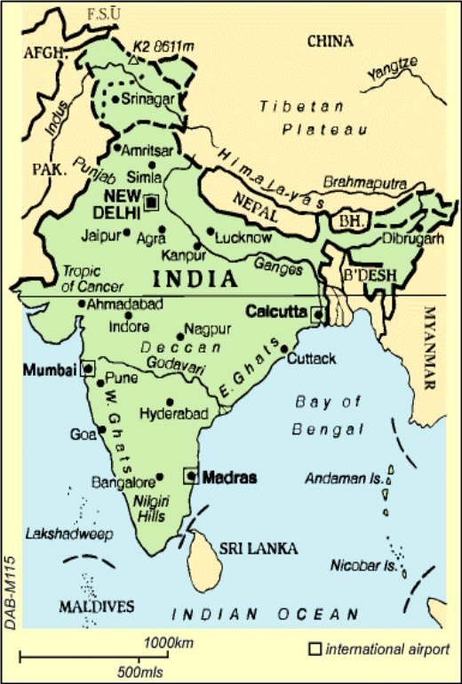
India is one of the world’s oldest civilizations and its largest democracy. It is a country of tremendous ethnic, linguistic and cultural diversity. Twenty-five states and seven union territories make up India’s federation, and each differs vastly from the other in terms of language, culture, natural resources and economic performance. English is the principal language of business and administration, a legacy from colonial times. Home to a billion people, India’s land mass covers 2.4 per cent of the world’s surface, or 3.38 million square kilometers. This makes it about the same size as Europe. Put together, its population is growing at 1.7 per cent p.a. and its labour force by 2.0 per cent p.a. India’s high-consumption middle class is 300 million strong.
India has come a long way in addressing famine, poverty, illiteracy and high fertility rates. However, World Bank estimates still place India’s poverty rate at 34 per cent despite high economic growth. India’s per capita incomes are also lower than other Southeast Asian countries, such as Korea, Thailand and Indonesia.

Human Development
India ranks as number 132 out of 174 countries in the United Nations Development Programme (UNDP) Human Development Index (HDI) and is categorized as being in the medium human development group. The HDI is a composite of key indicators of well being including life expectancy, literacy, school enrolment and per capita GDP. The table below provides basic social indicators for the country.

Table 1.1: Selected Social Indicators

Indicator | 1998
Poverty (% of population below national poverty line) | 34%
Urban Population (as % of total population) | 28%
Access to Safe Water (percentage of Population | 81%
Adult Literacy Rate | 53.5% [1997]
Infant Mortality Rate (per 1,000 live births) | 71
Life Expectancy at birth | 62.6 years [1997]
Source: UNDP and World Bank Data

Political Economy
Between 1950 and 1990, under what has become known as “Nehruvian socialism”, the state controlled the most influential sectors of the economy through large-scale public enterprises. The majority of the work force was employed by the state and technological change and innovation was thwarted by powerful labour unions. This affected overall productivity and growth rates. Indian isolationism in the early 1990s led to severe trade imbalances and double-digit inflation. In 1991, the International Monetary Fund (IMF) came to India's assistance with a US$ 2.3bn loan, but attached conditions to this aid, such as the deregulation of markets. The new Indian government under Prime Minister Narasimha Rao gave its full backing to market liberalization and adopted aggressive policy measures. Import duties were lowered, exports were increased, and liberal trade laws were enacted, allowing foreign investors and companies access to industrial sectors. Foreign direct investment in telecommunications over the past nine years has amounted to 8.2 billion US$.
Since 1980, the Indian economy has witnessed a trend growth of 5.8 per cent per annum. In 1998-1999, India’s GDP grew 6 per cent. This represents one of the highest growth rates in the world, up from 5 per cent in 1997-1998. Industrial production has increased by 6.4 per cent between April and November 1999, compared to 3.6 per cent during the same months the previous year. The export sector also witnessed an upward trend and is experiencing double-digit growth after a prolonged period of low or negative growth: exports between April and November 1999 rose by a robust 12.71 per cent. India is expected to rank fourth among industrial nations by 2020. In terms of GNP (adjusted for purchasing power parity), it is already the fifth largest economy after the US, Japan, China and Germany. Agriculture accounts for about a third of the country’s GDP and employs a third of the population. The national currency is the Indian Rupee, which is currently worth about 2.2 US cents. Table 1.2 provides a selection of economic indicators for India.
India has undergone substantial changes to its economy since its independence from Britain over 50 years ago. From a closed protectionist strategy, emphasizing import substitution and government intervention, India has moved over the last decade to a market economy characterized by foreign investment and liberalization initiatives. The heavy involvement of the public sector in the economy has gradually declined, and many areas that were previously the exclusive domain of the public sector have been opened up to the private sector. The liberalization of the telecommunications industry is a key example.

The Growth of the Indian Telecommunications Sector

Historical Perspective
It was in 1856 that the first telegraphic network was set up in India. Its initial use was during the First War of Independence the following year. For many years, therefore, the development of telecommunications was driven by military and governmental concerns, rather than consumer issues or commercial factors. This has changed somewhat over the past few years following the implementation of forward-looking liberalization policies.

Table 1.2: Selected Economic Indicators
 | 1998 | 1999
Total GDP (US$ billions) | 431.2 | 468.4
Real GDP Growth | 5.8% | 6.2%
GDP per Capita (US$) | 444 | 475
Government Expenditure as % of GDP | 19.6 | 20.2
Trade Balance (US$ millions) | -10,752 | -13,904
Source: Financial Times Survey from IMF, EIU, Datastream
Until the 1980s, the Department of Posts and Telegraphs (under the Ministry of the same name) had the mandate of regulating and offering telecommunications services. It was governed by the Indian Telegraph Act 1885 and the Wireless Act of 1933. In 1985, the Department of Posts and Telegraph was split up into the Department of Telecommunications (DoT) and the Department of Posts. The DoT was established as the state operator, regulator and licensor. It was only in October 1999 that the activities of the operator and licensor were somewhat separated, by the creation of the Department of Telecommunications Services (DTS). This separation, however, was a largely artificial one.
Although the DoT had been charged with operating telecommunications services, its efforts were seen as insufficient. Initial steps towards corporatisation saw the creation of Mahanagar Telephone Nigam Limited (MTNL), which started offering basic fixed services in Mumbai and Delhi in 1987. MTNL still holds a monopoly in those cities, where DoT/DTS is not present at the local level. MTNL is wholly owned by the Government of India and the DoT. Videsh Sanchar Nigam Limited (VSNL) was set up in 1986 as the monopoly operator for international gateway services.
On May 13, 1994, the government opened local basic and value-added telecommunications services to competition. Mobile services were introduced on a commercial basis in November 1994. India was thus divided into 21 “Telecom Circles”. Circles correspond approximately to states and are categorized as either “A”, “B” or “C” according to size and importance. Category A includes the heaviest volume areas such as Delhi, Uttar Pradesh, Maharashtra, Gujarat, Andhra, Karnataka and Tamil Nadu. Licenses for mobile services were also issued for the four metros (Delhi, Mumbai, Chennai, Calcutta). As part of the license conditions, traffic could be routed to VSNL’s international gateway only by passing through DoT/DTS’s network. In 1986, the Telecom Commission was set up with the mandate to accelerate the deployment of telecommunications services and to implement new telecommunication policy.
A bill passed in 1995 envisaged the creation of an independent and autonomous agency for the regulation of telecommunications, the Telecommunications Regulatory Authority of India (TRAI). Set up in 1997, the TRAI is responsible facilitating interconnection and technical interconnectivity between operators, regulating revenue sharing, ensuring compliance with license conditions, facilitating competition and settling disputes between service providers. The TRAI cannot grant or renew licenses and this remains the DoT’s responsibility. The TRAI may also set the rates for telecommunications services. Its decisions can only be challenged by the High Courts or Supreme Courts of India. Due to significant industry and government pressures, the TRAI has recently been restructured and this is discussed in greater detail in Section 2.4 below.

Basic Services
This section discusses the development of basic services in India. The growth of mobile telephony and Internet services are taken up in Chapters 3 and 5 respectively.

Network Development
The DTS and MTNL fixed telecommunications network is made up of 27,160 telephone exchanges with a switching capacity of about 32.6 million lines. There were 21.59 million main lines in India at the end of 1999, which makes it home to one of the largest telecom networks in Asia. There has been an increase of 21.3 per cent as compared to the preceding year (see Figure 2.1). More recent figures (April 2000) put the number of fixed connections at 22.63 million. As of April 2000, 374,605 Village Public Telephones (VPTs) had been set up across the country, representing a coverage of about 61.7 per cent (out of a total of 607,000 villages). The Metro regions are well serviced with 76 per cent of the total number of lines, the rest being in the circles.
Although the registered demand for telephone connections has steadily increased over the last decade, waiting lists, especially in rural areas, have yet to be substantially reduced. The year 1998-1999, however, saw the greatest reduction in waiting lists from 2.7 million to 1.9 million, and it is hoped that the new targets set by the NTP 1999 will be reached by the joint effort of public and private basic operators.

Figure 2.1: Main Telephone Lines and Demand for Services

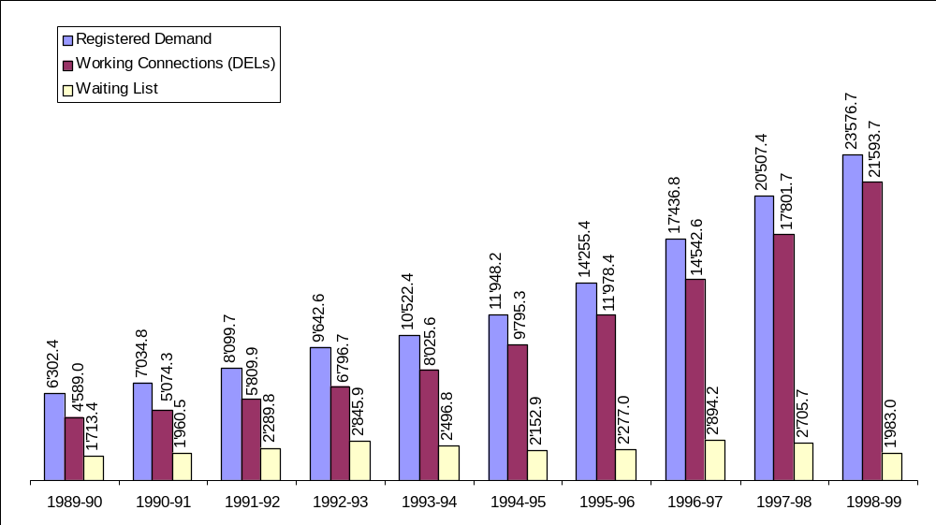

Source: DoT

Efforts to expand network development were significant in 1999. Trunk automatic exchange capacity was enhanced by 206,500 lines, 14,009 Route Kilometres (RKMs) of microwave were added and an additional 31,771 RKMs of optical fibre were laid. However, over the years, despite an aggressive NTP on universal access, India’s teledensity remains low at around 2.2 per cent (Figure 2.1), and has only increased of 0.7 percentage points since 1986. China and Thailand have higher teledensity rates, at 6.96 per cent and 8.35 per cent respectively. High income countries usually have between 45 and 75 per cent teledensity.
There are 830,000 Public Call Offices (PCOs) in India, 500,000 of which are in urban areas. However, much headway needs to be made in terms of the deployment of VPTs and both the public and private fixed line operators have consistently been falling short of their VPT targets (see Box 2.1).

Table 2.1: Teledensity in India
 | Population (millions) | Teledensity (Main Lines per 100 inhabitants)
1990-1991 | 846 | 0.60
1994-1995 | 908 | 1.07
1995-1996 | 927 | 1.29
1996-1997 | 943 | 1.54
1997-1998 | 959 | 1.86
1998-1999 | 975 | 2.20
1999-2000 | 991 (proj.) | 2.28 (proj.)
Source: Extrapolated from CMIE (Centre for Monitoring the Indian Economy) and the DoT

Box 2.1: Falling Short of Universal Service Targets
In 1999-2000, DoT added 3.07 million new DELs, of which 33,965 were VPTs. This represents just over 1 per cent of their roll-out and 75 per cent of their 45,000 VPT target. Of the private operators, Bharti Telnet is the only operator to have installed VPTs. Private operator licenses include the obligation that a minimum of 10 per cent of private DELs should be VPTs, which is a substantially higher proportion than for DTS. This would mean a requirement for Bharti of 10,000 VPTs – it has thus far set up 10, representing 0.01 per cent of its total network roll-out. Private operators are finding the requirement onerous, due to the high capital investment needed, the practical difficulties of accessing some remote and topographically difficult areas, and the shifting nature of human settlements. The NTP 1999 has, however, provided for a USO (Universal Service Obligation) Fund, the principles of which remain to be finalized. The TRAI is expected to release a Consultation Paper on the subject by the Fall of 2000. Operators argue that in order to make universal service a reality, there should be no restrictions on technology use and operators should have the freedom to use VSATs, LMDS, or high-frequency systems with wider coverage.
Source: DoT, ABTO (Association of Basic Telephone Operators)

Table 2.1 Teledensity in India

India has only one international operator, the publicly owned Videsh Sanchar Nigam Limited (VSNL), which currently operates through four main gateways at Mumbai, Calcutta, Delhi and Chennai. It also has additional gateways at Jallandhar, Kanpur, Gandhi Nagar, Hyderabad, and Ernakulam. These are connected to each other via dedicated leased lines from the DoT/DTS. VSNL’s International Telephone/Telex circuits operate via 7 satellite Earth Stations, located at Delhi, Mumbai, Dehra Dun, Arvi, Korattur, Calcutta and Bangalore. The number of circuits has increased from 17,922 in March 1999 to 19,253 at the end of 1999. More than 85 per cent of VSNL’s revenues are derived from basic services. VSNL began offering INMARSAT satellite services in May 1992. Total telecommunications revenues, broken down by service, are laid out in Figure 2.2.

Figure 2.2: Total Telecommunications Revenues (US$ million)

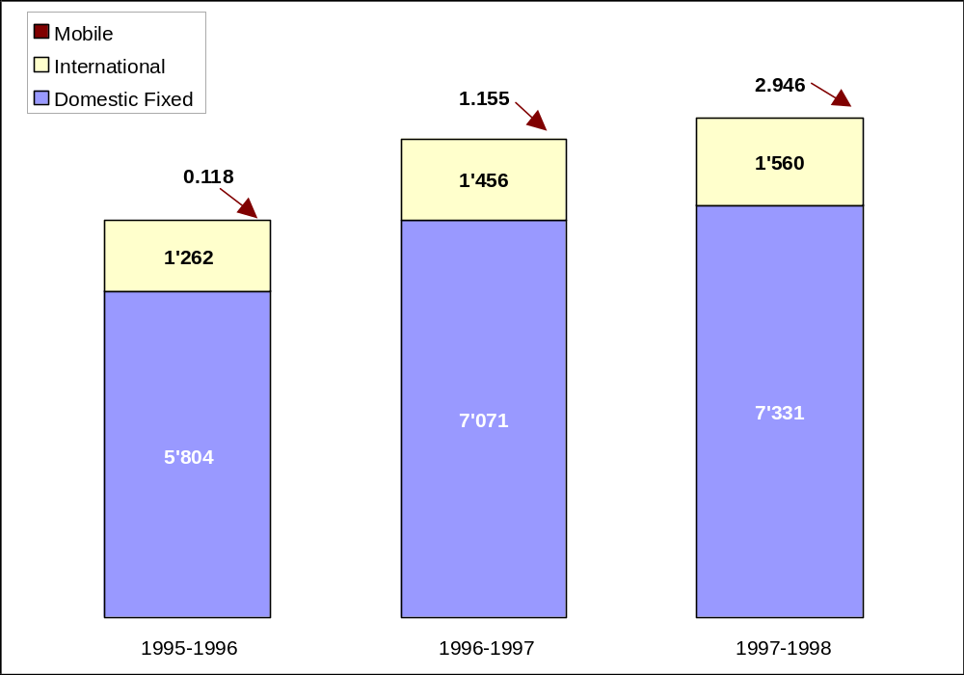

Source: DoT, COAI

Table 2.2: International Settlement Payments (US$ Million)
 | 1998-99 | 1997-98
Settlement receipts | 1018 | 928.4
Settlement payments | 381.5 | 356.4
Net receipts | 636.4 | 572.0
Source: VSNL Annual Report as per International Accounting Standards

Introduction of Competition
Interestingly, unlike many other countries, India first introduced competition in local or regional markets. Domestic long-distance services have not yet been liberalized, despite an initial regulatory deadline of 1 Jan 2000. This is currently being reviewed by the TRAI. The government’s attempt to break the monopoly of DTS and MTNL in the local market began in January 1995 when it invited private bids for 21 basic “circle” licenses. Ten bids were accepted in the first round of private bidding but only five were taken up: Delhi, Haryana, Maharashtra, Orissa and Uttar Pradesh (West). In the second round, bids were invited for 13 circles. Bids received at that time were awarded in five circles: Andhra Pradesh, Bihar, Gujarat, Punjab and Tamil Nadu. The third round of bidding for nine circles resulted in only one company bidding for, and being awarded, the Madhya Pradesh circle. 5-6 years later, only 6 operators have signed license and interconnect agreements for the circles: Bharti Telenet (Madhya Pradesh), Tata Teleservices (Andhra Pradesh), Hughes Ispat (Maharashtra), Shyam Telelink (Rajasthan), ECL Telecommunications (Punjab) and Reliance Telecom (Gujarat). However, only the first three operators have launched their services commercially. Bharti now boasts 100,000 DELs, Tata 24,000 DELs and Hughes 26,000 DELs. Put together, this represents less than 1 per cent of lines owned by DTS/MTNL. Thesse operators are using Wireless Local Loop (WLL) technology for the initial phases of their network rollout. As investment grows, WLL will be gradually replaced by a wireline network. Although WLL is a more costly solution than cable or copper, it is being used as a transitional technology allowing the new operators to respond quickly to demand for services.

Tariff Structure
After the TRAI was created in 1997, the mandate for fixing telecommunications tariffs shifted from the DoT to the TRAI. Tariffs for basic services include the following components: deposit and registration fee, bi-monthly rentals, charges for local calls (which are in excess of the relevant “free calls” basket), and charges for national and international calls. National long-distance calls (subscriber trunk dialing or STD) are metered and charged according to the time of call and the distance covered.
The current tariff structure provides for significant cross-subsidization of local rates by national and international long-distance rates, and of rural rates by urban rates. The structure for basic services is the same for business and residential users. One of the interesting features of telecommunications tariffs in India is that there is a higher rate per call as the number of calls increases. In other words, high-usage subscribers pay more for each call than low-usage subscribers. With the entry of new private fixed operators, this cross-subsidy may evolve, and new ways of ensuring “universal service” may need to be developed. The DoT’s main argument is that the concept of universal service requires the subsidization of low-income and low-usage subscribers. However, it must be noted that a significant proportion of the population in India lives in poverty, and telephone access is still considered a luxury in most areas. Any consideration of universal service and cross-subsidization should reflect this general context.
The last increase in tariffs, of around 20 per cent, occurred in May 1994. Since 1982, tariffs have been increasing at a cumulative annual growth rate (CAGR) of approximately 8 per cent, almost at par with the long-term inflation rate. In its consultation paper of September 1998, TRAI argued that cross-subsidies were unsustainable in a competitive environment and were resulting in an inefficient allocation of resources. Therefore, the primary objective of the tariff review process was to rebalance tariffs and move them closer to costs. The argument was made, however, that some deviation from cost-based prices would have to continue in order to encourage access and use of basic services.

Table 2.3: Charges for Basic Telecom Services
 | Existing Tariffs | Tariff Order
Monthly Rental¹ | Rs 50 – 190  (US$ 1.12 – 4.26) | Rs 70 – 310  (US$ 1.57 – 6.94)
Local calls² | Rs 0.60 - 1.40  (US$ 0.01 – 0.03) | Rs 0.80 - 1.20  (US$ 0.02 – 0.03)
Long distance³  (per minute) | Rs 0.46 – 42  (US$ 0.01 – 0.94) | Rs 1.20 - 30/25.20/21.60  (US$ 0.03 – 0.72/0.56/0.48)
International⁴  (per minute) | Rs 42 – 84  (US$ 0.94 – 1.88) | Rs 30 - 61.20 (US$ 0.72 – 1.37)  Rs 25.20 - 49.20 (US$ 0.56 – 1.10)  Rs 21.60 - 40.80 (US$ 0.48 – 0.91)
Notes: 1:The maximum rental is applicable for exchanges with a capacity of 100,000 as opposed to 300,000, as was previously set out. 2: The pulse rate has been reduced from 5 to 3 minutes. The number of free calls per month was reduced from 125 to 75 for rural areas and from 75 to 60 for urban areas. 3. The maximum long distance rate will decrease from Rs.30 to Rs.21.60 by April 2001. 4. The international rates will decrease further in April 2000 and April 2001. 5. As of June 2000, 100 Rs = 2.24 US$ and 2.34 Euros.
Source: DoT
In March 1999, the TRAI issued its Telecommunications Tariff Order, which aimed at re-balancing rates for basic telecommunications services. The order called for an increase in rentals and local rates, and a reduction in long-distance rates. In terms of methodology, the TRAI would have rather used the Long Run Incremental Cost (LRIC) method, but given the lack of relevant information, it used Fully Allocated Costs (FAC) as a starting point. The TRAI attempted to cost the various basic services by allocating all capital and operating costs across four categories – rental, local calls, long distance and international calls. The analysis used a ‘representative’ cost estimate for the current capital costs of the local network and long distance transmission network. Operating cost estimates are based on historical costs. The allocation of costs was based on estimates of the number of minutes of local, STD and international calls (because the DoT does not precisely measure the minutes of local and STD calls). All in all, it is clear that the TRAI was faced with a severe information problem in its costing exercise.
The TRAI 1999 Order restructured the tariffs for basic telecom services in the following manner:
- There was an increase in rentals, mainly to account for inflation and increase in real GDP per capita, since rentals were last revised in 1993. Rentals continued to be below the fully allocated cost, and the difference between the cost of rentals and rental charges is to be recovered through above-cost international and domestic long-distance charges.
- There was an increase in local call charges to cover the operational cost of the local network allocated to local calls.
- The tariff for domestic and international long distance calls was reduced. However, these continue to be above cost in order to cover the deficit on rentals.
Table 2.3 gives the charges for basic telecom service before the TRAI Order and those proposed by the Order and Table 2.4 gives the detailed structure of tariffs per metered call as per the TRAI Order.

Table 2.4: Call Tariffs (per minute) as stipulated by the TRAI Order
 | Free Calls per month | First 500 metered calls per month (“except for free calls”) | Metered calls in excess of the first 500 per month
Rural | 75 | Re 0.80 (calls 76-500)  (US$ 0.0179) | Rs 1.20  (US$ 0.027)
Urban | 60 | Rs 1.00 (calls 61-500)  (US$ 0.022) | Rs 1.20  (US$ 0.027)
Note: “except for free calls” is the terminology used by the TRAI to designate unmetered calls.
Source: TRAI

Table 2.5: DoT/DTS’s Revised Local Call Tariffs
Rural Subscribers | Urban Subscribers | Call Rates
1 to 125 calls | 1 to 75 calls | FREE
126-225 calls | -- | 0.60 (US$ 0.013)
226-250 calls | 76-200 calls | 0.80 (US$ 0.018)
251-500 calls | 201-500 calls | 1.00 (US$ 0.022)
500 + calls | 500+ calls | 1.20 (US$ 0.027)
Source: DoT
It seems that universal service considerations were being addressed by the TRAI order in two ways. First, rentals were kept below the cost worked out by the TRAI and the excess of rental cost over actual rental charge was added to the cost of long distance and international calls. The TRAI also devised a category of “low user subscribers”, those making up to 1,000 calls bi-monthly, which constitute about 70 per cent of the total subscribers. The rental for this category will remain unchanged for the period April 1999 to March 2002, even though it is scheduled to increase for other categories of consumers. The low-user category was designed to improve the targeting of universal service. Second, with regard to usage charges, for the first 500 calls (except for free calls) the charge is Rs. 0.80 per call for rural areas and Re. 1.00 per call for urban. For calls above 500 per month the charge is Rs. 1.20 per call.
The DoT strongly opposed the reduction in long distance and international charges and argued that this would have an adverse impact on profitability. This proposal was not fully implemented by the DoT, which announced an alternative tariff structure for basic services for a period of one year (from 1 May 1999 to 31 March 2000). This tariff structure did not include any increase in rental or call charges for rural or low-usage urban subscribers, and did not decrease the free call limits from existing levels. The line rental for high-usage urban subscribers was set at the TRAI’s recommended Rs. 120, except for exchange systems of up to 100 lines, for which DoT fixed the rate of Rs. 70. Long-distance rates were reduced by 20 per cent for domestic long-distance (STD or subscriber trunk dialing) and 21 per cent for international calls (ISD or international subscriber dialing), in line with the TRAI Order. The revised local call charges are set out in Table 2.5 and Figure 2.3.

Figure 2.3: Metered Call Tariff for Urban Subscribers.
(I
n Rupees, per call, according to the number of calls (slab) per subscriber)
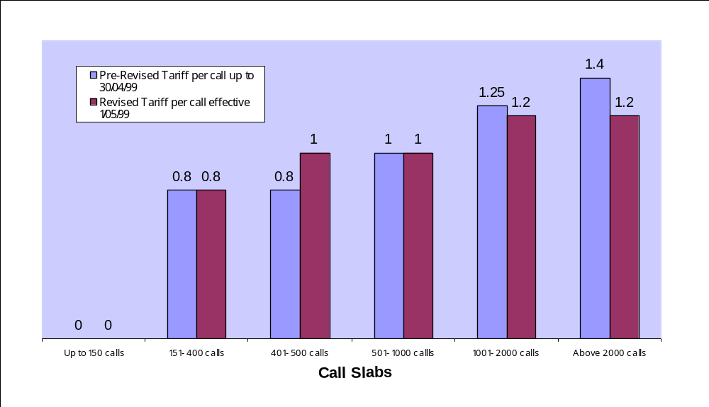

Source: DoT
It was estimated that the combined effect of these revisions would still lead to a decrease in DTS’s revenues for the year. To address this, the government issued a policy directive to the TRAI, asking it to review the tariff structure and its effect on the NTP 1999 for the two years following.

Trends in PSTN and International Traffic

The amount of PSTN traffic in India has been increasing over the years, and represents a compound annual growth rate of 21.1 per cent. A very small proportion of Indian subscribers, about 20 per cent, are responsible for generating 80 per cent of the total traffic. These subscribers usually come from middle or high-income classes. Figure 2.4 shows the growth of telephone usage in India since 1989.
International traffic has also grown steadily, at an average of about 15.5 per cent per year (see Figure 2.5). However, India still has a much higher volume of incoming international traffic than outgoing international traffic (see Figure 2.6). This is due in part to the large proportion of Indian expatriates overseas (numbering over 15 million), the lower cost of calls originating overseas and the considerably higher per capita incomes.

Figure 2.4: Number of Telephone Metered Call Units (in billions of units)

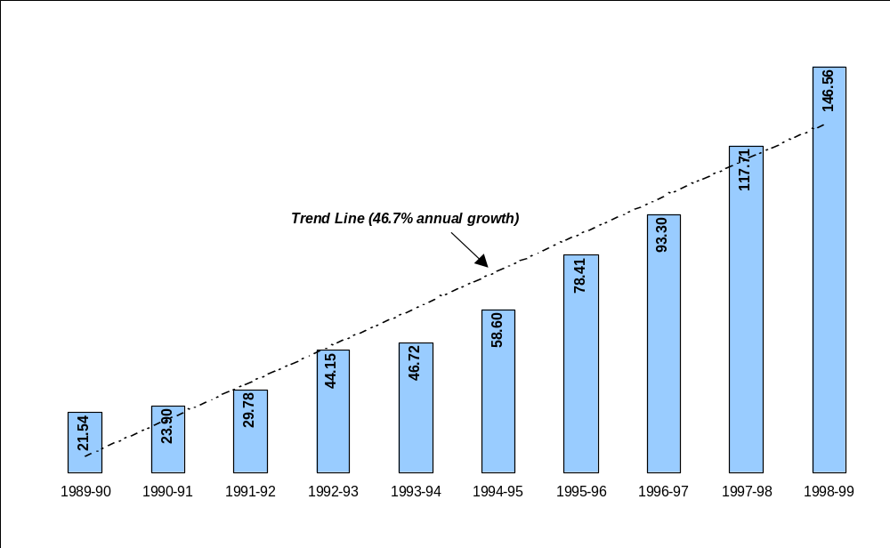

Note: These figures exclude free or “unmetered” calls.

Source: DoT

Figure 2.5: International Telephone Traffic (in millions of minutes)
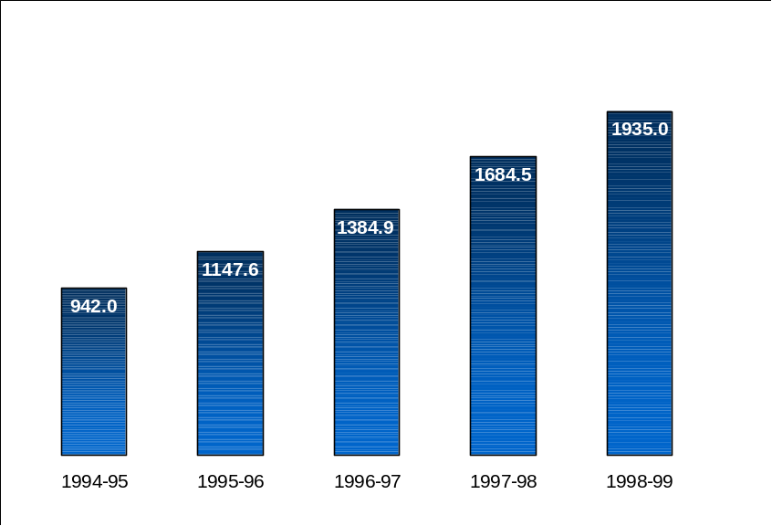

Source: DoT, VSNL

Restructuring the Regulatory Framework

Recent Reforms
In 1997, India made commitments, under the WTO negotiations on basic telecommunications services, to further liberalise its telecommunications sector through the licensing of new local fixed line and mobile service providers. As part of this agreement, the Government reaffirmed its commitment to liberalise the national telecommunications sector through the licensing of new local fixed line operators and mobile service providers. India also committed to review the liberalisation of the national long-distance market in 1999 and the international services market in 2004.
As mentioned earlier, in an effort to separate the service provider from the policy-maker and licensor, the Department of Telecom Services (DTS) was created in late 1999. The DTS is responsible for providing telecommunications services, whereas the DoT retains its mandate as policy-maker and licensor. However, it is to be noted that there is still significant overlap between the activities of the DTS and the DoT. Many observers note that they are still effectively one and the same organization. In fact, many DoT/DTS officials work for both organizations simultaneously. As in the case of China, new entrants find it difficult to obtain a fair treatment from the government due to this close organizational relationship. India’s Telecom Commission was set up to coordinate the activities of the DoT/DTS, in accordance with its mandate. This includes moving ahead with the planned privatization of DTS as India Telecom. It is hoped that this move will serve to reduce the current overlap between the DoT and the DTS.

Table 2.6: Incoming and Outgoing International Traffic (millions of minutes)
Total PSTN Minutes (millions) | 1996 | 1997 | 1998
Outgoing | 384 | 420 | 436
Incoming | 979 | 1’256 | 1’499
Surplus (Deficit) | 595 | 836 | 1’063
Total Volume | 1’363 | 1’676 | 1’935
Source: ITU World Telecommunication Indicators 1999.

On January 24, 2000, the Telecom Regulatory Amendment Ordinance 2000 was issued, forming a smaller TRAI without judicial powers. The ordinance enacted an important amendment to section 11(1), making a clear distinction between the advisory functions of the TRAI and its regulatory functions. Furthermore, the amended Act provided for the establishment of a separate disputes settlement and appellate body, the “Telecom Disputes Settlement and Appellate Tribunal”, which would adjudicate any dispute between a licensor and a licensee, between two or more service providers, and between a service provider and consumers. It would also hear and dispose of any appeals against decisions of the new TRAI, itself reduced in size to one Chairperson, and a maximum of two full-time Member and two part-time Members. The reconstitution of the TRAI followed a decision by the Delhi High Court striking down the TRAI’s revenue-sharing regulation on interconnection enacted in 1999. Following the Ordinance, the Government is required to seek recommendations of the TRAI before issuing licenses. The TRAI will advise the government as to the need and timing of new service providers, and the terms and conditions which should apply to them. The TRAI however, does not have the authority to issue further licenses or the authority to allocate spectrum for wireless communications (see Table 2.7). The process leading up to the restructuring of the TRAI is discussed in further detail in Chapter 4.

Table 2.7: The old TRAI and the new TRAI
 | TRAI- then | TRAI - now
Constitution | Seven-member team, i.e. Chairman and six members | 5 members: 1 chairman, 2 permanent and 2 part-time
Powers & Functions | - Ensure interrelationship between players  - Regulate revenue-sharing arrangements between players  - Ensure compliance with license conditions  - Settle disputes between service providers  - Fix tariffs | The TRAI’s decision would be mandatory for the government in the areas of tariff fixation, interconnectivity including tariffs and technology and laying down quality standards. In the case of granting and revoking licenses, the recommendations of the TRAI would not be binding. Settlement of disputes would be under a newly constructed dispute settlement tribunal
Appeals | Appeals against TRAI orders can be made within 30 days | Appeals would have to be made to the appellate authority
Settlement of Disputes | Though TRAI could settle disputes between service providers, it had no jurisdiction over disputes between private operators and the DoT (now DTS) relating to terms and conditions of a license. This was TRAI’s basic inadequacy | The new appellate authority would adjudicate any dispute between a licensor and a licensee, between two or more service providers, and between a service provider and consumers.
Source: Adapted from Warburg, Dillon, Read

The Indian government has also been setting new policy targets, in an effort to modernize the telecommunications sector. The New Telecom Policy 1999 (NTP 1999) was released in March 1999. The NTP 1999 puts forth firm governmental commitments towards the corporatization of the DoT/DTS, the introduction of competition for domestic long distance services (DLD), and the increase in competition for basic and mobile services. The policy also aims to create a modern and efficient telecommunications infrastructure taking account the convergence of electronics, telecom, IT and media. It commits to a strong and independent regulator and proposes new targets for telecommunications network development. Many of the targets of the National Telecom Policy 1994 (NTP 1994) had to be reconsidered and new objectives were set (see Table 2.8).

Table 2.8: National Policy Targets for Network Development
NTP 1994 | NTP 1999
Telephone should be available on demand by 1997.  All villages should be covered by 1997.  In the urban areas a PCO should be provided for every 500 persons by 1997  All value-added services available internationally should be introduced in India by 1996 | Telephone-on-demand by 2002  Teledensity of 7 per cent by 2005 and 15 per cent by 2010  Rural teledensity from 0.4 per cent to 4 per cent by the 2010  Universal service Obligation resources to be raised through contributions by all operators under various licenses (the level of this contribution is yet to be finalized).  Internet Access in all district head quarters by 2000  High-speed data and multimedia capability using technologies including ISDN to all towns with a population greater than 200,000 by the year 2002.
Source: DoT

Furthermore, the proliferation of new communications technologies such as mobile services led to the creation of a policy framework for “Cellular Mobile Service Providers” (known as CMSPs), covering issues such as interconnection, entry fees, and the introduction of competition. The main elements of the framework are as follows:
- CMSPs would to be granted separate licenses for each service area, for an initial period of twenty years.
- DoT/DTS or MTNL, if desirous, would be licensed as additional operators in each service area. The entry of more operators per service area would be based on recommendations of the TRAI, which will review this once every two years.
- CMSPs would be required to pay a one-time entry fee, and a license fee based on a revenue-sharing agreement (to be recommended by the TRAI).
- CMSPs would be free to provide, in their respective service area, all types of mobile services including voice & text messages, data services and public call offices (PCOs) utilizing any type of network equipment approved by the ITU/TEC.
- Direct interconnectivity between licensed CMSPs and any other type of service provider (including other CMSPs) within their respective service areas, was to be permitted.
- Interconnectivity between service providers in different service areas was to be reviewed in consultation with the TRAI.
- CMSPs would be allowed to directly interconnect with VSNL after the opening of the national long distance market.
- CMSPs would be permitted to provide mobile services – this includes the permission to carry long-distance traffic within their own service area without seeking an additional license.
This is a significant departure from the original license fee regime set out in NTP 1994 for telecommunications services. The new policy allows both mobile and private fixed operators to provide long-distance services within circle areas. Another key point of the policy is the possibility for cable operators to apply for basic licenses, allowing them to provide last-mile linkages and switched services within their areas of operation.

Regulatory Trends
As mentioned above, India made commitments under the under the General Agreement on Trade in Services (GATS) to review further opening up of national long distance service in the year 1999. This commitment was reinforced by the NTP 1999, which declared that the market for domestic long-distance (DLD) should be opened up to competition by January 2000. This, however, has yet to occur. The NTP 1999 requested the TRAI to make recommendations to the government in this regard. The TRAI released its discussion paper in September 1999 and announced its recommendations in December 1999. The Telecom Commission has not yet announced the government’s definitive policy but this is expected by April 2000. The main elements of the TRAI’s recommendation on DLD competition are as follows:
- Creation of a multi-player environment
- Competition limited to facilities-based players
- Entry fee of a one-time Rs 5 billion, with Rs 1 billion in cash and the rest as bank guarantee ensuring roll-out
- Revenue sharing scheme of 5 per cent
- A phased network rollout plan with obligatory coverage of 15-100 per cent of the total long-distance charging areas in the first 2-7 years
- Equal access and interconnection to be provided immediately
Thus far, the DoT/DTS has agreed to the separation of accounts proposed by the TRAI in order to set up a distinct long-distance operator. However, it has objected to both the open competition and the recommended level of revenue sharing, set at 5 per cent of the licensee’s revenue, which it considers sub-optimal. It is not eager to pay license fees equal to that of private long-distance operators. It argues that India’s telecommunications policy does not require the payment of license fees for basic fixed telecommunications. India is awaiting a decision on the corporatization of the DTS, and this is likely to have an impact on any decision regarding DLD.
Another important regulatory development relates to the government’s policy on Internet Service Providers. The policy stated that ISPs should be allowed to operate their own international gateways, and thus be able to lease either satellite transponder or submarine cable capacity for connection to the Internet backbones in other countries. Although the ISP policy was released in 1998, it is only as recently as February 2000 that private ISPs have been given official clearance for setting up International Gateways (see Chapter 6).

The Evolution of Mobile

Licensing Mobile
The DoT invited competitive bids from private sector companies for non-exclusive digital mobile licenses in the early 1990s. The license was to be for an initial 10-year period (renewable for 5 years) in the four metropolitan cities of Mumbai, Delhi, Calcutta and Chennai. Up to two licenses were to be awarded for each of the four metros, with the DoT/DTS reserving the right to offer mobile services in each of these cities. Each bidder was required to have a subscriber base of at least 100,000 and a minimum of three years experience of operating a mobile network as of January 1, 1995. As no Indian company had this breadth of experience, this prerequisite inevitably meant partnering with a foreign company. The foreign partner, whose track record served to fulfill the “experience” requirement, was to have an equity stake of at least 10 per cent. The maximum permissible foreign equity was 49 per cent. The bidders also had to conform to GSM standards (900 MHz spectrum).
In the tender for award of metro licenses, the license fee for the first three years was a given parameter, while the license fee from the fourth year onwards was fixed at Rs. 5,000 per subscriber (based on a unit call rate of Rs. 1.10) and subject to a minimum (see Table 3.1). The amount per subscriber was later revised to Rs. 6,023 based on the revision of the unit call rate. Along with the license fee, call charges were also a given parameter. Other parameters included financial strength, experience of the partners, committed rollout and lowest rentals charged to the customer. The value of lowest rental was determined at Rs. 156 per month. As a result of this process, 8 licenses were issued in the four metros.

Table 3.1: License Fee Schedule for Metros
 | Year 1 | Year 2 | Year 3 | Year 4-7 | Year 8-10
Fee (Rs million) | 30 | 60 | 120 | Max (180, Rs.5’000 per subs) | Max (240, Rs.5’000 per subs)
Fee (US$ million) | 0.67 | 1.34 | 2.68 | Max (4.0, US$ 112 per subs) | Max (8.0, US$ 112 per subs)
Source: DoT
In January 1995, the DoT invited tenders for licenses to provide digital mobile services in 20 circle regions (usually contiguous with states). Two operators were to be licensed in each circle. In the case of circles, rentals and call charges were given the parameters (as in the case for metros) and the bidding was for a levy to be converted into a license fee after the selection. Each bidder had to quote a stream of annual license fees for the license period. The bidders selected for each circle were asked to match the license fee quoted by the highest bidder. As a result of this process, 34 licenses were issued in 18 circles. Many observers considered the winning bids extremely onerous and unsustainable.
The licenses for mobile services stipulated the maximum tariffs that could be charged. The maximum monthly rental was set at Rs.156 per month, the refundable security deposit at Rs. 3,000 and the activation fee at Rs. 1,200. The standard airtime charge was set at Rs. 8.40 per minute, with peak hour rates double and off-peak rates half the standard rate. There was a charge for both incoming and outgoing calls.
The mobile licenses did not provide for the negotiation of interconnection agreements. This was perhaps because mobile operators were treated as ‘franchisees’ and not ‘access providers’. The licenses permit the operator to interconnect with the DoT/DTS’s or MTNL’s fixed line networks and, within the same service area, with another fixed line service provider. However, long distance connections, both domestic (outside the licensed service area) and international (to a VSNL gateway), have to be made through the DoT/DTS or MTNL network. For mobile to fixed calls, the mobile operator collects from the mobile subscriber the airtime charge as well as the local and long distance charges incurred on the fixed network. This call charge is assessed from the point of interconnection between the fixed and the mobile network. The fixed line charges are paid to the fixed line operator on a monthly basis. For fixed to mobile calls, the fixed line operator collects the appropriate fixed line charges and the mobile operator collects the airtime charges from the mobile subscriber receiving the call.
As indicated in Section 2.4, the New Telecom Policy 1999 (NTP 99) of the Government of India provides for a new policy framework for mobile operators (known as CMSPs in India) and implies certain changes to their license conditions. The changes were motivated partly by the inability of many of the circle licensees to obtain ‘financial closure”. Most importantly, the NTP 99 replaces the payment of license fees to the government by a revenue sharing scheme.

Market Structure
As mentioned above, at the time the market for mobile services was opened to competition in 1994, 8 licenses were issued in the four metros (Delhi, Mumbai, Calcutta, Chennai) and 34 licenses were granted for 18 Circles. Tables 3.2 and 3.3 list the licensed operators with their current subscriber base.

Table 3.2: Mobile Operators in the Metros
Metro Region | Licensed Operators | Subscribers (April 2000)
Mumbai | BPL Mobile  Hutchinson Max | 176 906  148 580
Delhi | Bharti Cellular  Essar (ex-Sterling) | 193 983  152 128
Calcutta | Usha Martin  Modi Telstra | 42 673  52 012
Chennai | SkyCell  RPG Cellular | 25 174  33 394
TOTAL |  | 824 850
Source: TRAI, COAI

Table 3.3: Mobile Operators in the Circles
Category | Circle | Licensed Operators | Subscribers  (April 2000)
« A » | Maharashtra | BPL Mobile  Birla AT&T | 65 473  53 098
« A » | Gujarat | Fascel  Birla AT&T | 111 665  39 329
« A » | Andhra Pradesh | Tata Cellular  JT Mobile (now Bharti) | 58 471  46 842
« A » | Karnataka | JT Mobile (now Bharti)  Spice Communications | 52 493  83 616
« A » | Tamil Nadu | BPL Cellular  Aircel Limited | 52 391  45 037
TOTAL « A » |  |  | 608 415
« B » | Kerala | Escotel  BPL Cellular | 59 388  55 453
« B » | Punjab | Spice Communications (Modicom)  JTM/Evergrowth | 99 728  N/A
« B » | Haryana | Escotel  Aircel Digilink | 27 068  N/A
« B » | Uttar Pradesh (West) | Escotel  Koshika | 58 752  N/A
« B » | Uttar Pradesh (East) | Aircel Digilink  Koshika | 27 354  91 437
« B » | Rajasthan | Aircel Digilink  Hexacom | N/A  20 476
« B » | Madhya Pradesh | RPG Cellcom  Reliance Telecom | 12 112  27 848
« B » | West Bengal | Reliance Telecom | 4 356
TOTAL « B » |  |  | 483 972
« C » | Himachal Pradesh | Bharti Telenet  Reliance Telecom | 5 023  529
« C » | Bihar | Koshika  Reliance Telecom | N/A  23 352
« C » | Orissa | Koshika  Reliance Telecom | N/A  9 598
« C » | Assam | Reliance Telecom | 6 246
« C » | North-Eastern States (N.E.) | Reliance Telecom  Hexacom | 802  nil
TOTAL « C » |  |  | 45 550
TOTAL  (All Circles) |  |  | 1 137 937
Source: TRAI, COAI

Since then, and especially since the announcement of the New Telecom Policy in 1999, there has been a growing trend toward consolidation in the Indian mobile industry. The major strands are the following: the Tata, Birla and AT & T joint venture, the extension of the Hutchison group across the metros, and the emergence of the Bharati group as a major player.
The Tatas and Birlas have signed a Memorandum of Understanding to merge their mobile businesses in a joint venture with equal stakes of the Tatas, Birlas and AT&T. AT&T is the joint venture partner in Birla AT&T, which holds mobile licenses for Maharashtra (excluding Mumbai), Gujarat and Goa. Tata Communications holds a mobile license for Andhra Pradesh. For the Tatas, the deal solves the problem of finding a replacement for Bell Canada, which recently divested its 39 per cent holding. AT&T is expected to play the role of technology partner in the joint venture.
The Hutchison Whampoa group of Hong Kong is seeking to establish its dominance in the metros with its Orange brand. It has increased its holding in Hutchison Max, which holds a Mumbai license. In February 2000, it acquired a 49 per cent stake in Sterling Cellular, which owns a Delhi license. Most recently, it has agreed to acquire a 49 per cent stake in Usha Martin Telecom, a Calcutta license holder. With this acquisition, Hutchison will have a presence in three out of the four metros.
Bharati Enterprises, which had Himachal Pradesh and Delhi licenses to begin with, has been extending its presence through acquisitions. It has acquired control of J T Mobile, which holds Karnataka and Andhra Pradesh licenses, and of Skycell, which holds a Chennai license. According to recent press reports, Bharati is also considering acquiring a stake of two other circle operators.
Apart from these new formations, two other groups - BPL and Reliance - continue to have a significant position on the basis of their initial licenses. BPL has licenses for Mumbai and the Maharashtra, Tamil Nadu and Kerala circles. Reliance has licenses for Madhya Pradesh, West Bengal, Assam, Bihar, Himachal Pradesh, Orissa and the North East.

Growth of Mobile Services
Subscriber growth has been relatively steady in both metro and circle regions. There were nearly two million mobile subscribers in India in April 2000. Since 1997, the number of subscribers has been growing at over 50 per cent per year (see Figure 3.1).
In 1998, the average monthly growth in subscribers was 45,000, which slowed down to 25,000 in 1999. The New Year has begun with a rapid acceleration in the number of mobile subscribers, with the latest figures showing an additional 363,000 subscribers since January (see Figure 3.1).

Figure 3.1: Annual Growth in Total Mobile Subscribers since 1997

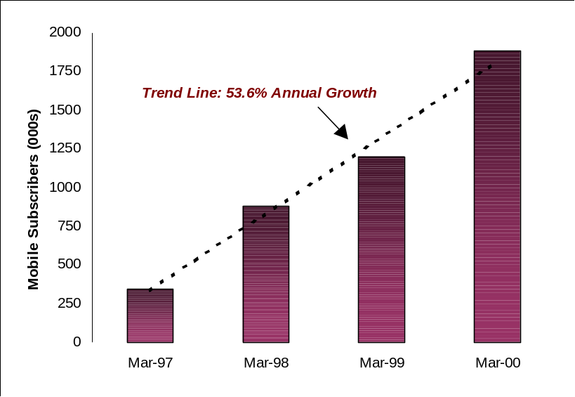

Source: COAI

Figure 3.2: Monthly Growth in Total Mobile Subscribers since April 1999

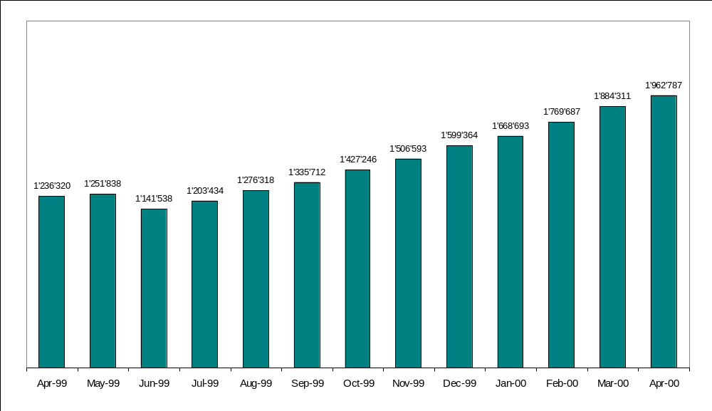

Source: COAI

Although average growth in the circles has been steady, the “C” circle has not witnessed much activity (see Figure 3.3). This is not surprising, given that the states of the “C” circle are characterized by low-income populations and topographically difficult areas. For the metros, Mumbai and Delhi are the fastest growing markets (see Figure 3.4) and have historically accounted for over 75 per cent of the market. However, their market share has been declining over the past two years and is now at 35 per cent. This is an indication that growth may be shifting to the circle regions.

Figure 3.3: Recent Growth in Circle Subscribers

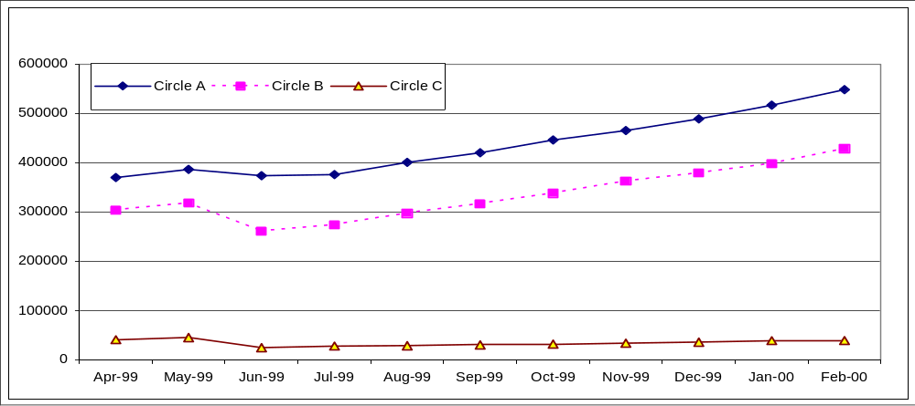

Source: COAI

Figure 3.4: Recent Growth in Metro Subscribers

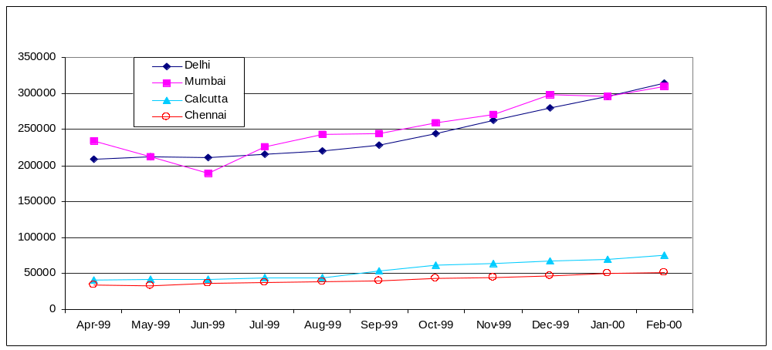

Source: Adapted from COAI

Mobiles represent 7.25 per cent of total connections in India, an increase of over 2 per cent from the preceding year (see Figure 3.5). According to the ITU’s World Telecommunications Development Report, the average proportion for low-income countries was 6.5 per cent in 1998-1999. However, it is to be noted that many other low-income economies have seen their mobile sector develop much more rapidly than India. Examples include Bangladesh, Cambodia and Vietnam (see Figure 3.6 and Figure 3.7).

Figure 3.5: Proportion of Mobile as Percentage of Total Connections in India

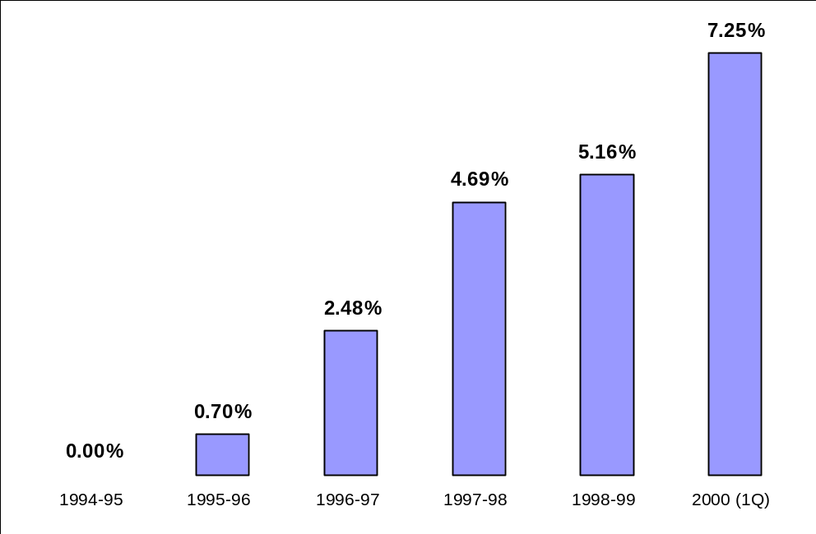

Source: Case Study

Figure 3.6: Proportion of Mobile as Percentage of Total Lines in Selected Low Income Countries
(1998-1999)

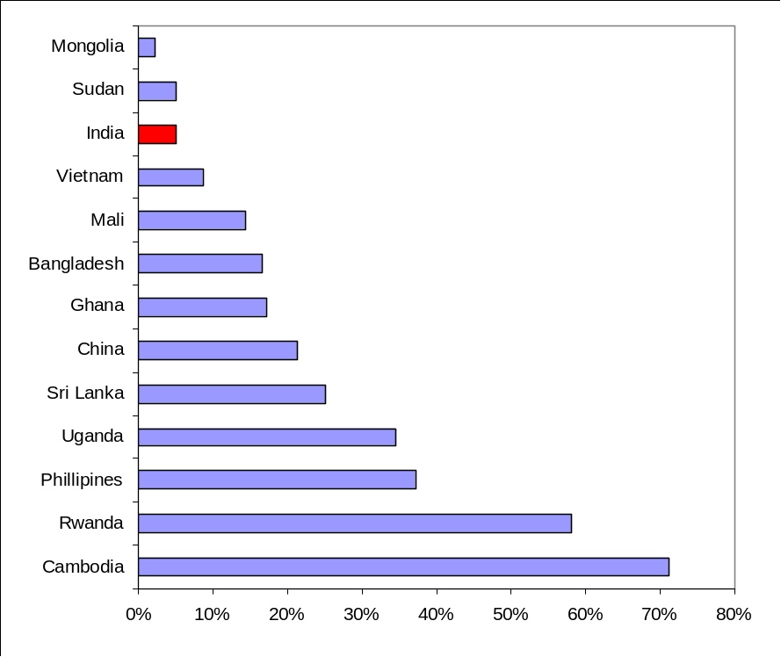

Source: 1999 ITU WTDR

Figure 3.7: “Mobiledensity” in Selected Low Income Countries (1998)

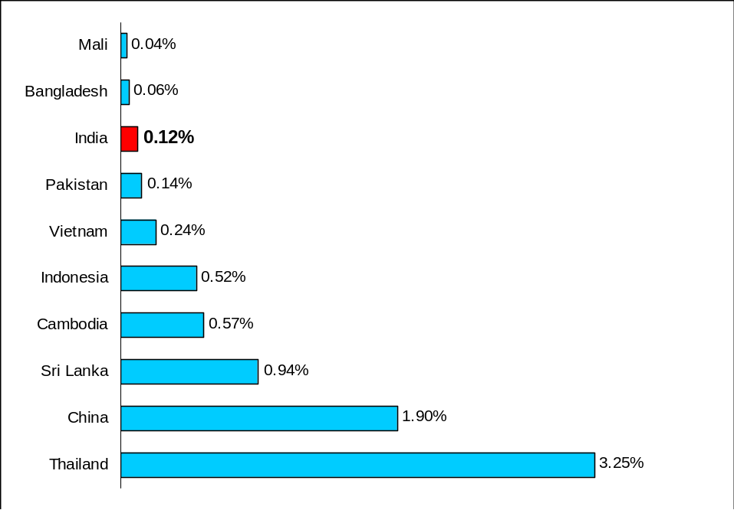

Source: ITU World Telecommunication Development Report 1999

Table 3.4: Trends in ARPU (per month)
 | 1997 |  | 1998 |  | 1999 |  | 2000E |  | 2001E
 | Rupees | US$ | Rupees | US$ | Rupees | US$ | Rupees | US$ | Rupees | US$
Metros | 1396 | 31.27 | 1683 | 37.70 | 1437 | 32.12 | 1600 | 35.84 | 1495 | 33.45
Circles | 758 | 16.98 | 1299 | 29.10 | 1080 | 24.19 | 1200 | 26.88 | 1150 | 25.76
Source: Warburg Dillon Read, (WDR), COAI
Although subscriber numbers will be increasing, revenues from mobile services seem set to decline in India. Average tariffs of Rs 8.0-10.0 per minute in 1996 have decreased to Rs 4.0 per minute. Rentals have recently been reduced by the TRAI from Rs 600 to Rs 475 per month. Value-added services such as roaming generated additional revenue of Rs 100 per month per user. Tariffs for these and other mobile services will continue to fall as competition grows. The years 1996 to 1998 have shown some growth in the average revenue per user (ARPU) for most operators, though few have been able to maintain this growth through 1999. According to data from Warburg Dillon Read (WDR), initial ARPU was Rs 2,256 (US$ 52) per month. This year, it has dropped to Rs 1600 for metros and Rs 1200 for A circles (see Table 3.3). DoT/DTS’s average revenue per DEL in 1999 was about Rs 755/month (US$ 17). Trends in ARPU for various mobile operators in the metros are set out in Figure 3.6.
According to the TRAI’s Consultation Paper on Issues Related to Cellular Mobile Service released in December 1999, all mobile operators have incurred losses since the commencement of their operations. This is due to overly optimistic projections on ARPU, subscriber numbers and usage at the time of bidding for licenses, and also to heavy capital expenditure. Also, procurement costs in many cases were higher than expected. The depreciation of the rupee has also affected project and handset costs, given that the majority of the equipment is imported into India and heavily taxed. Furthermore, the high incidence of interconnection charges, leased line charges and port charges contributed to increased set-up costs. Mobile operators also argue that the absence of any interconnection charges in their favour has made them financially vulnerable. Accumulated losses for Metro service providers were generally less than for Circles providers. This may be due to several factors. For instance, metro projects were kicked off earlier than circle projects and have thus progressed further. Moreover, metro license fees were less onerous than circle fees and the take-up of services in metro areas has generally been faster.

Figure 3.8: 1998-1999 ARPU for Selected Metros (in Rupees per annum)

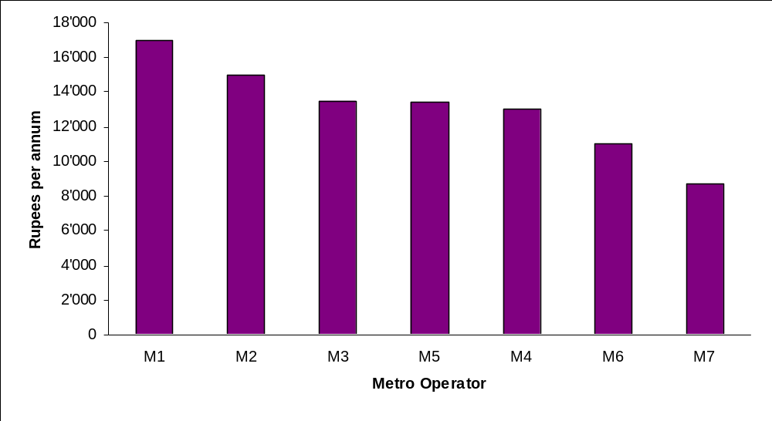

Note: M1, M2, etc. represent various metro mobile operators. The TRAI did not identify the operators.
Source: TRAI

Table 3.5: Annual Minutes of Usage (millions) for Circle Regions(Financial Year 1998-99)
Category | Mobile to PSTN | PSTN to Mobile | Mobile to Mobile | Total
“A” MoU | 75.28 | 104.82 | 26.67 | 206.77
Proportion | 36.4% | 50.7% | 12.9% | 100%
“B” MoU | 209.3 | 145.55 | 51.18 | 406.03
Proportion | 51.5% | 35.9% | 12.6% | 100%
“C” MoU | 17.31 | 7.6 | 5.7 | 30.61
Proportion | 56.6% | 24.8% | 18.6% | 100%
Average | 48.2% | 37.1% | 14.7% | 100%

Source: TRAI

Trends in Usage and Traffic
Information on minutes of use for the circles and metros, as well as the distribution of minutes of use between mobile-to-mobile traffic, fixed-to-mobile traffic and mobile-to-fixed traffic, are shown in Tables 3.5 and 3.6. On the whole, the proportion of fixed-to-mobile calls is about the same as mobile-to-fixed calls. Opponents to the introduction of a CPP regime argue that this will change drastically when mobile subscribers receive calls free of charge. However, the important thing to note about a country like India, is that in the case of mobile phones, the calling and receiving party are generally part of the same closed “community”. In the end, the same individual will bear the cost of the call, as most Indian consumers use their mobile phones to get in contact with members of their extended family or business group. In other words, while the overall cost of using the mobile may be split differently, it will generally be incurred by the same person or company.

Table 3.6: Annual Minutes of Usage (millions) for Metro Regions (Financial Year 1998-1999)
Metros | Mobile to PSTN | PSTN to Mobile | Mobile to Mobile | Total
All Operators | 324 | 351 | 53 | 728
% | 44.5% | 48.2% | 7.3% | 100%

Source: TRAI

Interconnection Issues
It has been said that interconnection is the cornerstone of a truly competitive market. The power to interconnect increases the value of any network and the inability to do so can be a severe barrier to entry. In India, interconnection has been one of the main stumbling blocks for the development of mobile telecommunication. In order to terminate their calls, mobile operators are forced to interconnect with MTNL in Delhi and Mumbai, and DoT/DTS for local and long-distance connections in other regions. They also need access to VSNL’s gateways for routing international traffic. Negotiating effective interconnection has been a daunting task for these operators.
One of the key issues is the access charge, that is to say the tariff that new entrants must pay to incumbents for carrying traffic over their network. At the moment, under the RPP (Receiving Party Pays) regime, fixed operators in India do not pay any access charges for terminating calls on mobile networks. The revenue sharing arrangement between mobile and fixed operators proposed by the TRAI in September 1999 having been overturned by the courts, the current revenue-sharing scheme has reverted back to what was set out in the May 1999 Telecommunications Interconnection Regulation. At present, therefore, fixed line operators (usually the DTS or MTNL) still do not pay any access charges for terminating a call on the mobile network. This is stipulated in a clause found in the license agreement originally signed by private mobile operators. In overturning the TRAI’s CPP tariff proposal, the High Court held that the Authority could only regulate “existing” interconnect agreements and could not introduce entirely new ones. Since there were no existing agreements between the DoT/DTS and private mobile operators, it was held that the TRAI had not jurisdiction to intervene. Since then, the TRAI Act has been amended to give the TRAI more power, but this new legislation has yet to be interpreted by the Courts.
For fixed to mobile calls, the fixed operator does not pay the mobile operators any interconnect fees. In the case of mobile to fixed calls, the mobile operators pay the incumbent fixed line operators the full local call charge of Rs. 1.20 per unit of metered call. The interconnection agreement between private fixed operators and the incumbents, DoT/DTS and MTNL, sets interconnection fees as follows: the private operator pays the incumbent 40 per cent of the unit call charge for domestic STD calls, 55 per cent of the unit call charge for international calls and nothing for local calls. On the other hand, government-owned MTNL only pays an access charge of 22.5 per cent to interconnect with the DoT/DTS network, for both long distance and international calls. Mobile operators argue that there should be no discrimination in terms of access charges between mobile operators, public fixed operators and private fixed operators.
Not only are access charges a significant issue, but so are the technical aspects of interconnection, and both of these aspects are discussed in greater detail in Chapter 4.

Future Developments
The NTP 1999 announces the entry of the DTS and MTNL as the 3rd mobile telephone service providers in every circle and metro region. As such, mobile operators are concerned that the DoT/DTS may be able to deploy mobile services at a lower capital investment, given the infrastructure it already has at its disposal. Furthermore, there is the fear that the DoT/DTS may subsidize operations in certain remote states from surpluses in high-usage circles. This situation will have to be closely monitored by the new TRAI. The DoT/DTS is already running GSM trials in 18 cities.
The DoT/DTS has also reported that it plans to provide over 1 million telephone connections based on wireless local loop (WLL) technology during 2000-2001. This means that of the target of 5.3 million connections for the year (including MTNL targets), a fifth may be provided through WLL systems.
MTNL also launched a mobile service in Delhi in October 1999. Its mobile service is based on CDMA technology, a low-cost alternative to existing mobile services. Private operators opposed the launch of this service, mainly on the grounds of cross-subsidization. However, MTNL has stated that it does not intend to cross-subsidize its mobile service and will pass on all STD revenues generated by its mobile subscribers to the DoT/DTS. MTNL is due to begin mobile services in Mumbai in August 2000.
Another important development to watch for is the TRAI’s current consultation process on universal service. The Authority has not yet released its consultation paper on the subject but it is expected to later this year. The paper will reconsider the obligations imposed on the incumbent operator as well as the private fixed operators. Mobile operators do not currently have any universal service obligations.
The Indian government has also realized that it must take other measures to increase the take-up of mobile services. One of the main deterrents to consumers is the high price of handsets. All mobile handsets are imported into India and are heavily taxed. The recent union Budget, however, reduced the basic import duty on handsets from 25 per cent to 5 per cent. Effectively, this means that the total import duties (that is to say, basic duty, special duty and countervailing duty) have been reduced drastically from 47 per cent to 27 per cent. It is hoped that this will stimulate demand for handsets and also enhance the popularity of new Internet-enabled devices.

Table 4.1: Changes in Mobile Tariffs as set out in the Fifth Amendment (September 1999)
 | Existing Tariffs | New Tariffs
 | Existing Tariffs | Metros | Non Metros
Incoming Calls | Rs 6.0/ min  (US$ 0. 13) | FREE | FREE
Outgoing Calls | Rs 6.0/ min  (US$ 0.013) | Rs 4.0/ first min  (US$ 0.090)  Rs 2.0/ add. 30 sec  (US$ 0.045) | Rs 4.50/ first min  (US$ 0.10)  Rs 2.25/ add. 30 sec  (US$ 0.05)
Rentals | Rs 600/ month  (US$ 13.4) | Rs 475/ month  (US$ 10.64) | Rs 500/ month  (US$ 11.2)
Source: TRAI

Tariff Reform and Interconnection

Restructuring Mobile Tariffs
The current tariff structure for mobile telephony is set out in the TRAI’s Tariff Order of March 1999. The Telecommunications Interconnection (Charges and Revenue-Sharing) Regulation was enacted in May 1999 in order to deal with interconnection charges and revenue-sharing agreements.
Amendments to the Interconnection Regulation in September 1999 attempted to introduce a CPP (Calling-Party-Pays) regime, a new tariff structure and a new revenue-sharing scheme between operators. This Fifth Amendment to the Interconnection Regulation set the retail tariff in metro service areas at peak time at Rs. 4 for the first minute and Rs. 2 for each subsequent 30-second duration. For circle service areas in peak time, the first minute tariff was set at Rs. 4.50 per minute and each subsequent 30-second period at Rs. 2.25. Rentals were also decreased for non-metro regions to Rs. 500. Metro rentals were kept at Rs. 475. The new structure also provided for free incoming calls, in line with the CPP regime. CPP is the most common pricing structure for mobile communications, under which the mobile customer pays for outgoing calls, and the fixed customer also pays for calling the mobile network. The person initiating the phone call is responsible for the cost of each call. Notable exceptions to this regime are found in the United States, Canada and Singapore, where mobile customers pay for receiving calls, and the “Receiving-Party-Pays” regime (RPP) is in effect. Advocates of the CPP regime argue that CPP will make mobile services more affordable to low-end customers and increase airtime in both the prepaid and subscription low-usage end of the market. Even though incoming calls on mobiles would be free, calls from fixed to mobile phones would costs at least twice the previous rate. Also, there would be different tariffs for subscribers in metro and non-metro regions (see Table 4.1 and 4.2). These rates were to be effective 1 Nov 1999. The Delhi High Court overturned the CPP order in January 2000. However, the proposed tariffs were still adopted by mobile operators as incoming and outgoing airtime charges (see Section 4.4).

Table 4.2: Fixed to Mobile Tariffs as set out in the Fifth Amendment (September 1999)
 | Rs 0.8/metered call | Rs. 1/metered call | Rs 1.20/metered call
0-60 secs. | 1.60 (US$ 0.036) | 2.00 (US$ 0.045) | 2.40 (US$ 0.054)
61-120 secs. | 2.40 (US$ 0.054) | 3.00 (US$ 0.067) | 3.60 (US$ 0.081)
121-180 secs. | 3.20 (US$ 0.072) | 4.00 (US$ 0.090) | 4.80 (US$ 0.108)
Source: TRAI

Table 4.3: Data on “Actual” CAPEX and Operating Expenses provided by Operators (1997-98)
 | Maximum | Minimum | Median
Cumulative Capex per subscriber (Rs.)
Metro | 54’335 (US$ 1’217) | 8’862 (US$ 199) | 24’869(US$ 557)
Circle | 1’206’021 (US$ 27’014) | 89’142 (US$ 1’997) | 184’446 (US$ 4’132)
Operating expenses
(Rs. per minute)
Metro | 11.30 (US$ 0.25) | 2.79 (US$ 0.06) | 7.72 (US$ 0.17)
Circle | 190.59 (US$ 4.27) | 28.23 (US$ 0.63) | 66.20 (US$ 1.48)
Source: TRAI
The original tariffs were based on TRAI estimates of cost of access and airtime. The cost of access was based on the cumulative capital expenditure (“capex”) per subscriber. The cost of airtime was based on operating expenses. The TRAI did not see any valid reason for including the license fee in either cost category - if 100 per cent of the license fee was included in the cost of access then the resulting access fee was considered to be too high. On the other hand, if it was included in the cost of airtime, the resulting airtime charges were considered to be too high. The TRAI finally accepted the alternative of allocating 50 per cent of the license fee to access costs and the balance 50 per cent to airtime charges.
The TRAI used cost information provided by the mobile operators. “Actual data” had been provided for the two years 1996-1997 and 1997-1998 and projections for the following four years. As shown in Table 4.3, there is considerable variation in cost between circles and metros, and within the different circles and metros. Given that the data available from the circle operators was limited as was the quality of estimates, TRAI based its the tariff proposals only on metro data. Rentals and airtime charges were calculated using the capex and operating expense forecasts for 1999-2000 and 2000-2001 (see Table 4.4). As mentioned above, the license fee was divided equally between the two cost categories. The TRAI calculated the monthly rental by applying an Annual Recurring Expenditure (ARE) of 30 per cent.
Using the median estimate above, the TRAI fixed a rental of Rs. 600 or US$ 13.4 (compared to an initial rental of Rs.156) and airtime charges of Rs. 6 or US$ 0.13 (initially Rs.16.80) per minute. Both of these are in the nature of price caps. The airtime charge applies to the peak period, which is not to exceed eleven hours. The proposed price cap tariffs of Rs. 600 for monthly rentals and Rs. 6 per minute for air time was used to define a “standard package” made available to subscribers by all operators. The operators were free to offer alternative packages with rentals and airtime higher than those in the standard package. However, in spite of requests by certain parties, the TRAI did not agree to differential tariffs for circles at the time. The reasons for this preference were not clearly stated. The TRAI also postponed the proposed implementation of the Calling Party Pays (CPP) system to August 1999. This was because the DOT/DTS had indicated that it would take some time to make the technical adjustments required to implement the new regime.

Fixed-Mobile Interconnection
As previously mentioned, there is no interconnection agreement between DTS/MTNL and the mobile operators. This differs from the Chinese Case, where each three-minute fixed-mobile or mobile-fixed calls incurs an interconnection charge. In India, DTS/MNL keep all revenues from fixed to mobile calls (under a sender-keeps-all arrangement). The mobile operators and the incumbents have been engaged in discussions on interconnection since 1996 but have not yet succeeded in reaching an agreement. The two major issues that need resolution are multiple points of interconnection and access charges.

Table 4.4: Projected Cost of Rentals and Usage for Metro Operators
 | Rental (Rs/month) |  | Usage cost (Rs/minute)
 | 1999-2000 | 2000-2001 | 1999-2000 | 2000-2001
Median | 644  (US$ 14.43) | 598  (US$ 13.40) | 6.30  (US$ 0.14) | 6.36  (US$ 0.14)
Maximum | 987  (US$ 22.11) | 826  (US$ 18.50) | 8.74  (US$ 0.20) | 8.04  (US$ 0.18)
Minimum | 480  (US$ 10.75) | 523  (US$ 11.72) | 3.66  (US$ 0.08) | 3.71  (US$ 0.08)
Source: TRAI

Points of Interconnection
It is clear that mobile operators stand to benefit from access to multiple points of interconnection within the DoT/DTS and MTNL networks. This would enable them to carry calls on their own network to a maximum extent and would minimize the fixed line charges they would pass on to the fixed operators. The DoT/DTS, however, would prefer to provide only a single point of interconnection, and to charge STD (subscriber trunk dialing or domestic long-distance) rates for originating and terminating calls on the mobile network. The DoT issued an order in January 1997 stipulating that intra-circle calls should be charged at pulse rates of 8/16/24/36 seconds. This implies that the peak rate for a fixed to mobile call would be equivalent to about 24 local calls. The argument given by the DoT for these charges was that, with a single point of interconnect, fixed to mobile traffic in a circle would have to travel an average of 100-200 km on the DoT/DTS long distance network before being handed over to the mobile network at the single point of interconnect. The charges specified by the DoT were equivalent to the STD rates for the 100-200 km slab.
In response to the DoT’s order, the mobile operators approached the High Court of Delhi, which then stayed the DoT order. Around this time, the government issued the Telecom Authority of India Ordinance, 1997 which set up the TRAI as the industry regulator. The court therefore directed the DoT and the mobile operators to approach the TRAI, as soon as it was operational, for a resolution of their dispute. The TRAI issued an order in April 1997 directing the DoT/DTS as follows: “… subject to technical integrity of the network and technical feasibility,… [DOT is to]… grant both-way connectivity at points of interconnect as also any number of points of interconnect and multiple GMSCs (Gateway Mobile Switching Centers) to the mobile network operators, as they may require”. With multiple points of interconnection, the basis for charging fixed to mobile calls at STD rates was eliminated. However, mobile operators continue to complain that the TRAI order is not being implemented by the DoT/DTS.
The concept of the “notional tax” is also a good illustration of DoT/DTS’s reluctance to follow the TRAI order. In certain areas, mobile operators are deemed to interconnect at a “notional point”, a point that may lie further than the actual termination point of the call. The billing for the call is based on this notional point rather than on the actual destination, which may mean that the call is deemed to travelled a longer distance. Moreover, mobile operators claim that the DoT/DTS is insisting that only one point of interconnect (POI) per secondary switching area (SSA) should be permitted. SSAs correspond more or less to district areas. Often, the nearest SSA through which the mobile operator can route a particular call lies further than the termination point. In both cases, the mobile operator is saddled with additional costs for carrying traffic over longer distances.

Access Charges
In its second consultation paper, on Telecom Pricing (September 9, 1998), the TRAI stated that interconnection charges apply to the link established between the two networks (set-up cost), and to the use of the interconnection provider’s network facilities (usage charges). The TRAI also stated that interconnection prices should, in general, be based on costs, and/or charged in the form of revenue sharing between the interconnecting operators. It is in this context that the first interconnection regulation was named, “The Telecommunication Interconnection (charges and revenue sharing) Regulation 1999”. In this Regulation, charges related to ‘set-up costs’ have been specified as interconnection charges - this includes charges for leased circuits and port charges. Usage charges are treated as revenue sharing arrangements.
The TRAI was careful to specify that the revenue sharing arrangements were of an interim nature and not based on detailed cost analysis: “application of an access/carriage charge regime will provide more logically tenable usage charges... till any access/carriage charge is implemented, a system of revenue sharing must be in place to give effect to the commercial relationships arising through interconnection”.
For basic services the following revenue sharing arrangement was specified:
- For local calls, bill and keep or sender-keeps-all;
- For domestic long distance calls, the originating service provider pays Rs. 0.48 (US$ 0.011) per unit of measured call. This is equivalent to 40 per cent of the highest per call charge of Rs. 1.20 (US$ 0.027);
- For international calls, the originating service provider pays Rs. 0.66 per unit of measured call. This is equivalent to 55 per cent of the highest per call charge of Rs. 1.20.
These arrangements were largely based on the interconnection terms set out in the basic services license. They are based on a percentage of retail tariffs, and not necessarily on real costs.
For calls between fixed and mobile networks, the revenue sharing arrangement is the same as set out in the original license. The arrangement was expected to change with the implementation of the Calling Party Pays (CPP) regime. In its second consultation paper, the TRAI suggested that the mobile operator should retain a percentage of the revenue earned from long distance and international calls. However, in the final order, the TRAI refrained from taking any action on this for the following reasons:
- Basic service providers have an access deficit to make up from long distance and international call charges. Mobile operators have no such requirement since profitability has been built into the specified tariffs that are based on median cost estimates (and not on lower estimates based on costs of an efficient provider);
- Tariff forbearance had been specified for supplementary services, a source of additional revenues;
- Tariff flexibility had been offered for mobile tariffs for long distance calls made within the circle.
Mobile operators continue to press for a share of long-distance and international call charges on the grounds of parity with basic services operators. As an interim measure, they are requesting that those interconnection access charges applicable to fixed operators should be applicable to them.

The Proposal for a Calling Party Pays (CPP) Regime

TRAI’s CPP Consultation and Order
In its second consultation paper on Telecom Pricing (September 9, 1998), the TRAI proposed a migration to the CPP regime. For mobile-to-mobile traffic, a ‘sender keeps all’ arrangement would exist. However, the TRAI felt that such a policy would not be appropriate in the case of fixed to mobile calls because of the asymmetric costs of the two networks. Hence, a migration to the CPP regime would have to be accompanied by a suitable interconnection policy. For fixed to mobile calls, the TRAI proposed a charge of Rs. 3.90 per minute (US$ 0.087), with the revenue being shared between the fixed and mobile operator at a ratio of 15:85. This arrangement was based on two considerations:
- At Rs. 3.90 per minute, the fixed to mobile charge would be about 9 times the fixed to fixed charge. In Europe the corresponding average ratio was 13.25 (see Table 4.5);
- A sharing of 15:85 would ensure that the fixed line operator receives the same revenue as for a fixed to fixed call.
However, the TRAI postponed the implementation of the CPP regime to August 1999.

Table 4.5: Fixed-Mobile/Fixed-Fixed Tariffs (US$ per minute)
 | PSTN to PSTN | PSTN to Mobile | Ratio
Belgium | 0.04 | 0.48 | 11.08
Denmark | 0.04 | 0.32 | 8.00
Finland | 0.04 | 0.34 | 7.85
France | 0.03 | 0.5 | 15.00
Germany | 0.04 | 0.77 | 21.00
Hungary | 0.03 | 0.26 | 7.80
Ireland | 0.04 | 0.38 | 8.77
Netherlands | 0.04 | 0.53 | 13.25
Spain | 0.02 | 0.52 | 22.29
Sweden | 0.03 | 0.56 | 16.8
Switzerland | 0.04 | 0.58 | 14.5
UK | 0.06 | 0.58 | 10.24
Source: Telecom Tariffs: Fixed Line, HSBC Securities (sector report), July 6, 1998; Global Mobile: January 9, 1997.
As noted earlier, one of the outcomes of the New Telecom Policy 1999 (NTP 99) was the replacement of the license fee regime by an interim revenue share of 15 per cent. A final decision on the percentage share is to be taken by government shortly on the basis of the TRAI’s recommendations. Since the license fee forms part of the costs incurred by the service providers, a migration to the revenue share regime required a review of the cost based tariffs specified in the first tariff order. The TRAI combined this review, along with an assessment of the CPP regime, in consultation paper No. 99/4 dated August 31, 1999. In this paper, the TRAI proposed a reduction in rentals and airtime charges. It also modified its earlier proposal of Rs. 3.90 per minute for local fixed-to-mobile calls with revenue sharing at 15:85 between the fixed and mobile operators. It now proposed a charge of Rs. 2.40 for the first two minutes and Rs. 1.20 for each successive two minute call duration with an equal share for the fixed and mobile operators. This reduction was done in response to comments on its earlier proposal that the fixed-mobile tariff was too high and would discourage fixed subscribers from calling mobile subscribers.
Following the release of this consultation paper, a number of operators claimed that their position would be adversely affected by the proposed tariffs. Mobile operators also expressed concern that the relatively low fixed to mobile tariff would encourage ‘call-back’. However, the TRAI felt that the data provided by these parties to support their claims was not sufficient. The TRAI decided that it would continue its study of the matter, while simultaneously legislating interim tariff reductions and the introduction of the CPP regime.
The TRAI set out the new tariffs in its Fifth Amendment to the Telecommunication Tariffs Order dated September 17, 1999 (see Table 4.1). The cap on rentals for mobile services was reduced from Rs. 600 to Rs. 475 per month for metros and Rs. 500 per month for circles. Airtime charges were reduced from Rs. 6 per minutes to Rs. 4 per minute for metros and Rs. 4.50 per minute for circles. With the implementation of CPP, the airtime charges were applicable only for outgoing minutes. For calls from the mobile to the fixed network, as before, the mobile subscriber would pay the relevant charges for the fixed network plus an airtime charge. The fixed network charges would be collected by the mobile operator and passed on to the fixed network operator.
Table 4.6 provides an overview of the TRAI proposals on revenue sharing, as discussed in its consultation papers, and the final order of September 1999.

Table 4.6: Details of TRAI Proposed Revenue-Sharing Arrangements
 | 1-Minute call |  |  | 2-Minute Call |  |  | 3-Minute Call
 | Consultation Paper 98/3 | Consultation Paper 99/4 | Order 9/99 | Consultation Paper 98/3 | Consultation Paper 99/4 | Order 9/99 | Consultation Paper 98/3 | Consultation Paper 99/4 | Order 9/99
Total Cost | 3.90 | 2.40 | 2.40 | 7.80 | 2.40 | 3.60 | 11.70 | 3.60 | 4.80
PSTN Share | 0.60 | 1.20 | 0.80 | 1.20 | 1.20 | 1.20 | 1.80 | 1.80 | 1.60
Mobile Operator Share | 3.30 | 1.20 | 1.60 | 6.60 | 1.20 | 2.40 | 9.90 | 1.80 | 3.20
Note: 1 Rupee = US$ 0.0224
Source: TRAI
For local calls from the fixed to mobile network the order specified a charge of Rs. 2.40 for the first minute and Rs. 1.20 for each successive minute. This was exactly double the charge specified in the consultation paper (where these same charges were to apply to two-minute call durations). The main reason cited for this increase was to address the risk of call-back from fixed to mobile networks and at the same time, provide a higher total revenue for sharing. However, the TRAI clearly stated that it would not like the fixed to mobile call charges to be as high as suggested in the second consultation paper on tariffs. As stated by the TRAI, the tariff levels should balance two objectives: “keeping low the charge for this premium call by basic service subscribers, while providing a reasonable amount of revenue to cellular mobile network to partially substitute for the revenue loss on account of removing the incoming call charge for cellular mobile, and to pay for utilizing the network”.
Issues relating to revenue sharing between fixed and mobile operators were set out in the accompanying First Amendment to the Telecommunication Interconnection Regulation 1999 (Charges and Revenue Sharing). This Amendment mandated the payment of a mobile termination charge (MTC) to the mobile operator of Rs. 1.60 for the first minute and Rs. 0.80 for each successive minute. This represents a 33:67 per cent share between the fixed and mobile operators. The TRAI reiterated that this arrangement was temporary and would be replaced the following year by a cost-based access charge.

Legal Proceedings against the TRAI’s CPP Order
Legal proceedings against the TRAI’s Orders were initiated by a consumer organization, Telecom Watchdog. The organization filed a public interest litigation against the orders arguing that the implementation of the CPP would cause an increase of 100-200 per cent in tariffs of fixed line calls. MTNL joined the proceedings by filing a writ petition asking for a stay of the CPP order. MTNL’s main objection was that the CPP regime would lead to a decrease in its revenue, as it would have to incur additional costs to implement the regime. Additional costs were attributed to the upgrade the fixed network, bill collection charges and bad debts. MTNL complained that the TRAI had not taken this into account in spite of its submissions on the subject.
MTNL’s argument regarding revenue can be best understood with reference to a specific example. According to MTNL, the average call duration for a fixed-to-mobile call is about 54 seconds. Let us consider a fixed-to-mobile call lasting one minute. Assume that the caller is in the highest slab rate, that is to say Rs. 1.20 per metered call. MTNL will collect Rs. 2.40 from the caller and will pay Rs. 1.60 to the mobile operator. This would mean a net retention for MTNL of Rs. 0.80 for the minute-long call. In the pre-CPP regime, the call would have been charged as a local call for Rs. 1.20 with no payment to the mobile operator. In this sense MTNL stands to lose Re.0.40 compared to its earnings in the pre-CPP regime. If the fixed-line caller is in a lower slab-rate, that is to say Re. 1.00 per metered call, then the net retention for a one-minute call would be Re.0.40 compared to Re.1.00 in the pre-CPP regime. MTNL had raised this same argument in its response to CPP consultation paper. However, according to MTNL, this objection was not dealt with in a satisfactory manner by the TRAI in the Explanatory Memorandum accompanying its CPP Interconnection and Tariff Orders.
Apart from the issue of revenue loss and increase in costs, MTNL also argued that the TRAI had no power or jurisdiction to regulate arrangements between service providers or revenue-sharing. Such a power, in their words, “would have the effect of over-riding the powers and functions of licensor and to rewrite contracts between the parties”. Such an interpretation, in their view, would be contrary to the intention of the TRAI Act.
The Court first addressed the jurisdictional issue: did the TRAI have the power to issue Orders affecting the rights of individuals under contracts or the power to override terms and conditions of government-issued licenses? If the TRAI had succeeded in convincing the Court of its jurisdiction, then it could consider all the objections and suggestions of the parties and decide afresh whether or not its CPP orders require any modification.
While addressing the question of jurisdiction, the Court had to closely examine Section 11 of the TRAI Act. The First Amendment to the Interconnection Regulation on revenue sharing had been enacted by the TRAI in exercise of its power under section 11. This section sets out the functions and mandate of the TRAI. The relevant clauses are set out below:
11(1) (c): ensure technical compatibility and effective inter-relationship between different service providers;
11(1) (d): regulate arrangement amongst service providers of sharing their revenue derived from providing telecommunication services.
The court argued that, by issuing the revenue sharing Regulation under sub-section 11(1)(c) and (d), the TRAI had effectively altered the license conditions of the mobile operators. Under the Act, however, the TRAI does not have the jurisdiction to change license terms and conditions. Under section 11(1)(b) of the Act, the TRAI can only recommend the terms and conditions of service provider licenses. The court also pointed out that section 11(1)(d) only empowers the TRAI to regulate revenue sharing arrangements between service providers, but only in the event that the service providers are unable to reach an agreement.
Section 14 of the TRAI Act provides the Regulator with dispute settlement powers. The TRAI has the authority to settle disputes on matters relating to revenue sharing arrangements between service providers. The court argued that if the TRAI was given the power to issue regulations regarding revenue sharing, which were binding on service providers and/or the Government, then regulations would be followed and the need for adjudicating disputes would not arise.
The court struck down both the Tariff Amendment and the Interconnection Amendment Orders as they related to the CPP regime. However, it suggested that the TRAI should take suitable steps to ensure that the benefits arising out of changes in the license fee structure are passed on to consumers, even if the CPP regime is not implemented. Mobile operators agreed to implement the reduced tariffs as airtime without the introduction of the CPP regime.

Amendment to the TRAI Act
In January 2000, the government issued the Telecom Regulatory Authority of India (Amendment) Ordinance, which amended the original TRAI Act of 1997. Changes were introduced both in the composition and powers of the Authority. In response to the court’s ruling in the CPP case, section 11(1) of the Act, which sets out the functions of the Authority, was amended. Section 11(1) now consists of two parts, (a) and (b). Part (a) defines the Regulator’s purely recommendatory functions and part (b) sets out its other functions. In part (b), a new clause has been added as follows:
11(1)(b)(ii): notwithstanding anything contained in the terms and conditions of the license granted before the commencement of the Telecom Regulatory Authority (Amendment) Ordinance, 2000, fix the terms and conditions of inter-connectivity between the service providers.
The amendment also altered the procedure for the settlement of disputes. In the original Act, all disputes between service providers, or between service providers and a group of consumers, were to be adjudicated by a bench constituted by the TRAI Chairperson. The amendment provides for the establishment of a new Appellate Tribunal, known as the Telecom Disputes Settlement and Appellate Tribunal. Apart from the disputes mentioned in the earlier Act, this Tribunal would also adjudicate disputes ‘between a licensor and a licensee’. It would also ‘hear and dispose of appeals against any direction, decision or order of the authority” under the Act. Decisions of the appellate Tribunal can be appealed against only in the Supreme Court.

Internet and Wireless Access
Despite low-capita incomes and poor fixed infrastructure, the Internet has spread quite widely in India. In larger cities, for instance, one can find Internet Cafés at almost every street corner. Internet services have been available in India since August 1995, initially through the state-owned international operator, VSNL. The Internet marketplace in India includes a wide array of players. More and more Indian content is being created and a large number of private Internet Service Providers have been licensed. The government’s rather liberal ISP policy announced in November 1998 allowed for the market entry of an unlimited number of private ISPs without any license fee requirement for the first five years. Beyond 2003, only a nominal license fee of 1 rupee is required. Furthermore, the policy encouraged ISPs to set up their own international gateways. ISPs could apply for All-India licenses (“A”) or regional/city licenses (“B” and “C”). They had to provide performance bank guarantees with their application. As of 28 February 2000, licenses for around 250 ISPs had been issued. Some 62 ISPs have already begun offering services. An inter-ministerial committee recently released the long-awaited guidelines on setting up international gateways and in February 2000, the DoT finally gave “in-principle” clearance to several ISPs for setting up VSAT gateways using foreign satellites.
The ISP market has a few concentrated players, and is dominated by India’s first ISP, the state-owned VSNL. The leading two private ISPs are Satyam Infoway, which offers the Satyam Online service, and Bharti BT Internet, which offers the Mantra Online service.
It is to be noted that the government’s more liberal ISP policy does not seem to have adversely affected VSNL’s market share. This may be due in part to the government’s decision to deny private ISPs access to international submarine cables. Currently, all international connections must pass through VSNL, which has a total capacity of about 300 megabits per second. Private ISPs argue that the government’s decision means that they are not being given the opportunity to effectively compete with VSNL or to provide adequate bandwidth to their customers.
VSNL is still India’s largest ISP and its subscriber base has reported 100 per cent growth from 175,000 subscribers in March 1999 to 344,000 subscribers at the end of March 2000. DTS and MTNL have a lower market share with a subscriber base of 96,000 and 21,000 respectively. Satyam Infoway is the only national player and is the country’s largest private ISP, with a subscriber base of 129,000 in 35 cities across the country. Bharti BT now has 63,000 subscribers in Delhi, Bangalore and Mumbai and plans to launch services in Chennai, Hyderabad, Puna and Calcutta in April 2000. “Free” Internet services have also commenced in India: Cal Tiger, a Calcutta-based ISP, offers subscription-free Internet services and now boasts 56,000 subscribers. Its revenue model is based on banner advertising.

Table 5.1: Key ISP Players
ISP | Subscribers (March 2000) | Cities served | Rollout plans
VSNL | 344,000 | 6 | 12 cities in 2 months
Satyam Infoway | 129,000 | 35 | -
DTS | 96,000
Dishnet | 70,000 | 1 | Chennai only
Bharti BT Internet | 63,000 | 3 | 16 more cities by 2000
MTNL | 21,000 (end 1999) | 2 | National presence planned
Source: Company Data, Warburg Dillon Read, March 2000

Figure 5.1: 1999 India Internet Subscriber Base and Forecast (in millions)

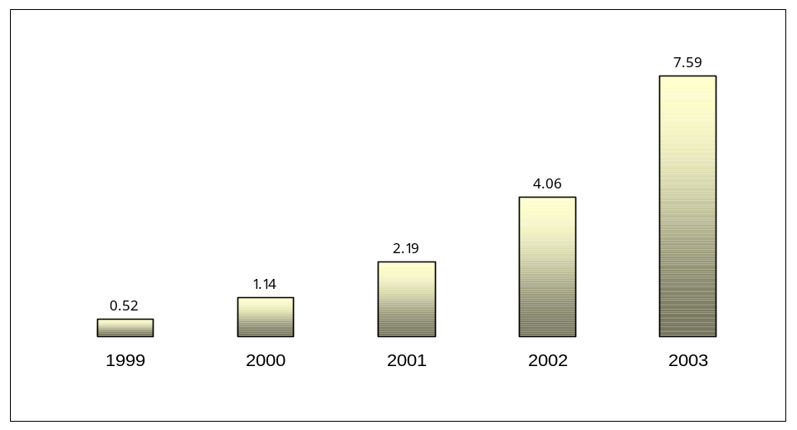

Source: IDC (India), April 2000
The Internet subscriber base in India has grown more than 14 times since services were launched in 1995. The latest Internet forecasts from IDC India indicate that there will be one million subscribers by the end of the year 2000. IDC places the subscriber base at about half a million at the end of 1999. Compared to China’s Internet subscriber base, 8.9 million at the end of 1999, India’s Internet penetration is low. However, it is set to grow exponentially over the next few years, due to the implementation of the government’s ISP policy (see Figure 5.1.). Average Internet usage in India is surprisingly high: at an average of 14-20 hours a month, it is comparable to North America.
It is estimated that the number of residential Internet users as a proportion of total users will increase 20 percentage points in 1999 to 67 percentage points in 2003 (see Figure 5.2). These projections are based on the drop in prices of home PCs and the emergence of Internet access via cable. IDC expects that by the end of 2001, cable Internet access would be available in most cities and towns with a population of over a million. Cable penetration in India is higher and cheaper than telephone access and many households set up cable connections before fixed telephone connections.

Table 5.2: Internet dial-up tariffs in South Asian countries

Based on a minimum of 15 hours per month of dial-up use, peak rate, US$, January 2000
Country | ISP | Plan | Hours included | ISP Connection (US$) | Monthly ISP charge (US$)
Bangladesh | BOL | Asheem | 15 | $59 | $31
Bhutan | Druknet | Casual | 15 | $34 | $34
India | VSNL | Plan 25 | 25 | $2 | $10
Maldives | DhivehiNet | Dial-up access | unlimited | $43 | $21
Nepal | Capital Online | Plan B | 20 | $51 | $7
Pakistan | Supernet | Basic 15 | 15 | $- | $10
Sri Lanka | Lanka Internet | Classic | 11 | $41 | $13
SAARC average |  |  |  | $32 | $19
Note: These are the lowest priced plans for 15 hours per month. Extra hours are billed at peak rate. Not including tax. National currency prices are converted to $US using 31 January 2000 exchange rates.
Source: ITU adapted from ISP tariff schedules.
Internet tariff plans are usually based on hours of use and are valid for a period of months (see Table 5.2). There is a significant demand in India for Internet services, such as e-mail, as is evident from the high number of Indian subscribers to the web-based email service provided by Hotmail – one third of the total number of Hotmail users are Indian, i.e. about 9-10 million.
Private ISPs typically lease lines from DoT/DTS. At the moment, they do not receive any of the revenue derived from telephone calls made to their Internet point of presence (POP). The DoT/DTS retains the entire 1.20 Rs, for each three-minute call. However, one of the advantages private ISPs have over private telecom operators is that, in the larger cities where VSNL has a gateway, they are permitted to directly interconnect with VSNL rather than having to go through the local incumbent operator. As mentioned earlier, ISPs have also been given clearance to set up their own international gateways. Direct interconnection between ISPs, or peering, is also allowed under the ISP license. The liberal policy towards ISPs has meant that, unlike the mobile sector, the Internet sector in India has been able to develop unhindered by regulatory constraints. The adoption of such a policy for ISPs may stem from the fact that the state did not have feel the urgent need to protect its commercial interests.
Partly for this reason, Internet commerce or e-commerce has been allowed to flourish despite India’s low per capita income. NASSCOM (National Association of Software and Service Companies) has recently released a survey evaluating the e-commerce market in India. The survey found that the total volume of e-commerce transactions in India amounted to about Rs. 1.31 billion, or 30 million US$, in the year 1998-99. Out of this volume, 9 per cent was attributed to business-to-consumer transactions (B2C), and 91 per cent to the business-to-business market (B2B). NASSCOM reports that the volume of e-commerce between 1999 and 2000 grew 2.5 times and predicts that this will continue to increase to touch 11.5 million US$ by 2003 (see Figure 5.3).

Figure 5.2: India Internet Subscriber Break-Up by Residential and Commercial segments (1999-2003)
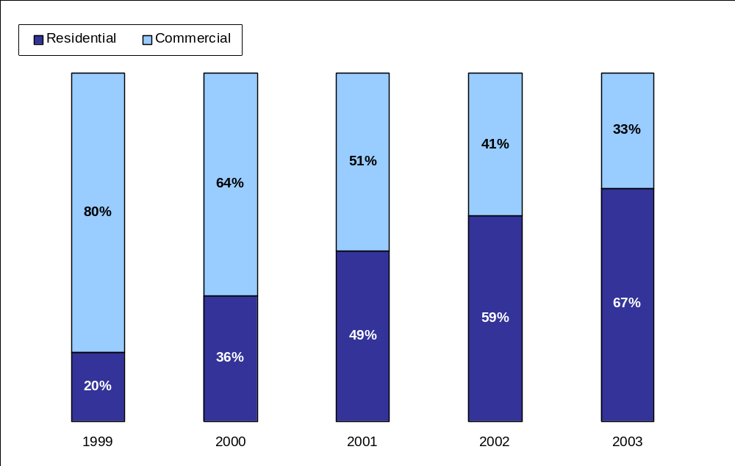

Source: IDC (India), April 2000

Figure 5.3: E-commerce Transactions in India (US$ Million)

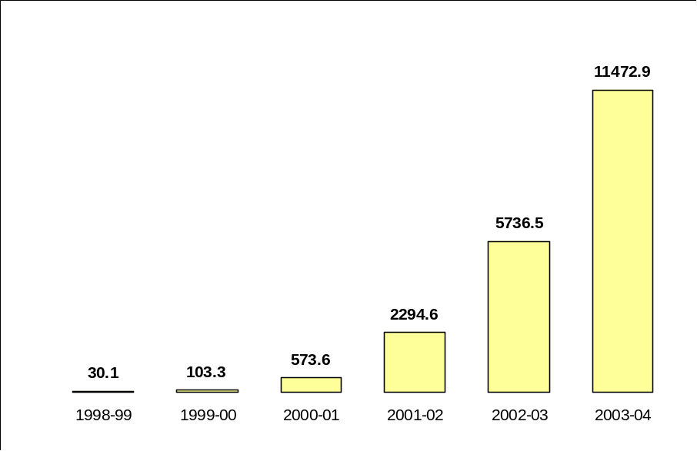

Source: Adapted from NASSCOM
At the same time, the Indian software industry has grown rapidly - over 50 per cent a year for the past five or six years. Analysts estimate that India has 16 per cent of the world’s software market. More than a fifth of the Fortune 1000 companies acquire their software from Indian firms. Indian software exports are expected to reach $3.9 billion in 1999-2000, of which Internet and e-commerce software and services exports make up just under 8 per cent.

Extensive lobbying by these software companies for the development of e-commerce in India led to the drafting of the Information Technology Bill in December 1999. It was passed into law on 16 May 2000. The IT bill legalizes electronic signatures and records and aims to facilitate electronic governance and trading. It mandates the creation of a system for organizations and individuals to have their digital signatures certified through Certification Authorities (CAs). These are to be licensed by the Controller of Certifying Authorities (CCA) appointed by the Government. It is to be noted by passing this bill, India joins a select group of 12 countries with similar laws governing cyberspace. This new Bill is an initiative by the government to encourage the take-up of Internet commerce in the country.
However, because of the lack of adequate infrastructure and low PC penetration (around 10 per cent in urban areas), transactional e-commerce in India will remain limited for some time. Nonetheless, electronic commerce services are growing rapidly, as more and more people get on line and as more Indian content is being made available. Increased competition in the content industry is a driving factor in increasing Internet penetration and fuelling the e-commerce marketplace.
Mobile commerce services, a subset of e-commerce services, have also made their debut in the Indian market. Analysts may differ in their views on the utility of mobile commerce (m-commerce), but it is clear that m-commerce applications promise to increase traffic on mobile networks and create new and evolving revenue streams. The worldwide potential of m-commerce is seen to be enormous, with revenues expected to reach $200 billion by 2005. The European market alone is set to increase from Euro 323 million in 1998 to Euros 23.6 billion by 2003 (this indicates a CAGR of 236 per cent until 2003). Predictions for mobile commerce are not as optimistic in India, but the demand for these services by India’s middle and upper classes is growing and operators are teaming up with software companies and banks to offer the “killer” combination of mobility and electronic commerce.
Bharti Telesoft is one of the first companies in India to have developed a mobile banking platform, which became a commercial service as of March 2000. It is being offered by mobile operators Airtel in Delhi and Orange in Mumbai, in conjunction with banks HDFC and ICICI. Mobile banking is available for all handsets that support SMS (Short Message Service) and provides users with complete access to their bank and credit card accounts. M-banking is a natural progression from on-line banking, which a handful of Indian banks have already began offering in 1999. The following products are currently being piloted: Internet access via WAP (Wireless Application Protocol) , mobile stock trading, and mobile ticketing. In order to create a suitable interface with the GSM network, the company is working with Integra Micro Systems, which was responsible for developing the first WAP server in India.
Internet access via WAP should be available in Delhi and Mumbai in the latter part of 2000. One of the main barriers to its widespread acceptance is the cost and availability of WAP-enabled phones, a problem that is not specific to India. The reduction in import duties may encourage the mass-scale commoditization of such phones, but there are still many WAP skeptics who see a limited future for the technology. For instance, interconnectivity with appropriate online content is a significant issue, as a large proportion of websites are not WAP-enabled. Much of the criticism also relates to the user interface, generally a four-line text display, offered over a slow, congested network with unreliable coverage. The WAP service being tested by Bharti Telesoft consists of a two-way SMS message: each outgoing SMS message costs 1 rupee and incoming SMS messages are free. As one operator put it, it is “the poor man’s Internet”. Users can interrogate a web page for 1 rupee and then each download is free of charge, regardless of the number of bytes involved. The system is still quite slow, given current Internet access speeds. Bharti Telesoft hopes this will change when ISPs set up their own international gateways.
In the past, billing for mobile services has been based on the duration of calls. However, as mobile services move increasingly towards a combination of data and voice, a different system of charging will need to be developed. This will undoubtedly affect the form and nature of interconnection agreements between operators. In this respect, as seen above, Bharti has already begun offering a different form of charging for mobile Internet: pay-per-click. The wealth of options available to service providers for billing and valuing these complex content services means that providers will face many challenges in the near future, as will regulators attempting to monitor service pricing.
Traditional mobile interconnection models and Internet interconnection models will have to be revisited. Traditionally, the structure of interconnection agreements with ISPs were based on a non-commercial model, with the underlying notion that the Internet is a free network. This structure is now being reconsidered as backbone providers are no longer content with sender-keeps-all (SKA) arrangements or peering arrangements involving zero settlements. The move from circuit-switched traffic, to packet-switched traffic, will involve a re-evaluation of interconnection models. Regulators are likely to face serious challenges in allocating value to the various elements of the Internet interconnection value chain, such as connectivity, capacity and content.

Concluding Remarks
The TRAI has repeatedly emphasized that interconnection or access charges should be based on incremental costs directly attributable to the provision of interconnection or access. Thus far, the only determination on access charges by the TRAI is the Mobile Termination Charge (MTC) for calls from the fixed to the mobile network in a Calling Party Pays (CPP) regime. In all other cases, it has essentially continued with the revenue sharing arrangements specified in the various licenses. While determining the MTC, the TRAI also had to determine the fixed to mobile retail tariff and, therefore, the amount retained by the fixed-line operator.
The TRAI’s tariff and revenue sharing proposals appear to be driven not so much by costs but by the need to ensure that the tariff is not ‘too high’ and that both mobile and fixed-line operators receive a ‘reasonable share’. The only feasible way to achieve these objectives in a convincing manner is to base them on costs rather than on general notions of affordability and reasonableness. The TRAI realized that its recommendations suffered from this problem and repeatedly emphasized the ‘interim’ nature of its proposals. It promised an eventual shift to cost-based rates. The fate of the CPP proposals demonstrates that non-cost-based interconnection rates, be they interim or final, may not be sustainable in a transparent regulatory environment. It may have been preferable if the TRAI had resorted to its earlier costing analysis of the basic and mobile networks in order to arrive at cost-based tariffs and mobile termination charges. Given the lack of adequate cost information and relevant international comparisons, such a determination would still have been problematic. However, it may have been more acceptable to operators and consumers.
In general, interconnection arrangements can be determined either through direct negotiations between operators or specified by the regulator at the end of a consultation process. Even in the case of direct negotiations, the regulator may have to intervene if the operators are unable to reach an agreement, or if the agreement is not in the interest of consumers. In the Indian CPP case, the TRAI opted for setting interconnect charges, despite the fact that it had been encouraging the DoT/DTS and the mobile operators to negotiate an interconnect agreement between them. The TRAI's actions were perhaps precipitated by the failure of the DTS and the mobile operators to reach an agreement, and by its own view that the introduction of a CPP regime was an urgent matter. However, according to the decision of the Delhi High Court in the CPP case, the TRAI Act did not give the Regulator the power to fix interconnection charges. The amended Act seeks to remedy this lacuna by giving the TRAI the jurisdiction to fix charges. It remains to be seen how that jurisdiction will be applied.
What is clear, however, is that mobile operators represent the only significant private sector presence in Indian telecommunications and are a major source of competition to the state-owned DoT/DTS. Given the early introduction of competition in this area, and despite the relatively late introduction of mobile services, mobile operators are in a unique position to take advantage of the ongoing liberalisation of the telecommunications sector as a whole. Even before the liberalisation of the national long-distance market, mobile operators have begun laying fibre backbone in their circles. Operators in contiguous circles are looking forward to the possibility of interconnecting their circle backbones to carry inter-circle long distance traffic. This will give them a significant head start when the long-distance sector is finally opened to competition. Many of the mobile operators are also fixed service licensees and will thus be in a position to exploit the advantages of fixed mobile convergence. Some have also obtained ISP licenses to prepare for the growing potential of the wireless Internet market. Mobile operators are therefore likely to play a key role in the future development of the telecommunications sector in India. However, being first in this wave of liberalisation has also meant that these operators have had to bear the costs of their own learning process as well as those of the State.

Annex 1: List of Participants

Government Officials & Public Operators
Representative | Position | Organization
S.P. Purwar | Advisor (Finance) | Department of Telecommunications
H.P. Mishra | Deputy Director General | DoT
S. Sundaresan | Director, Finance | Mahanagar Telephone Nigam Limited
N. K. Gupta | General Manager (Switching & IT) | MTNL
Udita C. Kumar | Deputy General Manager (Finance) | MTNL
Harsha V. Singh | Economic Adviser | Telecom Regulatory Authority of India
Rakesh Kapur | Joint Secretary, Commercial | TRAI
Rajendra Singh | Joint Secretary, Engineering | TRAI
Anita Soni | Joint Secretary | TRAI

Private Fixed Operators
Representative | Position | Organization
S. Ramakrishnan | Managing Director | Tata Teleservices, Hyderabad
Ajay Madan | Vice President, Network Implementation | Tata Teleservices, Hyderabad
Swami Krishnan | Vice President, Business Development | Tata Teleservices, Hyderabad
K.K. Trikha | Telecom Advisor | Tata Teleservices, Delhi

Private Mobile Operators - Metros
Representative | Position | Organization
Anil Nayar | Executive Director | Bharti Cellular, Delhi
Ashok Juneja | Director, Business Operations and Special Projects | Bharti Cellular, Delhi
Nalin Tikkoo | Chief Executive Officer | Essar Cellphone (ex- Sterling), Delhi
Sundeep Kathuria | Chief Administration and Legal Officer | Essar Cellphone, Delhi
Sarabjeet Singh | General Manager | Essar Cellphone, Delhi
Vivek Khanna | Chief, Information Technology | Essar Cellphone, Delhi
C. Karunakaran | Vice President | BPL Mobile, Mumbai

Private Mobile Operators - Circles
Representative | Position | Organization
Avinash Khandpur | Head, Regulatory | Escotel – Haryana, UP (W), Kerala
Wg. Cdr. A.K. Dighe | Chief Manager, Regulatory | Escotel – Haryana, UP (W), Kerala
Rajiv Burman | Chief Sales & Marketing Officer | Escotel – Haryana, UP (W), Kerala
Vivek Chandel | Dy. General Manager - Marketing | Escotel – Haryana, UP (W), Kerala
I. B. Mehra | Chief Executive Officer | JTM Mobiles (now Bharti) – Andhra Pradesh, Karnataka
Col. Yogendra Mishra | Chief Technical Officer | JTM Mobiles – Andhra Pradesh, Karnataka
B.K. Ravi Raju | Assistant Vice President, Technical | JTM Mobiles – Andhra Pradesh, Karnataka
Padma Radhika B | Senior Engineer, Switch | JTM Mobiles – Andhra Pradesh, Karnataka
Prabhat Pani | Chief Operating Officer | Tata Cellular – Andhra Pradesh
Manzoor ul Ameen | Manager- Marketing | Tata Cellular – Andhra Pradesh

Lawyers
Representative | Position | Organization
Arun Kathpalia | Orr, Digham and Company, Barristers and Solicitors | Counsel for the TRAI before the High Court of Delhi in the CPP Case

Industry Associations
Representative | Position | Organization
T.V. Ramachandran | Director General | Cellular Operators Association of India
Gopal Mittal | Assistant Manager – Accounts and Administration | COAI
S.C. Khanna | Secretary General | Association of Basic Telecom Operators
Naresh K. Dua | Technical Advisor | ABTO
Gajendra Upadhyay | General Manager, Operations | ABTO
P. Radhakishore | Deputy Director | Confederation of Indian Industry

Private Internet Service Providers (ISPs)
Representative | Position | Organization
Deepak Maheshwari | Senior Manager, Corporate Affairs | Satyam Online (Satyam Infoway)
R.P. Bahl | General Manager – Customer Care and Credit | Mantra Online (Bharti BT Internet)

Software Developers
Representative | Position | Organization
S.S. Sinha | Chief Executive Officer | Bharti Telesoft
Rajneesh Kapur | Deputy General Manager, Business Development | Bharti Telesoft

Other
Representative | Position | Organization
T.H Chowdary | 1. IT Advisor  2. Director | 1. Government of Andhra Pradesh  2. Centre for Telecom Management Studies

Annex 2: Links to Related Websites

Government Sites

Department of Telecommunications (DoT) at http://www.dotindia.com/
- National Telecom Policy 1994 at http://www.trai.gov.in/ntp1994.htm.htm
- National Telecom Policy 1999 at http://www.trai.gov.in/npt1999.htm
Telecom Regulatory Authority of India (TRAI) at http://www.trai.gov.in/indexa.html
National Informatics Centre (NIC) at http://www.nic.in/
Group on Telecommunications at http://www.nic.in/pmcouncils/got/
The Indian Parliament at http://alfa.nic.in/
Press Information Bureau (Government of India) at http://pib.nic.in/
Government of India: Directory of Official Web Sites at http://goidirectory.nic.in/
The Official Website of Andhra Pradesh at http://www.andhrapradesh.com/
Centre for Monitoring the Indian Economy (CMIE) http://www.cmie.com/
Ministry of Finance at http://finmin.nic.in/
- Economic Survey 1998-1999 at http://www.nic.in/indiabudget/es98-99/welcome.html

Public Operators

Department of Telecommunications Services (DTS) at http://www.dotindia.com/main.htm
VSNL at http://www.vsnl.net.in/english/index.html
MTNL at http://www.mtnl.net.in/

Public ISPs

VSNL at http://isp.vsnl.net.in/ and the VSNL Portal at http://internet.vsnl.net.in/
MTNL at http://www.mtnl.net.in/ and Bharat-On-Line at http://www.bol.net.in/

Industry Associations

Association of Basic Telephone Operators (ABTO) at http://www.abto.org/
Cellular Operators Association of India (COAI) at http://www.coai.com/
Confederation of Indian Industry at http://www.ciionline.org/

Private Mobile Operators

Bharti Cellular at http://www.airtelworld.com/
Birla AT&T at http://www.attcell.com/index1.html
Essar Cellphone at http://www.essarcellphone.com/
Fascel Limited (Celforce) at http://www.celforce.com/
Hutchinson Max (now Orange) at http://www.orange.co.in/indexfl.htm
Usha Martin Telekom at http://www.commandcell.com/
JT Mobiles at http://www.jtmobiles.com/
Koshika Telecom at http://www.koshika.com/
Modi Telstra at http://www.moditelstraindia.com/
Skycell at http://www.skycell-india.com/
Tata Cellular at http://www.tatacell.com/
BPL Mobile at http://www.bplglobal.com/press/out_bplmobile.html
List of GSM Network Operators in India from GSM World at http://www.gsmworld.com/gsminfo/cou_in.htm,
including information on network coverage and roaming
Private Fixed Operators
Tata Teleservices at http://www.tata.com/tata-teleservices/teleserv01.htm

Private Internet Service Providers (ISPs)
Satyam Infoway at http://www.satyam.com/ and the Satyam Online portal at http://www.satyamonline.com/
Bharti BT Internet at http://www.bhartibtinternet.com and the Mantra Online portal at http://www.mantraonline.com/

Various Reports and Articles
ITU Case Study on Accounting Rates at http://www.itu.int/wtpf/cases/India/ind_tk2.pdf
Gilbert & Tobin’s Brief on the Indian Mobile Telecommunications Policy at http://www.gtlaw.com.au/pubs/indianmobile.html
IDC Research on Indian Internet Market at http://www.idcindia.com/Pressrel/16Mar2000.html
World Bank Report: India: Policies to Reduce Poverty and Accelerate Sustainable Development at http://wbln1018.worldbank.org/sar/sa.nsf/a22044d0c4877a3e852567de0052e0fa/a416ffbabff94bdf85256881005f686f?OpenDocument
World Bank Brief: India Country Brief at http://wbln1018.worldbank.org/SAR/sa.nsf/Attachments/India/$File/ind.pdf
Internet Content in India: Local Challenges and Global Aspirations, at http://www.sasianet.org/indiacontent.html, Madamohan Rao, Workshop on Internet (April 1999), South Asian Networks Organisation
Indian Telecommunication Liberalization and Development at http://www.regulate.org/resources/india_telecoms.doc, Surinder Dhar, Essar Comvision, September 1998

India’s Population reached 1 billion at 13:30 New Delhi time on 12 May 2000 <www.singtao.com/news/header/t_news.html>.
The World Bank World Development Indicators on India <http://www.worldbank.org/data/countrydata/littledata/111.pdf>.
World Bank Estimate. Go to India at a Glance for recent World Bank figures on Economic Development in India <http://www.worldbank.org/data/countrydata/aag/ind_aag.pdf>.
Confederation of Indian Industry (see <http://www.ciionline.org/overview/ecowatch/sta_econ.html>)
June 2000 rate. The average exchange rate per US$ was Rs 35.43 in 1996, Rs 36.31 in 1997, Rs 41.26 in 1998, and Rs 43.06 in 1999.
The Government of India holds 56.25 per cent of the total equity.
The TRAI was set up under the TRAI Act, 1997 (<http://www.trai.gov.in/act.htm>). See also the 2000 ordinance amending certain provisions of the Act (http://www.trai.gov.in/ord_00.html).
The distribution of direct exchange lines between DTS and MTNL is 83 per cent and 17 per cent.
World Telecommunications Development Report 1999, ITU.
See also CIDA Grameen Case Study on Cellular Village Telephones in Bangladesh <http://www.telecommons.com/villagephone/>
DoT Annual Report 1999-2000
“DTS hopes that new TRAI will allow tariff hike” <http://www.timesofindia.com/090200/09indi9.htm>, Times of India, 9 February 2000.
ABTO (Association of Basic Telephone Operators), interview.
In China, the Department of Telecommunications Administration (DTA) and the incumbent, China Telecom, are both under the umbrella of the Ministry of Posts and Telecommunications (MPT). However, unlike the new entrants in the Indian market, the new China Unicom had the advantage of politically influential shareholders.
“TRAI disbanded, stripped of judicial powers” <http://www.expressindia.com/ie/daily/20000120/ifr20001.html>, The Indian Express, 20 January 2000
Except for Mr. A. Prasad, formerly from the Department of Telecommunications, all members of the newly formed TRAI came fresh to their posts.
See TRAI’s Consultation Paper on Introduction of Competition in Domestic Long-Distance Communications, <http://www.trai.gov.in/dld1.html>
Average revenue per DEL is based on actual cash, and not amount billed, DoT Annual Report 1999-2000
The average minutes of use per month per subscriber is 146 minutes (TRAI data on Circle CMSPs)
See Total Telecom article “India to launch state-run mobile phone services” (registration required for access), <http://www.totaltele.com/secure/view.asp?articleID=26867&Pub=TT&categoryid=625> 7 April 2000.
“Delhi high court throws out calling party pays scheme” <http://www.financialexpress.com/fe/daily/20000119/fec19049.html>, The Financial Express, 19 January 2000.
This number was based on informal discussions between the TRAI and industry representatives.
China Unicom (the new entrant) pays China Telecom (the incumbent) 0.08 Yuan (USD 0.0096) for every three-minute call originating from its mobile subscribers to China Telecom’s local fixed subscribers. For each three-minute call originating on the China Telecom’s fixed network and terminating on China Unicom’s mobile network, the latter pays one eighth of that charge (0.01 Yuan or USD 0.0012) to China Unicom. For more information, see the China Case Study at <www.itu.int/interconnect>.
Consultation paper on Review of Cellular Mobile Service Tariffs Following Migration to an Interim Revenue Share of 15 Per Cent As License Fee And Introduction of Calling party Pays (CPP) Regime for Cellular Mobile.
Explanatory Memorandum to Tariff Order (fifth amendment) dated 17 September 1999.
Bank Guarantees obligations are as follows: All India Licenses or Category A – Rs 20 million or USD 0.45 million, Category B – Rs. 2 million or USD 0.45 million, and Category C – Rs 0.3 million USD 6720.
For a list of the operational ISPs, see www.dotindia.com
See the DoT’s Guidelines and General Information for Setting up of International Gateways for Internet (<http:www.dotindia.com/investment/isp/guide_international_gateway.htm>)
See the List of ISPs with in-principle clearance to set up international gateways (<www.dotindia.com/investment/isp/isps_list_using_foreign_satellit.htm>)
Warburg Dillon Read (WDR) places it at 635,000 subscribers.
See ITU China Case Study in the same series at <www.itu.int/interconnect>.
The Hotmail service was the brainchild of Indian expatriate in the US.
An announcement was made by MTNL’s chairman in January of this year, stating that MTNL would be willing to consider revenue-sharing with ISPs. However, this announcement was vague and has not yet led to any concrete developments in this area. See “MTNL ready for revenue-sharing with ISPs” <http://www.financialexpress.com/fe/daily/20000123/fco21121.html>, The Financial Express, 20 January 2000.
The bandwidth that private ISPs lease from VSNL is currently 58 Mbps.
However, Satyam Infoway reports that a request for interconnection with a local ISP made in October 1999 had still not elicited any response from the DoT in April 2000.
See GIIC, Event: Enabling E-Commerce in India <http://www.giic.org/events/ec990615india.html#paper>
See Ovum, Report on Mobile Commerce <www.ovum.com> and Durlacher’s study of the m-commerce market available free of charge at <http://www.durlacher.com>
Mobile Commerce at ICICI <http://www.icici.com/banking/mob/mob.htm>
For an introduction to SMS, see Mobile IP World’s White Paper at <http://www.mobileipworld.com/wp/wp2.htm>. The popularity of SMS is increasing at an exponential rate. The GSM Association reports, that, in March 2000 alone, 5 billion SMS messages were exchanged between GSM subscribers and predicts that this number will double by December 2000 (see <http://www.allnetdevices.com/news/0004/000428sms.htm>).
For an introduction to mobile WAP, see the WAP White Paper <http://www.wapforum.org/what/WAP_white_pages.pdf>

