What Rules for IP-Enabled
Next Generation Networks?
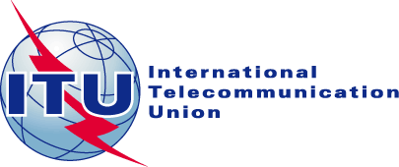
23-24 March 2006
Geneva, Switzerland

Consumer Protection in the IP-enabled NGNs

Sergio Antocicco

Chairman
INTERNATIONAL TELECOMMUNICATIONS
USERS GROUP

Abstract: NGN can open new perspectives to the telecommunication sector. Operators have already deployed, for their core network, IP based links; therefore they are enjoying advantages, of which, users are partially benefiting. NGNs make possible the delivery of new value added services, by which Operators can compensate the lower revenues from the voice services. For business users, NGNs can add new functionalities and create new business models. Residential users will enjoy lower costs for traditional services and a wider choice among new exciting devices and services. NGNs will allow access via one single line, using several devices and having access to the Internet at high speed. It will make possible to offer new interactive services, most of them to be invented. QoS should be redefined, in accordance with the characteristics of the new services. NGNs will be even more important for the shift from "network of persons" to "network of objects". Regulators must be aware that several technical problems must be considered, namely interoperability and interconnection issues. Previous agreements reached with business users, like the Loch Lomond accord for VPN, must be taken into consideration. Standardisation issues seem crucial: therefore a coordination between ITU, ETSI, 3GPP is essential and users must have a role. Transparency in QoS and tariffs for all Operators, in a comparable form, is essential for the users to make the right choice. The principle of cost orientation for basic services should be maintained in order to favour competition and allow a demand driven mechanism.

