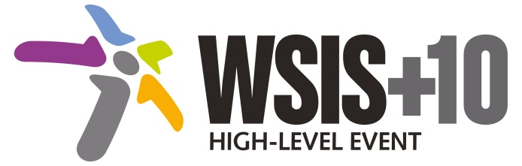
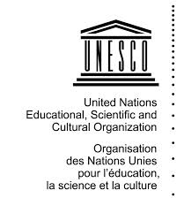
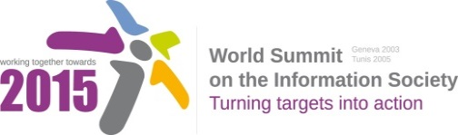

Document Number: WSIS+10/4/15

Note: This Executive Summary captures the main achievements, challenges and recommendations of the Action Line during the 10-year period of WSIS Implementation; this has been submitted by the Action Line Facilitator in response to the request by the participants of the Third WSIS+10 MPP meeting. The complete report on the 10-Year Implementation of the Action line was submitted to the Third WSIS+10 MPP meeting held on 17-18 February 2014 and is available at the following url:
www.itu.int/wsis/review/reports/#actionline

10-Year WSIS Action Line Facilitator's Reports on the Implementation of WSIS Outcomes
WSIS Action Line – C7: E-learning
Lead Facilitator: UNESCO

Executive Summary
- Achievements of the Action Line
The range of ICTs which can be used in schools and colleges, and in lifelong education, is constantly increasing. Particular attention has been paid in recent years to the use of low-cost access devices and to mobile phones which are widely available to teachers and students. ICTs are also increasingly important in the management of education, from curriculum planning to examinations and school administration. In particular, working with its partners in the Action Line, UNESCO has:
- promoted the inclusion of ICTs in national and global approaches towards meeting the Education for All targets, and published research on the educational outcomes of ICTs;
- developed, through the UNESCO Institute for Statistics, core indicators for ICTs in education, and led the analysis of the results of these within the WSIS outcome assessment process;
- promoted debate and policy development on media and information literacy;
- developed and introduced the influential ICT Competency Framework for Teachers, setting benchmarks for ICT pedagogy, including the development of a the ‘ICT CFT Toolkit’ which supports the harnessing of OER for related training materials;
- promoted Open Educational Resources (OER) through joint programmes with the private sector and academic institutions, the establishment of an online OER platform, the publication of guidelines and hosting of the OER World Congress in June 2013, resulting in the Paris OER Declaration;
- promoted awareness and understanding of mobile learning, developing also policy guidelines for this area;
- published case studies of the power of ICTs in education in developing countries under the title Transforming Education;
- led the work of the Broadband Commission for Digital Development’s Working Group on Education and prepared the Commission’s 2013 report on Technology, Broadband and Education: Advancing the Education for All Agenda.
UNESCO has worked hard to make the e-learning Action Line a focus for multistakeholder discussion and for the development of multistakeholder partnerships concerned with ICTs in education. Examples of partnership within the Action Line have included joint work by UNESCO with the William and Flora Hewlett Foundation and the Government of the United States on open educational resources and the launch of the ICT Competency Framework for Teachers, developed in cooperation with all stakeholder groups. In 2008, for instance, the Action Line focused on low-cost devices, including low-cost computers and online access terminals. In 2009, it concentrated on mobile learning. In 2010, it moved on to consider the impact of social networks and the potential of open educational resources. Meetings of the Action Line have also addressed other educational priorities including the development of educational management information systems (EMIS). There has been joint activity with Action Line C4, which focuses on capacity-building and for which UNDP was nominated as lead-facilitator.
- Challenges
Education is of fundamental importance in enabling societies to transform information resources into knowledge which can accelerate social and economic development. While considerable experience has already been gained in the use of ICTs in both formal and non-formal education, more research is needed into the best ways of integrating ICTs in education, in order to maximise learning outcomes and enhance educational management and information systems. The field of e-learning is increasing in scope and depth, and a critical challenge will be ensuring that ICTs in education reduce rather than increase relative disadvantage. Many governments have major problems funding education, and new ICT resources represent considerable investment costs, particularly in view of the fact that hardware presents in average only 1/3 of the total cost of well-designed initiatives, which include from the outset dimensions such as capacity and content development.
- Looking to the future
Particular attention will be paid to the creation of an enabling environment, which includes educational policies with clear priorities, capacity development of key institutions and actors, including teachers, with content and curriculum developments and the systematic evaluation of all efforts. Of increasing interest today are distance and online education, including Massive Open Online Courses (MOOCS), learning anytime anywhere through mobile technologies and innovations such as learning analytics to name but a few. It will be a key objective to ensure that all learners, regardless of geographic, physical or social boundaries, can make use of ICTs to access and benefit from quality teaching and learning activities. The Broadband Commission’s 2013 report on broadband and education also provides important background for the next stage of development in this context.
UNESCO and other stakeholders within the Action Line will need to build on the work which has already been done, particularly in innovative areas such as mobile learning, OER and the ICT Competency Framework for Teachers, by offering capacity-building in policy development, curriculum design and teacher training. New opportunities will arise from further developments in technology and from the spread of experience that students have with ICTs.

