

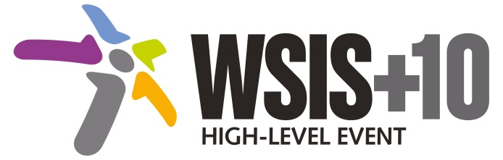

**Document Number: WSIS+10/4/21**

**Note: This Executive Summary captures the main achievements, challenges and recommendations of the Action Line during the 10-year period of WSIS Implementation; this has been submitted by the Action Line Facilitator in response to the request by the participants of the Third WSIS+10 MPP meeting.**

**10-Year WSIS Action Line Facilitator's Reports on the Implementation of WSIS Outcomes**

**WSIS Action Line –** **C7: E-government**

**Lead Facilitator: UNDESA**

**Executive Summary**

1. **Achievements**

E-government is recognized by governments and stakeholders as an enabler of good governance. Governments across the world have applied effectively and efficiently to enhance dialogue and cost effective service delivery leading to positive socio-economic growth.

Much work has gone into providing direct capacity development support to Member States with the sole purpose of developing integrated e-government strategies, policies and guidelines, with emphasis on whole-of-government approach, citizen engagement, online services, social media, open government/open data, smart government and m-government. The Compendium of Innovative E-governments Practices, published by UNDESA, promotes innovative e-government solutions, services and products by documenting them and sharing them with the aim of hastening innovation and creating public value for the citizenry.

The United Nations E-government Surveys focuses on e-government utilization for sustainable development, especially in the post-2015 era. Previous surveys have focussed on: people-centred e-government (2012), leveraging e-government at a time of financial and economic crisis (2010), changing e-government from e-government to connected governance (2008), From E-Government to E-Inclusion (2005), Towards Access for Opportunity (2004), and E-government at the Crossroads (2003). The research work towards these publications has focused on Member States’ government web portals with a focus on the provision of e-information and e-services; these services include interactive, transactional, and e-participation features that connect governments and citizens. Member States are ranked in accordance with the E-Government Development Index (EGDI), which is a composite indicator measuring the willingness and capacity of national administrations to utilize ICT technologies to deliver public services.

In addition, ITU and the UN Regional Commissions collaborated on a review of the current status of National e-Strategies for Development, drawing on the WSIS Stocktaking Database (see action line C1). WIPO also assisted 51 countries in modernizing intellectual property administration and worked with developing countries to improve the management of copyright.   
With the objective of strengthening e-government capacity building in the Latin America region, UNDESA collaborated with the Government of Columbia in the establishment of the Centre for Innovation on e-Government Development, with the aim to disseminate experiences and lessons learned on e-government development and the promotion of services and a culture of innovation within public institutions in Latin America and other regions.

1. **Challenges**
2. The biggest challenges in providing all these supportive activities are: moving and innovating with time. The socio-economic and especially technical conditions affecting innovation change over time. In this context, UNDESA will need to further disseminate new, effective practices and tools and provide support to build intrinsic government, government and public administration capacities.
3. Effective advisory missions lead to a couple of countries’ embrace of open data approach and government officials’ participation in related events are success. But while celebrating success in all of these projects and programmes, there are challenges such as imbalance among participating countries in competing events and projects.
4. **Recommendations**
5. At the most fundament level and ultimately, improving e-government endeavours should build on broad e-governance efforts; well beyond use of e-government tools.
6. Financing of e-government projects needs to be addressed based on creative exploring e-government financial resources, particularly for many developing countries.
7. Encourage integrated e-government services through whole-of-government approach to support the three pillars of sustainable development
8. Promote inclusive e-government through e-participation and increase availability of government data for reuse in order to promote participation in public policy-decision-making, responsiveness, transparency and accountability
9. Promote people-centred delivery of e-services and bridge the digital divide
10. Address privacy and security issues through concerted efforts
11. Promote capacity building and knowledge sharing for effective utilization of resources
12. Utilize existing infrastructure (e.g. community access points including kiosks, community centers, libraries, and post offices) and use of intermediaries to ensure that e-government services reach all end users.
13. Improve government service through introducing open, transformational government providing multi-channel service delivery, particularly through mobile devices
14. Enhancement of essential government services electronically to citizens through inclusive means; each government will choose an appropriate scope of the essential services through national and sub-national planning processes