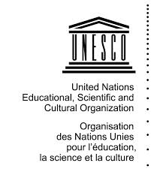
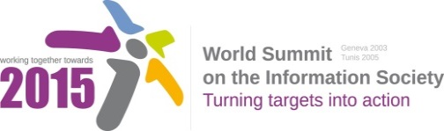
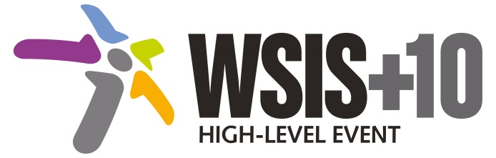

Document Number: WSIS+10/4/14

Note: This Executive Summary captures the main achievements, challenges and recommendations of the Action Line during the 10-year period of WSIS Implementation; this has been submitted by the Action Line Facilitator in response to the request by the participants of the Third WSIS+10 MPP meeting. The complete report on the 10-Year Implementation of the Action line was submitted to the Third WSIS+10 MPP meeting held on 17-18 February 2014 and is available at the following url:
www.itu.int/wsis/review/reports/#actionline

10-Year WSIS Action Line Facilitator's Reports on the Implementation of WSIS Outcomes
WSIS Action Line – C3: Access to information and knowledge
Lead Facilitator: UNESCO

Executive Summary
- Achievements of the Action Line
Access to ICT networks and services has expanded greatly, throughout the world, since WSIS. Meaningful access to ICTs, however, is not just a matter of access to networks and services. Users need to have the capabilities – including at present, for the Internet, literacy – to make effective use of them. Content needs to be available in more than only global languages. It also needs to be affordable. And for some groups, such as those with disabilities, additional facilities need to be provided which enable them to take advantage of the same opportunities as other people. In particular, working with its partners in the Action Line, UNESCO has:
- Shifted global discussions from information to inclusive knowledge societies by;
  - Developing understanding and awareness of the need to build strategies for inclusive Knowledge Societies around the conjunction of infrastructure, capabilities and content;
  - Providing concrete recommendations for building inclusive Knowledge Societies in its global report Towards Knowledge Societies which was focused not on the need to improve the quality of access to ICTs, infrastructure and services, but it also emphasized the importance of access to education and information, cultural and linguistic diversity, freedom of expression and preservation aspects.
  - Expanding a new literacy paradigm and developing a new composite concept of Media and Information Literacy (MIL) that includes Information Literacy, Media Literacy, ICT and Digital Literacy aspects translated through a curriculum, assessment framework, policy-strategy guidelines and global alliance for partnerships into reality.
- Enhanced access to public information and resources by;
  - Promoting multilingualism on cyberspace through its unique normative instrument entitled UNESCO Recommendation concerning the Promotion and Use of Multilingualism and Universal Access to Information to Cyberspace;
  - Providing a valuable platform for multistakeholder discussions of initiatives by UNESCO and other stakeholders in the areas such as Open Educational Resources, Open access, FOSS, persons with disabilities, media and information literacy and others focusing in different years on different aspects of its mandate;
  - Enhancing access to the Internet itself through internationalised domain names as well as access to multilingual content work as well as analyzing good practices and challenges of IDNs deployment in three annual World Reports on IDN deployment;
  - Researching and providing policy recommendations for local content, Internet development and prices published a benchmark study of The Relationship between Local Content, Internet Development and Access Prices as well as putting efforts to measure linguistic diversity on the Internet and stimulating a scientific discussion summarized in Twelve Years of Measuring Linguistic Diversity on the Internet;
- Supported community access to the Internet and ICTs, for example through facilities like schools and libraries by:
  - Establishing Community Multimedia Centres and other community access facilities which combine community radio and telecentres with open learning and other social welfare opportunities in Africa;
- Promoted access to both proprietary and open source software by;
  - Supporting open approaches to technology and software development, standard-setting, infrastructure access, and the publication and sharing of information and knowledge such as educational resources and scientific research;
- Provided access to scientific journals and other data sources which are valuable for research and community development by:
  - Encouraging the growing movement for Open Educational Resources and calling on governments worldwide to openly license publicly funded educational materials for public use through its international cooperation mechanisms such as World Congress on Open Educational Resources and Paris Declaration;
  - Providing guidelines to application of OER in Higher Education and encouraging decision makers in government and institutions to invest in the systematic production, adaptation and use of OER.
- Advocated access to ICTs, information and knowledge for vulnerable social groups, including those with disabilities by:
  - Encouraging governments and other stakeholders to improve access for disadvantaged groups, including women, persons with disabilities, and indigenous peoples;
  - Contributing to the joint United Nations efforts for the implementation of the United Nations Convention on the Rights of Persons with Disabilities
  - Mapping policies and practices on use of accessible, affordable and adaptable ICTs around the world that facilitate access to information and knowledge by persons with disabilities summarized in UNESCO’s Global Report. Opening New Avenue for Empowerment. ICTs to Access Information and Knowledge for Persons with Disabilities;
  - Assessing the progress of actions initiated after the first and second WSIS to the digital inclusion of persons with disabilities and providing policy recommendations which were published in the document WSIS+10 Review and Strategic Directions for Building Inclusive Knowledge Societies for Persons with Disabilities;
  - Supplying UNESCO’s Member States with Model Policy on Inclusive ICTs in Education for Persons with Disabilities that serves as a resource for developing the contents of new national policy documents.
- Challenges
Large disparities with regards to access to information and knowledge persist and in addition to the geographical, socio-economic, gender, age, rural-urban divides the importance of understanding local customs, traditions and perceptions is increasingly recognized. With the wider definition and understanding of access issues, the difficulty of measuring access and progress made becomes more difficult too. Developing national, regional and international data systems and indicators that are comprehensive, policy relevant and reliable for the proper understanding, monitoring and development of access to information and more difficult, knowledge, remains an important and potentially resource intensive challenge.
- Looking to the future
Access to information and knowledge is at the heart of UNESCO’s work to promote inclusive Knowledge Societies. The ten years since WSIS have seen a shift in emphasis from access to infrastructure towards access to skills and content. This will continue. The next five years will see rapid continued growth in the number of people having Internet access, and so gaining much greater access to information than was previously available to them. The continued deployment of broadband networks will also improve the ease of access to information, particularly for businesses, educational institutions and those with access to networked computers and/or smartphones.
This growth in access to communications facilities must be accompanied by greater access to the resources that people, businesses and communities require in order to transform information into knowledge which can enhance their lives and livelihoods. UNESCO and other stakeholders in this Action Line will continue to emphasize the importance of developing and enabling open access to content, stimulating local content, and enabling access for all through multilingualism, facilities and outreach to currently under-represented groups. Open data will be a particular area of importance for all stakeholders. It will also be important to develop more effective indicators for inclusion, diversity and empowerment.

