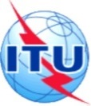
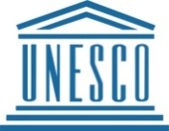
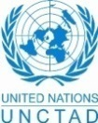
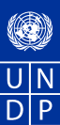
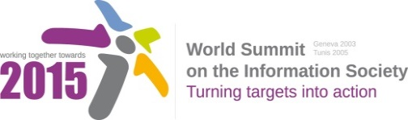

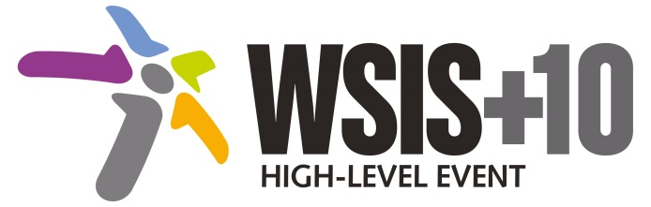

Document Number: WSIS+10/4/86

Submission by: UNESCO, International organization

Please note that this is a submission for the Fourth Physical meeting of the WSIS +10 MPP to be held on 14-17 April 2014.

Document Number: V2/C/ALC8

Note: This document is the result of the first reading of the document number V1.1/C/ALC8 and reflects the changes and comments received at the third physical meeting of the WSIS+10 MPP. This document is available at: http://www.itu.int/wsis/review/mpp/pages/consolidated-texts.html

This document has been developed keeping in mind the Principles.
Please note that the Geneva Declaration and the Geneva Plan of Action still remain valid until further decisions by the General Assembly.

Draft WSIS+10 Vision for WSIS Beyond 2015
С8. Cultural Diversity and identity, linguistic diversity and local content

1. Vision
Our vision of inclusive Knowledge Societies is that of a more culturally and linguistically diverse digital world as fundamental components of public space, where around half of all existing languages are present in cyberspace ; where the strategic link between culture, use of technologies and development is fully recognized and culture is integrated in all development policies and programmes, for poverty reduction and inclusive sustainable development, as in UN resolutions A/RES/65/166 (2010) , A/RES/66/208 (2011) and A/RES/ 68/223 (2013); where cultural diversity and knowledge society strategies are jointly developed and effectively implemented where development takes into account local, national and regional contexts, builds on the knowledge generated by all communities, promotes innovation and creativity, and allows all human beings to practice their own culture and enjoy that of others free from fear. It is a world where marginalized groups, including indigenous peoples, and those coming from migrations, diasporas and from language minorities, enjoy increased recognition and equity; artists, cultural professionals and practitioners are empowered to create, produce, disseminate enjoy and preserve a broad range of cultural goods, services and activities; and where intangible cultural heritage inherited from past generations is safeguarded for future generations.
2. Pillars
- Create enabling environments that support the respect, preservation, promotion and enhancement of cultural and linguistic diversity and cultural heritage within Information and Knowledge Societies, by advocating for, implementing and monitoring relevant agreed United Nations documents, including UNESCO’s recommendation concerning the Promotion and Use of Multilingualism and Universal Access to Cyberspace, the Convention on the Protection and Promotion of the Diversity of Cultural Expressions as well as the Convention for the Safeguarding of the Intangible Cultural Heritage and the UN Declaration on the Rights of Indigenous Peoples.
- Make culture a driver and enabler of economic, social and environmental development processes, including by capitalizing on intangible cultural heritage to foster innovative and sustainable models of cooperation, by facilitating investments in innovation and creativity that provide opportunities for the creation of local content production and that strengthen independent cultural and creative industries.
- Support development and access to rich and diversified cultural content in more languages in the digital age, including by measuring digital content especially in local language and formulating indicators/indices for digital content in local language, data collection and analysis of local digital content development, by developing region-wide standards for digital content creation specific to the vehicular languages that will enhance quality, interoperability, and inter-regional collaboration.
- Support national entrepreneurial and start-up ecosystem to help the digital content industry to flourish, including incubators, accelerators, mentorship, investments, and venture capital, focusing on digital content applications and building on recent technology trends.
- Launch and support governmental and other initiatives for preservation, digitization and digital archiving of cultural and documentary heritage and born-digital information.
- Promote the development and use of internationalised domain names.
- Promote the principles of the UN Declaration on the Rights of Indigenous Peoples, relevant in the context of WSIS and the ICT landscape, in particular, by bridging digital and knowledge divides with regard to Indigenous Peoples, by assisting in valuing, safeguarding and transmitting their traditional knowledge, by considering the inclusion of protection of digital heritage in a normative instrument on documentary heritage especially of indigenous people and in minority languages, and by supporting indigenous peoples’ full and effective participation in the WSIS process and beyond.
- Engage in South-South cooperation to facilitate productive mutual learning and inform international policy agendas for development in all areas relating to the Action Line C8.
- Encourage the integration of digital content development concepts and skills into IT curricula at the higher education level, including the development of inter-disciplinary post-graduate courses, and the establishment of training centres that provide technical training in digital content development.
3. Targets
- A more culturally and linguistically diverse world, where at least 40% of the existing 6,000 languages are present in public life;
- An increase of intangible cultural heritage safeguarding activities with a linguistic dimension
- An increase of diverse cultural and artistic expressions and increased investments in independent content production
- Near universal ratification of the Convention on the Protection and Promotion of the Diversity of Cultural Expressions and significant new resources mobilized for the International Fund for Cultural Diversity;
- Strong increase of measures implementing the principles of the UN Declaration on Indigenous Peoples.
- Development of internationally agreed strategies linking culture diversity, sustainable development and information society

The Future We Want For All”, United Nations Conference on Sustainable Development, Rio de Janeiro, June 2012, para 41)

