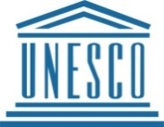
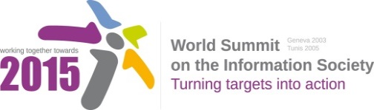

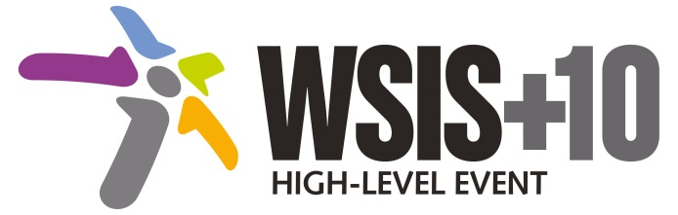

Document Number: WSIS+10/4/70

Submission by: Internet Democracy Project, CDT, Global Partners Digital, International Federation of Library Associations, Access, Civil society

Please note that this is a submission for the Fourth Physical meeting of the WSIS +10 MPP to be held on 14-17 April 2014.

Document Number: V2/C/ALC10

Note: This document is the result of the first reading of the document number V1.1/C/ALC10 and reflects the changes and comments received at the third physical meeting of the WSIS+10 MPP. This document is available at: http://www.itu.int/wsis/review/mpp/pages/consolidated-texts.html

This document has been developed keeping in mind the Principles.
Please note that the Geneva Declaration and the Geneva Plan of Action still remain valid until further decisions by the General Assembly.

Draft WSIS+10 Vision for WSIS Beyond 2015
С10. Ethical Dimensions of the Information Society

1. Vision
We envision inclusive Knowledge Societies, in which all stakeholders are well informed of ethical challenges and have adequate tools to support them in their decision making processes and that they regularly seek opportunities to engage and share their experiences through open and inclusive spaces for information sharing and dialogue .
- Alt we envision an inclusive Information Society, in which all stakeholders are informed of ethical challenges and policy makers have adequate tools to support them in their decision making process, through open and inclusive spaces of information sharing, dialogue and consultations
[New para] Brazil, Government: We reinforce our common understanding that the ethical dimension of the Information Society is a key aspect of the future development and deployment of ICTs, which should be based upon respect for individual rights and well-being, and support the overall social and economic development of societies.
2. Pillars
- Give consideration to the ethical principles that bear on technological and social issues in the information society and underlie specific regulatory frameworks, whether or not such principles are enshrined in existing normative instruments or codes of conduct.
- Strengthen regional and national capacity in to analyse, discuss and respond to the ethical challenges of the information society.
- Promote international, multistakeholder and interdisciplinary reflection and debate on the ethical challenges of emerging technologies and the information society.
- Raise awareness of the ethical implications of the information society, particularly among young people, along with life-long education initiatives to equip all citizens with the skills and competence to participate actively and knowledgeably in the information society.

- Affirm that considerations of the ethical dimensions of information societies must be rooted in international human rights frameworks, such as the Universal Declaration of Human Rights, which protects the right to freedom of expression and association, among other rights.
3. Targets
- Strengthen capacity of policy-makers to analyse, discuss, respond and also communicate with stakeholder about the ethical challenges of the Internet
  - Benchmark - Conduct capacity building based on gap analysis.

Annex: Zero Draft Stakeholder Contributions
- Protect privacy, personal data and human rights in the digital environment.
- Promote user education and user awareness to advance protection of human rights on-line and engage private sector in this effort.

- Support for enhancing the participation of developing countries in the debate on the ethical dimensions of the information society, responding to their specific needs and providing support for research as well as capacity building is needed.
- Emerging areas of ethical inquiry include: examining the interface between information technologies, social transformation and governance are the relation between human rights and ethical principles for the information society; the challenges of culture and traditions in information ethics; the possible tensions between issues of privacy and security; issues of free access to public and governmental information; and the fundamental question of personal and collective identities in a digital world.
- Additional concerted efforts to enhance the safety of children online are required.

- Information literacy should be promoted at all levels as it is essential for empowering users to make informed choices as well as for enabling them to exercise and protect their human rights.

- UNESCO and its Information for All Program (IFAP) efforts are establishing criteria for assessing ways of enhancing discussion, building capacity for decision-making at national and regional levels, and conducting research to measuring developments in the field of information ethics.

B) What are areas that have not been adequately captured by the framework of the existing 11 WSIS Action Lines and would need to be addressed beyond 2015? Please specify the Action Line you are providing an input for.

- Build and/or strengthen regional and national capacity to analyse, discuss and respond - including through the formulation of policy - to the ethical challenges of the information society. Advantage could be taken of initiatives in this area such as those led by UNESCO.

- Equip all citizens – especially youth - with the skills and competence to participate actively and knowledgeably in the information society.
- Pedagogical material and training programmes that address new modes of global citizenship and info-ethic and info-civic paradigms must be developed taking into consideration the cultural and traditional aspect. This material should address the roles of digital media and virtual political spaces. This training should not be limited to e-learning.
- Analyze gaps and lags that hamper policy in the face of the ethical challenges of the information society.
- Encourage policy-makers, technologists and other relevant stakeholders to work together to better understand the policy and technological dimensions of developments in ICTs.
- Encourage user education and awareness with regard to online ethical considertions.

- Promote the development of training to raise awareness of abusive uses of the Internet, ownership and ethical use of data,

- Recognize the right to disconnect and its implications.
- Promote on-line participation and inclusion of women, youth, indigenous peoples, persons with disabilities and other potentially marginalized stakeholders.
- Promote access to government, development-oriented information content supporting the use of local languages, fostering the development of forums where citizens can access public information and other local content.

- Promote the rights to communication and relevant information literacy training as a main pillar for realizing human rights in the emerging Information Society through relevant national strategies.

- Taking steps to promote and uphold of the fundamental values ​​of freedom, equality, solidarity, tolerance, shared responsibility, and respect for nature.
- All stakeholders should increase their awareness of the ethical dimension of their use of ICT

