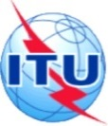
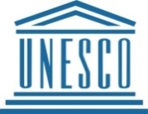
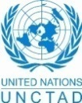
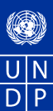
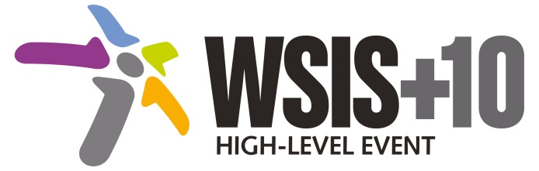
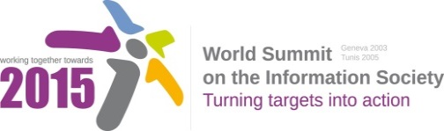

Document Number: WSIS+10/4/43
Note: This document is a clean version of the 1st reading to facilitate discussions in the 4th Physical meeting to be held on 14-17 April 2014.
Document Number: V2/C/ALC8

Note: This document is the result of the first reading of the document number V1.1/C/ALC8 and reflects the changes and comments received at the third physical meeting of the WSIS+10 MPP. This document is available at: http://www.itu.int/wsis/review/mpp/pages/consolidated-texts.html

This document has been developed keeping in mind the Principles.
Please note that the Geneva Declaration and the Geneva Plan of Action still remain valid until further decisions by the General Assembly.

Draft WSIS+10 Vision for WSIS Beyond 2015

С8. Cultural Diversity and identity, linguistic diversity and local content
1. Vision
Our vision on inclusive Knowledge Societies is that of a more culturally and linguistically diverse digital world, where around 40% of all existing languages are present in cyberspace ; where development takes into account local, national and regionalcontexts, builds on the knowledge generated by all communities, promotes innovation and creativity, and allows all human beings to practice their own culture and enjoy that of others free from fear. It is a world where marginalized groups, including indigenous peoples, and those coming from migrations, diasporas and from language minorities, enjoy increased recognition and equity; artists, cultural professionals and practitioners are empowered to create, produce, disseminate enjoy and preserve a broad range of cultural goods, services and activities; and where intangible expressions inherited from past generations are kept alive for future generations.
2. Pillars
- The Recommendation concerning the Promotion and Use of Multilingualism and Universal Access to Cyberspace.

- Reinforce and implement at national level of the Recommendation concerning the Promotion and Use of Multilingualism and Universal Access to Cyberspace
- Open up cyberspace to content production and content fruition in more languages, be they local, national, regional or international, including email, search enginesin diverse coding formats.
- Launch and support governmental and other initiatives for. preservation, digitization and digital archiving of cultural and documentary heritage .and born-digital information.
- Encourage implementation of national and regional initiatives and programmes launched and/or implemented by different international and regional organizations.
- Develop region-wide standards for developing digital content specific to the vehicular languages that will enhance quality, interoperability, and inter-regional collaboration.
- Promote infrastructure to facilitate development of local content, given the relationship between the deployment of Internet infrastructure and the development of local digital content,
- Support national entrepreneurial and start-up ecosystem to help the digital content industry to flourish, including incubators, accelerators, mentorship, investments, and venture capital, focusing on digital content applications and emphasizing the recent technology trends such as mobile devices, tablet computers, and cloud computing.
- Develop appropriate policies and procedures to help converting saved documents from analogue to digital system.
- Consider the inclusion of protection of digital heritage in a normative instrument on documentary heritage especially of indigenous people and in minor languages.
- Promote the development and use of internationalised domain names.

- The UN Declaration on the Rights of Indigenous Peoples.
- Promote the principles of the UN Declaration on the Rights of Indigenous Peoples, relevant in the context of WSIS and the ICT landscape,. In particular, through work to:
  - Support bridging the digital divides with regard to Indigenous Peoples.
  - Support the full and effective participation of Indigenous Peoples in the WSIS process and beyond.
  - Foster policies and programmes that promote media pluralism including Indigenous media.
  - Ensure , to safeguard traditional knowledge
  - Ensure that Indigenous knowledge is recognized to have an important place in inclusive knowledge societies.
  - OLD text in brackets (reminder)
  - Support the right to take part in cultural life for all to promote inclusive social development.

- [The Diversity of Cultural Expressions in Information Society.]
- [Advocate worldwide of the strategic link between culture and development].
- [Integrate culture within all development policies and programmes.]
- [Leverage culture for poverty reduction and inclusive economic development]
- Build on culture to promote environmental sustainability.
- Strengthen resilience to disasters and combat climate change through culture
- Harness culture as a resource for achieving sustainable urban development and management.
- Facilitate local content production with measures at governmental and community level.
- Develop North-South, and South-South cooperation in all areas relating to C8 AL.
- Promote the public service value on the Internet and particularly through safeguarding freedom of expression implemented by a multiplicity of platforms and services.]
- Safeguarding of Intangible Cultural Heritage.

  - Value, safeguard and transmit culture to future generations.
  - Capitalize on culture to foster innovative and sustainable models of cooperation.
  - Focus national policy on languages as a strategic factor for development policy.
  - Mobilize culture and mutual understanding to foster peace and reconciliation.
  - Bridge differences and discrepancies among the objectives of the diverse stakeholders in the field of linguistic policies worldwide, to create a global platform for joint action.

- New Pillar: Encourage the integration of digital content development concepts and skills into IT curricula at the higher education level, including the development of inter-disciplinary post-graduate courses, and the establishment of training centres that provide technical training in digital content development.

- New Pillar: measurement of digital content especially in local language. Such pillar will include the formulation of indicators/indices for digital content in local language, data collection and analysis of local digital content development.

3. Targets
- A more culturally and linguistically diverse world, where at least 40% of the existing 6,000 languages are present in public life;
- An increase of Intangible Cultural Heritage safeguarding plans with a linguistic dimension
- Near universal ratification of the Convention on the Protection and Promotion of the Diversity of Cultural Expressions and significant new resources mobilized for the International Fund for Cultural Diversity;
- Strong increase of measures implementing the principles of the UN Declaration on Indigenous Peoples.

