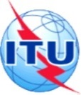
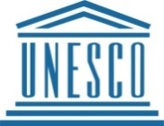
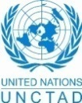
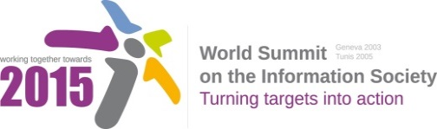

Document Number : WSIS+10/3/82
Submission by: Internet Democracy Project, CDT, IFLA and Access, Civil Society
Please note that this is a submission for the Third Physical meeting of the WSIS +10 MPP to be held on the 17th and 18th of February.

Document Number: V2/C/AlC7/E-Learning

Note: This document is the result of the first reading of the document number V1.1/ C/ALC7/E- Learning and reflects the changes and comments received at the second physical meeting of the WSIS+10 MPP. This document is available at: http://www.itu.int/wsis/review/mpp/pages/consolidated-texts.html

This document has been developed keeping in mind the Principles.
Please note that the Geneva Declaration and the Geneva Plan of Action still remain valid until further decisions by the General Assembly.

Draft WSIS+10 Vision for WSIS Beyond 2015

C7. ICT Applications: E-Learning

1. Vision
We envision an inclusive Information Society that offers global access to information and knowledge through ubiquitous and accessible e-learning opportunities for all, both within and beyond formal educational structures. Technology will enrich learning and enhance opportunity through multiple modes of delivery, ensuring universal education and supporting internationally agreed development goals including the right of all children to access quality education facilities in their community.. It will support media and information literacy and workplace learning, and will offer a medium for expression and communication to meet the specific needs of all learners. In this vision, e-learning will alsoimprove the effectiveness of administrative and planning tasks in education systems, [bearing in mind that copyright should not put any obstacle in the process of E-learning.]

2. Pillars
- Develop and implement national policies that focus on utilizing ICTs to deliver access to education for all, regardless of circumstances, improve quality of teaching, curriculum development and delivery.

- Support the development of new digital literacies for both teachers and learners and establish widespread cross-generational community learning initiatives to bridge technical skills gaps.

- Facilitate the transformation of Teacher Professional Development (TPD) through ICT integration in Teacher Training curricula, and ensure that TPD is ongoing and incremental through the active teaching careers.

- Utilise and enhance the use of ICTs in the planning, assessment and recognition of formal and informal learning and in developing pathways to further education and training.

Encourage research and promote awareness among all stakeholders of the possibilities offered by different models, including open modalities (i.e. Open Educational Resources - OERs, Free and Open Software – FOSS), distance education (Massive Online Open Courses- MOOCS) and emerging techniques (Text and Data Mining – TDM) in order to increase access to education, competition, freedom of choice and affordability, and to enable all stakeholders to evaluate which solution best meets their requirements.

- Develop and implement policies that preserve, affirm, respect and promote diversity of cultural expression and indigenous knowledge and traditions through the creation of varied information content and the use of different methods to support education and training, including the digitization of the educational, scientific and cultural heritage.

3. Targets
- [Every person can access and use ICTs for learning.
- Indicator: Percentage of population enabled to use ICTs for learning for quality teaching and learning.

- Global monitoring of development for e-Education services and quality assessment for e-Learning.]
- Indicator: Global monitoring system of development for e-Education services.
- Indicator: Number of relevant structures covered by the monitoring.
- Indicator: Quality assessment system for e-Learning.

- ]

