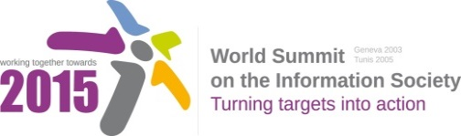

**Document Number : WSIS+10/3/59**

**Submission by: Canada, Government**

***Please note that this is a submission for the Third Physical meeting of the WSIS +10 MPP to be held on the 17th and 18th of February.***

**Document Number: V1.1/C/ALC10**

Note: This document consolidates the comments received by WSIS Stakeholders from the 9th October to 17th November. All the detailed submissions are available at:

<http://www.itu.int/wsis/review/mpp/pages/consolidated-texts.html>

This serves as an input to the 2nd Physical meeting and could be considered as the proposal for the 1st draft to be considered by the meeting.

This document has been developed keeping in mind the [Principles](http://www.itu.int/wsis/review/mpp/pages/consolidated-texts.html).

Please note that the Geneva Declaration and the Geneva Plan of Action still remain valid until further decisions by the General Assembly.

Draft WSIS+10 Vision for WSIS Beyond 2015

С10. Ethical Dimensions of the Information Society

**1. Vision**

For the post-2015 era, we envision inclusive Knowledge Societies, in which all stakeholders are well informed of ethical challenges and have adequate tools to support them in their decision making process; they regularly seek opportunities to engage and share their experiences among themselves.

**2. Pillars**

1. Give consideration to the ethical principles that bear on technological and social issues in the information society.
2. Strengthen regional and national capacity in to analyse, discuss and respond to the ethical challenges of the information society.
3. Promote international, multistakeholderand interdisciplinary reflection and debate on the ethical challenges of emerging technologies and the information society. Such reflection and debate should have a multi-tiered dimension that connects to policy and advisory bodies, with particular attention to participation of developing countries and sensitivity to their needs.

Raise awareness of the ethical implications of the information society, particularly among young people, along with life-long education initiatives to equip all citizens with the skills and competence to participate actively and knowledgeably in the information society.