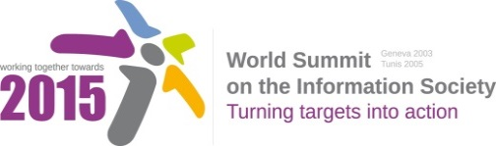
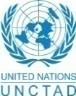
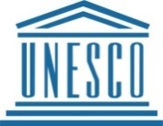
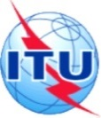

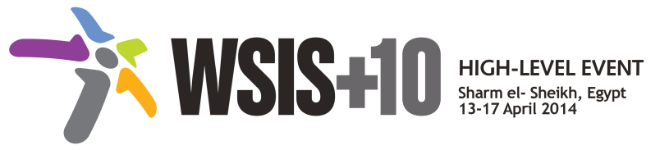

Document Number : WSIS+10/3/26
Submission by: Japan, Government
Please note that this is a submission for the Third Physical meeting of the WSIS +10 MPP to be held on the 17th and 18th of February.

Document Number: V2/C/ALC4

Note: This document is the result of the first reading of the document number V1.1/C/ALC4 and reflects the changes and comments received at the second physical meeting of the WSIS+10 MPP. This document is available at: http://www.itu.int/wsis/review/mpp/pages/consolidated-texts.html

This document has been developed keeping in mind the Principles.
Please note that the Geneva Declaration and the Geneva Plan of Action still remain valid until further decisions by the General Assembly.

Draft WSIS+10 Vision for WSIS Beyond 2015

C4 Capacity Building

1. Vision
Everyone should have an opportunity to acquire the necessary skills and knowledge to benefit fully from the information society in order to reduce and bridge the digital divide. Therefore, capacity building, digital literacy and competences are essential as well as professionalism that is a necessary standard for all who engaged in the ICT sector. Appropriate specialized training programmes in telecommunications/ICT, development of professional standards, lifelong learning initiatives and more affordable ICTs will empower all layers of society towards improving the quality of their lives. It will also assist people who are outside the formal education processes and will help them to acquire new skills as well as improve on existing ones
2. Pillars
- Content development and specialized training
While innovations in ICTs offer new tools, many people have yet to acquire the knowledge and skills to fully leverage the benefits these tools provide; therefore it is important to develop a wide and growing range of general and specialized training programmes for all stakeholders (creators, maintainers and operators) and beneficiaries of the ICT sector (especially in developing countries) in all aspects of telecommunications/ICT. As technology keeps changing rapidly existing knowledge quickly becomes obsolete, hence the need to upgrade this knowledge and package it into state of the art content and training materials

b) Development and use of maintenance of e-Education, e-Learning and mobile learning for education and for skills development.
With a view to determining scalable models for widespread implementation there is an urgent need to continue action research investment, and development of good practice models in e-learning and m-learning to assist in meeting the MDGs and Education for All (EFA) goals in terms of quantity and quality in education, skills development and lifelong learning for all, also beyond the classroom .
c) E-skilling, digital competence and professional standards
Ensure that development of ICT infrastructure takes place, to the extent practicable in parallel with e-skilling and human capacity buildingeveryone has the necessary digital competence that corresponds to professional standards in the ICT sector that are capable of comparison across countries and continents, in order to build a digital culture in all layers of society and foster development of these standards in order to facilitate human talent flow in the ICT sector.

d) Facilitation and fostering of capacity building activities
Capacity building is an important component in all aspects of human life; therefore it is important to ensure that human and institutional capacity building activities remain a priority objective for all beneficiaries of the ICT sector ( regardless of gender, age ,abilities and financial situation) and especially in developing countries in order to ensure continuing professional development and building the Information Society. Capacity building at national level in leadership skills for coherent policy making for social and economic development should include knowledge of the key drivers such as science, technology and innovation, education and ICT.

e) Partnership and collaboration
ICTs are cross cutting in all sectors, and their impact is also cross cutting in all aspects of daily life; consequently human and institutional capacity building requires partnership and collaboration for achieving desirable results. This collaboration should be done on national,regional and international levels within all sectors in order to maintain and ensure the access to ICT and ICT enhanced education for skills development and lifelong learning beyond the classroom.

