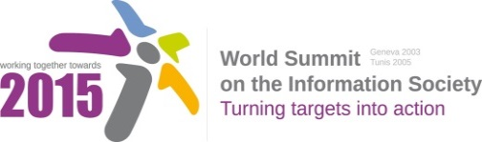

Document Number : WSIS+10/3/16
Submission by: Russian Federation, Government
Please note that this is a submission for the Third Physical meeting of the WSIS +10 MPP to be held on the 17th and 18th of February.

Document Number: V1.1/C/ALC7/E-Health

Note: This document consolidates the comments received by WSIS Stakeholders from the 9th October to 17th November. All the detailed submissions are available at:
http://www.itu.int/wsis/review/mpp/pages/consolidated-texts.html

This serves as an input to the 2nd Physical meeting and could be considered as the proposal for the 1st draft to be considered by the meeting.
This document has been developed keeping in mind the Principles.
Please note that the Geneva Declaration and the Geneva Plan of Action still remain valid until further decisions by the General Assembly.

Draft WSIS+10 Vision for WSIS Beyond 2015

С7. ICT Applications: E-Health

1. Vision
In every country and at every level, information and communication tools are essential to health. Access to ICTs, supported by a sound enabling environment, is critical for health services development, progress and their availability. This applies whether eHealth is used by individuals searching for health information or support, professionals and facilities providing health care services, public health services ensuring monitoring, alert and response, or for strengthening citizen-centered health systems.

2. Pillars
- Encourage the adoption of national eHealth strategies focusing on integrating ICTs to support the priorities of the health sector and to provide reliable and affordable connectivity to benefit all citizens.
- Promote the use of ICTs to strengthen health care and public health services, with special efforts to reach citizens in remote and under-served areas especially in developing countries.
- Facilitate innovation and access to eHealth applications to support health professionals, improve local access to information, and enable the flow of information in health services and systems.
- Ensure public trust and confidence in eHealth, through international collaboration and broad adoption of legislations, policies, regulations and other measures that address the concerns of the health sector, including those of a cross-border nature.
- Integrate the use of ICTs in preparing for, sharing information on, and responding to disease outbreaks, disasters and other emergencies requiring inter-sectoral collaboration and exchange of information in real-time.
- Encourage to create effective funding mechanisms, business models and partnerships to accelerate and sustain eHealth efforts beyond pilot stages and ensure scalability
- Enable access to the world’s medical knowledge through the use of ICTs.
- Share good practice, evidence and progress on eHealth, to enable informed development of eHealth activities worldwide.

3. Targets
- Will be available soon.

