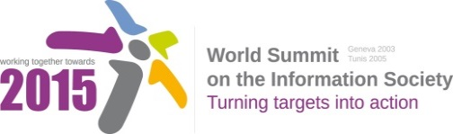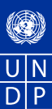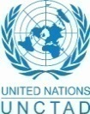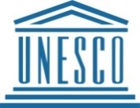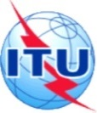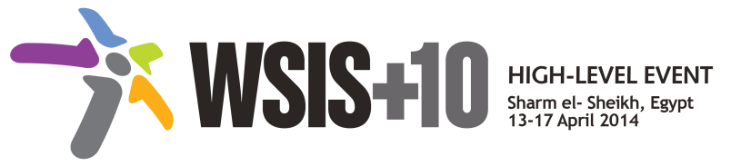

**Document Number: V1.2/C/ALC3**

Note: This document compiles all the submissions received from WSIS Stakeholders between 19th

December 2013 to 24th January 2014. All the detailed submissions are available at

http://www.itu.int/wsis/review/mpp/pages/consolidated-texts.html (reference: purple documents).

This document also includes the main outcomes of the second physical meeting .

The document serves as an input to the third physical meeting of the WSIS+10 MPP.

**Document Number: V1.1/C/ALC3**

Note: This document consolidates the comments received by WSIS Stakeholders from the 9th October to 17th November. All the detailed submissions are available at:

<http://www.itu.int/wsis/review/mpp/pages/consolidated-texts.html>

This serves as an input to the 2nd Physical meeting and could be considered as the proposal for the 1st draft to be considered by the meeting.

This document has been developed keeping in mind the [Principles](http://www.itu.int/wsis/review/mpp/pages/consolidated-texts.html).

Please note that the Geneva Declaration and the Geneva Plan of Action still remain valid until further decisions by the General Assembly.

Draft WSIS+10 Vision for WSIS Beyond 2015

С3. Access to information and knowledge

Regarding to the Document V1/C/ALC3, the approach toward ***“Access to information and knowledge”*** is not comprehensive and merely deals with the right of having access and not the right of controlling the access, meaning that ICT users should be able to merely receive the information they are willing to. In other words, the right to have access to information and knowledge encompasses the right of being protected against unwanted information (advertisements, malwares, spam etc.). Consequently, the both aspects of the So-rights have to be notified.

* **ISOC, Civil Society: Deleted**

**1. Vision**

For the post-2015, we envision inclusive Knowledge Societies to facilitate access to information and knowledge all the world's people, including those the aged and coming from previously marginalized groups and regions in addition to persons with impairments with a significant portion of knowledge flows and innovations that advance human rights and the attainment of development goals.

* **ISOC, Civil Society:** For the post-2015 agenda, we envision inclusive Knowledge Societies to facilitate access to information and knowledge all the world's people, including people coming from previously marginalized groups and regions in addition to persons with impairments. A significant portion of knowledge flows and innovations should contribute to support human rights and the attainment of development goals.
* **Canada, Government:** For the post-2015, we envision inclusive Knowledge Societiesto facilitate access to information and knowledge all the world's people, including those the aged and coming from previously marginalized groups and regions in addition to persons with impairments with a significant portion of knowledge flows and innovations that advance human rights and the attainment of development goals.
* **Uruguay, Government:** Wording of this section should be revised.
* **Center of Technology and Society, Civil Society:** For the post-2015 era, we envision inclusive Knowledge Societies to facilitate access to information and knowledge all the world's people, where there is an increased and informed participation of all groups, where there is an increased and informed participation of all groups, including those the aged and coming from previously marginalized groups and regions in addition toandand persons with impairments disabilities, with a significant portion of knowledge flows and innovations that advance human rights and the attainment of development goals. Facilitated access should be considered access that is unfettered by technological restraints, and respectful of users’ privacy and other human rights.
* **UNESCWA, International Organization:** We agree that it is no longer enough to ensure accessibility to information and knowledge, but it is also important to stress on the use of information and the generation of knowledge taking into account the national regulatory framework, intellectual property and copyright, as well as other instruments such as human rights.

**2. Pillars**

* **Uruguay, Government:** Wording of this section should be revised.
* **UNESCWA, International Organization**: We suggest the addition of another pillar that focus on the policies, action plans and initiatives aimed at ensuring access to information and knowledge for specific communities such as women and girls, youth, aged groups and people with disabilities.
  + *For example:* Promote the development and implementation of policies, actions plans and initiatives aimed at providing access to information and knowledge for specific communities (or vulnerable and marginalized groups), including women and girls, youth, elderly people and people with disabilities.
* *Pillar a:* We suggest the addition of “open information and knowledge” to this pillar.
  + *For example*: Promotion of government-led open data, information, knowledge, software (FOSS), and other open solution strategies, resources and standards in all countries and languages.

1. Government-led open data, FOSS, and other open solution strategies and resources promoted in all countries and languages.

**Center of Technology and Society, Civil Society:** Government-led open data, open science, open access, open educational resources, FOSS, and other open solution strategies and resources promoted in all countries and languages

1. Project support for expanding and enhancing access to information in the public domain or alternative: Strong policy, programme and project support for expanding and enhancing public access to information

* **Center of Technology and Society, Civil Society:**

1. Project support for expanding and enhancing access to information in the public domain
2. or alternative: Strong policy, programme and project support for expanding and enhancing public access to information, including through incentives for the adoption of open licensing models.
3. Enhance international solidarity to promote exchange of experiences and research within and across nations and regions in the context of information and knowledge societies.
4. initiatives focused on youth, elderly and the poor that emphasize the role of information-based development entrepreneurial activities.

* **Center of Technology and Society, Civil Society:** Youth-focused and pro-poor iinitiatives focused on youth, elderly and the poor that emphasize the role of information-based development oriented entrepreneurial activities.

1. Media and Information literacy as a core element of all formal, non-formal and life-long learning initiatives.

* **Center of Technology and Society, Civil Society**: Media and Information literacy emphasized as a core element of all formal, non-formal and life-long learning initiatives.
* **Russian Federation, Government:** Media and Information literacy as a core element of all formal, non-formal and life-long learning initiatives to ensure competent access to information and knowledge.

1. Information literacy emphasized as a core element of all formal, non-formal and life-long learning initiatives to promote healthy ageing and foster independent living solutions for the aged and the impaired.

**[New Pillar] Russian Federation, Government:** The long term preservation of digital information must become an inalienable part of cultural, educational, research and information policy, and the policy of information society and knowledge societies building.

1. National efforts undertaken to promote access to development content – accessibility standards, accessible and inclusive ICTs, multilingual/culturally diverse content and tools.
2. Strong commitment to creating, developing and supporting sustainable multi-purpose community public access points providing affordable or free-of-charge access for all citizens to ICTs

* **Center of Technology and Society, Civil Society**: Strong commitment to creating, developing and supporting sustainable multi-purpose community public access points providing affordable or free-of-charge access for all citizens to ICTs, as well as improved infrastructure, with universal coverage, under fair and equitable terms.

[**New Pillar]** **Center of Technology and Society, Civil Society** : The preservation user rightsprotection of privacy, freedom of expression, and other human rights , that are fundamental for the existence of an ecosystem that is enabling of unfettered access to information and knowledge., such as privacy, freedom of expression, and other human rights.

1. Continue the ongoing multi-stakeholder consultative and participatory processes for creating a post-2015 strategy, linking the Action Line C3 Access to Information to the post-2015 development agenda.

[**New Pillar]** **Center of Technology and Society, Civil Society** : Support of Open Government initiatives

**3. Targets**

1. Governments to undertake necessary efforts to support expansion of public domain, accessibility of public information services and products through the use of FOSS, open data and open solutions.
2. Indicator: Relevant national policies implemented.

* **Center of Technology and Society, Civil Society:** All Governments to undertake necessary ing efforts to support expansion of public domain, accessibility of public information services and products through the use of FOSS, open data and open solutions
* **Uruguay, Government:**

Development of ICT policies is already a target at AL C1.

[**New Targets]** **Center of Technology and Society, Civil Society**

The development of policies that promote and remove legal barriers to an unrestricted access to public domain;

The development of policies that facilitate digitization of libraries and collections, in order to promote preservation and broadened access.

The creation of an open educational resources policy and the incentive of an open access mandate;

The promotion of the production of FOSS and fostering its adoption by public administration.

The promotion of open standards for increased interoperability, innovation and ease of access.

The implementation of Open Government initiatives;

1. Indicator (a-f)r: Relevant national policies implemented.
2. Enhancing levels of Media and Information Literacy levels, and mass media and communications amongst school age population.
3. Indicator: % of schools with teachers trained to offer a MIL curriculum.
4. Indicator: Relevant lifelong educational and learning programmes and initiatives developed.

* **Center of Technology and Society, Civil Society** : Enhancing levels of Media and Information Literacy levels, and mass media and communications enhanced amongst school age population.
* **Uruguay, Government:** B should be revised.

1. Development and integration of accessible and inclusive ICTs including for persons with disabilities.
2. Indicator: Relevant national ICT teacher training programmes.
   * **Center of Technology and Society, Civil Society** Indicator: Relevant national ICT teacher training programmes developed.
3. Indicator: Relevant ICT training / tertiary education programmes included elements of accessible and inclusive ICT design

* **Canada, Government:** Deleted 3
* **Uruguay, Government:** C should be revised.