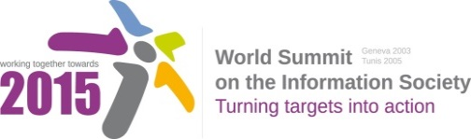
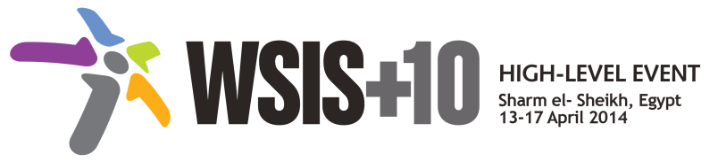

Document Number: V1.2/C/ALC1

Note: This document compiles all the submissions received from WSIS Stakeholders between 19th December 2013 to 24th January 2014. All the detailed submissions are available at
http://www.itu.int/wsis/review/mpp/pages/consolidated-texts.html (reference: purple documents).

This document also includes the main outcomes of the second physical meeting .

The document serves as an input to the third physical meeting of the WSIS+10 MPP.

Document Number: V1.1/C/ALC1

Note: This document consolidates the comments received by WSIS Stakeholders from the 9th October to 17th November. All the detailed submissions are available at:
http://www.itu.int/wsis/review/mpp/pages/consolidated-texts.html

This serves as an input to the 2nd Physical meeting and could be considered as the proposal for the 1st draft to be considered by the meeting.
This document has been developed keeping in mind the Principles.
Please note that the Geneva Declaration and the Geneva Plan of Action still remain valid until further decisions by the General Assembly.

Draft WSIS+10 Vision for WSIS Beyond 2015

С1. The role of public governance authorities and all stakeholders in the promotion of ICTs for development

1. Vision
The effective participation of governments and all stakeholders is vital in developing the Information Society. Through inclusive engagement, multistakeholder cooperation and partnerships, we collectively strive to provide sustainable and affordable access to information communication technologies (ICTs) and develop the requisite policies, legal and regulatory frameworks to enhance growth of the sector as well as address emerging challenges and opportunities. We strive to set international guidelines in the collection and analysis of datasets to induce the transformative changes needed to achieve sustainable development which also respect human rights and privacy.

- ISOC, Civil Society:
The effective participation of governments and all stakeholders is vital in developing the Information Society. Through inclusive engagement, multistakeholder cooperation and partnerships, we collectively strive to provide sustainable and affordable access to information communication technologies (ICTs) and develop the requisite policies, legal and regulatory frameworks to enhance growth of the sector as well as address emerging challenges and opportunities. We strive to set international guidelines in the collection and analysis of datasets to induce the transformative changes needed to achieve sustainable development which also respect people’s privacy.
2. Pillars
[New Pillar Uruguay, Government] Strengthen existing mechanisms at regional and international level for dialogue and collaboration in promoting ICTs for development.

- Encourage greater regional and international dialogue and collaboration in promoting ICTs for development

- Women and Information Society, Civil Society:
Encourage greater national, regional and international dialogue and collaboration in promoting ICTs for development

- Encourage development of national ICT policies legal and regulatory frameworks linked to sustainable development goals through an inclusive process.

- UNESCWA, International Organization: We suggest to add “sector-specific action plans” in the pillar.
  - For example: Encourage development of national ICT policies, legal and regulatory frameworks, and sector-specific action plans, linked to sustainable development goals through an inclusive process

[New pillar] Women and Information Society, Civil Society: Linking the Gender and ICT Policies. Women, as equal partners, active agents, innovators and decision-makers should be an integral part of, and key actors, in the Information Society. Ensure in the gender component inclusion in national ICT Development Policy.
- Foster greater multistakeholder engagement and cooperation at the local, national, regional and international levels among all stakeholders through capacity building, research and knowledge sharing for development of the ICT sector

- Russian Federation, Government:
Foster greater engagement and cooperation at the local, national, regional and international levels among all stakeholders through capacity building, research and knowledge sharing for development of the ICT sector

- Adopt policies and frameworks through multistakeholder consultation for the development of relevant, timely and accurate data and for the effective collection, application and open exchange of the same; ensuring respect for human rights and privacy. Moreover, the design of international frameworks to implement global best practices for the exchange of data would be an effective tool to achieve data interoperability.

- Russian Federation, Government:
Furthering the dialog on policies and frameworks through multistakeholder consultation for the development of relevant, timely and accurate data and for the effective collection, application and open exchange of the same; ensuring respect for human rights and privacy. Moreover, the design of international frameworks to implement global best practices for the exchange of data would be an effective tool to achieve data interoperability.

- ISOC, Civil Society:
Adopt policies and frameworks through multistakeholder consultation for the development of relevant, timely and accurate data and for the effective collection, application and open exchange of the same; ensuring respect for privacy. Moreover, the design of international frameworks to implement global best practices for the exchange of data would be an effective tool to achieve data interoperability.
- Uruguay, Government: does not specify data for what purposes?
- Promote the availability of affordable access to ICT as a key to the success of the all stakeholders’ efforts to establish an information society and bridge existing and emerging inequalities in digital economy

- Uruguay, Government: should be under AL C2 or C3

- Ensure that the services resulting from policies and frameworks can be accessed by citizens in the community, through affordable and public access to ICTs and training and encourage a feedback process as well as a monitoring and evaluation mechanism.

[New Pillar, APIG, Civil Society]: Agree a formal framework that provides for all governments to participate, on an equal footing, in the governance and supervision of the ICANN and IANA functions, and that provides for effective supervision and accountability of these functions in accordance with paragraphs 29, 35, 36, 61 and 69 of the Tunis Agenda.

3. Targets
- Development of national ICT policies, legal and regulatory frameworks by each state with involvement of stakeholders through an inclusive process;

- Women and Information Society, Civil Society:
Development of national ICT policies, legal and regulatory frameworks by each state with involvement of stakeholders through an inclusive process for youth, women, the vulnerable and marginalized, indigenous peoples, persons with disabilities.

- Uruguay, Government:
- By 2020, 100% of member states have established sustainable ICT policies with involvement of stakeholders through inclusive processes.

- By 2020, 100% of member states have implemented a statistical framework for measuring progress of national ICT policy and provided the necessary information for monitoring goals at regional and international level

