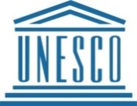
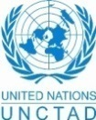
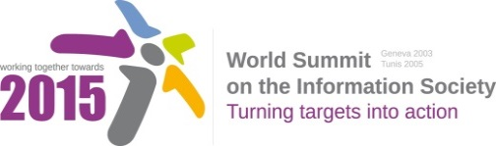
Document Number: V2/C/ALC9

Note: This document is the result of the first reading of the document number V1.1/C/ALC9 and reflects the changes and comments received at the third physical meeting of the WSIS+10 MPP. This document is available at: http://www.itu.int/wsis/review/mpp/pages/consolidated-texts.html

This document has been developed keeping in mind the Principles.
Please note that the Geneva Declaration and the Geneva Plan of Action still remain valid until further decisions by the General Assembly.

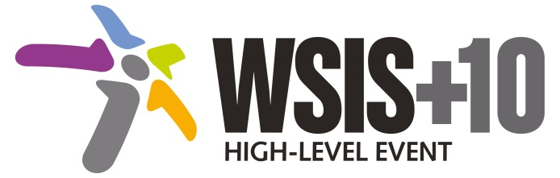

Draft WSIS+10 Vision for WSIS Beyond 2015

С9. Media

1. Vision
We envision inclusive Knowledge Societies, in which C9 Media will conceptualize the evolving mediascape within a broader and expanded role played by media on all platforms, with the vision of Internet and other digital platforms becoming increasingly valuable in enabling [freedom of expression], [responsibility of media], [good governance and developing rights-based] and sustainable development goals of the post-2015 agenda.
2. Pillars
- [Consider digital communications, and particularly Internet, as a core issue which has profoundly impacted media’s scope, reach and richness, as well as its breadth of direct stakeholders and its sustainability.]
- Stress the importance of respecting of [freedom of expression,] privacy, [objectivity, neutrality and responsibility] [online and offline, [and that public interest considerations will prevail in balancing these rights for responsible media.].]

- [Develop and update consolidated ICTs-media national policy frameworks based on multi-stakeholder dialogue (between governments, private sector, technical community and civil society organizations) ]
Alt : [Countries are encouraged to take into consideration the following while developing and updating ICTs-media policy frameworks the following aspects : ]
- Areas could include:[Privacy , freedom of expression,] the right to information, gender issues, considering that the same rights that people have offline must also be protected online; safety of journalists and [social media producers] user-generated content, ownership and spectrum issues; Media and information literacy (MIL);;; Content development and appropriation via mobile telephony; and enabling environments.
- [Continue the ongoing multi-stakeholder consultative and participatory processes for creating a post-2015 strategy, linking the Action Line C9 media to the post-2015 development agenda.]
- [Empower women to take part in and have a more influential role in the media sector, on all platforms, through promoting equal professional job and training opportunities].
Alt: [Encourage the active participation of Women in the media sector].
- [ Conceptualize the evolving mediascape within a broader framework such as “Internet Universality”. ]
- [Address the opportunities and challenges stemming from the increasing role played by the [Internet ]ICTs with regards to [new journalistic and users’ practices] and competencies.[as well as users' fundamental rights of freedom of opinion and expression and freedom of association and peaceful assembly[ in balance with responsibilities such as social responsibility, objectivity.].]]

: Promote a free, [independent ]and [pluralistic] and [responsible] media environment .

- [Promote community media (both on and offline), and public service media practice on all platforms, and within a context of pluralism]
- [Strengthen the presence of print, radio and TV on the Internet, so that programmes and services of these platforms, including public service broadcasters, are available through additional digital media platforms. ]
- New Pillar, [Encourage governmental and non-governmental, [online and offline] mass media to play a more substantial role in capacity building for the information society and building 21st century world outlook while promoting ICT for full-fledged Development and disseminating scientifically grounded content.]

See Geneva Plan of Action Para 24 on C9 Media and principles

3. Targets
- Target: All media and new media based on Internet and other digital platforms will play a more valuable role in advancing rights-based and sustainable development.
  - Indicator:
    - Development of updated concept, normative instruments and media policy framework.
    - Plurality and diversity of media landscape strengthened.
    - Number of institutions, journalists, media professions trained for capacity enhancement.
    - Number of multi-stakeholder driven events as regards media that are organized.
    - Content production and sharing on the internet

- Promoting media and information literacy, including for social media, in all countries and amongst all audiences, especially youth.

  - Baseline: The current context against which progress could measured may be characterised by: fragmented conceptualisations of media, inconsistent policy frameworks, and insufficient engagement with pluralism as measured across all platforms.

