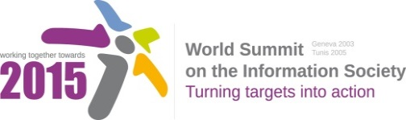
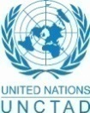
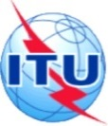

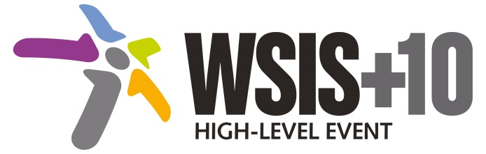

Document Number: V2/C/ALC3

Note: This document is the result of the first reading of the document number V1.1/C/ALC3 and reflects the changes and comments received at the third physical meeting of the WSIS+10 MPP. This document is available at: http://www.itu.int/wsis/review/mpp/pages/consolidated-texts.html

This document has been developed keeping in mind the Principles.
Please note that the Geneva Declaration and the Geneva Plan of Action still remain valid until further decisions by the General Assembly.

Draft WSIS+10 Vision for WSIS Beyond 2015

С3. Access to information and knowledge

Regarding to the Document V1/C/ALC3, the approach toward “Access to information and knowledge” is not comprehensive and merely deals with the right of having access and not the right of controlling the access, meaning that ICT users should be able to merely receive the information they are willing to. In other words, the right to have access to information and knowledge encompasses the right of being protected against unwanted information (advertisements, malwares, spam etc.). Consequently, the both aspects of the So-rights have to be notified.

1. Vision
For the post-2015, we envision inclusive [information and knowledge societies] to facilitate access and use of information and exchange of knowledge among all people, including those the aged and coming from previously marginalized groups and regions in addition to persons with impairments with a significant portion of knowledge flows and innovations that advance human rights and the attainment of development goals.
2. Pillars
- [Government-led open data, FOSS (free and open source software), and other open solution strategies and resources promoted in all countries and languages.]

- Project support for expanding and enhancing access to information in the public domain or alternative: Strong policy, programme and project support for expanding and enhancing public access to information

- Enhance international solidarity to promote exchange of experiences and research in the context of information society.
- initiatives focused on youth, elderly and the poor that emphasize the role of information-based development entrepreneurial activities.
- Media and Information literacy as a core element of all formal, non-formal and life-long learning initiatives [to support users to have the competency required to make good use of information and knowledge
UK:to promote skills in accessing information and knowledge ]
- Information literacy emphasized as a core element of all formal, non-formal and life-long learning initiatives to promote healthy ageing and foster independent living solutions for the aged and the impaired. (Merge e and f)
- [National efforts undertaken to promote development of content ,accessibility standards, accessible and inclusive ICTs, multilingual/culturally diverse content and tools.]
- [The long term digital preservation must become an inalienable part of cultural, educational, research and information policy, and the policy of information society and knowledge societies building, with the consent and collaboration of the communities and individuals involved.]
- Encourage the creation , development and support of sustainable multi-purpose community public access points providing affordable or free-of-charge access for all people to ICTs and knowledge.

- [Continue the ongoing multistakeholder consultative and participatory processes for creating a post-2015 strategy, linking the Action Line C3 Access to Information to the post-2015 development agenda.]

3. Targets
- Governments to undertake necessary efforts to support expansion of public domain, accessibility of public information services and products through the use of FOSS, open data and open solutions.
- Indicator: Relevant national policies implemented.

- Enhancing levels of Media and Information Literacy levels, and mass media and communications amongst school age population.
- Indicator: % of schools with teachers trained to offer a MIL curriculum.
- Indicator: Relevant lifelong educational and learning programmes and initiatives developed.

- Development and integration of accessible and inclusive ICTs including for persons with disabilities.
- Indicator: Relevant national ICT teacher training programmes.
- Indicator: Relevant ICT training / tertiary education programmes included elements of accessible and inclusive ICT design

