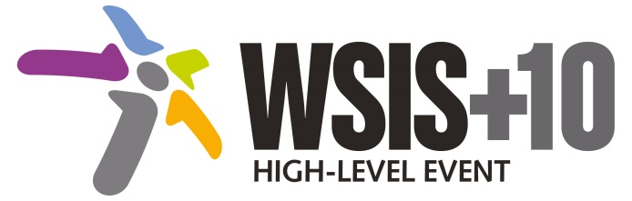

Document Number: S3/A3

Note: This para has been submitted by the Ad-hoc Group on Vulnerable Peoples facilitated by Health and Environment Program, Civil Society during the third physical meeting of the WSIS+10 MPP. This para, once agreed, will be reflected in the Preambles of the Statement and Vision to avoid duplication in the rest of the chapters.

This document is available at:
http://www.itu.int/wsis/review/mpp/pages/consolidated-texts.html

Recalling the UN Convention on the rights of people with disabilities, the Geneva principles paragraph 11, 13, 14 and 15. Tunis commitment para 20, 22 and 24 and reaffirming the commitment to providing equitable access to information and knowledge for all, building ICT capacity for all and confidence in the use of ICTs by all, including youth, older persons, women, indigenous and nomadic peoples, people with disabilities, the unemployed, the poor, migrants, refugees and internally displaced people and remote and rural communities.
It is crucial to increase the participation of vulnerable people in the building process of information society and to make their voice heard by stakeholders and policy-makers at different levels. It can allow the most fragile groups of citizens worldwide to become an integrated part of their economies and also raise awareness of the target actors on the existing ICTs solution (such as tolls as e-participation, e-government, e-learning applications etc) designed to make their everyday life better.
[this chapeau language does not preclude the possibility that individual groups of vulnerable people. May need to be referenced specifically in some action lines.
We recommend that this chapeau language is explicitly referenced at the beginning of each action line]

