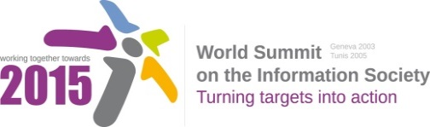
Document Number: V1/E/1
Submission by: Japan, Government

Draft WSIS+10 Vision for WSIS Beyond 2015

[Accountability and] Measurement of the WSIS Action Lines beyond 2015, targets and Indicators for an open and inclusive information/knowledge society for all beyond 2015
To enable the monitoring and evaluation of the WSIS Action Lines, stakeholders are calling for:
- The review of the WSIS Action Lines and Targets and the identification and development of forward-looking and clear targets and indicators and benchmarking tools to track progress. In particular:
  - WSIS targets and Action Lines should be reviewed and checked for their relevance and the objectives in the Action Lines should be measurable
  - Indicators should be widely available and able to track progress
  - Indicators should be forward-looking and go beyond access and also address the post-2015 development agenda and relevant development areas/policy issues
  - Indicators and benchmarking tools should address the needs of developing countries
  - Indicators should address and monitor ICT for development and the Partnership on Measuring ICT for Development could identify and disseminate statistical standards to monitor the impact of ICTs.

- An open and inclusive, multi-stakeholder monitoring process and framework. In particular:
  - The Partnership on Measuring ICT for Development should take a lead role in the monitoring of the Action Lines beyond 2015 and
  - The Partnership should expand its scope to include non-governmental organizations and other stakeholder into the monitoring process
  - Data collection should be open and inclusive and provide an online platform for all stakeholders to provide data/information
  - To increase the data availability and quality, the monitoring must be carried out in close cooperation with the National Statistics Offices (NSOs)

  - The monitoring framework could create national multi-stakeholder committees that include the government , the private sector, academia, and civil society
  - The monitoring framework should include a timetable and also regular assessments/reviews of progress
  - Public awareness, importance and benefits about the Action Lines and WSIS Targets should be raised, including through regional workshops

- The production of quantitative and qualitative information that will help policy makers identify appropriate policies. In particular:

  - Detailed analysis and evaluation of progress that goes beyond quantitative information
  - The development of best practice examples and the identification of success stories that could be replicated in other countries

