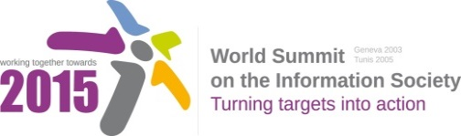
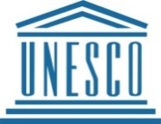
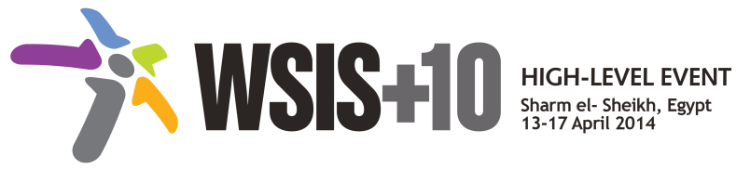
Document Number: V1/C/ALC7/E-Science/4
Submission by Russian Federation, Government

Draft WSIS+10 Vision Beyond 2015

С7. ICT Applications: E-Science

1. Vision
For the post-2015 era, we envision inclusive Knowledge Societies, in which e-Science will revolutionize science by changing: the way in which research is conducted; how the scientific agenda is defined; who participates in it; how the results and data are shared; the pace at which policymakers, scientists and individuals access knowledge; and who participates in the policy follow up of research outcomes. E-Science will improve the interface between policy, science and society by facilitating: more evidenced based policy actions; greater involvement of citizens in policy and scientific processes; more partnerships, better harmonized policy efforts and improved sustainability of outcomes.

2. Pillars
- Improve access to Scientific assessments on climate change, biodiversity and ecosystem services and agriculture by creating a web-based platform (with complementary mobile applications) based on a multidisciplinary knowledge system that critically reviews and synthesize new knowledge in as a real time as possible.
- Use e-science to promote data and knowledge exchange, provide relevant and timely information for citizens, scientists and policy-makers that will improve decision making, science, policy and society relations and standards of living, particularly for marginalized communities.
- Strengthen policy and programme activities in Citizen Science by encouraging the use of the internet and mobile technologies to facilitate greater participation of civil society in the entire scientific process.
- Facilitate more public and private partnerships to promote e-science in the post 2015 development agenda.
- Provide access for scientific society to publications of universities, scientific organizations and scientific and technical libraries based on aggregated information resources.
3. Targets
- Promote greater involvement of marginalized segments of society, particularly youth and indigenous peoples, in citizen science.
- Indicator: Percentage of target population actively engaging in citizen science activities.
- Indicator: Percentage of UNESCO- led or supported citizen science initiatives.
- Indicator: Percentage of e-science activities with gender focus.
- Establish a web-based platform to improve access to Scientific Assessments on climate change, biodiversity and ecosystem services and agriculture.
- Indicator: Web-based platform with mobile applications created and functional.
- Indicator: Number of users of the platform.
- Indicator: Number of gender focused policy options included in assessments.
- Enable the establishment of global system to monitor the level of development for e-Education services and assessment of quality in e-Learning.
- Indicator: Web-based platform with created and operational mobile applications.
- Indicator: Number of relevant structures covered by the monitoring.
- Indicator: Assessment of quality in e-Learning.

