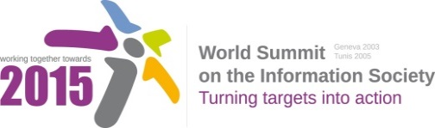
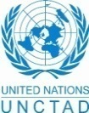
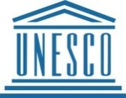
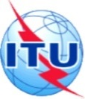
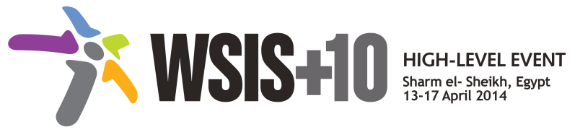
Document Number: V1/C/ALC7/E-Learning/5
Submission by: GESCI, Civil Society

Draft WSIS+10 Vision for WSIS Beyond 2015

C7. ICT Applications: E-Learning

1. Vision
For the post-2015 era, we envision inclusive Knowledge Societies, in which e-learning will be ubiquitous and accessible to all, within and beyond formal educational structures. No longer will children be refused educational opportunities for want of a classroom, nor will they have to walk long distances to school, or share text books. Technology will utterly transform the learning experience, bringing it beyond the current limited perception of formal education and opening it up to multiple modes of delivery and learning environments, truly transforming formal and non-formal education for all (EFA). Technology will facilitate lifelong learning and global access to information and knowledge, it will help provide media, information literacy (21st century) and technical skills and will offer a medium for expression and communication, allowing also to meet specific needs of all learners and to improve the effectiveness of administrative and planning tasks in education systems.
2. Pillars
- Develop enabling policies for ICTs in Education which focus on the full integration of ICTs in curriculum development and curriculum reform.
- Develop policies that ensure ICTs are integrated into training systems at all levels, including and especially Technical and Vocational Education and Training systems.
- Support the construction of new multiple literacies for the 21st Century for teachers and learners.
- Support the transformation of Teacher Professional Development (TPD) through ICT integration in Teacher Training curricula, and ensure that TPD is ongoing and incremental through the active teaching careers.
Note: [The action lines make but brief mention of the role of teachers, trainers, lecturers and instructors in the creation of sufficient national capacities to facilitate knowledge society advancement. In many African countries, these people are absolutely central to the provision of any kind of quality education, in a region of the world where limited access for many, to information and knowledge, connectivity, and supplemental private tuition means that the local teacher/instructor/lecturer/ is often the only means of any child or adult accessing a basic education. Without greater investment in teacher professional development initiatives that fully integrate ICT in curricula, and raise the quality of teaching and learning at the primary and secondary level, too many African youth will emerge from years of education without more than basic numeracy and literacy skills, making subsequent acquisition of modern 21st century skills a remote likelihood, and finding gainful employment even less likely.
- Harness emerging technological innovations for teaching and learning, including open modalities and strategies (i.e. Open Educational Resources - OERs, Free and Open Software - FOSS, Massive Online Open Courses- MOOCS).
- Encourage research and promote awareness among all stakeholders of the possibilities offered by different software models, and the means of their creation, including proprietary, open-source and free software, in order to increase competition, freedom of choice and affordability, and to enable all stakeholders to evaluate which solution best meets their requirements
- Support the creation of relevant content in local languages, curriculum integration and assessment.

Develop and implement policies that preserve, affirm, respect and promote diversity of cultural expression and indigenous knowledge and traditions through the creation of varied information content and the use of different methods, including the digitization of the educational, scientific and cultural heritage.
- Mobilize public and private funding to ensure that learners can benefit from ICTs and participate fully in Knowledge Societies.
- Support the establishment of wide-spread cross-generational community learning initiatives to bridge basis and technical skills gaps.
- Make mandatory the establishment of Education Management and Information Systems in all educational institutions.
- Develop and implement policies that preserve, affirm, respect and promote diversity of cultural expression and indigenous knowledge and traditions through the creation of varied information content and the use of different methods, including the digitization of the educational, scientific and cultural heritage.
- Leadership capacity building for coherent policy development for Education policy makers.
- Research in, investment in, and development of, good practice models for m-learning to widen access to learning opportunities to rural populations (in particular) in developing countries.
- Create policies that support the respect, preservation, promotion and enhancement of cultural and linguistic diversity and cultural heritage within the Information Society, as reflected in relevant agreed United Nations documents, including UNESCO's Universal Declaration on Cultural Diversity. This includes encouraging governments to design cultural policies to promote the production of cultural, educational and scientific content and the development of local cultural industries suited to the linguistic and cultural context of the users.

3. Targets
- Every person can access and use ICTs for learning.
- Indicator: Percentage of population enabled to use ICTs for learning.
b) Indicators need to be linked to improvements in the quality of teaching and learning attributable to varying to degrees to the use of ICTs.
Qualitative indicators must be linked to learning outcomes, and especially improvements in literacy and numeracy competencies.
Beyond that, ICT integration in Maths, Science and English curricula at the primary and secondary level should be directly tied to assessment indicators, as well as critical thinking, and analytical indicators.
Note: Percentage of population with access to ICTs for learning is an important indicator but will not measure quality of learning, which in many developing countries is now an educational crisis.

Annex: Zero Draft Stakeholder Contributions
- Support the construction of new multiple literacies for the 21st Century, including digital, media and information literacies.
- Harness emerging technological innovations such as open modalities and strategies for using ICT for education (Open Educational Resources - OERs, Free and Open Software - FOSS, Massive Online Open Courses- MOOCS) to ensure recognized learning opportunities to ease participation in Knowledge Societies.
- Mobilize public funding to ensure that learners have access to ICT to participate fully in Knowledge Societies.
- Develop enabling policies for mobile learning including support for making affordable devices, content and connectivity more widely available and ensuring the professional development to teachers on the use of mobile technologies to support teaching and learning in mixed, face-to-face and/or distance modes.
- Promote the effective policies to support e-learning for all, ensuring the inclusion of marginalized groups and empowerment of women.
- Support the creation of relevant content in local languages.
- Train teachers in online e-learning platforms so they can profit from existing programs or they can create their own learning content and program, with a preference on open licenses (as OER).

- What are areas that have not been adequately captured by the framework of the existing 11 WSIS Action Lines and would need to be addressed beyond 2015? Please specify the Action Line you are providing an input for.
  - Investing and deploying ICT to support open strategies for education (OER, Open Access to scientific data, Free and Open Source Software, new online strategies for distance education (including MOOCs)
  - Development of an ecosystem for the safe use of mobile technologies for education, including teaching digital citizenship and responsible use.
  - Leveraging mobile technologies for greater reach and inclusiveness
  - Greater support to programs and systems aimed at marginalized and diasadvantaged groups.

