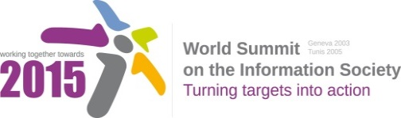
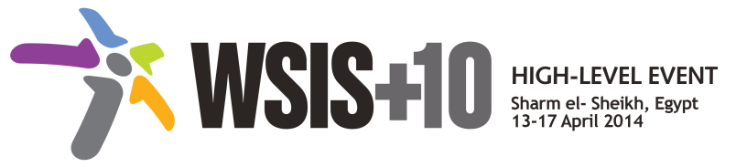
Document Number: V1/A/11
Submission by: United States, Government

Draft WSIS+10 Vision for WSIS Beyond 2015

Preamble
In 2003 and 2005, at the two phases of the World Summit of the Information Society (WSIS), the international community agreed on a set of commitments that recognize ICTs as enablers for development. World leaders representing Governments, civil society, private sector and the international organizations translated the common vision and guiding principles into concrete action lines in the Geneva Plan of Action, to advance the achievement of internationally agreed goals.

The Action Lines capture the potential of ICTs in enhancing access, especially of vulnerable populations, to education, health care and other public services, provision of ICT Infrastructure, creating enabling environments, building confidence and security in the use of ICTs to information, finance and knowledge, and the role of ICTs for the protecting the environment, for mitigating natural disaster risks, ensuring sustainable use of natural resources and sustainable food production and for women’s empowerment.

Though we have made considerable achievements, ten years since WSIS 2003, the ICT landscape has changed dramatically, several new trends have emerged in the information society like broadband, social networks, mobility and digital inclusion. These trends bring new Rapid innovation, diffusion and uptake of mobile technologies and improved access to the Internet have greatly expanded the gamut of opportunities that ICTs offer to promote inclusive development. As demonstrated by the ongoing overall review of the implementation of WSIS outcomes, international cooperation and multi-stakeholder collaboration on the strategic use of ICTs to address a wide range of issues during the past decade has produced a wealth of knowledge, experience and expertise – valuable resources.
Taking into account ongoing dialogue on the Post-2015 Development Agenda (MDG Review Process) and WSIS+10 review process it is important to note the possible interaction between both processes to ensure that efforts across the UN System are coherent, connected and coordinated to achieve maximum, sustainable impact.
The main task of bridging the digital divide and creating a people –centric, digitally inclusive and development oriented information society where everyone can create, access, utilize and share information and knowledge still remains.

Document Number: V1/A
Note: This section was shifted from the WSIS+10Statement to the WSIS+10 Vision for WSIS Beyond 2015. WSIS Stakeholders are invited to review this document, using track changes, and submit the document to wsis-info@itu.int by 17 November 2013 (non-extendable).

We envision:

- The full participation of all citizens of the world must be a priority for the information society. The full involvement of women, older people young people, people with disabilities and indigenous peoples, in the development of ideas and policies concerning the information society is essential if their concerns, needs and interests are to be fully incorporated in policies and outcomes of the information society.

- An information society that has the interests of the most poor and marginalised people of our societies at its heart is necessarily an information society that takes as its starting point a rights-based approach to development.

- That youth, women, the poor, indigenous people and persons with disabilities benefit from the opportunities provided by ICTs should remain a cross-cutting priority for bridging the digital divide, reinforced by accountability.

- The concept of digital inclusion goes beyond affordability and access to ICT networks, services and applications. It recognizes there are additional needs for different marginalized groups that include accessible ICTs for persons with disabilities, digital literacy training for women, youth and indigenous peoples, and the use of ICTs for social and economic empowerment, including, e.g. ICTs to promote youth employment and entrepreneurship.

- that in order to remove gender inequalities in the knowledge society and that the knowledge society actively empowers women in all aspects of their lives, it is necessary to apply a gender lens in all aspects of the knowledge society, across sectors and from strategies and planning through implementation and investments. This includes on the demand and supply side, from awareness, literacy and meaningful engagement to affordable access, appropriate policy frameworks and relevant content. An important way of ensuring this is realized is though women’s leadership and participation in decision-making.

- Providing equal opportunity and appropriate design for all to realize the benefits and opportunities of new technologies.

- Better cooperation with more funding and assistance for inclusive ICT initiatives in developing countries.

- Establishing the ICT infrastructure and its easy access that can provide access to all the communities and make available simplified devices, including text-free interfaces and applications aimed at digital inclusion

- Safe spaces, both online and off, should be available to build confidence in vulnerable users.

- Reach of broadband infrastructure and affordable services to everyone, including through universal service and universal access.

- Bridging the digital divide to cross and reap the benefits of ICT and broadband in transforming the lives of communities particularly the youth, women, poor, and persons with disabilities.

- Relevant and useful multilingual and local digital content should be encouraged to ensure that all members of the community are able to understand and participate in online life.

- In order to harness the opportunities provided by the ICT’s to the women, poor and persons with appropriate international technical standards and policies should be developed.

- Further development of appropriate national and regional policy and legal initiatives and approaches to pay specific attention to youth, women, poor, persons with disabilities and indigenous people when addressing the range of issues that impact their ability to benefit from the opportunities of ICTs and the information society.

- All persons have a voice in the development of policies that are important to them, as different marginalized and disadvantaged groups have different needs.

- Incorporation of accessibility issues in the public procurement policies and in international regulatory fora.

- Increased involvement of all stakeholders in leveraging the transformative potential of ICT and a better and more sustainable socio-economic development in order to reach an inclusive and people-centered Information Society.

- Deepening of the current multistakeholder model with particular emphasis on the benefits of the decentralized decision-making structure to ensure participation of youth, women, poor, persons with disabilities and indigenous peoples.

- Training and capacity building in ICTs, including media and information literacy be available to help users develop their abilities to evaluate and interact with online information resources.

- An enhanced learning experience for those with a range of disabilities through assistive technologies.

- Increased participation of youth in decision-making processes as vital ingredient for improving democracy.

- Fostering policies and projects that ensure para and per-Indigenous approaches to ICTs, that is policies and projects designed with and by Indigenous Peoples themselves.

- following inclusive approaches to e- science, including a citizen science approach, where local communities, indigenous peoples, youth, women, the poor, people with disabilities etc. can participate fully in the scientific process.

- An enabling environment with adequate market and legal reforms would spur competition and improve access to ICTs by making them more affordable.

- Affordable access to ICTs, that not only has the potential to transform lives of citizens and communities, but also to help the marginalized persons with disabilities and indigenous people by empowering them and their communities.

- Availability of affordable user devices.

- An information society where the most vulnerable, especially children, feel secure and protected online.

- That policy makers may consider transforming existing universal service programmes into programmes for digital inclusion that support broadband services for all citizens while further facilitating the access to ICTs of women, girls, the disabled and indigenous people.

- inclusion of people in rural and remote areas where not only market forces, but investment from the government might be necessary.

