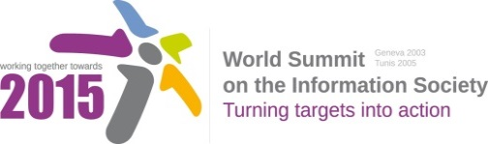
Document Number: V1/D
Note: Based on the outcomes of the First Physical Meeting of the WSIS+10 High-Level Event Open Consultation Process, WSIS Stakeholders are invited to provide their input towards this document and submit the document to wsis-info@itu.int by 17 November 2013 (non-extendable).

While providing your inputs please keep in mind that the Geneva Declaration and the Geneva Plan of Action still remain valid until further decisions by the General Assembly.

Draft WSIS+10 Vision for WSIS Beyond 2015

Other issues not covered by Action Lines above [, if any]

