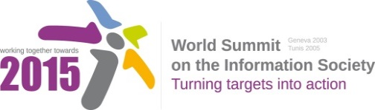
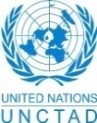
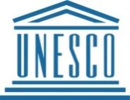
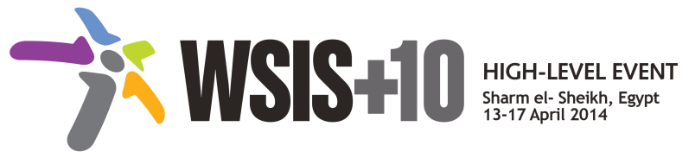
Document Number: V1/C/ALC9
Note: This Consolidated Text has been prepared by the UN Action Line focal points for review by WSIS Stakeholders. WSIS Stakeholders are invited to review this document, using track changes, and submit the document to wsis-info@itu.int by 17 November 2013 (non-extendable). The consolidated texts aim at building a vision upon the existing framework of Action Lines, identifying emerging trends, challenges and priorities for the new decade, without making the existing framework of Action Lines obsolete. The Geneva Declaration and the Geneva Plan of Action still remain valid until further decisions by the General Assembly.

Draft WSIS+10 Vision for WSIS Beyond 2015

С9. Media

1. Vision
For the post-2015 era, we envision inclusive Knowledge Societies, in which C9 Media will conceptualize the evolving mediascape within a broader and expanded role played by media on all platforms, with the vision of Internet and other digital platforms becoming increasingly valuable in enabling freedom of expression, good governance and developing rights-based and sustainable development goals of the post-2015 agenda.
2. Pillars
- Consider digital communications, and particularly Internet, as a core issue which has profoundly impacted media’s scope, reach and richness, as well as its breadth of direct stakeholders and its sustainability.
- Stress the importance of respecting both the principles of freedom of expression and privacy online and offline, and that public interest considerations are primary in balancing these rights in any cases of conflict.
- Develop and update consolidated ICTs-media national policy frameworks based on multi-stakeholder strategies (between governments, private sector, technical community and civil society organizations)
- Areas could include: Freedom of expression, the right to information, safety of journalists and social media producers who generate a significant amount of public-interest journalism, user-generated content, ownership and spectrum issues; Media and information literacy (MIL); Gender; Privacy; Content development and appropriation via mobile telephony; and enabling environments.
- Continue the ongoing multi-stakeholder consultative and participatory processes for creating a post-2015 strategy, linking the Action Line C9 media to the post-2015 development agenda.
- Empower women to take part in and have a more influential role in the media sector, on all platforms, through promoting equal professional job and training opportunities.
- Conceptualize the evolving mediascape within a broader framework such as “Internet Universality”.
- Address the opportunities and challenges stemming from the increasing role played by the Internet and ICTs with regards to new journalistic and users’ practices and competencies, as well as users' fundamental rights of freedom of expression, freedom of association and peaceful assembly.
- Approach media convergence with a pluralistic approach that promotes diversification of news sources, news producers and platforms, transparency of ownership, and the conceptualisation of the term ‘journalist’ and “journalists’ safety” in this context.
- Promote community media (both on and offline), and public service media practice on all platforms, and within a context of pluralism.
- Strengthen the presence of print, radio and TV on the Internet, so that programmes and services of these platforms, including public service broadcasters, are available through additional digital media platforms.

3. Targets
- Target: All media and new media based on Internet and other digital platforms will play a more valuable role in advancing rights-based and sustainable development.
  - Indicator:
    - Development of updated concept, normative instruments and media policy framework.
    - Plurality and diversity of media landscape strengthened.
    - Number of institutions, journalists, media professions trained for capacity enhancement.
    - Number of multi-stakeholder driven events as regards media that are organized.
  - Baseline: The current context against which progress could measured may be characterised by: fragmented conceptualisations of media, inconsistent policy frameworks, and insufficient engagement with pluralism as measured across all platforms.

Annex: Zero Draft Stakeholder Contributions
- Consider Internet a core issue which has profoundly impacted media’s scope, reach and richness, as well as its breadth of direct stakeholders and its sustainability.
- Elaborate an updated understanding of media and the media function within the novel information and communication environment, given the impact that ICTs have had in the media and other sectors.
- Conceptualize the evolving mediascape within a broader framework such as “Internet Universality” as is currently being explored by UNESCO in order to formulate a post-2015 media-ICTs converged strategy and facilitate collaboration between C9 and other relevant WSIS Action Lines.
- Develop and update consolidated ICTs-media national policy frameworks based on multi-stakeholder strategies (between governments, private sector and civil society organizations) in the areas of: Freedom of expression, the right to information, safety of journalists and bloggers, user-generated content, ownership and spectrum issues; Media and information literacy (MIL); Gender; Privacy; Content development and appropriation via mobile telephony; and enabling environments.
- Ensure that the principles of freedom of expression and privacy are adhered to wherever possible, and that public interest considerations are primary in balancing these rights in any cases of conflict.
- Continue the ongoing multi-stakeholder consultative and participatory process for updating the post-2015 strategy and formulating a coordinated strategy with stakeholders including UN agencies on the implementation of Action Line C9 media feeding into the post-2015 development agenda.
- Expand the role of media and new media based on Internet/mobile and digital platforms as promoted by WSIS Action Line C9 in fostering transparent and good governance and contributing to rights-based and sustainable development goals of the post-2015 agenda.
- Address the opportunities and challenges stemming from the increasing role played by the Internet and ICTs with regards to new journalistic practices, as well as users' fundamental rights of freedom of expression (Article 19 UDHR) and freedom of association and peaceful assembly (Art. 20 UDHR), and ensure that users are equipped with media and information literacy competencies to take full advantage of the expression opportunities that the Internet offers.
- Approach media convergence with a pluralistic approach that promotes diversification of news sources, news producers and platforms, and which approach also helps to conceptualise the term ‘journalist’ in this context of diversification as relevant to the protection of freedom of expression.
- Promote community media (both on and offline), and public service media practice on all platforms, and within a context of pluralism, and functional differentiation between these media in relation to private and social media, and to do so in with consideration of issues of sustainability, spectrum allocation, harmonization of commercial and public interests, digital safety, legislative and regulatory frameworks, and digital literacy/media and information literacy.
- Strengthen the presence of radio and TV channels on the Internet, so that programmes and services of public/private service broadcasters are available through additional digital media platforms.
- Increase quality of journalistic content, as well as access, live updates and interactivity with media consumers, to continue contributing to strengthening democracy.
- Promote the professional ethics amongst those contributing journalism on the Internet, and build professional associations as well as supporting structures such as NGOs and journalism education institutions in such a way that they are better positioned in their use of the right to press freedom online.
- Empower women to take part in and have a more influential role in the media sector, on all platforms, through promoting equal professional job and training opportunities.
- Promote field research that analyzes the media sector and shares the results with the public in order to raise awareness on the best means and practices needed for the development of a free and professional media system that covers all platforms.
- Strengthen access to both traditional and new media systems in remote areas and for marginalized communities, and support this access with media and information literacy programmes.
- Promote new ways of using media that can maximize the availability of spectrum to enable diversity of users and access through mobile devices.
Which areas have not been adequately captured by the framework of the existing 11 WSIS Action Lines and would need to be addressed beyond 2015? Please specify the Action Line you are providing an input for.
- Address interdependence between human rights aspects and online media content, and infrastructure convergence of media-ICT, and prompt the evolution of a more comprehensive framework to formulate a post-2015 media strategy whilst also facilitating collaboration between C9 and other WSIS Action Lines such as C3 - Access, C7 – E-earning, C8 - Cultural diversity and C 10 – Ethics.
- Action line C9: Consider the connection between media and social media, and media and mobile convergence.
- Action line C9: Address issues concerning the deployment of next-generation broadcasting services where broadcasting and Internet are truly converged.
- Action line C9: Address freedom of expression online and online privacy issues.
- Action line C9: Support the growth of converged media industries and the applications that will devolve from it.
- Action line C9 and C10: Deal with the liability of intermediaries and governmental surveillance, particularly in relation to freedom of expression on internet and privacy protection.
- Action line C9: Optimize the role of traditional media, such as public service broadcasters and community radios, by embracing new media platforms and user-generated content in the emerged Internet era.
- Action line C9: Develop policies and strategies for the increasing role of media and Internet/mobile and digital platform based on new media.
- Action line C9: Continue ongoing multistakeholder consultative and participatory process and formulate a coordinated strategy for media with stakeholders, including UN agencies.
- Action line C9: Support the entire media initiative from a human rights perspective.

