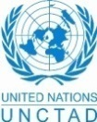
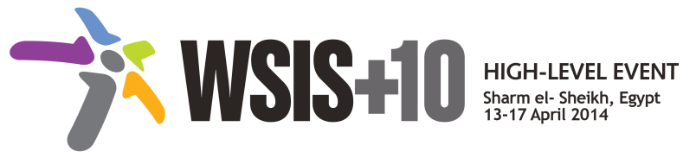
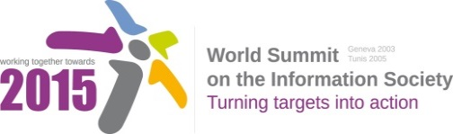
Document Number: V1.1/C/ALC9

Note: This document consolidates the comments received by WSIS Stakeholders from the 9th October to 17th November. All the detailed submissions are available at:
http://www.itu.int/wsis/review/mpp/pages/consolidated-texts.html

This serves as an input to the 2nd Physical meeting and could be considered as the proposal for the 1st draft to be considered by the meeting.
This document has been developed keeping in mind the Principles.
Please note that the Geneva Declaration and the Geneva Plan of Action still remain valid until further decisions by the General Assembly.

Draft WSIS+10 Vision for WSIS Beyond 2015

С9. Media

1. Vision
For the post-2015 era, we envision inclusive Knowledge Societies, in which C9 Media will conceptualize the evolving mediascape within a broader and expanded role played by media on all platforms, with the vision of Internet and other digital platforms becoming increasingly valuable in enabling freedom of expression, good governance and developing rights-based and sustainable development goals of the post-2015 agenda.
2. Pillars
- Consider digital communications, and particularly Internet, as a core issue which has profoundly impacted media’s scope, reach and richness, as well as its breadth of direct stakeholders and its sustainability.
- Stress the importance of respecting both the principles of freedom of expression and privacy online and offline, and that public interest considerations will prevail in balancing these rights.
- Develop and update consolidated ICTs-media national policy frameworks based on multi-stakeholder strategies (between governments, private sector, technical community and civil society organizations)
- Areas could include: Freedom of expression, the right to information, safety of journalists and social media producers who generate a significant amount of public-interest journalism, user-generated content, ownership and spectrum issues; Media and information literacy (MIL); Gender; Privacy; Content development and appropriation via mobile telephony; and enabling environments.
- Continue the ongoing multi-stakeholder consultative and participatory processes for creating a post-2015 strategy, linking the Action Line C9 media to the post-2015 development agenda.
- Empower women to take part in and have a more influential role in the media sector, on all platforms, through promoting equal professional job and training opportunities.
- Conceptualize the evolving mediascape within a broader framework such as “Internet Universality”.
- Address the opportunities and challenges stemming from the increasing role played by the Internet and ICTs with regards to new journalistic and users’ practices and competencies, as well as users' fundamental rights of freedom of expression, freedom of association and peaceful assembly.
- Approach media convergence with a pluralistic approach that promotes diversification of news sources, news producers and platforms, transparency of ownership, and the conceptualisation of the term ‘journalist’ and “journalists’ safety” in this context.
- Promote community media (both on and offline), and public service media practice on all platforms, and within a context of pluralism
- Strengthen the presence of print, radio and TV on the Internet, so that programmes and services of these platforms, including public service broadcasters, are available through additional digital media platforms.

3. Targets
- Target: All media and new media based on Internet and other digital platforms will play a more valuable role in advancing rights-based and sustainable development.
  - Indicator:
    - Development of updated concept, normative instruments and media policy framework.
    - Plurality and diversity of media landscape strengthened.
    - Number of institutions, journalists, media professions trained for capacity enhancement.
    - Number of multi-stakeholder driven events as regards media that are organized.
    - Content production and sharing on the internet

- Promoting media and information literacy, including for social media, in all countries and amongst all audiences, especially youth.

  - Baseline: The current context against which progress could measured may be characterised by: fragmented conceptualisations of media, inconsistent policy frameworks, and insufficient engagement with pluralism as measured across all platforms.

