Radiocommunications and Climate Change
Alexandre VASSILIEV,
International Telecommunication Union
Almost everybody now recognizes that climate change represents a threat to mankind on a similar level to violent conflict and war, and indeed can lead to a breakdown of peace because of the increased competition for the earth’s resources. Radiocommunications are undoubtedly part of the cause of global warming as witnessed, for instance, hundreds of millions TV-sets, VCR and other radio devices that are left on stand-by mode 24 hours a day still consuming altogether significant amount of power. But radiocommunications can also be part of a solution, because of the role they play in climate change monitoring, mitigating and adapting to it.

1. Radiocommunications Use in Monitoring the Environment and Climate Change
Timely warning of impending natural and environmental disasters, accurate climate prediction and detailed understanding of the status of global water resources: these are all critically important everyday issues for the global community. At present, remote sensors provide the main source of information about the Earth’s atmosphere and surface. This information is used for climate, weather and water monitoring, prediction and warnings, natural disasters risk reduction, support of disaster-relief operations and for planning preventive measures for adapting to and mitigating the negative effects of climate change.
The science of climate change, which has developed over the last century or so, has benefited greatly from the parallel development of ICTs in general and radio technologies in particular. The role of radicommunications in weather and climate monitoring is clearly shown in the structure of the World Meteorological Organization’s (WMO) Global Observing System (GOS). GOS provides observations of the atmosphere and the Earth’s surface (including oceans) from the globe and from outer space (see Figure 1). The GOS uses remote sensing equipment placed on satellites, aircraft, radiosondes and relay data to environment control centres.
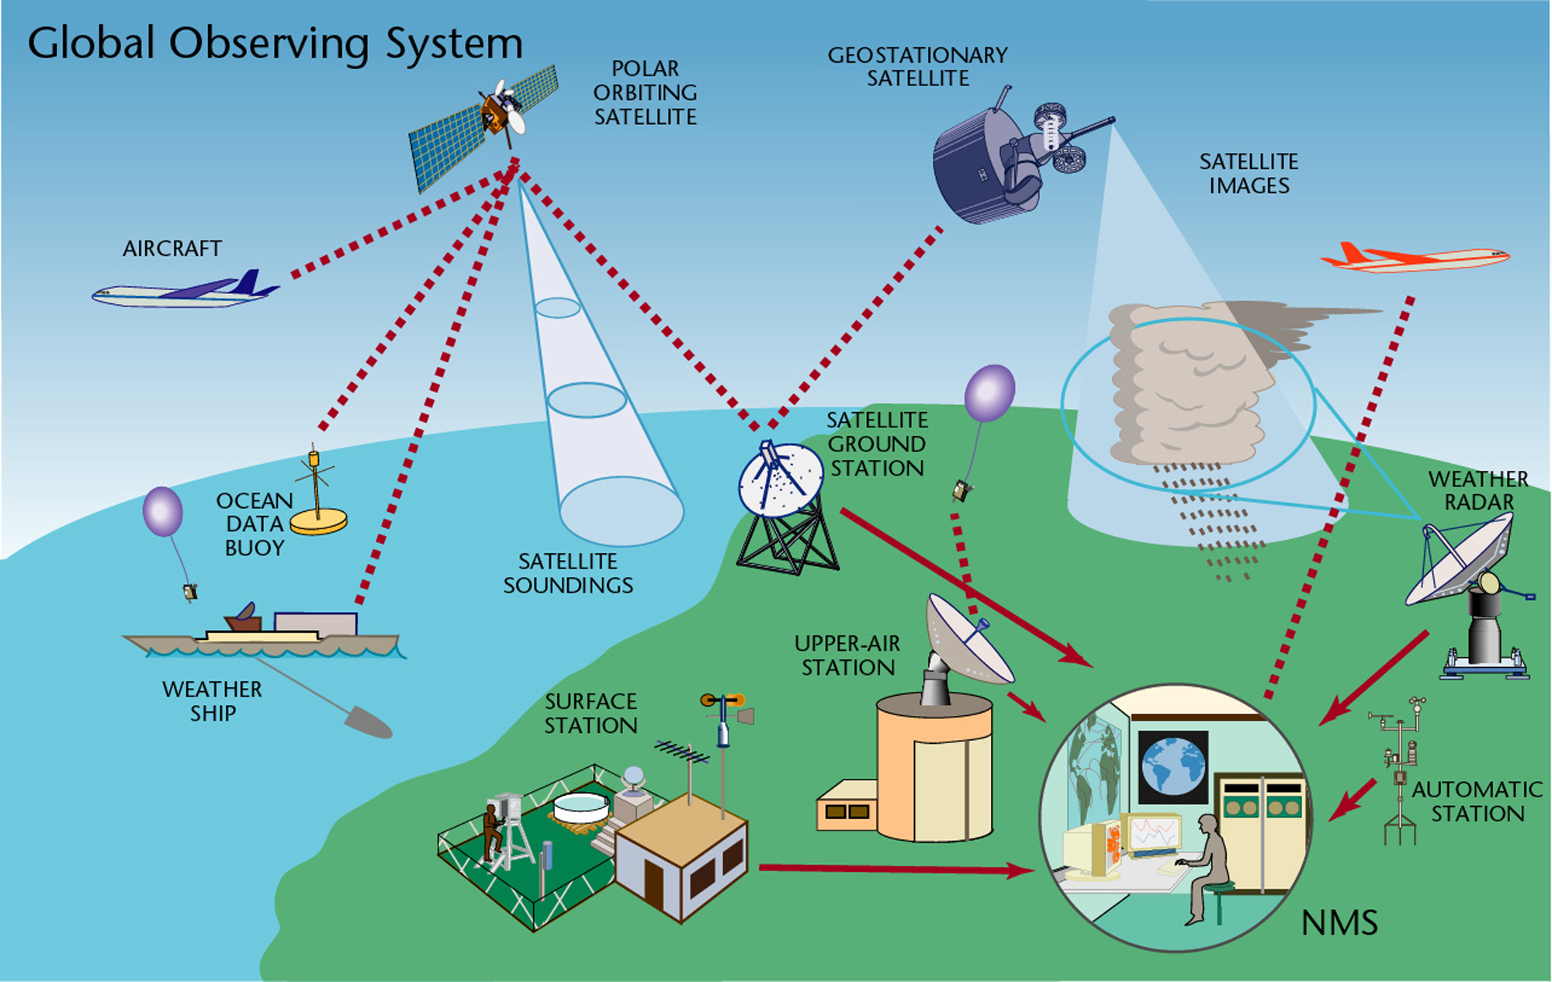
Figure 1 WMO Global Observing System (GOS)
Environment monitoring activities that result in constant media attention include:
- weather satellites that track the progress of hurricanes and typhoons;
- weather radars that track the progress of tornadoes, thunderstorms, and the effluent from volcanoes and major forest fires;
- radio-based meteorological aid systems that collect and process weather data, without which the current and planned accuracy of weather predictions would be seriously compromised; and
- broadcast sound and television systems and different mobile radiocommunication systems that warn the public of dangerous weather events, and aircraft pilots of storms and turbulence;
Satellite systems that are also used for dissemination of information concerning different natural and man-made disasters, etc.
Let’s consider few examples of remote sensing use. In order to promote global warming countermeasures, it is essential to monitor the state of global warming precisely, and for this purpose it is necessary to observe the concentration and increase/decrease in greenhouse gases at various locations throughout the world. Remote sensing applications placed satellites observes the concentration distribution of greenhouse gases from outer space, and its purpose is to contribute to the international effort toward prevention of warming, including monitoring the greenhouse gas absorption and emission state. A recently produced global satellite map of carbon dioxide distribution based on remote sensing data is shown on Figure 2.
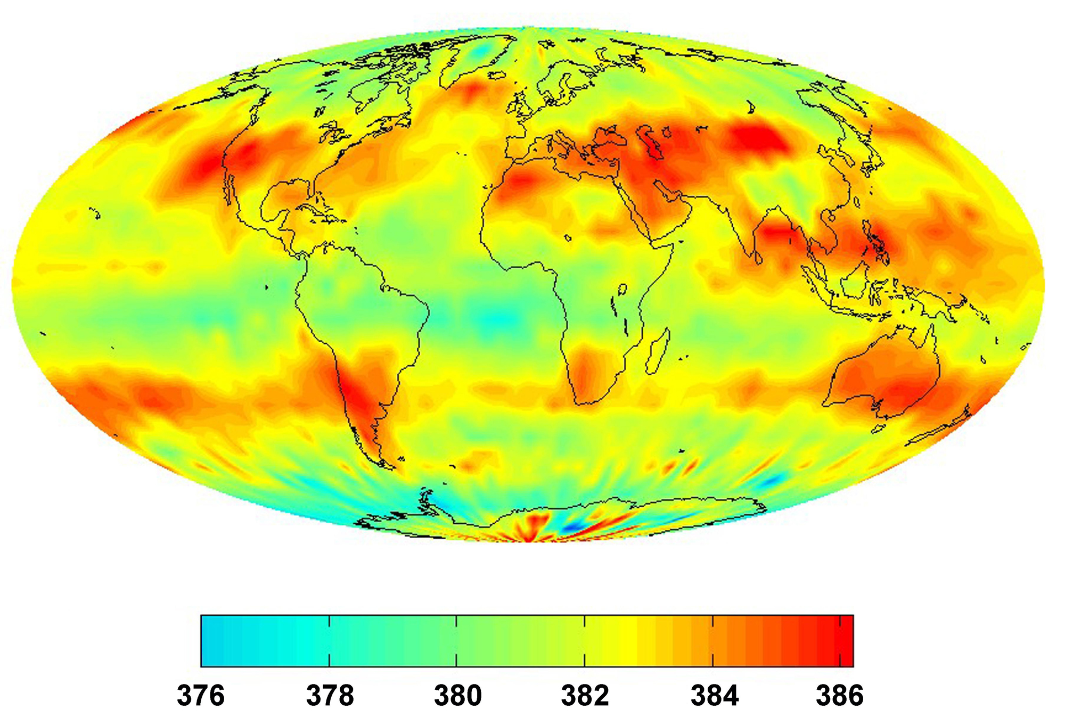
Figure 2: CO2 global map July 2008 - in parts per million by volume (Source: NASA)
Increasing ocean surface temperature is one of the governing factors influencing violent storms, hurricanes and rising sea level. The global control of the ocean temperature is also being carried out by remote sensors from satellites. Modern remote sensing applications measure the sea surface temperature with an accuracy of up to 0.2° C (see Figure 3).
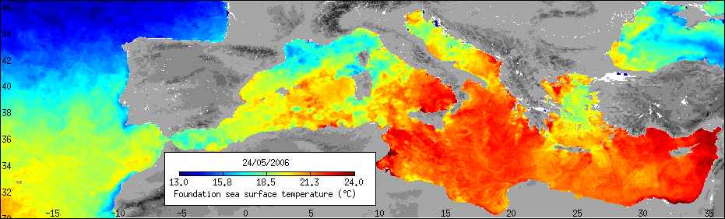
Figure 3: Mediterranean sea surface temperature map (Source: ESA)
However, it is important to remember that frequency bands used for remote sensing are determined by fixed physical properties (molecular resonance) and cannot hence be changed or ignored, nor are these physical properties able to be duplicated in other bands. That is why only certain frequencies are suited for extracting the environmental information (see Figure 4).
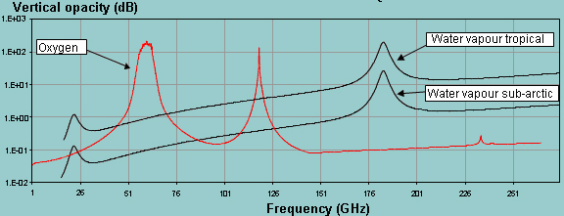
Figure 4: Atmospheric opacity in frequency range 1-275 GHz (Source: ITU)
Other information and communication technologies, such as wired and wireless telecommunication systems, and computers, are also essential components of the Global Climate Observing System.

2. Radiocommunications for Adaptation and Mitigation
Adaptation to the adverse effects of climate change is a key issue for all countries, but especially for developing countries, which are often the most vulnerable and the least equipped to protect their population.
The major contribution of radiocommunications to climate change comes from the proliferation of user devices, all of which need power and radiate heat. For instance, in the decade between 1996 and 2008, the number of mobile phones rose from 145 million to 4 billion.
One of the most effective ways of preventing further climate change is energy saving due to reducing radiocommunication equipment consumption and “dematerialisation”.
An impressive example in radiocommunications is switching to digital broadcasting. The use of digital modulation allows significantly reduce (by almost 10 times) transmitter power. Taking into account that there are hundreds of thousands of transmitters around the world with power of up to 100-150 kW each, the resulting effect is very significant. Moreover the number of transmitters may be reduced due to the possibility of transmitting up to 10 TV programmes in one 8 MHz channel instead of 1 TV programme per channel.
Radiocommunicaitons in mitigation of negative effects of natural disasters initiated by climate. The main tasks are the following:
- prediction and detection of disasters;
- delivery of early warning information to the general public;
- damage assessment and providing information for planning relief operations;
- ensure communication between humanitarian response crews and other agencies working onsite, providing contact with local hospitals and paramedics, and also with the victims.
As it is shown on Figure 5 the annual disaster occurrence has almost doubled between 1995 and 2005. In contrast mortality trend is almost ‘flat’, that may prove an increased effectiveness of disaster relief operations. However it is necessary to indicate that the mortality trend is also conditioned by major reduction in drought mortality in Africa since the early 1980s.
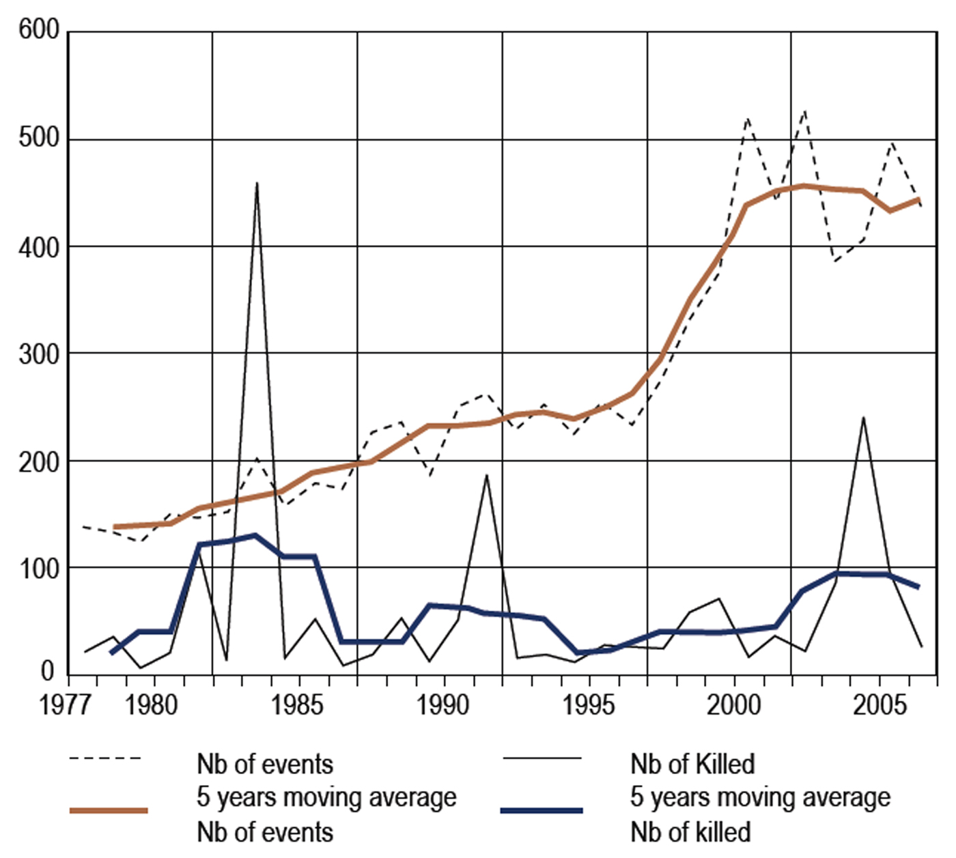
Figure 5: The annual number of disaster events recorded and the annual recorded mortality
(number of killed in thousands) - using a five-year moving average (Source: ISDR)
The disaster prediction and detection is one of the main functions of Earth exploration-satellite systems, which also provide the relevant data to emergency telecommunications for distribution of early warning signals.
The same systems control one of the most dangerous consequences of climate change - raising sea level that may lead to inundation of coasts worldwide with some small island States possibly facing complete inundation. A sample of a remote sensing instrument for sea level monitoring – a spaceborne altimeter is shown on Figure 6. Modern altimeters can identify a change in sea level with a precision of 2-3 cm. The sea-surface height is the difference between the satellite’s altitude relative to the reference ellipsoid and the altimeter range.
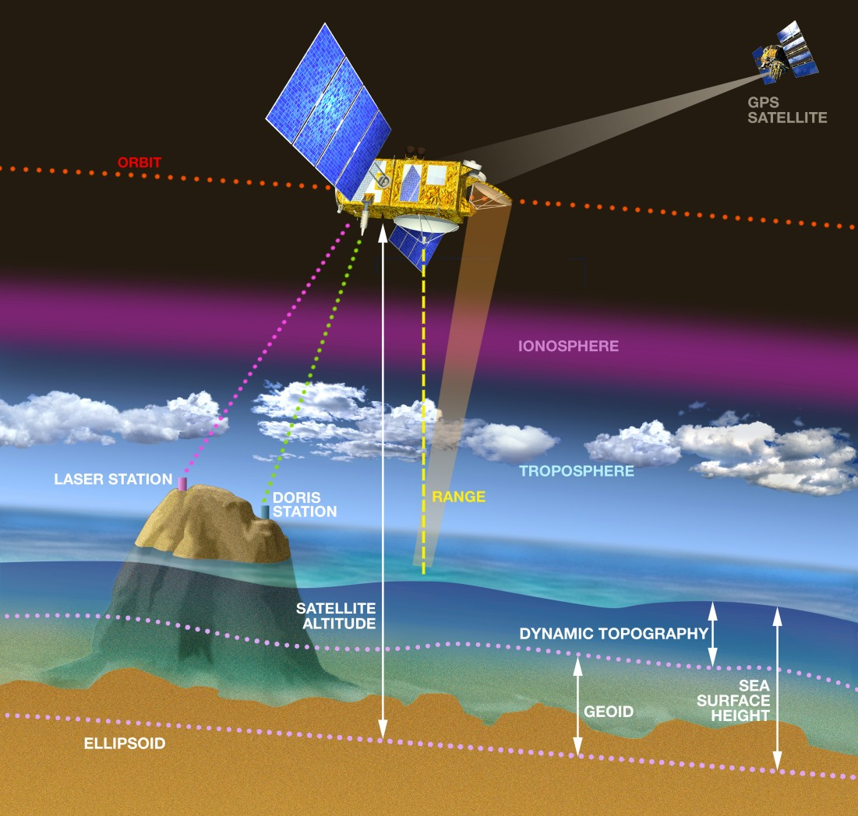
Figure 6: A spaceborne altimeter monitoring sea level (Source: CNES)
Radiocommunications in planning the organization of relief operations. Radiocommunication systems are especially important in disaster relief operations because in many cases, the "wired" telecommunication infrastructure is significantly or completely destroyed by a disaster, and only radiocommunication systems (especially satellite systems and high-frequency terrestrial systems) can be employed for disaster relief operation. That is why deploying wireless communications is typically among the first priorities in any emergency response, rescue, or relief situation.
Radiocommunications such as satellite communication systems (see Figure 7), Earth-exploration systems employing remote sensing equipment and satellite imaging can make a real difference during those first crucial hours and days. Typically they can assess the extent of damage, help locate survivors, measure the potential danger for rescue teams and ensure that humanitarian response crews can communicate effectively with their team members, with other agencies working onsite, with local hospitals and paramedics, and also with the victims.
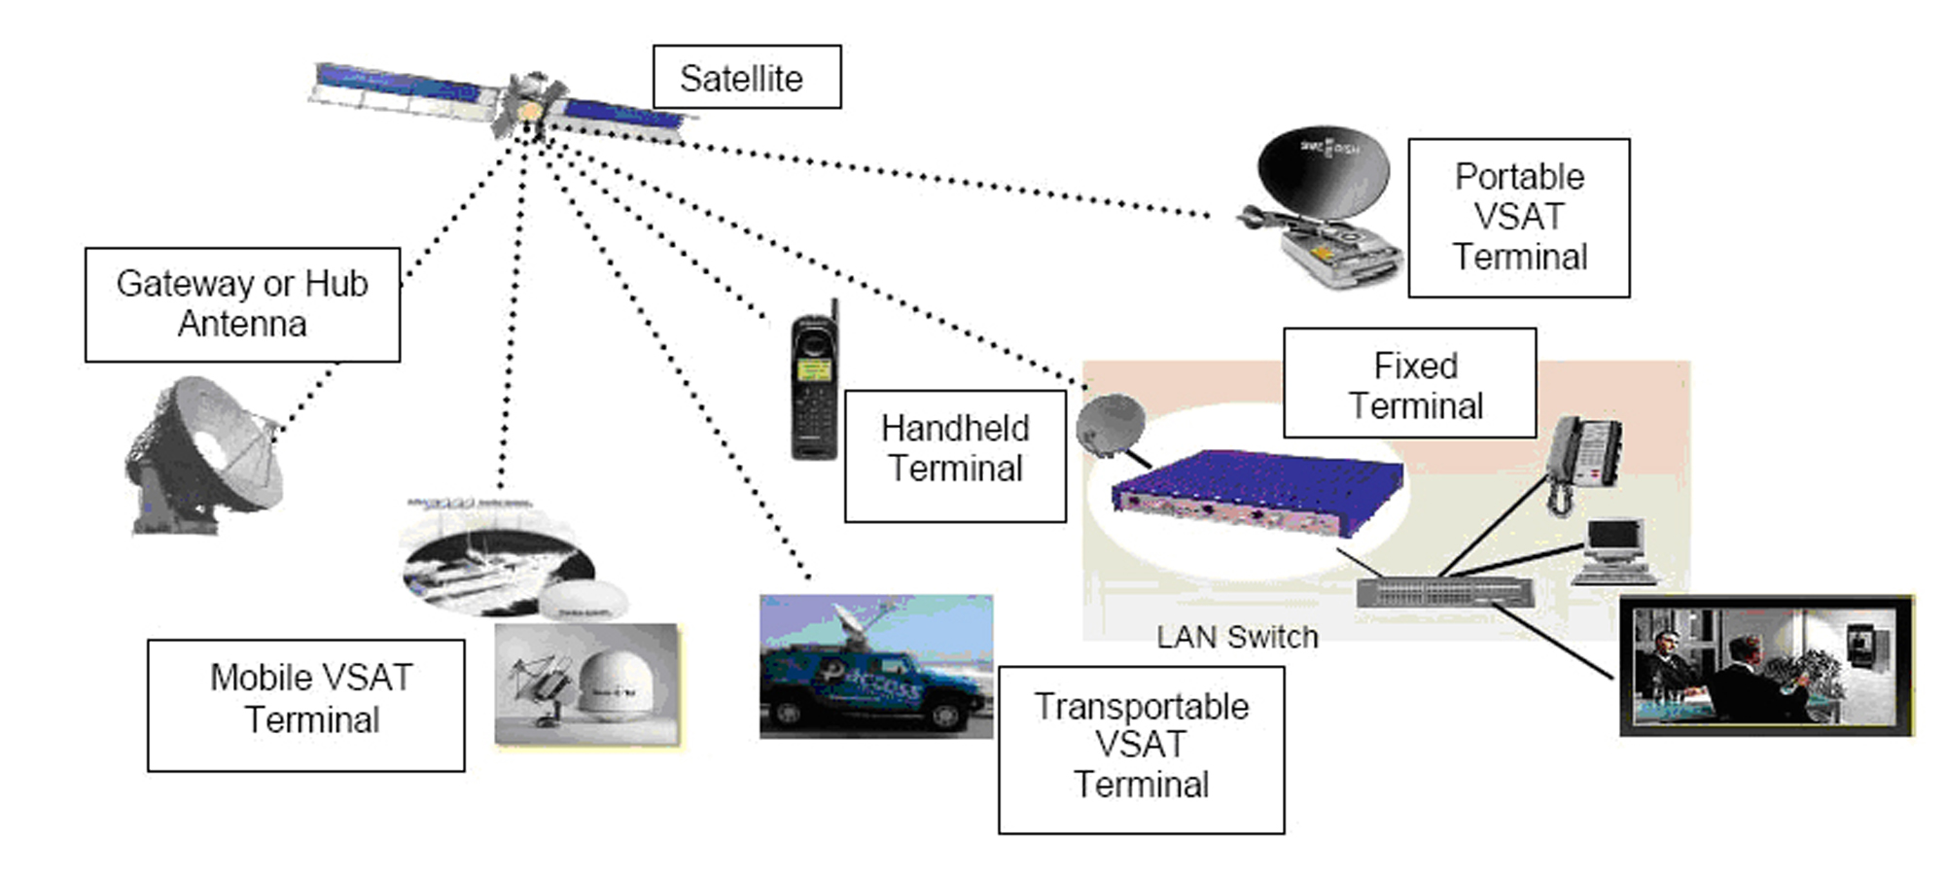
Figure 7: A satellite system in disaster relief operation

4. ITU and Climate Change
In 2007, ITU and its membership and partners launched a major programme to investigate the specific relationship between ICTs and climate change. In accordance with this programme ITU will:
- allocate the necessary radio frequencies and provide the interference-free operation of radio-based applications and radiocommunication systems (terrestrial and space) used for climate monitoring and prediction, weather forecasting and disaster early warning and detection;
- work to limit and reduce GHG emissions and promote the use of more energy-efficient devices and networks and the development of corresponding technical standards;
- facilitate the use ICTs (including radiocommunications) for travel replacement, dematerialization and, as the result, reduced energy consumption and GHG emissions in other industries;
- assist Member States to take full advantage of ICT applications for environmental management and sustainable development and to use telecommunication/ICTs to adapt to, and mitigate the effects, of climate change;
- join the UN commitment to lead by example through achieving climate-neutral status within three years.
The latest information on ITU activities related to battling of Climate Change is available at: http://www.itu.int/themes/climate/.

International Telecommunication Union (ITU) is the leading United Nations agency for information and communication technology issues, and the global focal point for governments and the private sector in developing networks and services. The ITU was established in 1865.
Remote sensors (passive and active) are radio devices, that derive environmental information by analyzing the characteristics of received radio waves
ITU/WMO Handbook “Use of Radio Spectrum for Meteorology: Weather, Water and Climate Monitoring and Prediction”, ITU/WMO, 2009, Geneva, see at: http://www.itu.int/publ/R-HDB-45/en.
“Replacing atoms with bits”: use of electronic publications instead of documents on paper, on-line delivery instead of pre-recorded on DVDs/CDs movies and music, videoconferencing to reduce business travel, etc.
“The Disaster Risk Reduction: 2007 Global Review”, International Strategy for Disaster Reduction, see at: http://www.preventionweb.net/files/1130_GlobalReview2007.pdf.

