|  |  |
| --- | --- |
| **Radiocommunication Study Groups** |  |
|  |  |
|  |  |
| Source: Document 5A/TEMP/191(Rev.2)  Subject: WRC-19 agenda item 1.11 | **Annex 16 to Document 5A/469-E** |
| **June 2017** |
| **English only** |
| Annex 16 to Working Party 5A Chairman’s Report | |
| PRELIMINARY DRAFT NEW  REPORT ITU-R M.[RSTT.Description] | |
| Description of Railway Radiocommunication Systems between Train  and Trackside (RSTT) | |

TABLE OF CONTENT

1 Scope 3

2Background 3

3Related documents 3

4List of acronyms and abbreviations 3

5Overview of RSTT 4

6Generic Architecture of RSTT 5

7Main applications of RSTT 5

7.1 Train radio 5

7.2 Train positioning information 7

7.3 Train remote 9

7.4 Train surveillance 9

8Current Technologies for RSTT 9

8.1 Technologies used for train radio application 9

8.2 Technologies used for train positioning application 13

8.3 Technologies used for train remote application 13

8.4 Technologies used for train surveillance application 13

9Generic operating scenarios 13

9.1 Railway lines 14

9.2 Railway stations 15

9.3 Shunting yards 15

9.4 Maintenance Bases 16

9.5 Railway hub 16

# 1 Scope

This report addresses the architecture, applications, technologies and operational scenarios of railway radiocommunication systems between train and trackside (RSTT) for all types of trains (e.g., high-speed trains, passenger trains, freight trains, and metro trains). This report provides some elements for studies in preparation of WRC-19 agenda item 1.11, in response to Resolution **236 (WRC-15)**.

# 2 Background

Railway Radiocommunication Systems between Train and Trackside (RSTT) provide improved railway traffic control, passenger safety and improved security for train operations. Those systems also provide for interoperability of train operations in some regions.

WRC-19 agenda item 1.11 calls upon the World Radiocommunication Conference 2019 (WRC-19) to take necessary actions, as appropriate, to facilitate global or regional harmonized frequency bands, to the extent possible, for the implementation of RSTT, within existing mobile service allocations.

Resolution **236 (WRC-15)** recognized that timely studies are required on technologies providing for railway radiocommunication and that international standards and harmonized spectrum would facilitate worldwide deployment of radiocommunication systems between train and trackside. Further, Resolution **236 (WRC-15)** invited ITU-R to study the spectrum needs, technical and operational characteristics and implementation of railway radiocommunication systems between train and trackside.

# 3 Related documents

ITU-R Recommendations

Recommendation ITU-R M.[RSTT]

Recommendation ITU-R M.2012

ITU-R Report

Report ITU-R M.[RSTT. USAGE]

# 4 List of acronyms and abbreviations

ATC Automatic Train Control

CCTV Closed Circuit TV

CTC Centralised Traffic Control

DMO Direct Mode Operation

DMS Device Monitoring System

ERTMS European Railway Traffic Management System

ETSI European Telecommunications Standards Institute

GSM-R GSM for Railways

LCX Leaky Coaxial Cable

LMR Land Mobile Radio

LTE Long Term Evolution

NB Narrow Band (typically 25 KHz)

OFDM Orthogonal Frequency Division Multiplexing

QPSK Quadrature Phase Shift Keying

RAN Radio Access Network

RSTT Railway Radiocommunication systems between train and trackside

SDS Short Data Services

SwMI Switching and Management Infrastructure in a TETRA system

TBS TETRA base Station

TDMA Time Division Multiple Access

TETRA Terrestrial trunk Radio based on ETSI standard

TGV Train à Grande Vitesse – Very High speed Train

THSR Taiwan (China) High Speed Rail

TMO Trunk Mode Operation (in TETRA)

UIC Union Internationale des Chemins de fer-(International Union of Railways)

UE User Equipment

VBS Voice Broadcast (in GSM-R)

VGCS Voice Group Call (in GSM-R)

# 5 Overview of RSTT

Railway transportation is a mean of conveyance of passengers and goods (freight). It is also commonly referred to as train transport. Various radiocommunication systems/technologies have been used for many years for railway operational applications. There are various degrees of implementation of numerous technologies among countries. Radiocommunication networks are critical to train operations including stringent requirements for reliability, availability, safety and security for these operations. Different security measures are considered based on the assumption of transmission error or communication blackout in RSTT.

In general, radiocommunications for railway operations are considered as “mission critical” for train operations in general and the management of train emergency situations. Furthermore, railway radiocommunication systems require the support of legacy technology and to have a long life cycle.

RSTT provide improved railway traffic control, passenger safety and security for train operations. RSTT carry train control, command, operational information as well as monitoring data between on-board radio equipment and related radio infrastructure located along trackside. To date, railway radiocommunication systems between train and trackside (RSTT) have included narrowband wireless technologies for carriage of train control, command, and operational information, as well as monitoring data between on-board equipment and related radio infrastructure located along the trackside.

Such legacy systems also usually took the form of dedicated mobile radio systems for dispatching, train control and other operational safety-related and efficiency needs of railway transportation systems.

Radiocommunication systems supporting RSTT generally need system interoperability and seamless continuity, especially for tracks crossing borders or tracks operated by multiple railway network entities. As such, regional and global standardization and harmonization efforts of the railway industry become essential.

# 6 Generic Architecture of RSTT

The main elements of the RSTT may consist of on board radio equipment, radio access units and other trackside radio infrastructure. Other systems, such as the core network, etc., are supporting systems for the RSTT.

– *Radio Access Unit:* including antenna and base station, to provide radio access to the terminals (especially cab radio)

– *On board radio equipment:* Radio equipment installed on train as well as handsets (for example, mobile terminals of automatic train control - ATC)

– *Other trackside radio infrastructure:* Radio infrastructure operating along trackside (for example: shunting radio devices)

A diagram of the architecture of RSTT is illustrated in Figure 1.

Figure 1

Diagram of the Architecture of RSTT



*Editor’s note: This figure should be further improved in the next meeting*

# 7 Main applications of RSTT

## 7.1 Train radio

Part of a railway radiocommunication system used for communication between train and track side for signalling and traffic management with the aim to contribute to safe train operation.

Train radio provides mobile interconnect to landline and mobile-to-mobile voice communication and also serves as the data transmission channel within various bearer services. For voice communication Train radio provides call functions (point to point / group / emergency / conference) with specialized modes of operation (e.g. location depending addressing, call priorities, late-entry, and pre-emption).

### 7.1.1 Voice/Dispatch

System for Voice/Dispatch includes point-to-point voice calls, public emergency voice calls, broadcast voice calls, group voice calls and multi-party voice calls.

One of the main functions of RSTT is to provide Dispatching Communication, which is to provide specific voice communication features for railway shown in Table 1.

Table 1

Dispatching Communication Functionalities

|  |  |
| --- | --- |
| Service Type | Feature Description |
| REC/enhanced REC | Railway Emergency Call / enhanced Railway Emergency Call |
| eMLPP | enhanced Multi-Level Precedence and Pre-emption |
| FA | Functional Addressing |
| LDA | Location Dependent Addressing |
| VGCS | Voice Group Call Service |
| VBS | Voice Broadcast Service |
| PTT | Push-To-Talk |
| … |  |

For further information, please refer to [UIC Project EIRENE functional requirements specification](http://www.uic.org/IMG/pdf/frs-8.0.0_uic_950_0.0.2_final.pdf).

### 7.1.2 Maintenance

This application provides voice communication (Point-to-Point, point to many point call, or Group-Call) and data communication for maintenance services in railway infrastructure.

### 7.1.3 Train Control (Interlock/movement authorization)

This application provides reliable communication bearer for train control system in order to ensure efficient data transmission between the on-board equipment and trackside equipment.   
The limitations of the trains distance to run are sent in the form of a Movement Authority[1] from the trackside.

The train control application can be categorised into decentralised and centralised modes.   
In a decentralised operation, the train movements are controlled by local interlocking stations.   
The operators of neighbouring interlocking stations communicate with each other by means of communications. In a Centralised Traffic Control (CTC) as one way of train control, all points and signals inside the controlled area are directly controlled by the dispatcher.

### 7.1.4 Emergency

Emergency applications allow an authorised user setting up an emergency communication to other users within an automatically configured area or group, which is based upon the originator’s location or characteristics and those users likely to be affected by the emergency.

Figure 2

Principle of Railway Emergency Call



### 7.1.5 Train information

Generally, railway information transmitted by RSTT could be classified into two catagories:

– to provide the railway transportation information for the train operators, such as train operating status, mobile ticketing and check-in services;

– to provide relevant railway transportation information for passengers, such as travel information.

## 7.2 Train positioning information

The knowledge of the positions of all trains and other vehicles on the tracks in normal and high-speed operations is one of the essential information to provide for railway traffic control, passenger safety, and security of train operations and therefore systems and applications providing information on the intermittent train positioning or constant train tracking are an integral part of RSTT.

These systems gather all kind of train positioning information (exact location of all units on trackside) relevant to train operations. This includes line- and location-oriented information.

The information about the position of the train can be obtained by detection systems. These include following specific active communication devices.

### 7.2.1 Balises

A passive or active device normally mounted in proximity to the track for communications with passing trains. Balise is a vital spot transmission based system conveying information between train and trackside. The system consists of the Balise and the transmission equipment. Balises can provide fixed or variable content. The on-board transmission equipment consists of the antenna unit and the BTM (Balise Transmission Module). The relevant positioning information can be repeated also by other means, e.g. train radio.

Figure 3

Example of railway balise

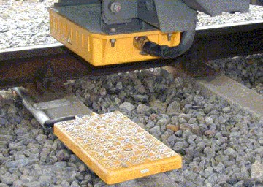

### 7.2.2 Loops/Leaky cable

Euroloop is a component based on leaky cable and a modem that is providing signalling information in advance of the next main signal.

The relevant positioning information can be repeated also by other means, e.g. train radio.

### 7.2.3 Annunciators

Annunciators control level crossings when a train route has been set and the indication point is passed by an approaching train.

### 7.2.4 Radar

The radar systems measure the motion parameters of the approaching rolling stock (speed, distance) and transmits that data into a Comprehensive system of safety on the dead-end paths, passenger stations for high-speed, passenger, suburban trains and shunting. Such radar is installed on a stationary object on the railway track (e.g. track focus stalled on railroad tracks), as shown in Figure 4.

One of the radar application is to detect the threat of a dangerous convergence with an obstacle and to send data and commands to the speed reduction or forced stop the locomotive or the head of an approaching motor car of rolling stock.

Figure 4

The deployment of a radar at the track focus stalled on the railroad tracks



### 7.2.5 Axle counters

Systems that control the integrity of trains in all operations by counting the number of axles at a given position and sending the data to the control center.

## 7.3 Train remote

This application provides data communication between a locomotive and a ground based system in order to control the engine. The remote driver can operate the locomotive via the ground system. This application enables and allows remote controlled movement of trains typically for shunting operation in depots, shunting yards and/or for banking. This application provides a point to point localized functionality to control trains in an assemble/disassemble operation.

## 7.4 Train surveillance

Train surveillance systems enable the capture and transmission of video of the public and trackside areas, driver cabs, passenger compartments, platforms and device monitoring.

Train surveillance contributes to analysis of the railway environment, improvement of maintenance services, and gathering of information on infrastructure.

A set of cameras at specific locations (front, interior, rear view) is used in low to high resolution, low and high frame-rates depending on the event. Data may be either stored on-board/locally or streamed (e.g., realtime video) to control centres via dedicated radio communication system.

# 8 Current Technologies for RSTT

## 8.1 Technologies used for train radio application

### 8.1.1 Analogue Radio based

Analog radio used for RSST that utilizes analogue modulation and constitute a set of mobile-to-mobile(s), mobile-to-fixed operating on common channel(s) without control channel typically in narrow band channels. Analog trunked radio systems used for RSST that utilizes analogue modulation and constitute a set of mobile-to-mobile(s), mobile-to-fixed on common channel(s) and a control channel for control or resources and dispatch.

### 8.1.2 Digital Radio based

#### 8.1.2.1 Conventional Digital Radio

Conventional Digital Radio use digital modulation for communications between mobile-to-mobile(s), mobile-to-fixed including repeaters sharing common channel(s) without control channel for resource management. Conventional Digital Radio in RSST are used in some countries for wagon tail communications, shunting operation and intercom communication. Onboard staff, locomotive driver and people involved in maintenance and management are normally participating.

#### 8.1.2.2 TETRA based

Terrestrial Trunked Radio (TETRA) is a professional land mobile radio standard specifically designed for use by government agencies, emergency services, public safety networks, rail transport, transport services and the military. TETRA is a European Telecommunications Standards Institute (ETSI) standard, first version published 1995. TETRA uses Time Division Multiple Access (TDMA) with PI/4 QPSK modulation with four user channels on one radio carrier and 25 kHz channel raster. Both point-to-point and point-to-multipoint transfer can be used. Digital data transmission is also defined in the standard.

TETRA Mobile Stations can communicate direct-mode operation (DMO) or using trunked-mode operation (TMO), using switching and management infrastructure (SwMI) made of TETRA base stations (TBS). As well as allowing direct communications in situations where network coverage is not available, DMO also includes the possibility of using a sequence of one or more TETRA terminals as relays. This functionality is called DMO gateway (from DMO to TMO) or DMO repeater (from DMO to DMO). In emergencies, this feature allows direct communications underground or in areas of bad coverage.

In addition to voice and dispatch services, the TETRA system supports several types of data communication. Status messages and short data services (SDS) are provided over the system's main control channel, while packet-switched data or circuit-switched data communication uses specifically assigned channels. TETRA provides for authentication of terminals towards infrastructure and vice versa. For protection against eavesdropping, air interface encryption and end-to-end, encryption is available. The common mode of operation is in a group-calling mode in which a single button push will connect the user to the users in a selected call group and/or a dispatcher.

TETRA has been successfully deployed in a number of high-speed and a large number of METRO projects around the world[2] and is being considered in many European countries as well[3]. A list of TETRA Rail projects is enclosed as Annex 1.

Studies conducted on TETRA train communication systems at speeds of up to 500 km/h show that the performance of the channels at higher speeds is not significantly different from that at lower speeds. This is due to the forward error correction applied, which has better performance at higher speeds. Fading causes bursts of errors for the duration of a fade, and TETRA compensates for this by interleaving bits over a timeslot so that the error bits during a fade are spread out in between ‘good’ bits before the error correction mechanism operates on the decoded information. As speed increases, whereas the fades become closer together, the duration of each fade becomes shorter, affecting fewer bits.

An example ofthe TETRA system used for High speed Train communications is the Taiwan (China) High Speed Rail (THSR) system that connects Taipei city in the north to Kaohsiung city in the south,   
a distance of 345 km. THSR’s service operation speed is 300 km/h, but was designed and tested at 315 km/h. THSR has been in operation since January 2007[4]. TETRA was also tested during the French TGV (Train à Grande Vitesse) with train speed at 574.8 km/h.

#### 8.1.2.3 B-TrunC based

B-TrunC is a professional trunking system which can support emergency call, voice group call, video group call, private voice call, private video call, real-time short data, floor control, late entry, dynamic regrouping, etc. The B-TrunC standard is developed by the CCSA and published by the Ministry of Industry and Information Technology of the People’s Republic of China. The standard of B-TrunC can be referred to ITU-R M.2014. In China, the B-TrunC system is used for railway plane shunting and freight train inspection in shunting yards, providing voice communication and data communication. Also, it is used for control and voice/dipatch applications in metro lines of China.

### 8.1.3 GSM-R based

GSM-R supports mobile radio connectivity between train and track and serves terminals mounted on or integrated in trains from base stations along the trackside. A description of GSM-R features and specifications can be found in [UIC-GSM-R](http://www.uic.org/gsm-r).

GSM-R, Global System for Mobile Communications – Railway or GSM-Railway is a wireless communications standard for railway communication and applications. A sub-system of European Rail Traffic Management System (ERTMS), it is used for communication between train and the track. GSM-R is built on GSM technology, and benefits from the economies of scale of its GSM technology.

The specifications were finalized in 2000, based on the European Union-funded MORANE (Mobile Radio for Railways Networks in Europe) project. The specification is being maintained by the International Union of Railways (UIC) project ERTMS. GSM-R is a secure platform for voice and data communication between railway operational staff, including drivers, dispatchers, shunting team members, train engineers, and station controllers. It delivers features such as group calls (VGCS); voice broadcast (VBS), location-based connections, and call pre-emption in case of an emergency. This will support applications such as cargo tracking, and passenger information services.

According to the GSM-R industry[5], GSM-R will be supported until 2025-2030.

### 8.1.4 LTE based

LTE supports mobile broadband radio connectivity between base stations (eNBs) and terminals (UEs). Hence LTE is able to serve terminals being mounted on or being integrated in trains from base stations along the trackside. In addition, relaying and direct device-to-device (D2D) communications are also supported.

A description of LTE features up to and including Release 12 can be found in Recommendation ITU-R M.2012. In addition 3GPP has been working on the following LTE enhancements in Release 13 and 14, which might be relevant also for RSTT:

– UE performance enhancements for high speed scenario, where the target moving speed is at least 350 km/h and at most 750 km/h, depending on candidate solution, which can be found in TR36.878.

– Coverage enhancements with up to 2048 repetitions leading to ~20 dB coverage extension.

– Narrowband operation with a minimum channel spacing of 200 kHz.– Multi-antenna transmissions with up to 32 steerable antenna ports, which can be used for beamforming to reach far away receivers.

– Vehicle-to-vehicle (V2V) side link designed for direct communication with up to 500 km/h velocity.

– Optimizations for vehicle-to-network/infrastructure/pedestrian (V2N/V2I/V2P) communication.

– Latency reduction reducing both signalling and data transmission delays.

Examples Technical characteristics

|  |  |
| --- | --- |
| Parameter | LTE |
| Frequency Range | From 450 MHz up to ~6 GHz, see 3GPP TS36.101 |
| Channel separation | 1.4, 3, 5, 10, 15, 20 MHz carrier bandwidth |
| Antenna gain (dBi) | Not limited by 3GPP standards |
| Polarization | - |
| Transmitting radiation power (dBm) | UE power classes defined for 20, 23, 26 and 31 dBm  BS power classes defined from below 11 dBm up to 38 dBm, no upper limit for Wide Area BSs |
| e.i.r.p. (dBm) | Not limited by 3GPP standards |
| Receiving noise figure (dB) | As per 3GPP 36.101 & 36.104 |
| Transmission data rate (kb/s) | [TBD] |
| Transmission distance (km) | [TBD] |
| Modulation | DL: OFDM  UL:SC-FDMA single-tone FDMA |
| Multiplexing method | FDD, TDD |
| … |  |

### 8.1.5 Leaky Coaxial Cable (LCX) based

In general mobile communications, the spaced wave method is commonly used, where base stations and mobile stations communicate with each other by antennas through some distance of space. But in closed spaces such as a tunnel, radio waves are weakened rapidly and radio propagation becomes very short range. In order to solve this problem, LCX is commonly used in such spaces. In LCX based RSTT, LCX systems are laid at trackside all along the line and base stations are connected to the cables and transceivers. Through the cables and onboard antennas, radio communications between base stations and mobile stations are enabled. The most distinctive feature of this system is to use the cable even at no-tunnel area.  The close distance between LCX and onboard antennas mitigates the effect of interference which results in much lower noise level compared to other spaced method, and it is possible to maintain stable communication regardless of the location of train, even in open-site or inside of tunnels. The LCX based RSTT can be applied to any applications, like analogue train radio, digital train radio, and so on. Applying LCXs to RSTT enables high quality communication service areas in almost all the line and it contributes safety of railway.

## 8.2 Technologies used for train positioning application

### 8.2.1 Radar based

Radars, particular short range radars, are used for measuring train movement parameters. Such RSTT radar systems could provide information on the motion parameters of the approaching train (speed, distance) to determine position to avoid collision with obstacles or other moving trains.   
The measured motion parameters are transmitted to the train control center to be used to reduce speed or stop train movement.

### 8.2.2 Short Range Radio based

Short Range Radio for RSTT is specific technology that limits the electromagnetic field of the transceiver within a certain distance. The transceiver using Short Range Radio technology is optimized for movement speeds, power consumptions etc., which uses invariable, repeating or oscillating of electromagnetic field to indicate the exact position information of the train.

## 8.3 Technologies used for train remote application

Common technologies including but not limited to Analogue Radio, Digital Radio, GSM-R, LTE and RLAN can be used for train remote application. Detailed information of Analogue Radio, Digital Radio, GSM-R and LTE could be found in sections 8.1.1 to 8.1.4.

RLAN technology is a specific radio communication technology which uses random access method to share the channel without having control channel for resource management. The most popular standard of RLAN technology is constructed by IEEE and published within 802.11 series.

## 8.4 Technologies used for train surveillance application

Common technologies including but not limited to RLAN, LTE B-TrunC and Millimetric wave can be used for train surveillance application. Detailed information for RLAN and LTE could be found in sections 8.3, 8.1.2.3 and 8.1.4.

Millimetric wave radio technologies can provide broadband transmission capabilities to support functions such as multiplexed uncompressed high-definition video transmission from train to trackside and vice versa. The millimetric wave radio technologies can use pencil beam antennas to reduce the frequency interference.

# 9 Generic operating scenarios

This section provides a brief overview of RSTT operating scenarios. These scenarios are Railway line, Railway station, Shunting yard, Maintenance Base and Railway Hub. The general service characteristics of RSTT in different operating scenarios are listed in Table 2.

Table 2

**General Service Characteristics of RSTT in different operating scenarios**

|  | Priority | Latency | Reliable | Density | Moving speed |
| --- | --- | --- | --- | --- | --- |
| Railway line | High | Low | High | Low | High |
| Railway station | High | Low | High | High | High/Stop |
| Shunting yard | High | Low | High | High | Low/Stop |
| Maintenance Base | Low | Medium | High | High | Stop |
| Railway hub | High | Low | High | High | High/Low/Stop |

## 9.1 Railway lines

The train communication between the tracksides and moving trains, in this operating scenario, requires reliable wireless radio-links. It needs to satisfy all train to trackcommunication application, including voice and data services, for example, the data transmission for the control‑command of trains, provided by railway operators.

Whenever needed, the interoperability requirements of the RSTT should be taken into account during cross-border railway transportation. Compatible RSTT system can support international roaming and international data exchange, that is also helpful to improve the efficiency of cross-border transportation and to reduce the relevant cost.

Figure 5

Railway lines

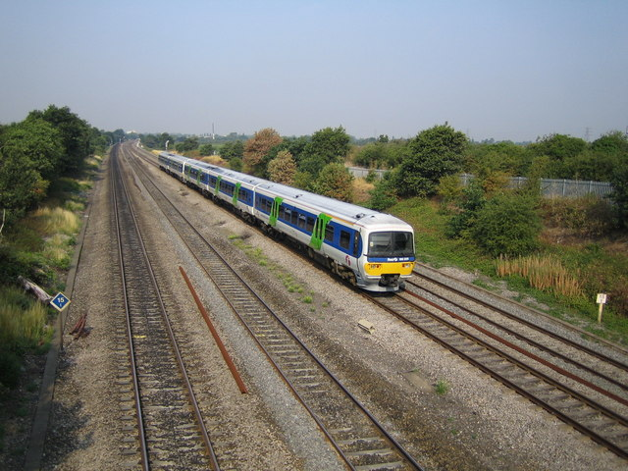

In addition, there are several specific operating scenarios of railway lines, e.g. parallel railway lines, viaducts and tunnels, etc.

Figure 6

Several specific operating scenarios

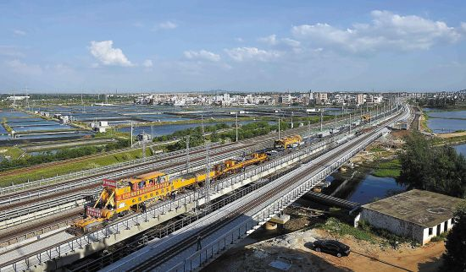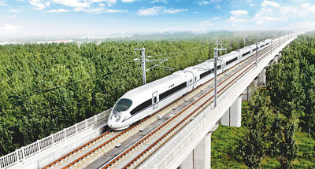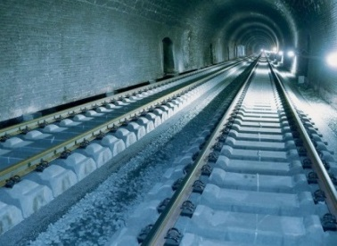

(a) Parallel railway lines (b) Viaducts (c) Tunnel

## 9.2 Railway stations

Typical applications in railway stations may include train control, interlock, train survelliance, train information etc., e.g., device monitoring system (DMS), information transmission system of end-of-train safety equipment. Especially, one of the main task of railway stations is the interlocking which is the central function to ensure that trains move safely in technical terms. For interlocking, RSTT obtains information about track occupancy and the position of movable track elements.

Figure 7

Railway station

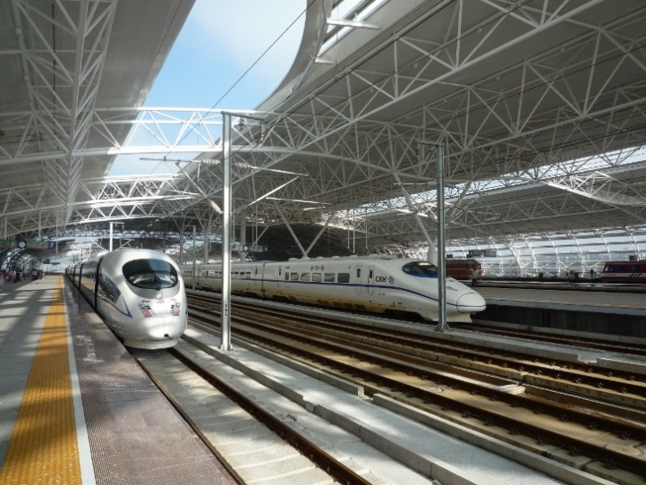

## 9.3 Shunting yards

Shunting operations is the process for assembling and disassembling of trains, moving carriage from one track to another, storing carriages and trains, and similar purposes.

In shunting mode[6], the typical applications may include voice and alerting data mixed transmission, monitoring. (Source: [FRS 8.0.pdf](http://www.uic.org/IMG/pdf/frs-8.0.0_uic_950_0.0.2_final.pdf))

Figure 8

Shunting mixed with railway lines

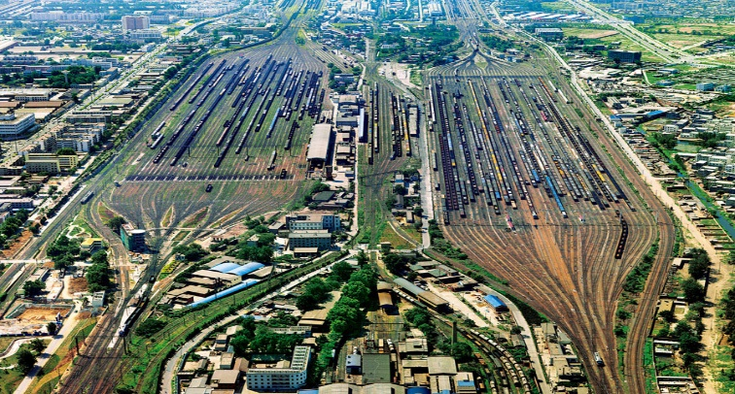

## 9.4 Maintenance Bases

The operating scenario of RSTT in the maintenance bases is similar to that of in railway stations. In this scenario, RSTT need to support the following applications: monitoring, maintenance information (Sources: [FRS 8.0.pdf](http://www.uic.org/IMG/pdf/frs-8.0.0_uic_950_0.0.2_final.pdf)).

Figure 9

Maintenance Base

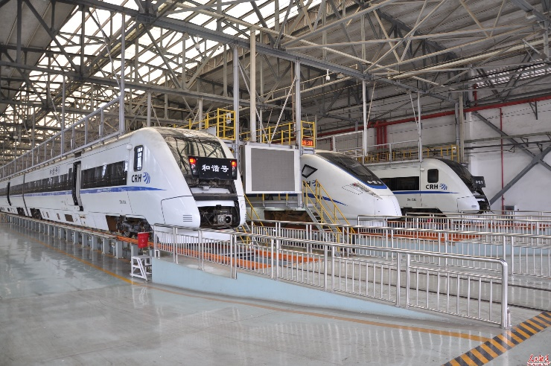

## 9.5 Railway hub

The RSTT in hub scenario is the combination of other typical railway scenarios.

In this scenario, a common usage of the radiocommunications systems and applications with urban rail or other transport systems could be possible (e.g., big hub stations, airports, etc.). Figure 10 is a diagrammatic sketch in a big city, in which railway stations (including Maintenance base and shunting yard etc.) are connected by different railway lines. Due to the complex operations in the hub, the moving speed of the trains in the hub is quite different, ranging from 0 to high speed level.

Figure 10

Railway hub

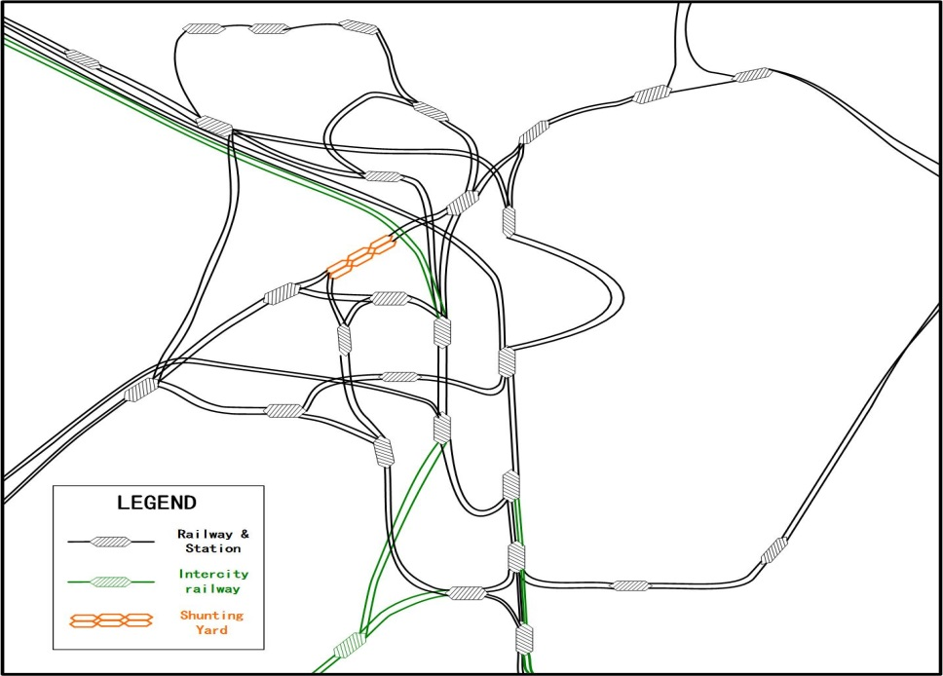

1. Movement authority is permission for a train to run, within the constraints of the infrastructure, up to a specific location (IEC 62290-1).
2. See list of TETRA projects <https://en.wikipedia.org/wiki/Terrestrial_Trunked_Radio>.
3. From TETRA Rail group <http://www.tandcca.com/Library/Documents/TETRA_Resources/Library/Presentations/MiddleEasti2011Davis.pdf>.
4. [http://en.wikipedia.org/wiki/Taiwan (China) High_Speed_700T_train](http://en.wikipedia.org/wiki/Taiwan%20(China)%20High_Speed_700T_train).
5. From the GSM-R Industry Group’s strategic key messages: <http://www.gsm-rail.com/drupal/messages>.
6. Shunting mode is the term used to describe the application that will regulate and control user access to facilities and features in the mobile while it is being used for shunting communications.